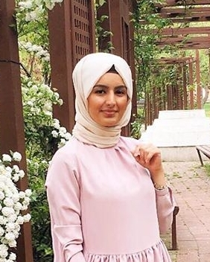

The Effects of PLGA-Curcumin Nano-formulation on the Levels of Nf Kappa B Sub-Units in Cancer Cell Lines

Seyma Bulut¹, Pınar Obakan Yerlikaya², Fatmanur Babali Balibey¹, Fatemeh Bahadori*³

¹Department of Biotechnology, Health Sciences Insitiute, Bezmialem Vakıf University, 34093, Fatih Istanbul, Turkey, seybulut@gmail.com
²Department of Molecular Biology and Genetics, Istanbul Kultur University, 34156, Bakirkoy Istanbul, Turkey, p.obakan@iku.edu.tr
³Department of Pharmaceutical Biotehnology, Faculty of Pharmacy, Bezmialem Vakıf University, 34093, Fatih Istanbul, fbahadori@bezmialem.edu.tr

In addition to the toxic effects of cancer chemotherapeutics on healthy cells, it is important to increase the effectiveness of these drugs by means of pro-oxidant polyphenols especially by considering their costly price in clinical use. Polylactic-co-glycocolic acid (PLGA), the most used one among polymeric materials, is a biomaterial commonly used in new drug delivery systems and approved by the FDA. In many studies, safety and efficacy of curcumin in prevention and treatment of cancer has been emphasized. NF-kB; is a transcription factor in regulation of many genes which are responsible of inflammation, immune response, proliferation and apoptosis. The increase in the level of reactive oxygen species due to stress affects the NF-kB transcription factor in the cell. A better understanding of the NF-kB structure and mechanism of action will play an important role in the reduction of cellular stress and hence the emergence of new approaches and mechanisms of action in eliminating the negative effects of stress. The investigation of the effect of PLGA-Curcumin Nano-formulation (Nano Curc) on the level of NF-kB subunits in cancer cells were investigated in this study.
The effect of Nano-Curc on the ratios of four sub-units of NF-kB including P65, P52, P50 and C-Rel were evaluated on MCF-7 breast cancer cell lines which were pre-treated with paclitaxel. P65 was the most supressed sub-unit by Nano-Curc which could be counted as the success of this nano formulation in decrease of inflammation at cancer tumor.

Biography

Şeyma Bulut is studying in Master's Programme in Bezmialem Vakif University, Department of Biotechnology- Istanbul-Turkey. She was graduated from department of Molecular Biology and Genetics- Bilim University-Istanbul, Turkey. She has the experiences in studying molecular mechanisms of anti-cancer agents in national and international internship programs.

Presenting author details
Full name: Seyma Bulut
Contact number: +90 534 974 65 30
Linked In account: Şeyma Bulut
Session name/ number:
Category: Oral presentation

