Electrochemical Immunosensor based on graphene quantum dots@Carbon nanotubes composite for foodborne mycotoxin detection

Hema Bhardwaj^{1,2}, G. Sumana², R.K.Kotnala², Christophe Marquette³,
¹AcSIR, CSIR-National Physical Laboratory, Dr. K.S.
Krishnan Marg, New Delhi-110012
² CSIR-National Physical Laboratory, Dr. K.S. Krishnan
Marg, New Delhi-110012
³Supramoléculaires Université Lyon 1-CNRS 5246
ICBMS Bâtiment CPE 43, bd du 11 novembre 1918,
69622 Villeurbanne, Cedex,
France

Abstract
Since the last decades, food borne pathogen affect the humans and animal’s life gradually, where 40% of the approximately 50 million peoples died annually in worldwide¹. Infectious disease naturally occurs in food and cannot be removed once get infected. Among the various foodborn toxins, aflatoxin B1 is one of the most affected toxic chemical which mainly produced by secondary metabolite mold such as Aspergillus parasiticus and Aspergillus flavus². These fungi usually infect the crops such as wheat, cereals, pulses, walnut, almond, flour, etc. and lead to create serious complication for human’s health and animals such as teratogenicity, immunotoxicity, and hepatotoxicity. It has been reported that, in the developing countries, 4.5 billion peoples affected because of the chronic exposure of aflatoxin in infected foods³. However, there is urgent need of some accurate, fast, reliable and specific tool for the detection in food contents. The biosensor is one of the most suitable and appropriate technique which involve specificity, sensitivity, reliability and selectivity for quantification and determination of food born pathogen. We report results of studies in the designed of electrochemical immunosensor using graphene quantum dots integrated carbon nanotubes for the determination of aflatoxin B1 in dialy usage food contents. The chemically synthesized graphene quantum dots interagted onto multiwalled carbon nanotubes which further deposited onto ITO coated glass electrode using electrophoretically deposition process. The monoclonal antibodies of aflatoxin B1 immobilized further onto the deposited substrate matrix using cross linkers. Various characterization techniques have been utilized for the structural, morphological and electrochemical studies such as Transmission Electron Microscopy, Scanning Electron Microscopy, UV-visible spectroscopy, X-ray Diffraction, Fourier Transform Infrared spectroscopy, etc. Moreover, biosensing charcaterstics have been investigated using electrochemical impedance spectroscopy and cyclic voltammetry techniques. The results of this studies demonstrate the potential of this platform for the determination of aflatoxin B1 in food contents.

Image

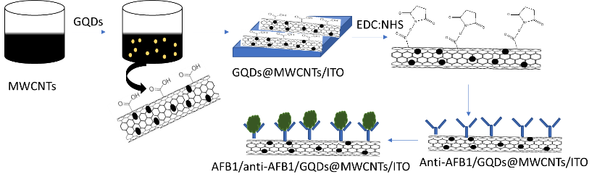
Recent Publications
- White, D. L., Kanwal, F., Jiao, L., & El-Serag, H. B. (2016). Epidemiology of Hepatocellular Carcinoma. Springer, Cham 3-24.
- da Rocha, M. E. B., Freire, F. D. C. O., Maia, F. E. F., Guedes, M. I. F., & Rondina, D. (2014). Mycotoxins and their effects on human and animal health. Food Control, 36(1), 159-165..
- Smith, L. E., Stasiewicz, M., Hestrin, R., Morales, L., Mutiga, S., & Nelson, R. J. (2016). Examining environmental drivers of spatial variability in aflatoxin accumulation in Kenyan maize: potential utility in risk prediction models. African Journal of Food, Agriculture, Nutrition and Development, 16(3), 11086-11105. Room R, BaborT, Rehm J (2005) Alcohol and public health. Lancet
365: 519-530.
- Hou, L., Gan, F., Zhou, X., Zhou, Y., Qian, G., Liu, Z., & Huang, K. (2018). Immunotoxicity of ochratoxin A and aflatoxin B1 in combination is associated with the nuclear factor kappa B signaling pathway in 3D4/21 cells. Chemosphere, 199, 718-727.
5. Songa, E. A., & Okonkwo, J. O. (2016). Recent approaches to improving selectivity and sensitivity of enzyme-based biosensors for organophosphorus pesticides: A review. Talanta, 155, 289-304.

Biography
Hema Bhardwaj is working as a doctoral candidate at Biomedical Instrumentation Section, CSIR-National Physical Laboratory, New Delhi, India in collaboration with supramoleculaires University Lyon 1, ICBMS, Villeubanne,France. She received her M.Sc. degree in Chemistry from Amity University, Noida, U.P, in 2014. She is working on fabrication of immunosensor using nanomaterials for the detection of food borne mycotoxin like aflatoxin B1.
Email: hema_bhardwaj28@yahoo.in

