Green biosynthesis of Silver Nanoparticles (AgNPs) by using aqueous extracts of Hypericum perforatum L (St John's wort) for cancer targeting

Abdalrahim Alahmad, RN PhD, Institute of Technical Chemistry, Leibniz University of Hannover, Germany Johanna-Gabriela Walter, Institute of Technical Chemistry, Leibniz University of Hannover, Germany
Thomas Scheper, Institute of Technical Chemistry, Leibniz University of Hannover, Germany

Abstract
The Green synthesis of silver nanoparticles (Ag NPs) with biological molecules through using of plants has received much attention lately because it is fast, effective and environmentally friendly[1-2]. The present study reports that Ag NPs were synthesized from a silver nitrate solution with Hypericum perforatum L (St John's wort) [4-5] aqueous extracts with different concentrations. Resulting Ag NPs were characterized by UV-VIS spectroscopy, Atomic Force Microscopy (AFM), Fourier Transform Infrared (FTIR) Spectroscopy, Dynamic Light Scattering (DLS), Scanning Electron Microscopy (SEM), Transmission Electron Microscopy (TEM), x-ray diffraction (XRD), Nanoparticle Tracking Analysis (NTA), atomic absorption spectroscopy (AAS) and Energy Disperse X-ray Spectroscopy (EDX). At the end of this work we have monodisperse spherical nanoparticles, their size is approximately between 20 to 50 nm as is evident through the results and images: TEM, SEM, DLS and NTA. These nanoparticles were coated with a protective surface layer from a component or group of organic components that have not been identified so far. Currently the composition of the surface layer is investigated using High-performance liquid chromatography-mass spectrometry (HPLC-MS) and (GC-MS). UV–VIS absorption studies revealed the presence of surface Plasmon resonance (SPR) peaks in range of 425-450 nm. The XRD studies, energy dispersive X-ray analysis confirmed the formation of metallic silver and these particles are crystallized in face-centered cubic structure. The EDX spectrum indicated the presence of 71% of silver particles by weight with least impurities. FTIR showed that nanoparticles were capped with bio-moieties on their surface, where it refers to the hydrophilic functional groups in the capping matrix which can improve the stability of AgNPs. In future work, these nanoparticles will be conjugated with aptamers to result in specific targeting of tumor cells [3], where the small size of produced AgNPs will facilitate penetration of tissues.

Image
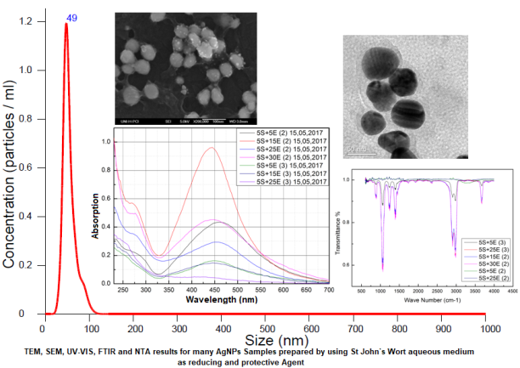
Recent Publications (minimum 5)
- R.R. Bhosale*, A.S. Kulkarni, S.S. Gilda, N.H. Aloorkar, R.A. Osmani and B.R. Harkare, Innovative Eco-friendly Approaches for Green Synthesis of Silver Nanoparticles, International Journal of Pharmaceutical Sciences and Nanotechnology Volume 7 Issue 1 January – March 2014
- Xi-Feng Zhang ¹, Zhi-Guo Liu ¹, Wei Shen ² and Sangiliyandi Gurunathan ^{3,*}, Silver Nanoparticles: Synthesis, Characterization, Properties, Applications, and Therapeutic Approaches, Int. J. Mol. Sci. 2016, 17, 1534
- M. Mishra¹ , P. Shauhan^{2*}, Nanosilver and its Medical Implications, J Nanomed Res 2015, 2(5)
- U M Rao Vattikuti and Veeresham Ciddi*, An overview on Hypericum perforatum Linn, Natural Product Radiance, Vol 4(5) September-October 2005
- Jinous Asgarpanah, Phytochemistry, pharmacology and medicinal properties of Hypericum perforatum L., African Journal of Pharmacy and Pharmacology Vol. 6(19), pp. 1387-1394, 22 May, 2012

 Biography
Abdalrahim Alahmad has excellent experience in production and characterization of nanomaterials using various chemical and physical methods through his master thesis and work as a lecturer in the Department of Chemistry, Faculty of Science, Damascus University. During a German Federal Environmental Foundation (DBU) funded internship at the University of Hannover he learned more about biological concepts such as cultivation of cancer cells, and cytotoxicity studies. Currently he is PhD Student at Institute of Technical Chemistry, Leibniz University Hannover, Germany. In his research project funded by Avicenna Foundation he is investigating the preparation of silver nanoparticles with green methods by using plant extracts and the anti-cancer and antiproliferative activities of resulting AgNPs.

Email: alahmad@iftc.uni-hannover.de

Notes/Comments:

