Terahertz light emission and lasing in graphene-based vdW 2D heterostructures
Taiichi Otsuji, Dr. Eng., RIEC, Tohoku University, Japan

Abstract
Graphene has attracted considerable attention due to its massless and gapless energy spectrum. Carrier-injection pumping of graphene can enable negative-dynamic conductivity in the terahertz (THz) range, which may lead to new types of THz lasers [1]. The dual-gate graphene channel transistor (DG-GFET) structure serves carrier population inversion in the lateral p-i-n junctions under complementary dual-gate biased and forward drain biased conditions, promoting spontaneous incoherent THz light emission. A laser cavity structure implemented in the active gain area can transcend the incoherent light emission to the single-mode lasing. We designed and fabricated the distributed feedback (DFB) DG-GFET [2]. The GFET channel consists of a few layer (non-Bernal) epitaxial graphene [3], providing an intrinsic field-effect mobility exceeding 100,000 cm2/Vs. The teeth-brash-shaped DG forms the DFB cavity having the fundamental mode at 4.96 THz. The modal gain and the Q factor at 4.96 THz were simulated to be ~5 cm-1 and ~240, respectively [2] (Fig. 1). THz emission from the sample was measured using a Fourier-transform spectrometer with a 4.2K-cooled Si bolometer. Broadband rather intense (~10~100 μW) amplified spontaneous emission from 1 to 7.6 THz and weak (~0.1~1μW) single-mode lasing at 5.2 THz [2] were observed at 100K in different samples. When the substrate-thickness dependent THz photon field distribution could not meet the maximal available gain-overlapping condition, the DFB cavity cannot work properly, resulting in broadband LED-like incoherent emission. To increase the operating temperature and lasing radiation intensity, further enhancement of the THz gain and the cavity Q factor are mandatory. Plasmonic metasurface structures promoting the superradiance and/or instabilities [4] as well as double-graphene-layered van der Waals heterostructures promoting photon/plasmon-assisted resonant tunnelling [5] are promising for giant THz gain enhancement. The author thanks V. Ryzhii, S. Boubanga-Tombet, A. Satou, T. Watanabe, D. Yadav, G. Tamamushi, and A. Dubinov. This work was financially supported by JSPS-KAKENHI No. 16H06361 and No. 16K24374, Japan.
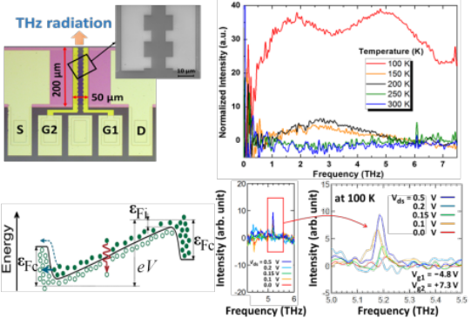

Figure 1: THz broadband light emission and single-mode lasing in a DFB-DG-GFET.

Image
Recent Publications
- Otsuji T et al. (2013) Terahertz-wave generation using graphene -toward new types of terahertz lasers. J. Sel. Top. Quantum Electron. 19:8400209.
- Tamamushi, G et al. (2016) Current-injection terahertz lasing in distributed-feedback dual-gate graphene-channel field-effect transistor. CLEO Dig., 1:SM3L.7.
- Yadav D et al. (2017) Terahertz LED based on current-injection dual-gate graphene-channel field effect transistors. 75th DRC Dig. 1: 273-274.
- Koseki Y et al. (2016) Giant plasmon instability in dual-grating-gate graphene field-effect transistor. Phys. Rev. B 93:245408.
- Yadav D et al. (2016) Terahertz wave generation and detection in double-graphene layered van der Waals heterostructures. 2D Mater. 3:045009.

Biography (150 word limit)
Taiichi Otsuji received the Dr. Eng. degree from Tokyo Institute of Technology, Japan in Feb. 1994. He has been a professor at the Research Institute of Electrical Communication, Tohoku University, Sendai, Japan since 2005 after working for Kyushu Inst. Tech. (1999-2005) and NTT Laboratories (1984-1999), Japan. His current research interests include terahertz electronic, photonic, and plasmonic materials/devices and their applications. He is authored and co-authored more than 250 peer-reviewed journals. He was awarded the Outstanding Paper Award of the 1997 IEEE GaAs IC Symposium, and has been served as an IEEE Electron Device Society Distinguished Lecturer since 2013. He is a Fellow of the IEEE, a senior member of the OSA, and a member of the MRS, SPIE, JSAP, and IEICE.
Email: otsuji@riec.tohoku.ac.jp

Notes/Comments:

