S-Nitrosated human serum albumin dimer with superior antitumor activity, long blood retention and excellent EPR effect
Masaki Otagiri, PhD, Sojo University, Japan
Yu Ishima, PhD, Tokushima University, Japan
Toru Maruyama, PhD, Kumamoto University, Japan

Abstract (300 word limit)
Objective: Recombinant human serum albumin dimer (HSA-dimer) was produced by the yeast Pichia pastoris. HSA-dimer has a longer circulation, compared with HSA-monomer. Thus, HSA-dimer is expected to have an enhanced accumulation in solid tumor via the EPR mechanism due to its large molecular weight(130 kDa). In this conference, we will present a novel DDS system of NO, potential anticancer therapeutic, using HSA-dimer as a carrier, namely, SNO-HSA-dimer. Results and Discussion: SNO-HSA-dimer treatment induced apoptosis of C26 tumor cells in vitro, depending on the concentration of NO. In in vivo experiments, SNO-HSA-dimer was found to specifically deliver large amounts of cytotoxic NO into tumor tissue but not into normal organs in C26 tumor-bearing mice. Interestingly, SNO-HSA-dimer caused a much higher concentration of NOx in the tumor than SNO-HSA-monomer. Moreover, especially, SNO-HSA-dimer has a high level of blood retention. The accumulation of SNO-HSA-dimer in tumor tissue significantly high compared with SNO-HSA-monomer, suggesting that S-nitrosation of SNO-HSA-dimer further enhanced its EPR effect. Next, we examined whether SNO-HSA-dimer can enhance the activity of other macromolecular antitumor drugs via the augmented EPR effects. As antitumor drugs, we selected N-(2-hydroxypropyl)methacrylamide (HPMA)-zinc proporphyrin (ZnPP) and Doxil. HPMA-ZnPP(mean particle size:80nm) forms micelles and Doxil has liposomal structure(mean particle size:90nm). The tumor growth was significantly inhibited when the two compounds were given simultaneously. The combination of SNO-HSA-dimer did inhibit the tumor growth, compared with Doxil or SNO-HSA-dimer alone. Furthermore, the combination of Doxil and SNO-HSA-dimer significantly reduce the number of lung metastasis. Finally, possible side effects of SNO-HSA-dimer administration were evaluated by measuring blood pressure, heart rate and biochemical parameters. Fortunately, none of these above parameters were significantly affected by repeated administration of SNO-HSA-dimer. Thus, SNO-HSA-dimer strategy is a safe and effective therapeutic approach for improving the antitumor effects of macromolecular drugs.

Image
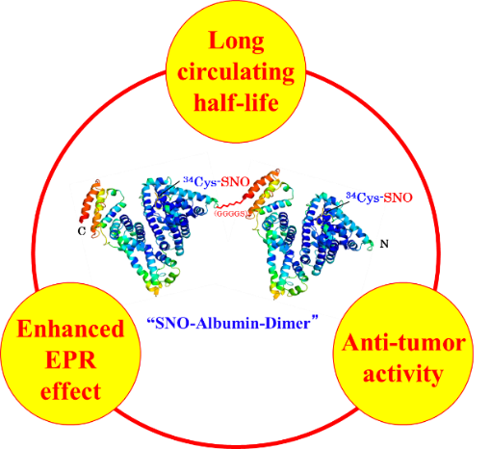

Figure 1: A novel therapeutics, SNO-HSA-dimer
Recent Publications (minimum 5)
- Katayama N et al. (2008) Design and evaluation of S-nitrosylated human serum albumin as a novel anticancer drug. J Pharmacol Exp Ther 325:69-76
- Ishima Y et al. (2012) S-Nitrosated human srum albumin dimer is not only a novel anti-tumor drug but also a potentiator for anti-tumor drug withaugmented EPR effects. Bioconjug Chem 23:264-271
- Ishima Y et al. (2014) Tuning of poly-S-nitrosated human serum albumin as superior antitumor nanomedicine. Phamaceutic Nanotech 103: 2184-2188
- Ishima Y et al. (2015) S-nitrosated human serum albumin dimer as novel nano-EPR enhancer applied to macromolecular anti-tumor drugs such as micells and liposomes. J Control Release 217:1-9
- Otagiri M and Victor T G Chuang (eds) (2016) Albumin in medicine : pathological and clinical application. Springer


Biography (150 word limit)

Dr. Masaki Otagiri is currently a Professor and Dean of Faculty of Pharmaceutical Sciences, Sojo University. He graduated from Nagoya City University with a PhD degree in 1975. In 1980, he joined the Pharmaceutics Department of Faculty of Pharmaceutical Sciences, Kumamoto University as an Associate Professor and then promoted to Professor of Biopharmaceutics Department, Kumamoto University in 1983. After his retirement from Kumamoto University in 2009, he was appointed as Professor of Faculty of Pharmaceutical Sciences and Director of DDS Research Institute, Sojo University, Kumamoto.
Email: otagirim@ph.sojo-u.ac.jp

Notes/Comments

