Realistic Expressive Visual Speech Virtual Human Character
Itimad Raheem Ali, PhD, Baghdad, Iraq

Abstract

A major unsolved problem in computer graphics is the construction and animation of realistic human facial models. Fortunately, animators are now able to digitize facial geometries through the use of scanning range sensors and animate them through the dynamic simulation of facial tissues and muscles. However, these techniques require considerable user input to construct facial models of individuals suitable for animation. 3D face model is now being used in a multitude of important fields. It brings a more human, social and dramatic reality to computer games, films and interactive multimedia, and is growing in use and importance. High level realism can be used in demanding applications such as computer games and cinema. Authoring lip syncing with complex and subtle expressions is still difficult and fraught with problems in terms of realism. Animated lips require a 3D face model capable of representing the movement of face muscles during speech and a method to produce the correct lip shape at the correct time will increase the realism and improve the interaction between human and 3D model in the virtual environment.

Image
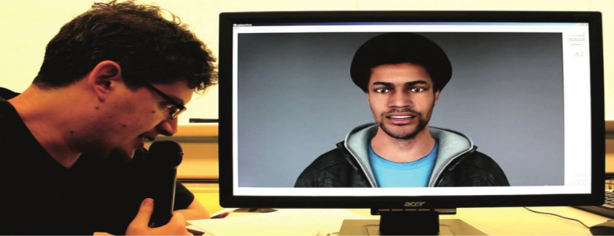
Recent Publications
- Itimad R. Ali, Sulong, G., and Hoshang K. (2016). Real Time Talking System for Virtual Human based on ProPhone. Research Journal of Applied Sciences, Engineering and Technology, 13(8): 611-616.
- Itimad R. Ali, Sulong, G., and Hoshang K. (2015). Realistic Lip Syncing for Virtual Character Using Common Viseme Set. Canadian Center of Science and Education, 8(3). 71-82.
- Itimad R. Ali, Sulong, G., and Basori A. H. (2014). A Natural Conversational Virtual Human with Multimodal Dialog System. Journal Teknologi, 71(5). 75-78.
- Itimad R. Ali, Sulong, G., and Basori A. H. (2014). Emotional Facial Expressions, Eye Behaviors, Lips Synchronization: Current and Future Direction. Life Science Journal, 11(6), 171-181.
- Itimad R. Ali and KA Khudhair. (2014). Using Feature Extraction to Recognize Handwritten Text Image. International Journal of Scientific & Engineering Research. 5(1).
- Itimad R. Ali and Basori A. H. (2013). Emotion Expression of Avatar through Eye Behaviours, Lip Synchronization and MPEG-4 in Virtual Reality based on Xface Toolkit: Present and Future. Proceeding of Social and Behavioural Sciences, The 9th International Conference on Cognitive Science, 700-706. Elsevier.
- Itimad R. Ali, Prasetyahadi M. C., Basori A. H., and Nadzaari Saari (2013). Eye, Lip and Crying Expression for Virtual Human. International Journal of Interactive Digital Media, 22-26.
- Itimad R. Ali and Sulong, G. (2013). Wavelet Fractal Image Watermarking System (WFIWS). IJCSI International Journal of Computer Science Issues, 10(6), No. 2.
- Itimad R. Ali. (2011). Neural net approach for image thinning /published in Al- Rafidain magazine. Iraq. No. 28.
- Hamdan Said, Iqbal Ahmad, M. Al-Muz-Zammil Yassin, Syed Shafeq Syed Mansor, Zainudin Hassan, and Itimad Alrubaay (2014). Life Science Journal. 11(3), 154-159.

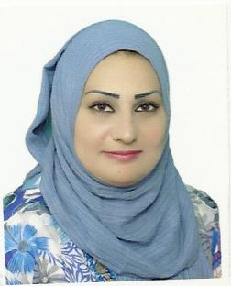
Biography
Itimad Raheem Ali was born in Baghdad, Iraq, in 1977. She received the B.Sc. degree in computer science from Al-nahrain University, Baghdad, Iraq, in 2000, and the M.Sc. degree in computer science also from from Al-nahrain University, Baghdad, Iraq in 2006. She received the Ph.D. degree in computer science from Universiti Teknologi Malaysia, Johor Bahru, Johor. She is currently a lecturer in Department of Management Information Systems, Collage of Business Informatics, University of Information Technology and Communication, Baghdad, Iraq. She is research interests include Computer graphics, Facial Animation, Facial Skin color, Emotional Expression of Virtual Human, Image processing and Data Hiding. She has attended international conferences and has published researches in international journals like Elsevier, web of Science, Hindawi and SPRINGER
Email: itimadra@uoitc.edu.iq

Notes/Comments:

Presenter Details:
Name: Dr. Itimad Raheem Ali
Phone number:009647502612212
Oral/Poster presentation: Oral Presentation
Country: Iraq
LinkedIn: https://www.linkedin.com/in/itimad-raheem-14736674/

