Automatic swimmer tracking using video sequences: application to performance analysis
D. Benarab, T. Napoleon, A. Alfalou. ISEN Brest, France

Abstract (300 word limit)
In order to improve the performance of professional swimmers, we developed, in collaboration with the FFN (French Swimming Federation), an automatic tracking approach using video sequences. To do this, we proposed a new 8K shooting system adapted to the aquatic environment and allowing a pool calibration using the DLT technique (Direct Linear Transform). This establishes the link between pixel and metric coordinates, which allows, among others, to extract the concerned lane to carry out the different treatments. In order to initialize the tracking, it is necessary to localize the swimmer. For this, we applied the a contrario technique to detect his movement in the lane. Then, the initial reference (swimmer’s head) of our tracking system is detected using the proposed Scaled Composites JTC which is based on a pre-generated database. Afterwards, we implemented and adapted several tracking techniques, namely those based on the NL-JTC correlation, color histograms, Local Binary Patterns (LBP) and Histograms of Oriented Gradient (HOG). Given the various limitations of these techniques, we proposed an optimized approach based primarily on data fusion. This approach is called dynamic fusion and it combines NL-JTC correlation plane and color scores plane in order to generate a richer description of the target (form + color). This approach has shown very good results in the cases of visible target but it is still sensitive to occlusions. To solve this problem, we improved it by tracking simultaneously the head and the swimsuit of the athlete. This multi related targets approach enables, through a complex decision criterion, to find the occluded zone based on the visible one. Finally, a swimmer performance study is conducted and the results allowed to validate the proposed system. In particular, we were interested in cyclical, intra-cyclical and instantaneous speed measurements, to study and improve the swimmers’ performance.

Image
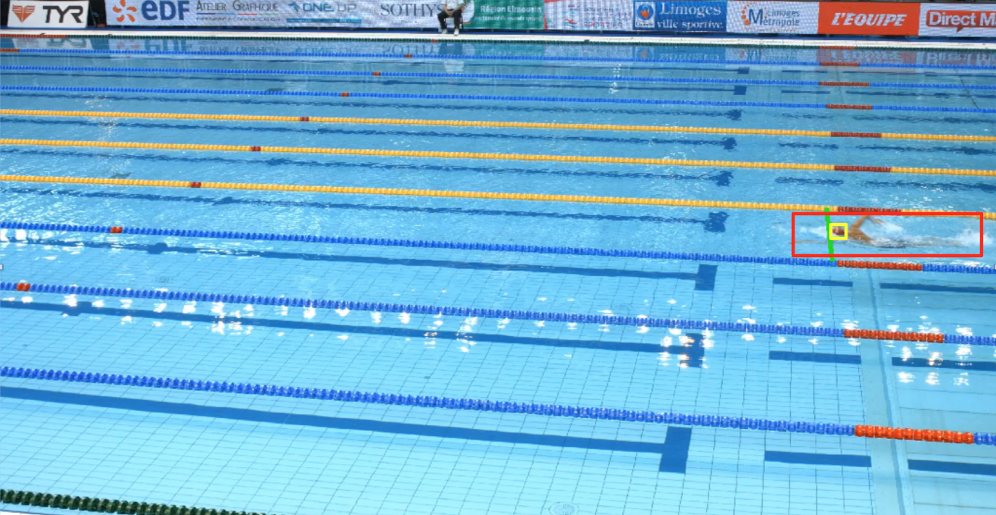
Figure: Example of swimmer tracking using the proposed dynamic fusion approach
Recent publications (minimum 5)
(1) D. Benarab, T. Napoleon, A. Alfalou, A. Verney, P. Hellard, "Adapted image pre-processing techniques for swimmer tracking optimization", (Submission in progress 2017).
(2) D. Benarab, T. Napoleon, A. Alfalou, A. Verney, P. Hellard, "Optimized swimmer tracking system based on a novel multi-related-targets approach" OLEN, Optics and Lasers in Engineering 89, 195-202, (2016).
(3) D. Benarab, T. Napoleon, A. Alfalou, A. Verney, P. Hellard, "All-automatic swimmer tracking system based on an optimized scaled composite JTC technique", Proceedings of SPIE 9845, (2016).
(4) D. Benarab, T. Napoleon, A. Alfalou, A. Verney, P. Hellard, "Optimized swimmer tracking system by a dynamic fusion of correlation and color histogram techniques", Optics Communications 356, 256-268, (2015).
(5) D. Benarab, T. Napoleon, A. Alfalou, A. Verney, P. Hellard. A novel multitracking system for the evaluation of high-level swimmers performances. In: Proceedings of the SPIE 9094, Optical Pattern Recognition XXV, 90940A; 2014.

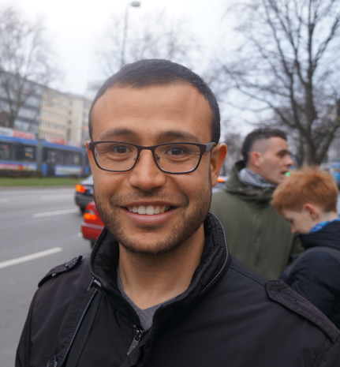
Biography (150 word limit)
Djamel-Eddine BENARAB is a researcher at the CRAN laboratory (Research Center Of Automatic Control) in Nancy, France. He is working on 3D reconstruction of buildings and object recognition. During his PhD studies, he worked on video analysis, object detection and tracking. His proposed swimmer tracking system based on the dynamic fusion approach is used by the French Federation of Swimming in order to track and evaluate high-level swimmers during the competitions. He has an experience also in biometric systems in general, and particularly, face and voice recognition systems.
Email: djamel-eddine.benarab@univ-lorraine.fr

Notes/Comments:

Presenting author details
Full name: BENARAB Djamel-Eddine
Contact number: +33752546126
Twitter account:
Linked In account: https://www.linkedin.com/in/djamel-eddine-benarab-b59b358b/
Session name/ number:
Category: (Oral presentation/ Poster presentation)

