A novel relationship strength model for online social networks
Prof. Chunhua Ju, PhD, Zhejiang gongshang university, China

Abstract (300 word limit)
Statement of the Problem: With the rapid development of online social networks, the relationship strength between users in online social networks has received great attention. Comparing with general friends, people are more inclined to contact with their relatives and the closer friends. In the real world, acquaintance and friend recommendations are significant means that contribute to building the behavior of users. And the relationship strength can be effectively applied to friends recommendation, commodity recommendation, item recommendation, link prediction and newsfeeds. So, the precise evaluation of the relationship strengths in online social networks is very important. However, with most of the selected factors affecting the relationship strength between users are too simple, the existed researches show low accuracy in calculating the strength. The purpose of this study is to consider the factor of topic and indirect links and improve the accuracy of user relationship strength in online social networks. Methodology & Theoretical Orientation: An online social networks user relationship strength estimation model which is based on topic classification and incorporates direct relationship and indirect relationship was proposed. K-means clustering method using ABC algorithm was used to cluster all the interactive activity documents and the standard Google distance was used to calculate the correlation between clusters and activity topic name. Then, the calculation of the relationship strength between users which belong to the same topic is based on user profile and interaction data. The similarity, timeliness, and interactivity are taken into account, and a language model based on sentiment classification approach was utilized during interactivity calculation. Conclusion & Significance: The experiments on two microblog datasets and the results showed that the proposed model was promising and can be used to improve the performances of various applications.

Image
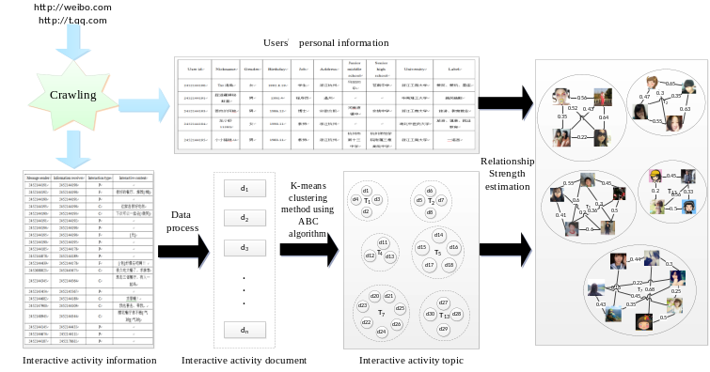 Fig. 1. The model of relationship strength estimation between online social networks users
Recent publications (minimum 5)
- Zhao X, Yuan J, Li G, et al. Relationship strength estimation for online social networks with the study on Facebook. Neurocomputing, 2012, Vol. 95, PP. 89-97.
- Gilbert E, Karahalios K. Predicting tie strength with social media. In Proceedings of the SIGCHI Conference on Human Factors in Computing Systems. ACM, 2009: 211-220.
- Wilson C, Boe B, Sala A, et al. User interactions in social networks and their implications. In Proceedings of the 4th ACM European conference on Computer systems, 2009: 205-218.
- Xiang Lin, Tao Shang, Jianwei Liu. An Estimation Method for Relationship Strength in Weighted Social Network Graphs. Journal of Computer and Communications, 2014, Vol. 2, No. 4, pp.82-89.
- R. Xiang, J. Neville, M. Rogati, Modeling relationship strength in online social networks, in: Proceedings of ACM International Conference on World Wide Web, 2010.


Biography (150 word limit)
Chunhua Ju is a professor doctoral supervisor in Zhejiang Gongshang University. He has been responsible for several projects of national and provincial level, such as Natural Science Foundation of China, National Social Science Fund, National Science and technology support project and Doctoral Scientific Fund Project of the Ministry of Education of China. And he has published academic papers more than 50. He has his expertise in intelligent information processing, data mining and E-commerce. His relationship strength model based on topic classification and indirect relationship promotes the development of some field such as commodity recommendation and itemrecommendation.
Email: juchunhua@hotmail.com

Notes/Comments:

Presenting author details
Full name: Chunhua Ju
Contact number:+8613905819716
Twitter account:
Linked In account:
Session name/ number:
Category: Poster presentation

Women, trauma and alcohol dependency: Connections and disconnections in alcohol treatment for women
Deanna L Mulvihill, RN PhD, TLI Foundation, USA Deanna L Mulvihill, RN PhD, TLI Foundation, USA

Abstract
Statement of the Problem: Women who have experienced intimate partner violence (IPV) are at greater risk for physical and mental health problems including posttraumatic stress disorder (PTSD) and alcohol dependency. On their own IPV, PTSD and alcohol dependency result in significant personal, social and economic cost and the impact of all three may compound these costs. Researchers have reported that women with these experiences are more difficult to treat; many do not access treatment and those who do, frequently do not stay because of difficulty
Biography

Deanna Mulvihill has her expertise in evaluation and passion in improving the health and wellbeing. Her open and contextual evaluation model based on responsiveconstructivistscreatesnewpathwaysforimprovinghealthcare.She has built this model after years of experience in research, evaluation, teaching and administration both in hospital and education institutions. The foundation is based on fourth generation evaluation (Guba& Lincoln, 1989) which is a methodologythatutilizesthepreviousgenerationsofevaluation:measurement, description and judgment. It allows for value-pluralism. This approach is responsive to all stakeholders and has a different way offocusing.
Email: drdeanna.rpm@hotmail.com

maintaining helping relationships. However, these women’s perspective has not been previously studied. The purpose of this study is to describe
the experience of seeking help for alcohol dependency by women with

PTSD and a history of IPV in the context in which it occurs. Methodology & Theoretical Orientation: An inter subjective ethnographic study using hermeneutic dialogue was utilized during participant observation, in- depth interviews and focus groups. An ecological framework was utilizedtofocusontheinteractionbetweenthecounselorsandthestaffto understand this relationships and the context in which it occurs. Findings: The women in this study were very active help seekers. They encountered many gaps in continuity of care including discharge because of relapse. Although the treatment center was a warm, healing and spiritual place, the women left the center without treatment for their trauma needs and many without any referral to address these outstanding issues. Conclusion & Significance: Women with alcohol dependence and PTSD with a history of IPV want help however the health and social services do not always recognize their calls for help or their symptoms of distress. Recommendations are made for treatment centers to become trauma- informed that would help this recognition.

Image


Notes/Comments:
Recent Publications (minimum 5)
- Harper C (2009) The neuropathology of alcohol-related braindamage. Alcohol Alcohol 44:136-140.
- Heilig M, Egli M (2006) Pharmacological treatment of alcohol dependence: Target symptoms and target mechanisms. Pharmacology and therapeutics 111:855-876.
- LiX, SchwachaMG, ChaudryIH, ChoudhryMA (2008)Acutealcohol intoxication potentiates neutrophil-mediated intestinal tissue damage after burn injury. Shock 29:377.
- Room R, BaborT, Rehm J (2005) Alcohol and public health. Lancet
365: 519-530.
5. Sullivan EV, Zahr NM (2008) Neuroinflammation as a neurotoxic mechanism in alcoholism: Commentary on “Increased MCP- 1 and microglia in various regions of human alcoholic brain”. Experimental neurology 213:10-17.

