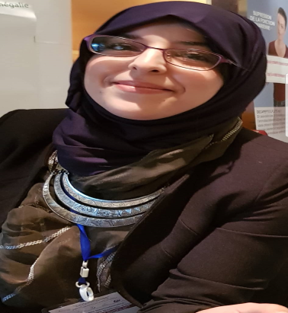
Title: No Specific carcinoma of the breast

Author (s) Name: Bouchikhaoui Hiba, Professor Hacene. F
EHUO hospital of Oran
Objective: How to diagnose a NOS carcinoma of the breast

Methodology: In my work I used all differences cases of NOS carcinoma of the breast in a period of 2018 of our laboratory (pathologic laboratory of EHUO hospital), with a clinical, histological diagnosis (macroscopic and microscopic diagnose).
To explain more the important differentiation with other type of carcinoma of breast we used some comparison with other grade and type.

Results: A NOS carcinoma of breast can be diagnosed easier if the case is evident, if it s not evident we have to follow other ways to diagnose it for an eventual therapy.

Biography
Dr. Bouchikhaoui Hiba is a pathologist at EHUO hospital of Oran and a 4th year resident in pathologic laboratory. She is a teacher of Histologie and Physiologic courses in Belgaid university, and INESM university & also she teaches medical English at university of biology.
She is a Member of AIP (International academic of Pathologi). She published her poster in Maghrebin day in Algeria, International congress of Oncology.
Presenting author details
Full name: Bouchikhaoui Hiba
Contact number: 00213669134213
Email id: biba_s3@live.fr
Category: (Oral presentation)
Research interest: No specific carcinoma of breast

