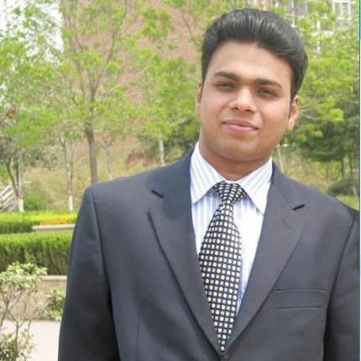
Title: Interpretation And Diagnosis of Chronic Lymphoproliferative Disorders by Flow Cytometry Using Four-Color Combinations for Immunophenotyping Name: DR. SOMIL SINGHAL
Consultant Pathologist
Kriti Pathology (A Complete Diagnostic Solution)
A Unit Of Kriti Scanning Centre (P) Ltd.
NABL Accredited : MC-3218

Background: Multiparametric flow cytometry (MFC) is a powerful tool for the diagnosis of hematological malignancies and has been useful for the classification of chronic lymphoproliferative disorders (CLPD) according to the WHO criteria. Following the purpose of Flow Cytometry , the aim of this report was to standardize the minimum requirements to achieve an accurate diagnosis in CLPDs, considering the different economic possibilities of the laboratories in our country. Most laboratories in India work with 4-fluorescence flow cytometers, which is why this study has been proposed 4-color monoclonal antibody (MoAb) panels.

Methods/Results: Panels for screening and diagnosis in B, T and NK lymphoproliferative disorders were developed based on the normal differentiation pathways of these cells and the most frequent phenotypic aberrations. Important markers for prognosis and for minimal residual disease (MRD) evaluation were also included. The MoAb panels presented here were designed based on the diagnostic expertise of the participating laboratories and an extensive literature review.

Conclusion: The 4-color panels presented to aid in the diagnosis of lymphoproliferative neoplasms by Flow Cytometry aim to provide clinical laboratories with a systematic, step-wise, cost-effective, and reproducible approach to obtain an accurate immunophenotypic diagnosis of the most frequent of these disorders.

Key terms: chronic lymphoproliferative disorders; flow cytometry; monoclonal antibody panel; lymphoma; multiple myeloma

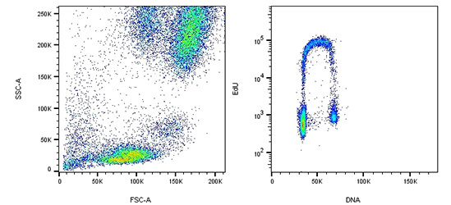

Biography

Somil Singhal has completed his Bachelor of Medicine and Surgery (MBBS) at the age of 25 years of age from Beijing Medical University, China and Post Doctoral Studies in Doctor of Medicine In Pathology from Rajiv Gandhi University of Health Sciences, Bangalore, India. Currently, he is working as Consultant Pathologist in the Kriti Scanning And Diagnostic Center Private Limited at Kriti Scanning Group Of Institute, Allahabad, Uttar Pradesh India. He has attended various Conferences, CME’s and published Case studies, Dissertations in reputed journals like IJLSSR, Index Copernicus, Poland Journal of Dermatology and is the life member of Indian Medical Association, Allahabad Medical Association and Association Of Pathological Society Of India. Besides this, he had worked as a Ex .resident in AIIMS Trauma Center in the Department Of Emergency Medicine, Ex. Cardiac resident at Fortis Hospital Okhla, Delhi, Ex. Senior Resident in Ashwini Rural Medical College, Solapur, Maharashtra, Ex. Senior resident at Maharaja group Of hospital, New Delhi, India and attended various ITO and blood bank camps for service to the society.

Presenting author details
Full name: DR. SOMIL SINGHAL
Contact number:0091-9140163023, 0091-9026405151
Twitter account:NOT APPLICABLE
Linked In account:95920894
Session name/ number:Oral Presentation (Key Note)
Category: (Oral presentation/ Poster presentation) Oral Presentation

