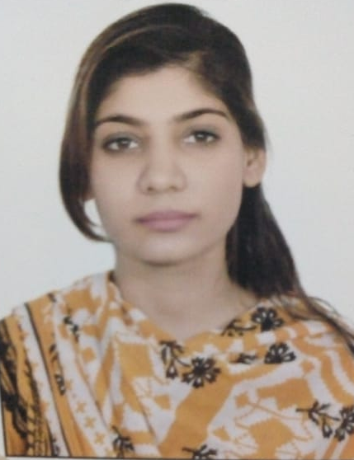

Exploration of Flavonoid as an Adjuvant Therapy against Breast Cancer

Ramsha Khalid¹, Areeba Naeem¹, Madiha Farooqui¹ , Sadaf Naeem¹*

^{1.} Department of Biochemistry, University of Karachi , Pakistan

*Corresponding authors: snaeem@uok.edu.pk
Abstract
Breast Cancer, one of the leading causes of death in females, is a complex multifactorial disorder, with the pathophysiology and molecular mechanism still not completely unraveled. It can be hypothesized that the dysregulation of breast cancer associated proteins can potentially lead to malignancies. It has been identified that the B-cell lymphoma 2 (BCl2), eukaryotic initiation factor-4A (EIF4aI) and tumor suppressor p53 proteins are chiefly associated with breast tumorigenesis. A number of studies have established the anti-cancer potential of flavonoids. In this respective study, we aim to explore anticancer efficacy of nineteen flavonoids by performing the in-depth analysis of binding affinity and interaction of these flavonoids against the target enzymes (BCl2, EIF4aI and P53) using the in-silico methods. Methodology: The structures of the selected nineteen flavonoids have been downloaded from PubChem. 3D Homology models were generated for target enzymes through CPH model,and all the nineteen flavonoids were docked into the active site BCL2, EIF4a and P53 by using Molegro Virtual Docker (MVD) 6.0 software. Results and Conclusion: In the light of our results, all the flavonoids particularly Rutin, Hesperitin, Luteolin, Theaflavin, Myricetin and Quercitin exhibit high binding affinity with the target proteins. Furthermore, flavonoid in EIF4aI chiefly targeted ATP binding region. On the contrary, flavonoids were observed to form interactions with DNA binding region in p53. Since, flavonoids forms interactions with functionally crucial residues in target proteins therefore, it can be inferred that flavonoids can serve as potential adjuvant therapy against breast cancer.
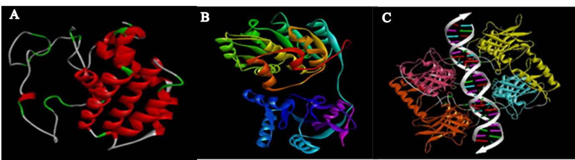
Figure 1: 3D Structures of A) BCL2, B) EIF4a and C) P53.
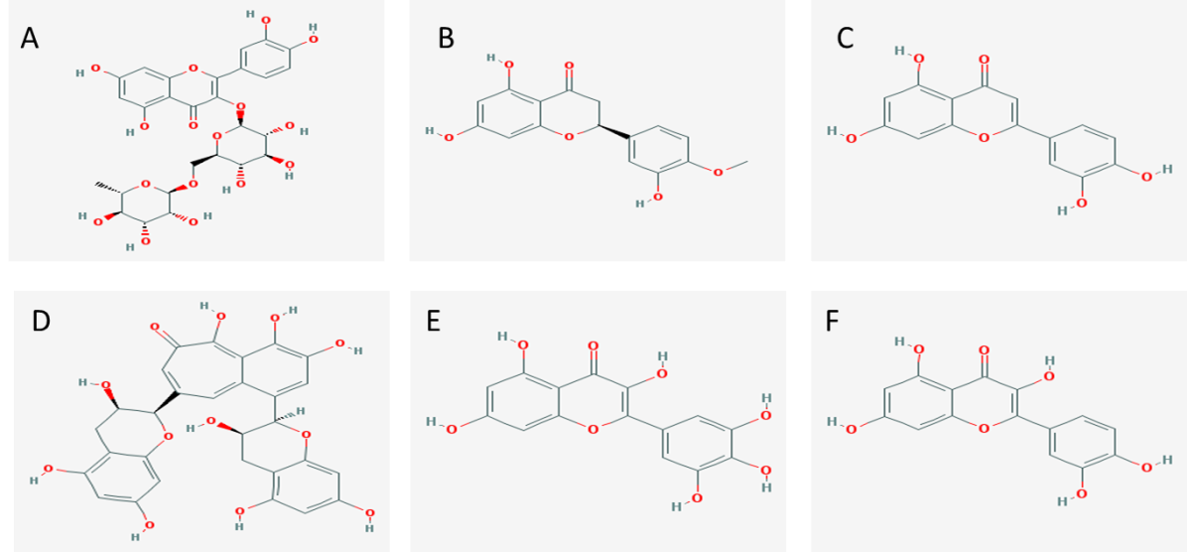
Figure 2: Structures of Flavonoids namely A) Rutin,B) Hesperitin,C) Luteolin ,D) Theaflavin, E) Myricetin and F) Quercitin.
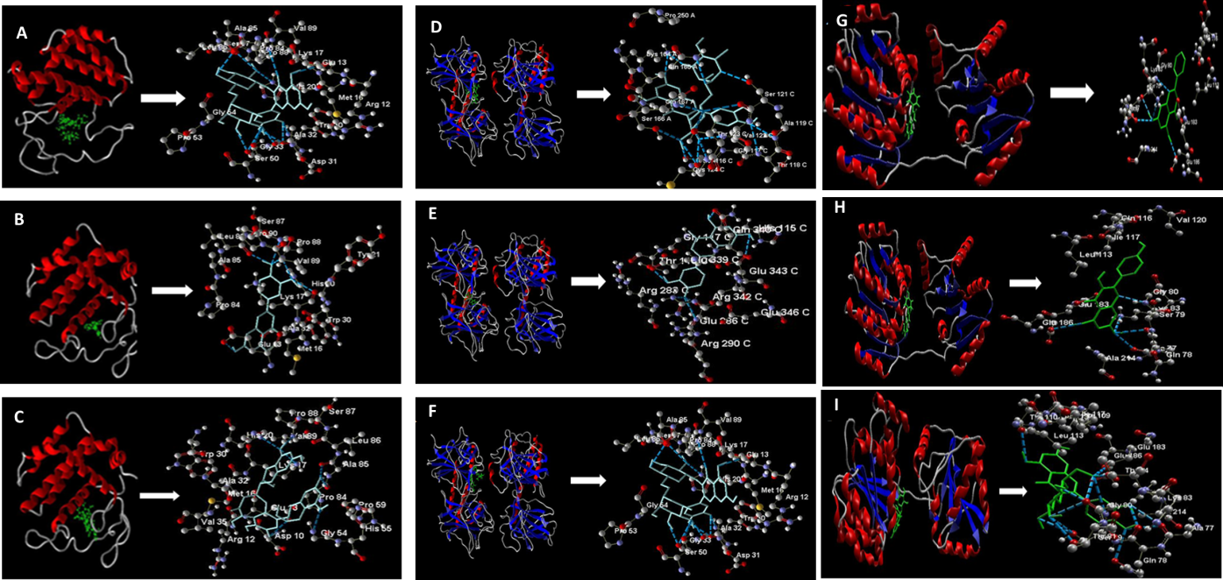
Figure 3: Docking poses of A-C) BCL2, D-E) EIF4a and G-I) P53 interacting with flavonoids.
References:
1. Modelska, A., et al., The malignant phenotype in breast cancer is driven by eIF4A1-mediated changes in the translational landscape. Cell Death Dis, 2015. 6: p. e1603.
2. Abotaleb, M., et al., Flavonoids in Cancer and Apoptosis. Cancers (Basel), 2018. 11(1).
3. Hwang, K.T., et al., BCL2 Regulation according to Molecular Subtype of Breast Cancer by Analysis of The Cancer Genome Atlas Database. Cancer Res Treat, 2018. 50(3): p. 658-669.
4. Takemura, H., et al., Breast cancer and flavonoids - a role in prevention. Curr Pharm Des, 2013. 19(34): p. 6125-32.
5. Walerych, D., et al., The rebel angel: mutant p53 as the driving oncogene in breast cancer. Carcinogenesis, 2012. 33(11): p. 2007-17.

Bibliography
Ramsha Khalid is an effective communicator with excellent planning, organizational, and negotiation strengths as well as the ability to lead, reach consensus, establish goals, and attain results. Ramsha’s expertise lies Bioinformatics and Molecular Biology.
Email: ramsha.khalid.rk@gmail.com
Contact number: +923362601538

