A novel immune role for NgR on B-cell populations localized in the central nervous system in a mouse model of multiple sclerosis.

Maha Bakhuraysah^{1,2}, Amani Alrehaili¹, Sara Mokhtar, Jae Young Lee¹, Peimun Aui¹, Steven Petratos¹
¹Department of Medicine, Central Clinical School, Monash University, Prahran, VIC, Australia.
¹Department of Clinical Laboratory, College of Applied Medical Science, Taif University, Taif, Saudi Arabia.

Abstract
Despite clear evidence demonstrating that the deletion of Nogo-receptor 1 (NgR1) can protect against axonal degeneration and thus progression of experimental autoimmune encephalomyelitis (EAE), an immunological role for this receptor is yet to yield mechanistic evidence. However, recently NgR has been suggested as an alternate receptor for the B-cell activating factor (BAFF) in the central nervous system (CNS). Therefore our strategic aim was to define whether NgR contributes in the modulation of the adaptive immune response during EAE by promoting maturation and differentiation of BAFF-reactive B-cells within follicles during the induction of disease. The results showed that CNS-infiltrating blood cells revealed an augmented response in the B-cells, which expressed NgR1 and NgR3, observed in ngr1^{+/+} mice with the onset and progression of the disease that could not be demonstrated within the spinal cords of EAE-induced ngr1^{-/-} mice. Remarkably, a cluster of B-cells-expressing NgR was present at the meninges of lumbosacral spinal cords of the of ngr1^{+/+} EAE-induced mice at clinical score 1. Furthermore, there were significant increases of secreted immunoglobulins from these NgR1-expressing B-cells. Importantly, these cells could be directed into the synthesis phase of the cell cycle, after stimulating sorted cells by extracellular BAFF in vitro; however, when BAFF signaling was blocked using either rBAFF-R, or NgR1-Fc, or NgR3 peptides, the cells were observed to be into G0/G1 phase. As a consequence, when we blocked NgR1-ligand signaling using a novel hematopoietic stem cell-based delivery of a therapeutic protein, immune lineage-differentiated cells, including ZsGreen and fusion protein, were trafficking into the CNS during acute EAE. Collectively, these data indicate that the existence of an inducible expression of NgR1 and NgR3 in specific immune lineage cells upon the induction of EAE, and that the follicular-like NgR1 and NgR3-positive B-cells in the meninges may play an active role during the induction of EAE. Thus, our data reinforce the idea that blocking the interaction of BAFF and NgR1 and NgR3 may be vital for neuroprotection during inflammatory insults.
Figure 1. Localisation of double-immunofluorescence staining (NgR1-positive B-cell clusters) on 10 μm-thick longitudinal spinal cord sections during EAE in ngr1^{+/+} EAE-induced mice at clinical score 1. Anti- B220 and anti-NgR antibodies have been used to stain B-cells (green fluorescence) and NgR (red fluorescence) respectively. Infiltrate cells were present at the meninges of ngr1^{+/+} mice during disease onset. Double-positive cells were aggregated and presented in follicles at the meninges (the white arrows), magnification 40x, scale bar= 50 μm
Keywords: Nogo-receptor, B-cells, B-cell activating factor, experimental autoimmune encephalomyelitis, Multiple sclerosis.

Image

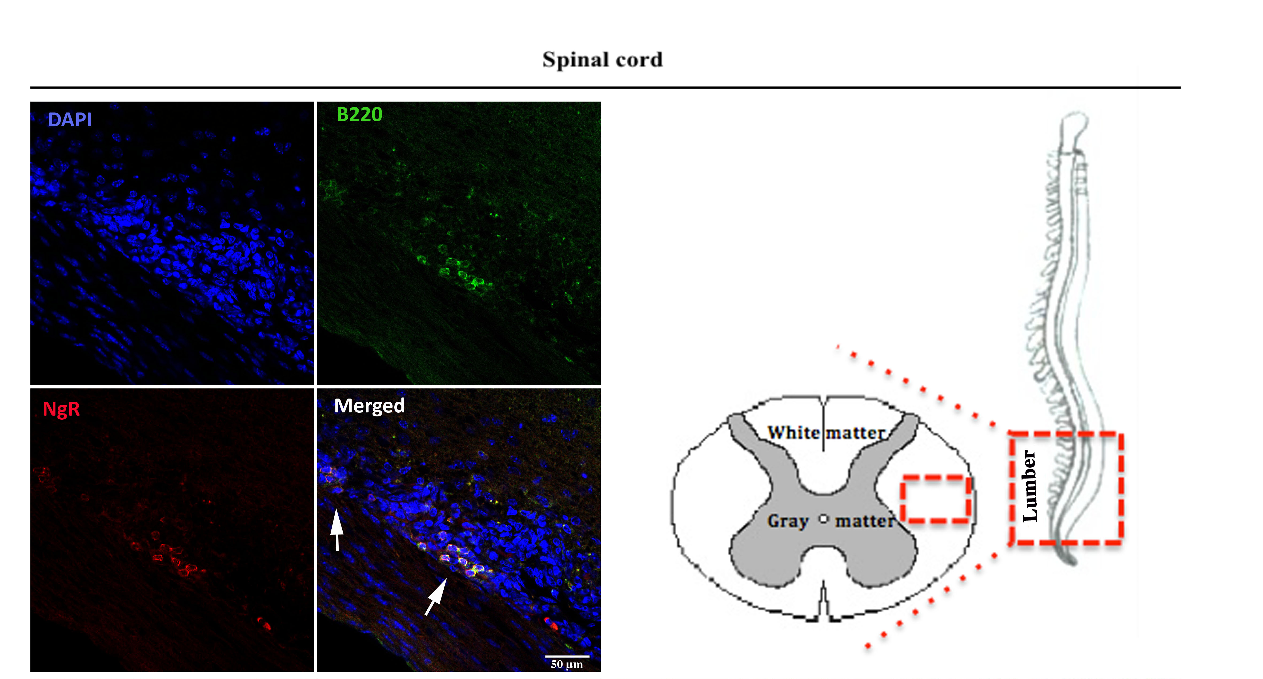

Recent Publications (minimum 5)
- AMANI ALREHAILI, PHD; JAE LEE, PHD; MAHA BAKHURAYSAH, PHD; MIN JOUNG KIM, BIOMEDSCI(HONS); PEI-MUN AUI, BBIOMEDSCI(HONS); KYLIE ANN MAGEE, BSC (HONS); STEVEN PETRATOS. Nogo receptor contributes to Microglial/Macrophage activity during EAE progression. J Neuroinflamm. 2017, In press
- MOKHTAR, S. H., MAGEE, K., LEE, J. Y., BAKHURAYSAH, M. M., CRAM, D. S., ALREHAILI A., Kim, M. J., THOMAS, S., KENNY, R., MCLEAN, C., BIRPANAGOS, A., AZARI, M., STEER, D., PETRATOS, S. The Amyloid-beta-dependent phosphorylation of CRMP-2 dissociates kinesin
in Alzheimer’s disease, Int J Alzheimers Dis, 2017, In press.
- BAKHURAYSAH, M. M., SIATSKAS, C. & PETRATOS, S. 2016. Hematopoietic stem cell transplantation for multiple sclerosis: is it a clinical reality? Stem Cell Res Ther, 7, 12.

- ALREHAILI A, LEE JY, TAGHIAN K, MAHABAKHURAYSAH, THOMAS SPEROS, PETRATOS S. 2014. Microglial mechanisms governing axonal degeneration in multiple sclerosis. J Neurol Neurophysiol. 5:206.

- MOKHTAR, S. H., BAKHURAYSAH, M. M., CRAM, D. S. & PETRATOS, S. 2013. The Beta-amyloid protein of Alzheimer's disease: communication breakdown by modifying the neuronal cytoskeleton. Int J Alzheimers Dis, 2013, 910502.

- LITWAK, S. A., PAYNE, N. L., CAMPANALE, N., OZTURK, E., LEE, J. Y., PETRATOS, S., SIATSKAS, C., BAKHURAYSAH, M. & BERNARD, C. C. 2013. Nogo-receptor 1 deficiency has no influence on immune cell repertoire or function during experimental autoimmune encephalomyelitis. PLoS One, 8, e82101.

Biography (150 word limit)
Dr Maha Bakhurayah has her expertise in evaluation and passion in improving the health and wellbeing. My research focuses on the role of the Nogo receptor in Multiple Sclerosis, and we are working with Experimental Autoimmune Encephalomyelitis (EAE). Previous data has mentioned that there was no new role associated with Nogo receptor, thus I focused on the immunological arm in this model and i discovered the existence of B-cells expressing NgR in EAE. It has been published recently that in MS patients B cells are localised in the brain, and we found it in mice. The studies haven't mentioned anything about the Nogo receptor but we found them too.

Email: maha.bakhuraysah@hotmail.com
Ocean_star_121@hotmail.com

Notes/Comments:

If it’s possible, I’ll make a poster as well as oral talk.

