Production of insulin gene knockout piglets using CRISPR/Cas9 system
Bumrae Cho, Su Jin Kim, Eun-Jin Lee, Sun Mi Ahn, Sang Hoon Lee, Jin Seok Lee, Shin Hye Ahn, Dal-Young Ji, and Jung-Taek Kang
Biotechnology Research Institute, Mgenplus Co., Ltd., Seoul, Korea

Abstract (300 word limit)
Diabetes mellitus is the chronic disease with severe complications including diabetic nephropathy, neuropathy, and cardiovascular disease. To investigate the pathophysiology of diabetes or develop the drugs for diabetes, various animal models have being used. Although rodent models are commonly used for diabetes research, the interest about the pig diabetic models is increasing because of their similarity with human in many respects like size, pathology, physiology, and metabolism. There are some methods to generate diabetic pig model. The treatment of chemicals like streptozotocin is generally used and pancreatectomy is also the one of the methods. Recently, genetically modified pigs which were modified genes related with pathogenesis to induce diabetes were reported. In this study, we have successfully generated insulin gene knockout piglets by targeting the porcine INS gene in somatic cells using CRISPR/Cas9 system combined with somatic cell nuclear transfer (SCNT). Single cell derived somatic cell colonies carrying a modified INS gene were generated using CRISPR/Cas9 system and their genotypes were confirmed by T7E1 assay and sanger sequencing method; targeting efficiency was 40.4% (21/52). After SCNT and embryo transfer, eight piglets (including five stillborn piglets) were born. As expected, INS knockout piglets presented high blood glucose levels. Also, the expression of insulin in the pancreas was absent in those piglets. This study demonstrates effectiveness of CRISPR/Cas9 system in generating genetically modified pigs. We expect that these insulin gene knockout pigs can be used in diabetes research as an animal model for the efficacy and safety test of new drugs and the recipient of islet transplantation to investigate optimal strategies for islet transplantation.

Image
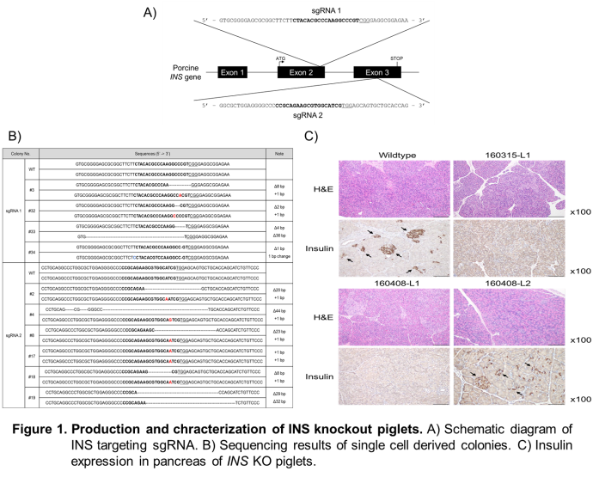
Recent Publications (minimum 5)
- Kang JT, Cho B, Ryu J et al. (2016) Biallelic modification of IL2RG leads to severe combined immunodeficiency in pigs. Reprod Biol Endocrinol.14(1):74.
- Kang JT, Ryu J, Cho B et al. (2016) Generation of RUNX3 knockout pigs using CRISPR/Cas9-mediated gene targeting. Reprod Domest Anim. 51(6):970-978.
- Yang JJ, Yeom HJ, Jeong JC et al. (2016 Beneficial effects of the transgenic expression of human sTNF-αR-Fc and HO-1 on pig-to-mouse islet xenograft survival. Transpl Immunol. 34:25-32.
- Hurh S, Kang B, Choi I et al. (2016) Human antibody reactivity against xenogeneic N-glycolylneuraminic acid and galactose-α-1,3-galactose antigen. Xenotransplantation. 23(4):279-292
- Park SJ, Cho B, Koo OJ et al. (2014) Production and characterization of soluble human TNFRI-Fc and human HO-1(HMOX1) transgenic pigs by using the F2A peptide. Transgenic Res. 23(3):407-419

Biography (150 word limit)
Bumrae Cho has his expertise in genetic modification and generation of donor cells for somatic cell nuclear transfer. Especially, he is focusing on the generation of genetically modified pigs for xenotransplantation, disease resistance pigs, and various pig models to investigate human disease.
Email: bumrae77@gmail.com

Notes/Comments:

