THE 64-TRIPLET GENETIC CODE STRUCTURE REVISITED AND REFUTED, FROM COMBINATORIAL PERSPECTIVE

BY

W. B. BOZEGHA
+2348068029860,
wbbozegha@yahoo.com
No. 9, Otiotio Road, Yenizue-Gene,
Yenagoa, Bayelsa State,
Nigeria.

THE 64-TRIPLET GENETIC CODE STRUCTURE REVISITED AND REFUTED, FROM COMBINATORIAL PERSPECTIVE
Abstract
Molecular biologists upon observing in the early 1950s that the sequence of the DNA four bases A,T,G,C (Adenine, Thymine, Guanine, Cytosine) in the nucleus of a cell influenced the sequence of the twenty amino acids of protein in the surrounding cytoplasm thought of establishing a code to typify the correlation between the two entities, and sought for ways of doing so. In 1954, George Gamow, a Russian cosmologist, offered them his proposal of 64 triplet codewords given by 4³ and they produced them with Punnett Square and got them experimentally allocated unevenly to the twenty amino acids and three non-descript operational control signals and declared the code deciphered and adopted it in 1968 for coding application in protein synthesis studies. The declaration notwithstanding, genetics literature since then till date is rife with discussions on irregularities of the 64-triplet code. Many dissatisfied scientists are now seeking for a derivation free from irregularities.
This revisit is made from the perspective of computational combinatorics, which is concerned with the generation of permutations and combinations of specified input set and selection. Combinatorial computation errors of derivation are detected and corrected to yield an irregularity-free genetic code structure of 24 permutation quadruplet codons to the achievement of collinearity as well as codon integrity and potency. Merits of the new 24 quadruplet codons in the light of computational combinatorics are also furnished with assurance of combinatorial validity and significance in molecular biology.

Keywords:
Triplets, Quadruplets, Permutations, Non-permutations, Collinearity.

THE 64-TRIPLET GENETIC CODE STRUCTURE REVISITED AND REFUTED, FROM COMBINATORIAL PERSPECTIVE
Introduction
The 64-triplet genetic code structure that begged for revisit is immature and a mixture of 24 permutation and 40 non-permutation triplet codons derived in 1954 by the base-4 neo-digibreed indirect method with input set of RNA four bases A,U,G,C (Adenine, Uracil, Guanine, Cytosine). The revisit is from combinatorial perspective, because the task of deriving a genetic code structure from the given four nucleotide bases is in the province of computational combinatorics and borders on the generation of permutations of 4 from 4.

The objectives of this work are four-fold, given the challenge to derive afresh a code from the four RNA bases, A,U,G,C (Adenine, Uracil, Guanine, Cytosine) to account for the correlation between them and twenty amino acids of protein as sequel to molecular biologists’ observation in the early 1950s, that the sequence of the four nucleotide bases A,U,G,C in the nucleus of a cell influenced the sequence of the 20 amino acids of protein in the surrounding cytoplasm in the cell, because the one of 64-triplet structure based on 4³ derived in 1954 in response to the scientists’ quest and spelt thereafter and adopted since 1968 in coding application in protein synthesis studies is bedeviled with irregularities which are only widely discussed in genetics literature, but without remedy to date, hence the first objective is to derive a genetic code without any irregularity using the same material and indirect method used in 1954 by the authors of the current one now in disfavour. The second objective is to use a direct method to produce the irregularity-free genetic code for confirmation of validity. The third one is to show why the 64-triplet genetic code structure is bedeviled with the well-known irregularities. Lastly, the fourth objective is to highlight the combinatorial and molecular biological merits of the new genetic code structure of 24 quadruplets, and thereby attract spelling experts to spell it in order to render it fit for adoption for coding application in protein synthesis studies, in the event of the publication of this work as per this attempt, and that to the relief of all stakeholders worldwide.

Results
A genetic code structure of 24 permutation quadruplets is presented in Table I as a computational reality for the result, being a combinatorial derivation with the two sources or methods stated.The list of 20 amino acids of protein^{[1]} is adapted from the book, The World of the Cel lby Becker, Wayne M. (1986), Fig. 17.4, p. 529.

Table 1: New genetic code of 24-quadruplet codon structure
Input set of RNA four bases | Output permutations of quadruplet codons |  |  |  |  |  | Remarks
Input set of RNA four bases | Serial no. of  24 quadruplet codons |  | 20 amino acidsª/  4 signals |  | Methods |  | Some salient points
Input set of RNA four bases |  |  | 20 amino acidsª/  4 signals | Amino acids 20  /signals 4 to be specified by codons upon spelling by the experimental experts | - Indirect | (2) Direct | Some salient points
 |  |  |  |  | Base-four neo-digibreed,  Ref. Chart 2 lines 22-85 | Square Kinematics,  Ref. Chart 3 lines 1-24 | Some salient points
Input set of RNA four bases |  | [1] |  |  | Genetic  Code  Sequence | Genetic  Code  Sequence | Some salient points
AUGC | 1  2  3  4  5  6  7  8  9  10  11  12  13  14  15  16  17  18  19  20  21  22  23  24 | Alanine  Arginine  Asparagine  Aspartic acid  Cysteine  Glutamic acid  Glutamine  Glysine  Histedine  Isoleucine  Leucine  Lysine  Methionine  Phenylalanine  Proline  Serine  Threonine  Tryptophan  Tyrosine  Valine  Signal 1  Signal 2  Signal 3  Signal 4 |  | YTBD  “  “  “  “  “  “  “  “  “  “  “  “  “  “  “  “  “  “  “  “  “  “  “ | AUGC  AUCG  AGUC  AGCU  ACUG  ACGU  UAGC  UACG  UGAC  UGCA  UCAG  UCGA  GAUC  GACU  GUAC  GUCA  GCAU  GCUA  CAUG  CAGU  CUAG  CUGA  CGAU  CGUA | AUGC  CGUA  UGCA  ACGU  UAGC  UACG  CAUG  GUAC  AGUC  UCGA  UCAG  GACU  GAUC  CAUG  CUGA  AGUC  AUCG  GCUA  UAGC  CGAU  ACUG  GUCA  CAGU  UGAC | (1) Output sequence of permutations per method is unique .  (2) All 24 codons per sequence possess integrity and potency.  (3) Collinearity between 24 codons and 20 amino acids/ 4 signals evident.  (4) All codons are convertible to equivalents of DNA rungs in base content by the replacement of U by T showing that the genetic code is actually the RNA transcribed from the DNA as intimated.[2] (b)
Total | 24 | 24 |  | 24 | 24 | 24

ª List of 20 amino acids of protein adapted from Fig. 17.4, The World of Cell, p.529 by Becker, Wayne M. (1986).
^{b} By Jill Wright et al (1988) in their book, Prentice Hall Life Science at page 63 with regard to protein synthesis, where it is stated that the RNA in the ribosomes, along with the RNA sent out from the nucleus directs the production of proteins.
Key
YTBD = Yet to be determined
Signal 1 = Place start signal
Signal 2 = Time start signal
Signal 3 = Place stop signal
Signal 4 = Time stop signal

Discussion
This discussion is geared to exploring the significance of the results of the work in the context of the four objectives of the revisit set out in the introduction as follows:-
- Derivation of a genetic code without any irregularity, using the same material and indirect method used in 1954 by the authors of the current 64-triplet code;
- Using the same material of RNA four bases A, U, G, C to produce an irregularity-free genetic code structure by a direct method for confirmation of validity;
- To show why the 64-triplet genetic code is bedeviled with the much publicized irregularities; and
- To highlight the combinatorial and molecular biological merits of the new genetic code structure of 24 quadruplet codons and thereby attract spelling experts to spell it in order to render it fit for adoption in coding application, and that, to the relief of all stakeholders worldwide.
The significance of the result of 24-quadruplet genetic code structure recorded in Fig.1 under item (i) above is, it is concise and precise. The difference in quantum in terms of codewords and base units from 64 codewords to 24codewords i.e a reduction to less than half, and in base units from 64 x 3 equal to 192 to 24 x 4 equal to 96, showing a reduction of base units involved to exactly half, is clear. The significance here boils down to less labour, besides combinatorial accuracy. Secondly, inspection of Chart 2 lines 6-20 will reveal some codewords amongst columns A, U, G, C crossed out, which upon counting would be 40 in number. They are infested with isodigitation i.e repetition of digits (bases) and therefore belong to the category of digitism (codewords at this instance) known in computational combinatorics as non-permutations. The number of codewords surviving the crossing out in the designated region of the chart upon counting would be 24. They are free from isodigitation or base repetition(s) and are said to belong to the category of codewords known in combinatorics as permutations. Only permutations are qualified for engagement in the genetic code structure which is a natural example of input/output multiplicative replication system in computational combinatorics. So the distinction made between permutations (crops, bearing no repeated letters) and non-permutations (weeds, bearing some repeated letters) amongst the 64 triplets produced by the indirect method of successive collateral posting (SCP) is a remarkable significance in the derivation of the true genetic code structure from the input set of A, U, G, C. The 24 permutation triplets surviving the crossing out or de-isodigitation, nevertheless, are immature and undersize relative to the input set of 4 and are therefore disqualified as codewords, hence the chart is continued to the digitality level 4 combination covering lines 22-85 wherein 256 quadruplets are carried. Of these only 24 are permutations (crops) and are standing as residue for harvesting, while 232 are crossed out being non-permutations (weeds). The distinction between permutations and non-permutations has therefore helped to yield 24 valid codewords from a list of 256 quadruplets produced by the indirect method of SCP or the base-4 neo-digibreed indirect method of permutation production, Chart 2. Therefore another significance of the result under item (i) is the offer of a reliable indirect method or technique for deriving the true genetic code structure of 24 quadruplets of the status of permutation. If we might consider the results of the work in terms of software and hardware, then under item (ii) above, the significance of the result of the work can be identified as the provision of additional direct method or combinatorial technique (hardware) for deriving a correct 24-quadruplet genetic code structure (software) from the same material input set of RNA four bases A, U, G, C with precision as per Chart 3 under Fig 5. Thus the square kinematics technique for direct production of the true genetic code structure is of much significance in molecular biology in the context of protein synthesis studies. With the 24-quadruplet structure confirmed by an independent method, the validity of the derivation result is assured, and it is definitely a breakthrough in the derivation of the combinatorially correct genetic code structure. Under item (iii) above: “To show why the 64-triplet genetic code is bedeviled with the much publicized irregularities” as per Fig. 1 the significance of the result of the work (revisit) is the identification and elimination of the forty non-permutation triplets as combinatorial irregularities of the genetic code structure as the combinatorial output of the input set of RNA four bases A, U, G, C, by the indirect base-4 neo-digibreed method.
Combinatorial error is detected in the derivation of the 64-triplet genetic code structure from the four RNA bases A, U, G, C, as shown in Fig. 2. The source of the error is traced to the wrongful interpretation of selections for permutation as neo-digibreed population formula (b^{d}), where b is base-strength or input set and d is the digitality required, instead of permutation factorial complements for set (n) and selection (r) given by (r) from (n) i.e nPr = $\frac{n!}{\left(n-r\right)!}$ as depicted in Fig. 2: “The parted ways of right and wrong at selections for permutation in the derivation of genetic code from input set of four RNA bases in box-graphics”.
The significance of greater importance is that the new 24-quadruplet genetic code structure is a corrective measure freed of all the irregularities associated with the 64-triplet structure and doubling as a refutal to the degenerate code to the end that there is no room again for hypotheses of the kind of the Wobble^{[3]} phenomenon. The derivative is now a true copy of the genetic code engaged in protein synthesis in plants and animals, flawless, since creation and upholding the inerrancy of Nature all the way.
Lastly, under item (iv) above, on highlighting the combinatorial and molecular biological merits of the new genetic code structure of 24 quadruplets of permutation status, the significance of the result of the work (revisit) in molecular biology as conveyed in Chart 1 “Protein type proliferation and diversification, climax of merits of quadruplet codons” is two-fold. Firstly, the material is easily adapted to demonstrate the working of the observation in the early 1950s by molecular biologists that, the sequence of the four RNA bases A, U, G, C, in the nucleus of a cell, influenced the sequence of the 20 amino acids of protein in the surrounding cytoplasm of the cell as per Chart 1 in which Column 1 bearing the
input set A, U, G, C, at the top and the output of 24 quadruplets is meant to represent the nucleus of a cell, while Column 2 carrying the various output sequences of the input sets in numbered rows 1 - 24 is meant to represent the cytoplasm of the cell. There are two subrows per numbered horizontal chamber in Column 2. The upper subrow carries the output sequence of the genetic code structure corresponding to the input set in the adjoining chamber in Column 1. The lower subrow per numbered horizontal chamber in Column 2 carries the related protein type with four interspersed codon-sized empty spaces left by four signals 1-4 for time and place based start/stop controls in protein synthesis. The configuration of the chart, ideally consists of odd rows to the right and even rows to the left of Column 1 in order to represent the neighbourhood of nucleus and cytoplasm in the cell, but it is altered to what is seen in the chart, because of space constraint.
Secondly, Chart 1 carrying 24 protein types (in the lower subrows) is an illustration of ABC of protein type proliferation and diversification. Chart 1 is evidence of the efficiency of the new genetic code of 24-quadruplet structure which can boast of collinearity (Chart 1, Col.2). Two other molecular biological merits are that each quadruplet codon is identifiable with a specific amino acid or control signal and is capable of reproducing the entire genetic code structure when deployed as input set. Both functions are exercisable in furtherance of protein synthesis. Two more molecular biological merits of the new genetic code structure hinged on codon integrity are the workability of both Chargaff’s rules of A= T or U and G=C^{[4]} and Watson-Crick’s base pairing of A/T or U, and G/C^{[5]}as illustrated in Diagram 1 captioned “New Genetic Code Structure in Dendritic Dichotomization”, where 2(A=C=12) lines, and 2(G=C=12) lines per genetic code sequence of 24 quadruplet codons bearing 96 nucleotide base units in four kinds in keeping with Chargaff’s rules. Also base pairing of 2(A/U x 12) lines and 2(G/C x 12) lines per genetic code sequence of 24 quadruplets codons featuring 96 nucleotide base units in four kinds in conformity with Watson-Crick’s rules is apparent. Yet another remarkable molecular biological merit of the new genetic code structure is that it represents any portion of the DNA double helix comprising 24 consecutive rungs in base-content as depicted in Chart 1 Col.1, when U is replaced by T. The combinatorial merits are exemplified by codon integrity, codon potency, and codon deployability as input set in the input/out multiplicative replication system of computational combinatorics, all owed to permutation status as shown in Fig. 3, titled, Combinatorial essentials of theoretical plant flow-chart for protein synthesis and primary folding of protein type in box-graphics.”It is also noteworthy that the work has asked and answered a fundamental question in protein synthesis, “Why the genetic code in protein synthesis?” as per Fig. 4 parts 1 and 2. Whence the genetic code option to justify its adoption in nature must be the workforce of 24 quadruplet codons that it is with collinearity and repeatability for continuity and sustainability that can match the unending task of protein synthesis in plants and animals since creation.

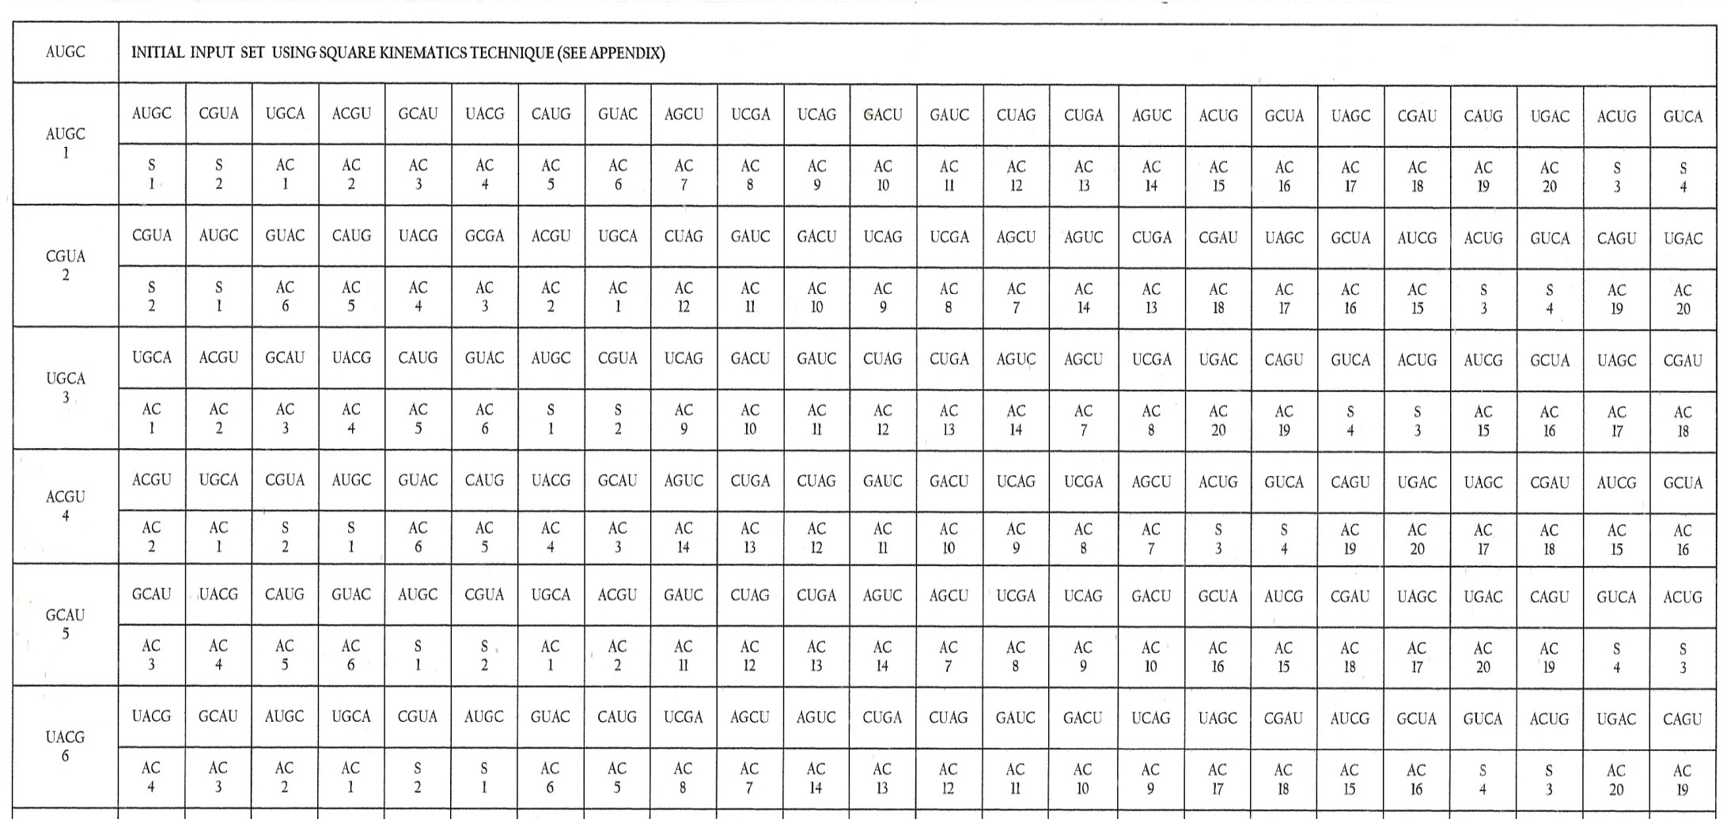
CHART 1: PROTEIN TYPE PROLIFERATION AND DIVERSIFICATION, CLIMAX OF MERITS OF QUADRUPLETS CODONS

1 2 3 4 5 6 7 8 9 10 11 12 13 14 15 16 17 18 19 20 21 22 23 24
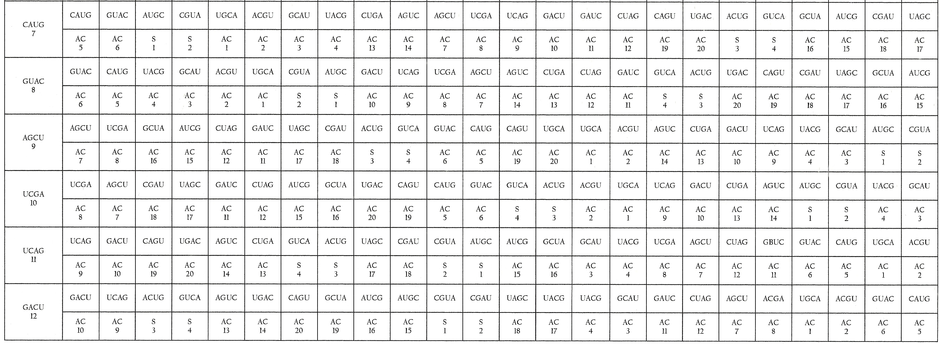
1 2 3 4 5 6 7 8 9 10 11 12 13 14 15 16 17 18 19 20 21 22 23 24
Chart 1 continued
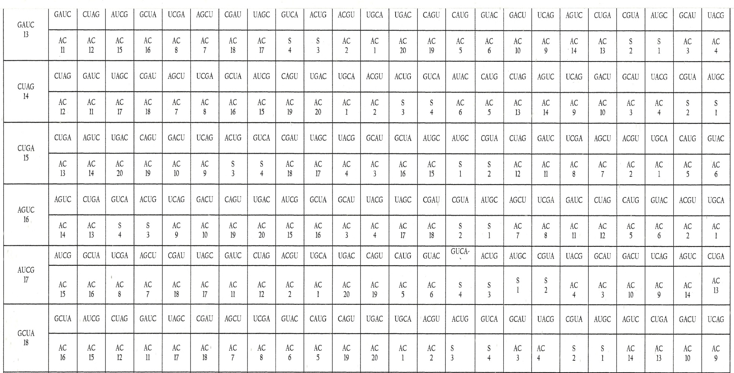
Chart 1 continued

1 2 3 4 5 6 7 8 9 10 11 12 13 14 15 16 17 18 19 20 21 22 23 24
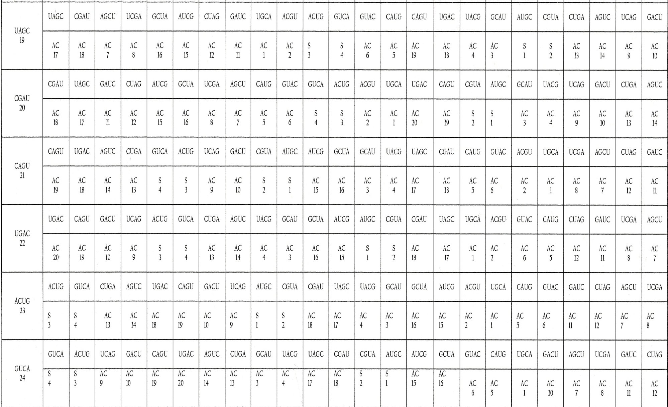
Chart 1 continued

1 2 3 4 5 6 7 8 9 10 11 12 13 14 15 16 17 18 19 20 21 22 23 24
Key to Chart 1
S1 = Signal 1 = Place Start signal
S2= Signal 2 = Time start signal
S3 = Signal 3 = Place stop signal
S4 = Signal 4 = Time stop signal
AC = Amino acid
AC (1) – (20) = Amino acids numbering 20

Materials and Methods
Materials
The materials consist of the RNA four bases in the sequence of A,U,G,C (Adenine, Uracil, Guanine, Cytosine) as transcription from the DNA four bases in the order of A,T,G,C (Adenine, Thymine, Guanine, Cytosine) as carried in a particular rung of the double helix and are used as input set of 4 bases in the multiplicative replication input/output system in computational combinatorics developed by this author in the 1990’s.

Methods
The methods are two, namely: base-four neo-digibreed indirect method, Chart 2 and Square kinematics direct method, Chart 3 under Fig.5

First, base-four neo-digibreed indirect method uses an input set of the RNA four bases in the linear sequence of A,U,G,C involving successive collateral posting (SCP) in Fati’s Geotropic Frame to the limit of 4⁴ where 256 quadruplets are produced. This product is a mixture of 24 permutation quadruplets (crops) bearing no repetition(s) of letters, and 232 non-permutation quadruplets (weeds) bearing repeated letters as carried in Chart 2 in lines 22-85. The 232 non-permutation quadruplets are crossed out as weeds to leave a residue of 24 permutation quadruplets as crops for harvesting as the valid codons.

Chart 2: Derivation of 24 quadruplet genetic code structure from the four RNA bases A, U, G, C by successive collateral posting method using base four neo-digibreed and de-isodigitation.

Corridor | Digibreed | Line No. | Output  No. of permutations per line per digitality
A  U  G  C | Co1l Col 2 Col 3 Col 4  Input  A U G C | 1 | Digitality  2 | Digitality  3 | Digitality  4
A  U  G  C | OUTPUT  AA AU AG AC  UA UU UG UC  GA GU GG GC  CA CU CG CC | 2  3  4  5 | 3  3  3  3
Valid total no. of permute-tion doublets per col. | 3 3 3 3 |  | 12
AA  AU  AG  AC | AAA AAU AAG AAC  AUA AUU AUG AUC  AGA AGU AGG AGC  ACA ACU ACG ACC | 6  7  8  9 |  | -  2  2  2
UA  UU  UG  UC | UAA UAU UAG UAC  UUA UUU UUG UUC  UGA UGU UGG UGC  UCA UCU UCG UCC | 10  11  12  13 |  | 2  -  2  2
GA  GU  GG  GC | GAA GAU GAG GAC  GUA GUU GUG GUC  GGA GGU GGG GGC  GCA GCU GCG GCC | 14  15  16  17 |  | 2  2  -  2
CA  CU  CG  CC | CAA CAU CAG CAC  CUA CUU CUG CUC  CGA CGU CGG CGC  CCA CCU CCG CCC | 18  19  20  21 |  | 2  2  2  -
Valid total No. of permutation triplets per col. | 6 6 6 6 |  |  | 24
AAA  AAU  AAG  AAC | AAAA AAAU AAAG AAAC  AAUA AAGU AAGG AACG  AAGA AAGU AAGG AACG  AACA AACU AACG AACC | 22  23  24  25 |  |  | -  -  -  -
AUA  AUU  AUG  AUC | AUAA AUAU AUAG AUAC  AUUA AUUU AUUG AUUC  AUGA AUGU AUGG AUGC  AUCA AUCU AUCG AUCC | 26  27  28  29 |  |  | -  -  1  1
AGA  AGU  AGG  AGC | AGAA AGAU AGAG AGAC  AGUA AGUU AGUG AGUC  AGGA AGGU AGGG AGGC  AGCA AGCU AGCG AGCC | 30  31  32  33 |  |  | -  1  -  1
corridor | Digibreed | Line  No | Output  No. of permutations per line per digitality
 | Co1l Col 2 Col 3 Col 4  Input  A U G C |  | Digitality  2 Digitality  Digital | Digitality  3 Digitality  Digital | Digitality  4 Digitality  Digital
ACA  ACU  ACG  ACC | OUTPUT  ACAA ACAU ACAG ACAC  ACUA ACUU ACUG ACUC  AGGA ACGU ACGG ACGC  ACCA ACCU ACCG UACC | 34  35  36  37 |  |  | -  1  1  -
UAA  UAU  UAG  UAC | UAAA UAAU UAAG UAAC  UAUA UAUU UAUG UAUC  UAGA UAGU UAGG UAGC  UACA UACU UACG UACC | 38  39  40  41 |  |  | -  -  1  1
UUA  UUU  UUG  UUC | UUAA UUAU UUAG UUAC  UUUA UUUG UUUG UUUC  UUGA UUGU UUGG UUGC  UUCA UUCU UUCG UUCC | 42  43  44  45 |  |  | -  -  -  -
UGA  UGU  UGG  UGC | UGAA UGAU UGAG UGAC  UGUA UGUU UGUG UGUC  UGGA UGGU UGGG UGGC  UGCA UGCU UGCG UGCC | 46  47  48  49 |  |  | 1  -  -  1
UCA  UCU  UCG  UCC | UCAA UCAU UCAG UCAC  UCUA UCUU UCUG UCUC  UCGA UCGU UCGG UCGC  UCCA UCCU UCCG UCCC | 50  51  52  53 |  |  | 1  -  1  -
GAA  GAU  GAG  GAC | GAAA GAAU GAAG GAAC  GAUA GAAU GAUG GAUC  GAGA GAGU GAGG GAGC  GACA GACU GACG GACC | 54  55  56  57 |  |  | -  1  -  1
GUA  GUU  GUG  GUC | GUAA GUAU GUAG GUAC  GUUA GUUU GUUG GUGC  GUGA GUGU GUGG GUGC  GUCA GUCU GUCG GUCC | 58  59  60  61 |  |  | 1  -  -  1
GGA  GGU  GGG  GGC | GGAA GGAU GGAG GGAC  GGUA GGUU GGUG GGUC  GGGA GGGU GGGG GGGC  GGCA GGCU GGCG GGCC | 62  63  64  65 |  |  | -  -  -  -
GCA  GCU  GCG  GCC | GCAA GCAU GCAG GCAC  GCUA GCUU GCUG GCUC  GCGA GCGU GCCG GCGC  GCCA GCCU GCCG GCCC | 66  67  68  69 |  |  | 1  1  -  -
CAA  CAU  CAG  CAC | CAAA CAAU CAAG CAAC  CAUA CAUU CAUG CAUC  CAGA CAGU CAGG CAGC  CACA CACU CACG CACC | 70  71  72  73 |  |  | -  1  1  -
.

Chart 2 continued

Chart 2 continued

Corridor | Digibreed | Line No. | Output  No. of permutations per line per digitality
 | Co1l Col 2 Col 3 Col 4  Input  A U G C | 1 | Digitality  2 | Digitality  3 | Digitality  4
CUA  CUU  CUG  CUC | OUTPUT  CUAA CUAU CUAG CUAC  CUUA CUUU CUUG CUUC  CUGA CUGU CUGG CUGC  CUCA CUCU CUCG CUCC | 74  75  76  77 |  |  | 1  -  1  -
CGA  CGU  CGG  CGC | CGAA CGAU CGAG CGAC  CGUA CGUU CGUG CCGC  CCGA CCGU CCGG CCGC  CCCA CCCU CCCG CCCC | 78  79  80  81 |  |  | 1  1  -  -
CCA  CCU  CCG  CCC | CCAA CCAU CCAG CCAC  CCUA CCGU CCGG CCGC  CCGA CCGU CCGG CCGC  CCCA CCCU CCCG CCCC | 82  83  84  85 |  |  | -  -  -  -
Valid total no. of permutation quadruplets per  Col. | 6 6 6 6 |  |  |  | 24
Valid total no. of permutation quadruplets per  digitality | 6 6 6 6 |  | 12 | 24 | 24

Note; The 24 quadruplet digitisms standing in lines 22 to 85 represent the valid genetic code structure in agreement with combinatorics

Summary of valid permutation codons
Calculated value ₄P₄ = 4! = 4x3x2x1 = 24 quadruplets
Computed value ₄P₄ = 24 quadruplets

Direct Method, Designated as Square Kinematics.

The input set of RNA four bases A,U,G,C are loaded at the corners of the square in clockwise direction as depicted in Fig.5. The loaded square is deployed in three ways as depicted in Fig. 5 (a), (b), and (c) to generate 8 combinatorially valid quadruplets per deployment per section using kinematics and view mixing as shown in Chart 3 carrying a genetic code structure of 24 quadruplet codons from lines (1) to (24).

A U A U A U

C G C G C G
(a) (b) (c)
Fig.5 (a) Sides deployment
(b) Diagonals deployment
(c) Parallels deployment

Square Kinematics Technique for generating permutations of 4 from 4: input set AUGC
U
Chart 3: Output of ₄P₄Permutation

A
From A From A Clockwise AUGC Line1
Fro CGUA Line 2
From U Clockwise UGCA Line 3
Fro ACGU Line 4
C
G
Step 1 (a) Sides Deployment

From G Clockwise GCAU Line 5
Fro UACG Line6
From C Clockwise CAUG Line 7
Fro GUAC Line 8

From A Clockwise AGCU Line 9
U
A

Fro UCGA Line 10
From U Clockwise UCAG Line 11
Fro GACU Line 12
From G Clockwise GAUC Line 13
G
C
Fro CUAG Line 14
Step 2, (b) Diagonals Deployment

From C Clockwise CUGA Line 15
Fro AGUC Line 16
U
A
AU//CG Horizontals AUCG Line 17

Fro GCUA Line 18
UA//GC Horizontals UAGC Line 19
Fro CGAU Line 20
CA//GU Verticals CAGU Line 21
C
G
Fro UGAC Line 22
AC//UG Verticals ACUG Line 23
Step 3, (c) Parallels Deployment

Fro GUCA Line 24

Summary of valid products: lines 1-24 = 24 quadruplets
Factorial ₄P₄= 4! = 4x3x2x1 = 24 quadruplets
Production = prediction = 24 quadruplets

Conclusion:
Collinearity evident in the one-to-one correlation between the 24 quadruplet codewords and the 20 amino acids of protein and 4 control signals in protein synthesis in plants and animals as portrayed in Chart 1 is the sure evidence of the combinatorial correctness or accuracy of this new genetic code combinatorial structure yielded by this revisit of the degenerate 64-triplet genetic code structure. This new genetic code version is wholeheartedly recommended to experimental experts in molecular biology etc for spelling in order to render it fit for coding application in protein synthesis studies.

THE 64-TRIPLET GENETIC CODE STRUCTURE REVISITED AND REFUTED, FROM COMBINATORIAL PERSPECTIVE

Highlights
- Let it be noted at this point that the 64-triplet genetic code structure begging for combinatorial revisit is immature and a mixture of 40 non-permutation and 24 permutation triplets which are as incompatible as weeds and crops during harvest.
- The genetic code structure of 24 permutation quadruplets is the combinatorial answer to the raising of enough codewords from the four-letter alphabet of the RNA four bases A, U, G, C. (Adenine, Uracil, Guanine, Cytosine).
- The diversification of protein types follows from the variation of sequence of 24 output factorial complements being the codewords as influenced by changes of sequence of bases in the input set of four.
- With a quadruplet input set of RNA bases whether in the indirect method of base-4 neo-digibreed scheme or direct method of Square Kinematics, the combinatorially correct output factorial complements of 4 from 4 can only be 24 permutation quadruplets given by factorial 4=4!= 4x3x2x1= 24 quadruplets.
- The new genetic code structure of 24 quadruplets affords collinearity, one-to-one correspondence, with the 20 amino acids of protein/4 control signals for effective protein synthesis characterized by protein type diversification.

THE 64-TRIPLET GENETIC CODE STRUCTURE REVISITED AND REFUTED, FROM COMBINATORIAL PERSPECTIVE
Glossary
Codon: One of 24 quadruplet codewords comprising the output material of 4 from 4 permutation of the nucleotide bases A, T, G, C or A, U,G, C.
Codon Integrity: Completeness of the four base types of the input set in a codon.
Codon Potency: The ability of a codon to generate the factorial complements of 4 from 4 permutation i.e 4! = 4x3x2x1 equal to 24 quadruplets when deployed as input set, plus vitality of association with a specific amino acid or control signal in protein synthesis.
Collinearity: One-to-one correspondence between the 24 quadruplet codons of the true genetic code structure and the 20 amino acids of protein/4 signals for four time and place based start/stop controls in protein synthesis.
Combination: a group of things chosen from a larger number of dissimilar things without regard to order in the group.
Combinatorial: Descriptive of the affairs of permutations and combinations centred on calculating the possible output total and computing the calculated value and also the formulary and techniques utilized.
Combinatorics: The study of permutations and combinations in all its ramifications.
De-isodigitation: Is the elimination or removal of digitisms affected by isodigitation.
Digibreed: Is number population in serial sequence to a specified digitality generated by successive collateral posting (SCP) of a given base-strength, normally including zero, 0.
Digitality: Is number of digits in a number or digitism.
Digitism: Is digital composition of a number or simply the set of digits in a number.
Factorial Complements: The number of units possible as output for a specified set (n) and selection (r) in respect of permutations or combinations.
Input Set: The set of digits in a specific sequence meant for multiplicative replication.
Isodigitation: Is the condition in a digitism (number) whereby one or more digits or letters are repeated.
Kinematic: Of motion considered abstractly without force or mass.
Kinematics: Science of kinematic motion.
Neo-digibreed: Is a digibreed whose base-strength does not include zero,0.
Permutation: An arrangement of dissimilar discrete objects in which order is important.
View Mixing: Is the art of composing a digitism in combinatorial computation following the order of encounter of subjects in sight or view in a specified direction.

References
[1] Becker, Wayne M. (1986), The World of the Cell, Glossary p.529, The Benjamin/Cummings Publishing Company, Inc. 2727 Sandfill Road, Menlo Park, California 94025.
[2] Wright, Jill et al (1988), Prentice Hall Life Science, Prentice Hall, A Division of Simon & Schuster Englewood Cliffs New Jersey 07632.
[3] Becker, Wayne M. (1986), The World of the Cell Glossary p.529. The Benjamin/Cummings Publishing Company, Inc.2727 Sandfill Road, Menlo Park, California 94025, Glossary p.853
[4] Ibid Glossary p. 819
[5] Ibid Glossary p.93

