Syndrome Raine, a rare autosomal recessive dysplasia sclerotic osteoarthritis, the first reports of a new mutation of Tabriz city in IRAN

SHAHIN ASADI* ( Student of Molecular Genetics )
ALI NAZIRZADEH (phd Biotechnology and Genetics)
ELNAZ HEYDARI ( student of Molecular Biology-Gemetic )
SAEEDEH HABIBI (MS.c Molecular Biology-Genetics)
Tabriz University of Medical Sciences and Research Institute of Hematology and Oncology Research Center of Stem Cells and Tabriz in Iran
Young Researchers and Elite Club,Tabriz Branch,Islamic Azad University,Tabriz, Zanjan,Iran.
 Shahin Asadi→ Author and research projects, Student of Molecular Genetics,
Tell;+989379923364
Email;shahin.asadi1985@gmail.com
*Author;SHAHIN ASADI-Molecular Genetics-IRAN-TABRIZ
Abstract
Syndrome Raine, a severe skeletal dysplasia is usually caused the deaths of patients aged newborn. There are reports that patients with a milder form of the disease to live longer and have reached the age of a child. Radiological surveys show an increase in bone density generalized sclerosis and osteoarthritis.
Bone density at the base of the skull, causing changes in the craniofacial skeleton, leading to specific dysmorphic signs in the figures. Symptoms of the disease include prominent forehead, proptosis, nasal root sunk, hypoplastic middle part of the face, hypoplastic nose, mouth, triangular, Atresia Cowan and intracranial calcification. Bone density in the disease so that the disease osteopetrosis is wrong. Raine syndrome is an autosomal recessive hereditary disease, which is caused by mutations in the gene is FAM20C. This gene encodes a protein that phosphorylase-kinase activity has been implicated in bio-mineralization. In this study, a patient with Raine syndrome is introduced from Iran. Based on available information, this patient is the first known case in Iran reported. Molecular analysis of the patient, a homozygous mutation new were identified. Already known about the patient's seventeenth in the world.
Key words: syndrome Raine, gene FAM20C, new mutations of Tabriz.
Introduction
Sclerosing bone dysplasia, a diverse group of hereditary diseases characterized by bone are included in their bone mass density and calcification is unusual. Among them, osteoarthritis dysplasia sclerotic because of severe and fatal, and the incidence of preterm infants have a special place. osteoarthritis dysplasia sclerotic baby Raine syndrome known about it first was reported in 1989 by Raine and Winter (OMIM 259775).
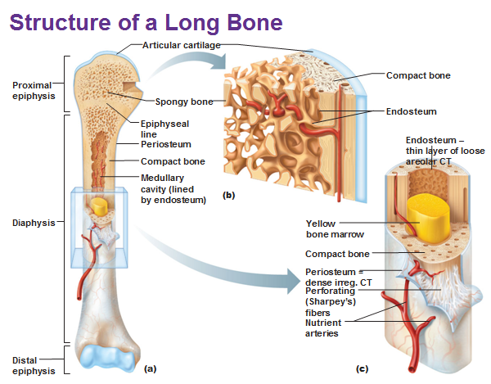
Figure 1: Schematic view of the structure of the bone marrow
The patient was referred to the baby girl born by vaginal delivery and 86 minutes later, he died due to respiratory failure. Most patients a few days to a few weeks after birth because of breathing problems die. Four of the patients were reported to suffer from a milder form of the disease and have a longer life¹. One of them reached the age of 11, ²⁻⁸. X-rays and bone mineral density in the bones indicate Osteoarthritis Fixation too much is Osteopetrosis. Bone mineral density in the bones of the skull base and facial dysmorphic signs, especially in the face of the patients. Major symptoms include: prominent forehead and narrow, Proptosis eyes, small nose, nasal root sunk, hypoplasia of the maxillary bone, the periosteum of diaphyseal bone additional. Raine syndrome of osteopetrosis can be caused by discrimination. This syndrome is autosomal recessive inheritance, since most patients including patients we obtained marriages and relationships are inbred. Simpson and colleagues in 2007 with studies of chromosome ³, as well as telomeric and centromeric probes and the FISH technique, FA and telomeric distal short arm of chromosome 7 patients have discovered. Further studies in this area found that a single parent isodisomy paternal origin occurred. SSR markers using the area finally became clear that the disease locus is distal to the marker D7S2563. One of the genes FAM20C this place that has 10 exons. Simpson has reported various mutations in their patients. One of the mutations, the same mutation found in our patient at the junction of intron 4 and exon 5 (Splice-Site) and at codon 957 as (c.957-3C> G), respectively. FAM20C gene mutation in our patient (c.957-1G> A) is.
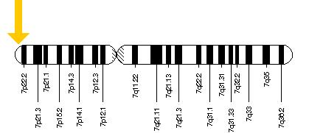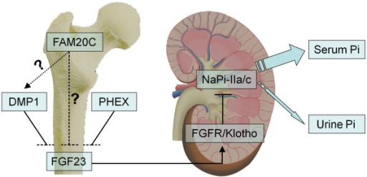
Figure 2: Schematic view of the structure of the gene FAM20C
Case Reports
Baby girl, the mother's first pregnancy. Controls and screening during pregnancy was normal. Healthy couples and third degree relative (cousin-cousin) are. Polyhydramnius have cravings during pregnancy and fairly dramatically. The end of the eighth month of pregnancy bleeding that a doctor because of the lack of progress termination of pregnancy delivery C / S is. Children 4 to 5 minutes after birth due to cardiac arrest - respiratory dies. Because of the apparent anomalies, dysmorphic and premature death, to identify the genetic referred to the hospital. On examination, the patient was severely dysmorphic. Symptoms include prominent forehead and narrow, extremely open fontanelle and sutures. In the middle part of the face hypoplasia, hypoplasia in the nose, sunken bridge of the nose, nose tilted forward, micrognatia, severe proptosis in the eyes, swelling of the gums and mouth was triangular. X-ray skeletal bones and severe and generalized seizures osteosclerosis with severe thickening of the periosteum of the long bones and skull base showed diaphysis area. Skin biopsy was performed and cell culture. Culture and chromosomal karyotype was normal. DNA was extracted from cultured cells exons and intron 1 to 10 FAM20C adjacent gene was amplified by PCR. PCR products were sequenced in both directions by Sanger method and a homozygous mutation (c.957-1G> A) were identified. Simpson also almost the same mutation in one of the patients listed. We have a new mutation is a mutation in patient ⁵, which in previous cases have been reported. Due to detect genetic mutations in patients, pregnant mothers, prenatal diagnosis by molecular methods were tested. Fortunately for homozygous embryos were normal and examinations after birth that the baby was healthy.
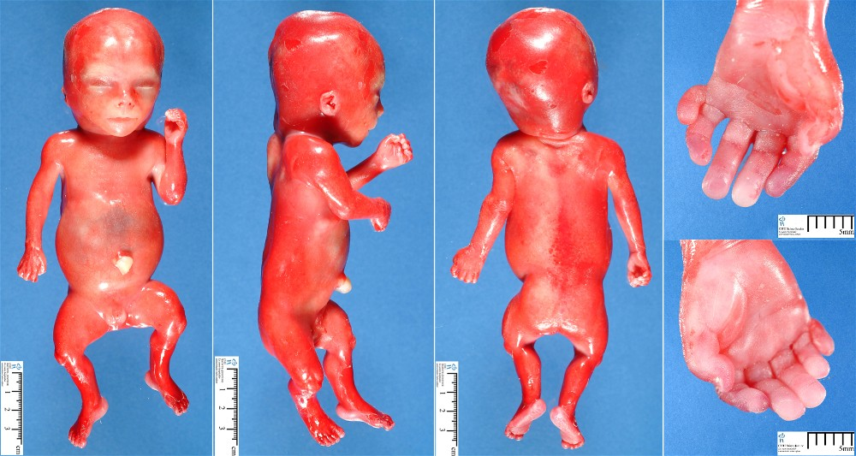
Figure 3: Schematic view of the fetal syndrome Raine
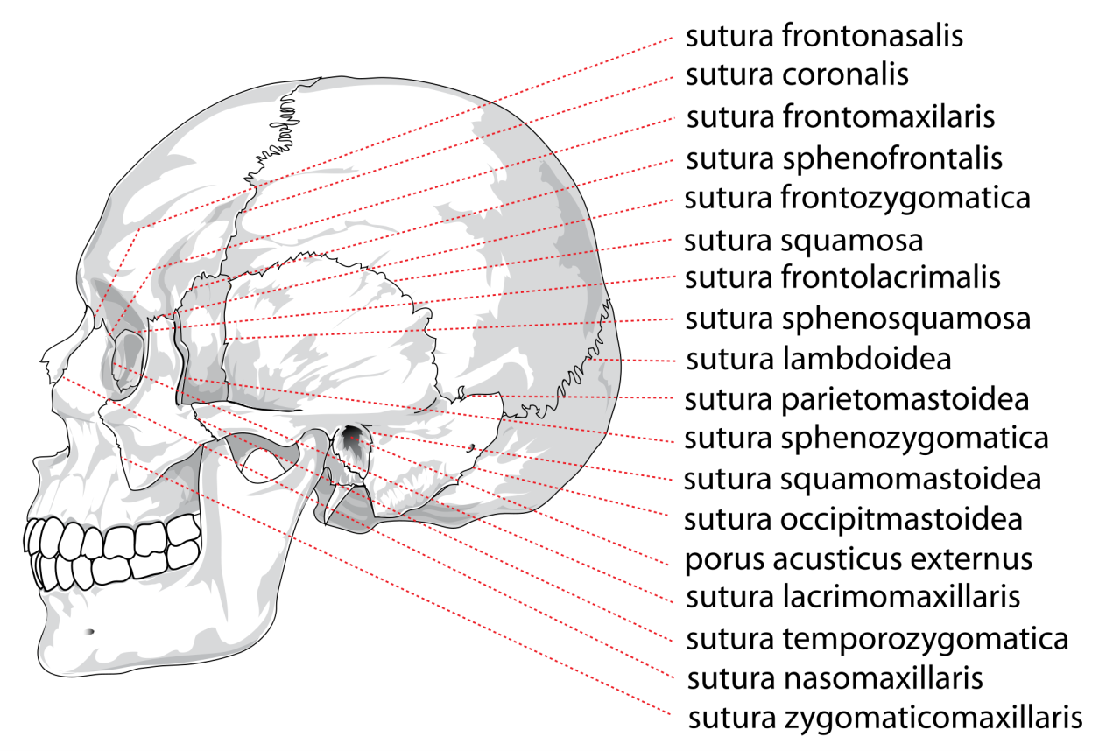
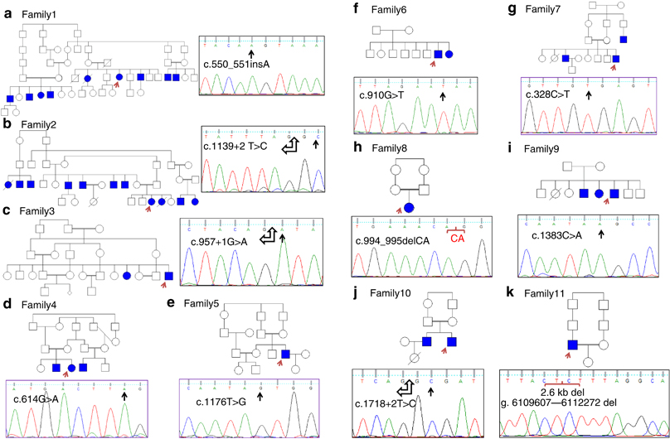
Figure 4: Schematic view of human skull sutures and nucleotide sequences of the genes mutated in patients Raine
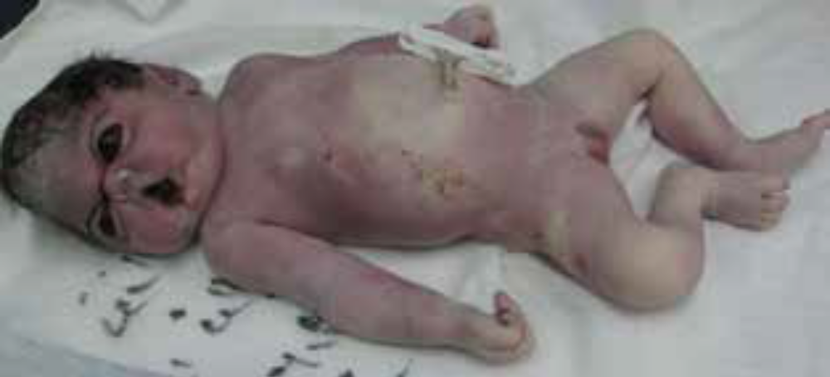
Figure 5: Schematic view of the fetal syndrome Raine that was born dead
Discussion
From 1989 to date, 16 patients with Raine syndrome has been reported in the literature ³⁻¹². Our patient seventeenth Iran is confirmed by molecular testing. This syndrome is very rare and its characteristics are: severe dysmorphic face and head with generalized osteosclerosis And bone periosteum in the area, especially at the base of the skull and diaphyseal long bones and gums. Most patients have died in the early neonatal respiratory failure. In 4 patients the symptoms are milder and have a longer life. Iran's recent illness of 4-5 minutes after birth died. Most patients were relatives of marriage. Autosomal recessive transmission follows the pattern of heritability.
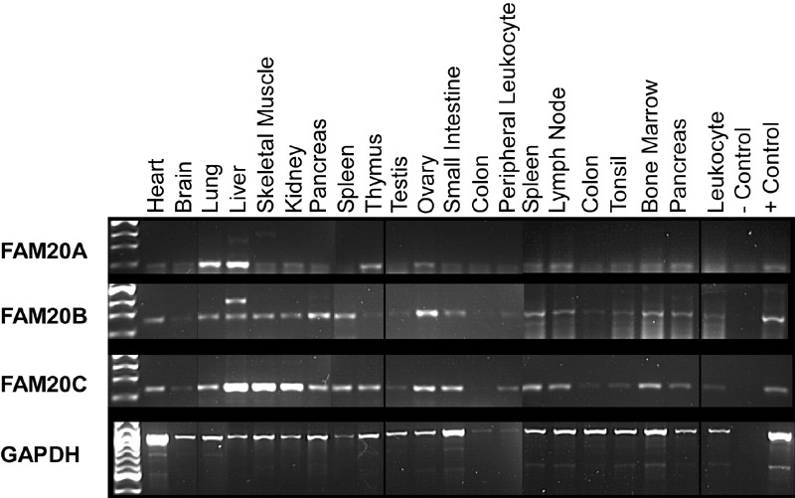
Figure 6: Schematic view of the bands in the reaction product PCR for the gene FAM20C
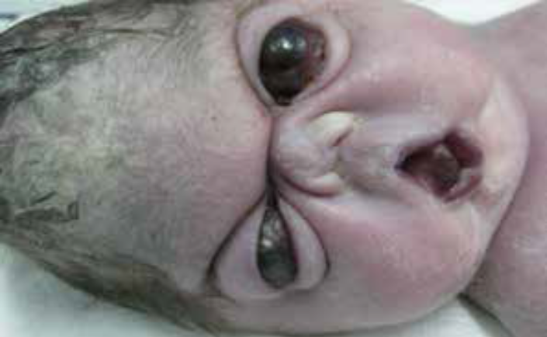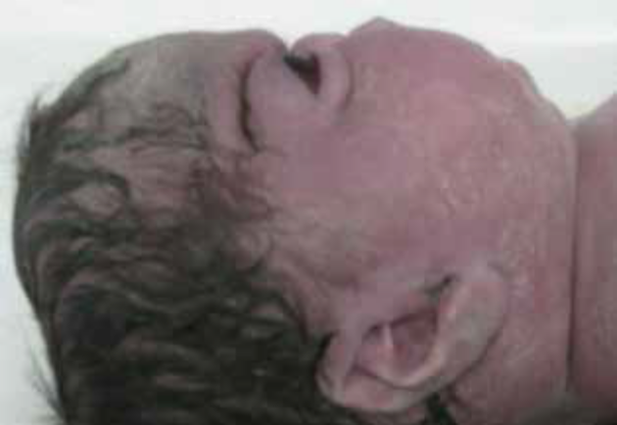
Figure 7: Image syndrome Raine who was born dead
Molecular pathways Raine syndrome
The gene responsible for Raine syndrome at the end of the short arm of chromosome 7p22.3 is detected ³. This gene is FAM20C. FAM20C gene belongs to a gene family that has three members, two other members of FAM20A and FAM20B names. Various mutations of missense, splice-site, homozygous and heterozygous compound has been reported in patients.
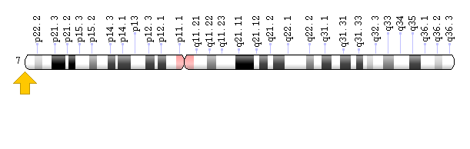
Figure 8: Schematic view of the FAM20C gene on chromosome 7 human

FAM20C
Family with sequence similarity 20, member C also known as FAM20C or DMP4 is a protein which in humans is encoded by the FAM20C gene.^{[1][2][3]} Fam20C, a Golgi localized protein kinase, is a serine kinase that phosphorylates both casein and other highly acidic proteins and members of the small integrin-binding ligand, the N-linked glycoproteins (SIBLING) family at the target motif SerXGlu.^{[4]}
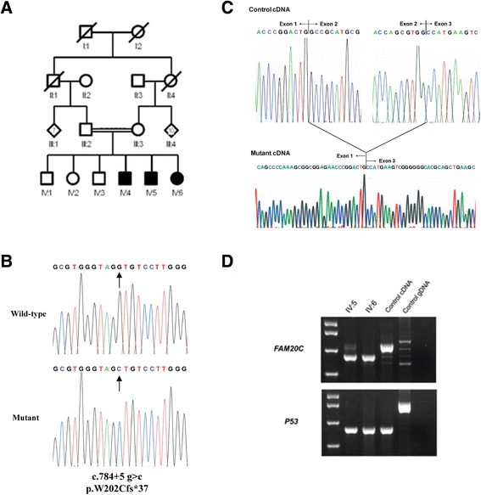
Figure 9: Schematic view of the nucleotide sequence FAM20C a syndrome Raine in fetuses with normal human

Function
Dmp4 causes differentiation of mesenchymal stem cells into functional odontoblast cells and is likely to function as a regulator of dentin mineralization.^{[2][5]} FAM20C is a secretory kinase, responsible for the phosphorylation of all secreted proteins, from milk to bone proteins.^{[4]} Phosphorylation by Fam20C in the secretory pathway is essential for proper biomineralization of bone. The substrate specificity of FAM20C indicates, however, that it is not likely to account for the tyrosine phosphorylation of the secreted protein. The characterization of FAM20C as an active serine kinase in the Golgi apparatus provides a clear precedent that ATP dependent protein phosphorylation can take place in the secretory apparatus.^{[4][6][7]} Fam20C knockout mice develop severe hypophosphatemic rickets due to an increased renal phosphate wasting that is likely attributed to the remarkable elevation of serum FGF23,^{[8]} while their dentin and enamel defects are largely independent from the hypophosphatemia and appear to be a local effects of phosphorylation failure in the SCPP proteins^{[8][9][10]}

Clinical significance
Mutations in the FAM20C gene are associated with Raine syndrome.^{[3]}

FAM20A
FAM20A is a protein that in humans is encoded by the FAM20A gene.^{[1]}

Function
FAM20A belongs to an evolutionarily conserved family of secreted proteins expressed in many tissues. This locus encodes a protein that may function in hematopoiesis.^{[2]} This locus encodes a protein that is likely secreted and may function in hematopoiesis. A mutation at this locus has been associated with amelogenesis imperfecta and gingival hyperplasia syndrome. Alternatively spliced transcript variants have been identified. [provided by RefSeq, Aug 2011]

Clinical significance
A mutation in FAM20A was reported to be associated with amelogenesis imperfecta, an inherited enamel defect, and gingival hyperplasia syndrome.^{[3]}
Human mutations in FAM20A were also reported to cause Enamel-Renal Syndrome, an autosomal recessive disorder characterized by severe enamel hypoplasia, failed tooth eruption, intrapulpal calcifications, enlarged gingiva, and nephrocalcinosis.^{[4]}
This enzyme phosphorylase FAM20C particular genes that code for casein-kinase Golgi (G-CK) is called. Secretory phospholipase enzyme protein binds to calcium in the bones and teeth phosphorylated extracellular matrix tissue is ¹⁴. The reaction to create balance in the bones, bones and teeth, and other calcium binding proteins like milk and saliva plays a vital role. Studies have shown that mutations of the foregoing are FAM20C loss of gene function. As a result of severe osteosclerosis distinction is too odontoblast ¹⁴.

Conclusion
Raine syndrome is a case to be introduced from Iran. Seventeenth patient identified and documented by molecular methods. Now the same syndrome not has been reported in Iran and the world. Our patient was discovered in a new type of mutation.
Thank
Due to the cooperation of the patient's family in clinical trials and genetic testing am grateful.
Studies have shown that mutations in the gene that causes loss of function are FAM20C. Thus Osteosclerosis Ubuntu blasts crowd out is too intense and differentiation ¹⁴.

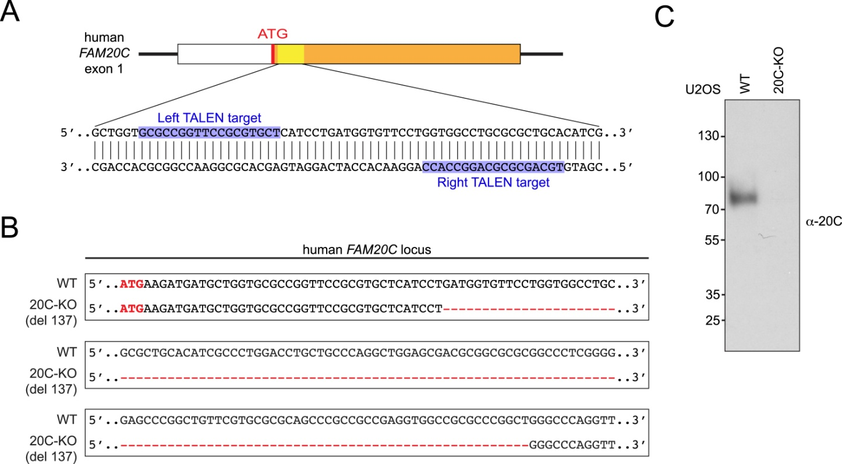
Figure 10: Schematic view of the nucleotide sequence of nucleotide of exon FAM20C with the movement target gene promoter
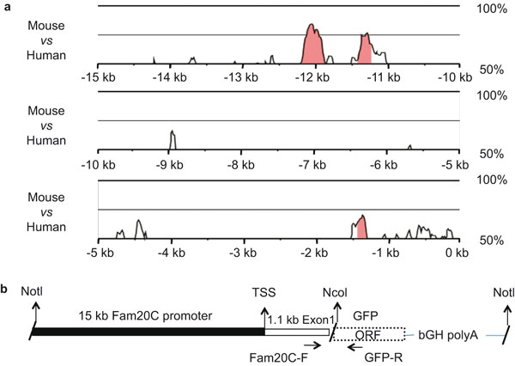
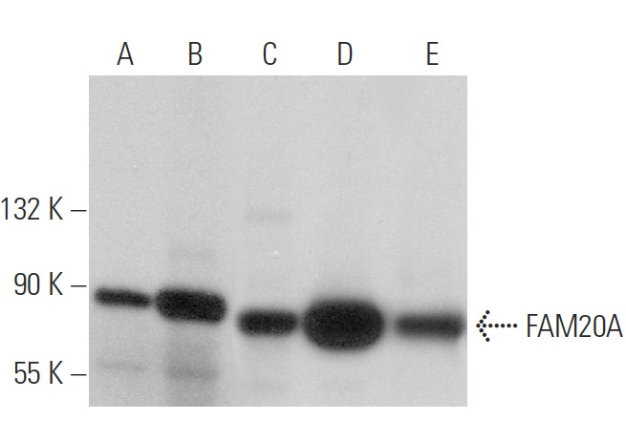
Figure 11: Schematic view of the nucleotide sequence of nucleotide of exon FAM20A with the movement target gene promoter and formed a band in the gel electrophoresis pattern
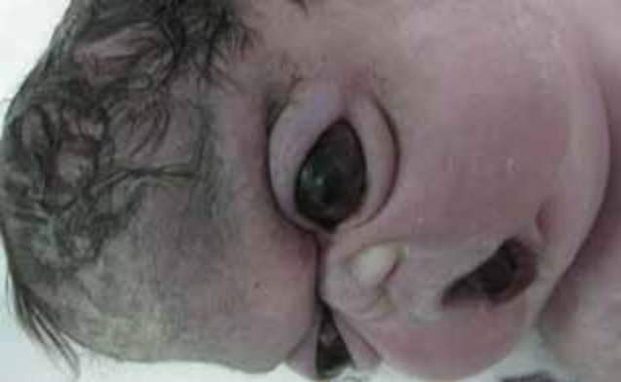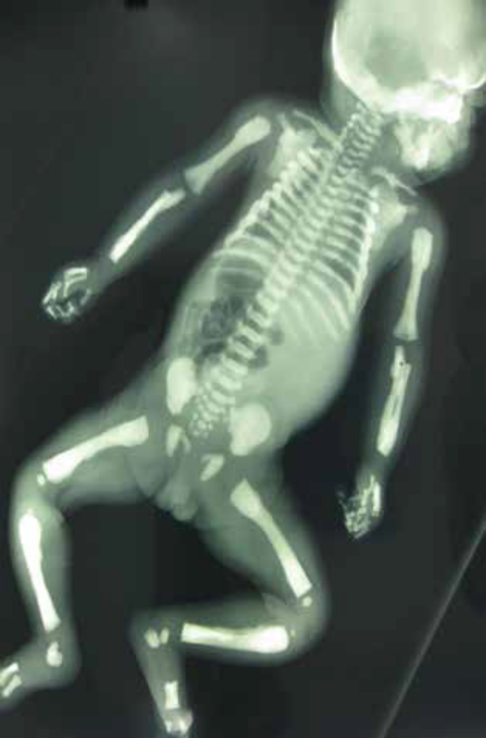
Figure 12: Picture syndrome Raine with X-ray image

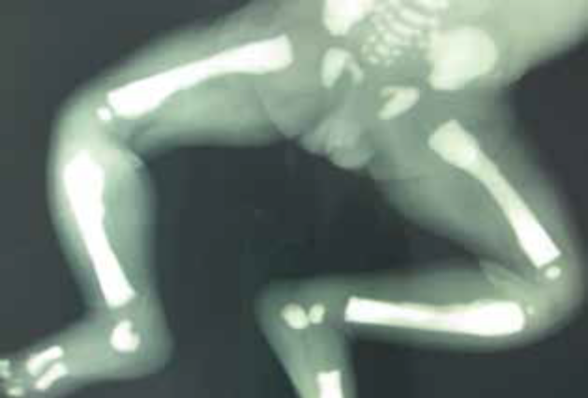
Figure 13: Picture syndrome Raine with X-ray image

Conclusion
Raine syndrome, a case is presented of Iran. Seventeenth patient identified and confirmed by molecular methods. As far as we know has been the case in the world. We have discovered a new type of mutation in patients has not been reported in any other condition.
Thanks
Co-authors of the patient's family because of genetic testing in clinical trials and appreciative.
References
1. Raine J, Winter RM, Davey A, Tucker SM. Unknown syndrome:
microcephaly, hypoplastic nose, exophthalmos,
gum hyperplasia, cleft palate, low set ears, and osteosclerosis.
J. Med. Genet. 1989; 26: 786-788.
2. Simpson MA, Scheuerle A, Hurst J, Patton MA, Stewart H,
Crosby AH. Mutations in FAM20C also identified in nonlethal
osteosclerotic bone dysplasia. Clin. Genet. 2009; 75:
271-276.
3. Simpson MA, Hsu R, Keir LS, et al. Mutations in FAM20C are
associated with lethal osteosclerotic bone dysplasia (Raine
syndrome), highlighting a crucial molecule in bone development.
Am. J. Hum. Genet. 2007; 81: 906-912.
4. Acosta AX, Peres LC, Chimelli LC, Pina-Neto JM. Raine dysplasia:
a Brazilian case with a mild radiological involvement.
Clin. Dysmorph. 2000; 9: 99-101.
5. Al-Gazali LI, Jehier K, Nazih B, Abtin F, Haas D, Sadagahatian
R. Further delineation of Raine syndrome. Clin. Dysmorph.
2003; 12: 89-93.
6. Al Mane KA, Coates RK, McDonald P. Intracranial calcification
in Raine syndrome. Pediat. Radiol. 1996; 26: 55-58.
7. Chitayat D, Shannon P, Keating S, et al. Raine syndrome: a
rare lethal osteosclerotic bone dysplasia: prenatal diagnosis,
autopsy, and neuropathological findings. Am. J. Med.
Genet. 2007; 143A: 3280-3285.
8. Fradin M, Stoetzel C, Muller J, et al. Osteosclerotic bone
dysplasia in siblings with a Fam20C mutation. Clin. Genet.
2011;80: 177-183.
9. Hulskamp G, Wieczorek D, Rieder H, et al. Raine syndrome:
report of a family with three affected sibs and further delineation
of the syndrome. Clin. Dysmorph. 2003; 12: 153-160.
10. Kan AE, Kozlowski K. New distinct lethal osteosclerotic
bone dysplasia (Raine syndrome). Am. J. Med. Genet.
1992;43: 860-864.
11. Kingston HM, Freeman JS, Hall CM. A new lethal sclerosing
bone dysplasia. Skeletal Radiol. 1991; 20: 117-119.
12. Mahafza T, El Shanti H, Omari H. Raine syndrome: report of
a case with hand and foot anomalies. Clin. Dysmorph.
2001;10: 227-229.
13. Shalev SA, Shalev E, Reich D, Borochowitz ZU. Osteosclerosis,
hypoplastic nose, and proptosis (Raine syndrome):
further delineation. Am. J. Med. Genet. 1999; 86: 274-277.
14. Tagliabracci VS, Engle JL, Wen J, et al. Secreted kinase phosphorylates
extracellular proteins that regulate biomineralization.
Science 336: 2012; 1150-1153.
15. Nalbant D, Youn H, Nalbant SI, Sharma S, Cobos E, Beale EG, Du Y, Williams SC (2005). "FAM20: an evolutionarily conserved family of secreted proteins expressed in hematopoietic cells". BMC Genomics 6: 11. doi:10.1186/1471-2164-6-11. PMC 548683. PMID 15676076.
16. Hao J, Narayanan K, Muni T, Ramachandran A, George A (May 2007). "Dentin matrix protein 4, a novel secretory calcium-binding protein that modulates odontoblast differentiation". The Journal of Biological Chemistry 282 (21): 15357–65.
17. Simpson MA, Hsu R, Keir LS, Hao J, Sivapalan G, Ernst LM, Zackai EH, Al-Gazali LI, Hulskamp G, Kingston HM, Prescott TE, Ion A, Patton MA, Murday V, George A, Crosby AH (Nov 2007).

