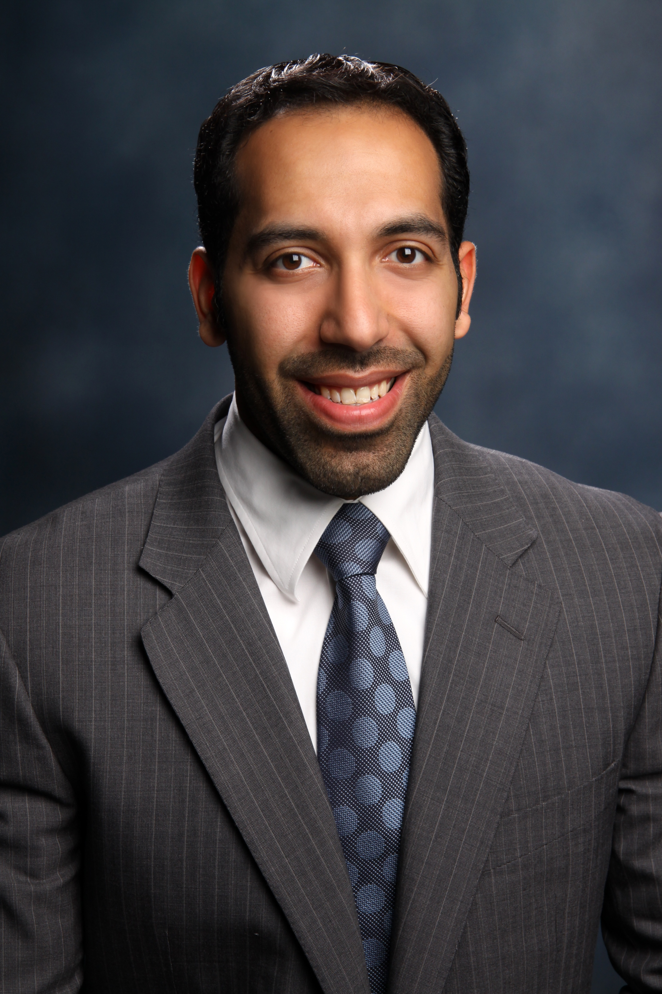 The effect of one night’s sleep loss on physical and cognitive task performance in Kuwaiti college students: a sleep dose–response study.

Mohammed Alkatan, Ph.D.
Department of Physical Education & Sports, College of Basic Education
Public Authority for Applied Education & Training, Kuwait
Abstract:

Adequate sleep supports normal physiological and cognitive function and is critical for optimal health. Inadequate sleep has been shown to be associated with a variety of negative physical and mental health outcomes including depression, violence-related behaviours, and poor academic performance. Sleep loss, including sleep restriction and sleep deprivation, is common among college students especially prior to exams. Late-night studying or pre-exam anxiety could delay sleep onset leading to significant sleep loss that may impair academic performance. Currently, there is insufficient evidence to fully describe the detriments (or negative consequences) of sleep loss in the student cohort. Therefore, the purpose of the present study is to empirically determine the effects of sleep loss (restriction and deprivation) on strength, power, muscle endurance, balance, agility, reaction time, and memory in Kuwaiti college students.

Biography
Mohammed Alkatan has completed his PhD at the age of 32 years from the University of Texas at Austin. He is an assistant professors at Public Authority for Applied Education & Training- Department of Physical Education & Sports. He has published more than 10 papers in reputed journals.
Recent Publications:
- Alkatan M, Machin DR, Baker J, Akkari AS, Park W, and Tanaka H. Effects of Swimming vs. Cycling Exercise Interventions on Vascular Function and Inflammation in Middle-Aged and Older Adults with Osteoarthritis. American Journal of Cardiology. 2016
- Alkatan M, Baker J, Machin RD, Park W, Akkari AS; Pasha EP, and Tanaka H. Improved Functional Capacity and Pain after Swimming and Cycling Training in Patients with Osteoarthritis. Journal of Rheumatology. 2016
- Kaur S, Gonzales MM, Tarumi T, Villalpando A, Alkatan M, Tanaka H, Haley AP. Serum Brain-Derived Neurotrophic Factor Mediates the Relationship between Abdominal Obesity and Executive Function in Middle Age. Journal of the International Neuropsychological Society. 2016
- Lim J, Pearman M, Park W, Alkatan M, and Tanaka H. Interrelationships among Various Measures of Central Artery Stiffness. American Journal of Hypertension. 2016
- Hunter SD, Dhindsa MS, Cunningham E, Tarumi T, Alkatan M, Nualnim N, Elmanshawy A, and Tanaka H. The Effect of Bikram Yoga on Endothelial Function in Young and Older Adults. Journal of Bodywork & Movement Therapies. 2016
- Hunter SD, Dhindsa MS, Cunningham E, Tarumi T, Alkatan M, Nualnim N, and Tanaka H. Impact of Hot Yoga on Arterial Stiffness and Quality of Life in Normal and Overweight/Obese Adults. Journal of Physical Activity and Health. 2016

