Energy, Climate Change and “Clean” Coal Technologies towards Near-Zero Emissions Technologies (ZETs) from Coal Fired Power Plants.

by
S.M . Shamsuddin khaled

Abstract: Studies by the Intergovernmental Panel on Climate Change (IPCC) indicate that the likelihood of significant environmental and social damage increases significantly if CO2 concentration in the atmosphere exceeds about 550 ppm (roughly twice the present level). To stabilize concentrations at or below this level over the next 100 years would require a global emissions reduction relative to the ‘business as usual’ trend of 5% to 60% by 2050 and 70% to 90% by 2100. THE Royal Commission on Environmental Pollution supports this view and has recommended that the UK should aim for a 60% reduction in CO2 emissions compared with current levels by 2050. The UK government in its recent Energy White Paper has committed itself to this aim.
These are formidable targets since fossil fuels underpin the economic and social activities of both developed and developing countries, and with current trends this will continue for many decades to come. To change this trend without adverse effects on economic and social development will require a portfolio of measures including energy efficiency and switching to low to zero emission supply technologies.
Keywords:
IGCC power plants,Carbon Capture and Storage (CCS), Clean Coal Technologies(CCT) ,Pulverized Coal Fired System (PCF), Coal To Transportation Liquids (CTL), IGFC.

Introduction
As the price of coal is cheap, stable ,with large minable reserves, and because it is not geographically concentrated, with coal mines located in politically stable regions, it is seen as remaining an important primary energy source for some time to come. However, the amount of carbon dioxide (CO2) emitted per unit of energy produced from coal is high compared to other fossil fuels, such as natural gas or oil. This has created an expectation for clean coal technologies. It is estimated that total global power generation in 2030 will be about 1.7 times that in 2007, and it is also predicted that the use of coal-fired thermal power generation will continue to grow as it remains a key source of electric power(1). In Hitachi’s work on technical development aimed at achieving near-zero emissions (very low levels of CO2 and soot emissions), its approach is to seek to minimize loss of net thermal efficiency while also reducing construction costs.
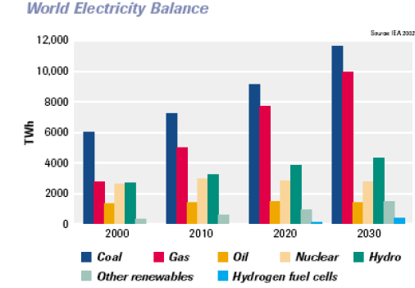
Figure 1: World Energy Balance(IEA,USA)
Zero Emission Technology (ZET) combines and forms a part of :Clean Coal Technologies,
Solid to liquid fuel technology, GHG mitigation technology, Clean Development Mechanism for power sector, Non-CFC Refrigerant and Non-CFC Aerosol Propellant Technology, Clean Aviation Fuel or ATF for aircraft, Substitute LPG for domestic use.
Table 1: Current plant emissions and suggested ZETs targets (stack gas concentrations at 6% O2, dry)
Techn’gy | SO2  mg/m³ | NOx as NO2  mg/m³ | Particles  mg/m³ | Mercury | CO2  kg/kWh
PCC +FGD | 100-400  (to 98%) | 100-200  (SCR) | 10-50 |  | 710-920
CFBC | As PCC | <200-400 | <50
PFBC | As PCC | 120-400 | <50
IGCC | 98-99% removal | <75 | <1
NGCC | Negligible | <30 (SCR)-300 | <30 (SCR)-300 | 0 | ~370
PCC as ZETs | <100 (interim)  <30 (eventual) | <100 (interim)  <50 eventual) | <10 | 90% removal
IGCC as ZETs | <25 | <25

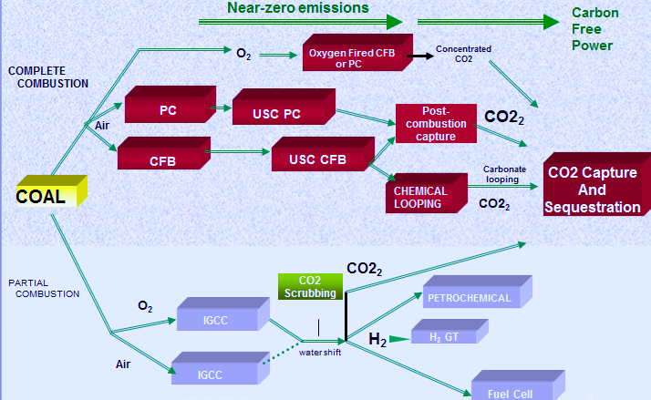
Fig: Near Zero Emission Portfolio.
Clean Coal Technology (CCT) combines and forms a part of the following
:Mining - Management & Practices (Reduction of Extraneous material),
Coal Preparation Process after mining to improve inherent & Extraneous material (washing & beneficiation)
Conversion Technologies Supercritical, PFBC and IGCC
Post combustion cleaning, Particulate and gaseous ,pollutants removal Environmental
requirement) 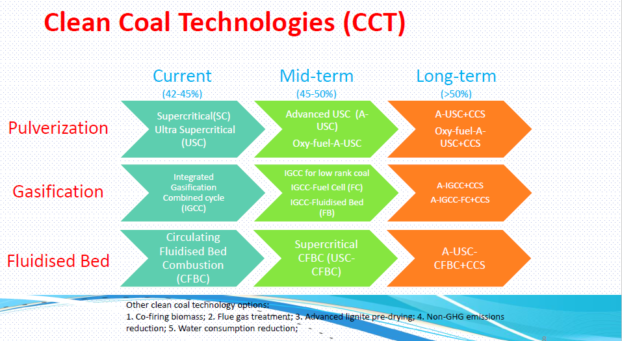

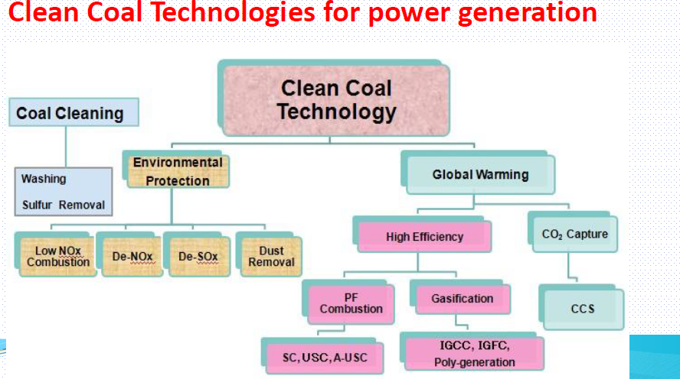
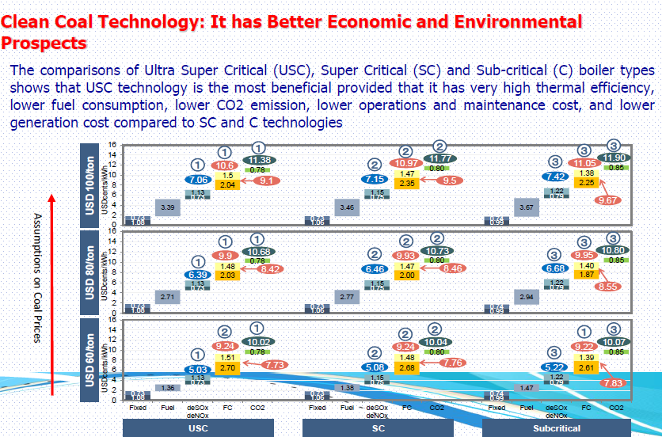
- Technologies as possible bases for ZETs
- Starting point is current technologies: PCC, CFBC, PFBC and IGCC
- CO₂ capture over-riding in setting ZETs plant designs
- As platforms for CO₂ capture, supercritical PCC and IGCC most valuable
- PCC: large commercial base and experience of flue gas scrubbing for CO₂ capture
- IGCC: good emissions performance and possible less efficiency loss for CO₂ capture
- CO₂ capture - flue gas chemical scrubbing:
- Based on methods established on reducing gases using amines
- Experience on flue gas flows up to equivalent of 50 MWe
- Flue gas introduces issues like corrosion, solvent degradation
- Energy consumption high but being reduced (new solvents and integration improvements)
- Around a ~9% points efficiency penalty looks achievable
- Other work: inorganic absorbents; membrane contactors; physical separation
- Will need to consider how to integrate with SOx, NOx, particulates controls and possibly mercury removal
- IGCC – ZETs
- CO₂ capture – pre-combustion:
- For CO₂ capture, syngas would be shifted to CO₂ plus additional H₂, CO₂ separated and the H₂ burnt in the gas turbine
- CO₂ in relatively high concentration, capture with lower efficiency penalty compared with PCC plant
- Experience of E-class GTs on 95% H2. F-turbines under development
- Syngas shift requires steam - quench gasifier simplifies and reduces cost
- Integrating enhanced abatement of conventional emissions:
- SO₂ - already very low levels. Capture of CO₂ can be integrated
- NOx - SCR or future ultra low-NOx combustion systems
- Co-disposal with CO₂ could lower costs
- Particulates emissions already virtually nil
- Mercury emissions depend on the gasifier
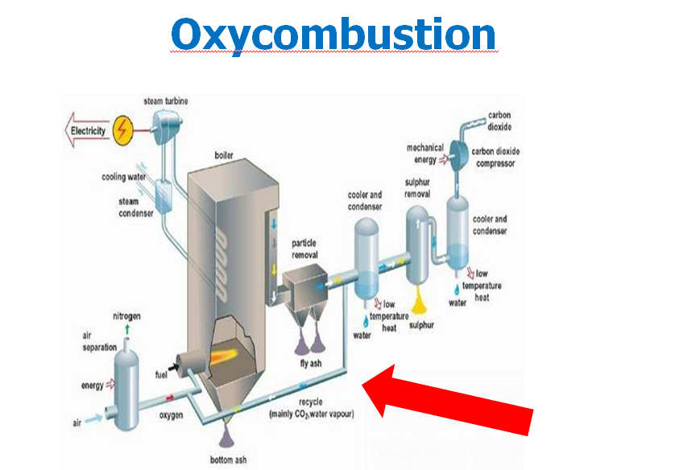
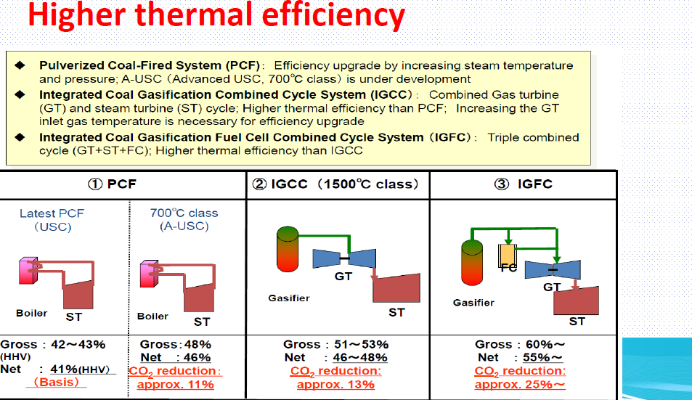
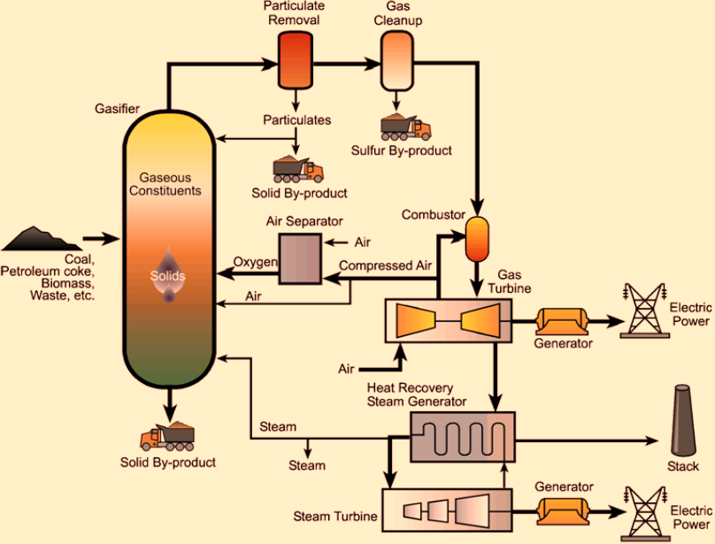
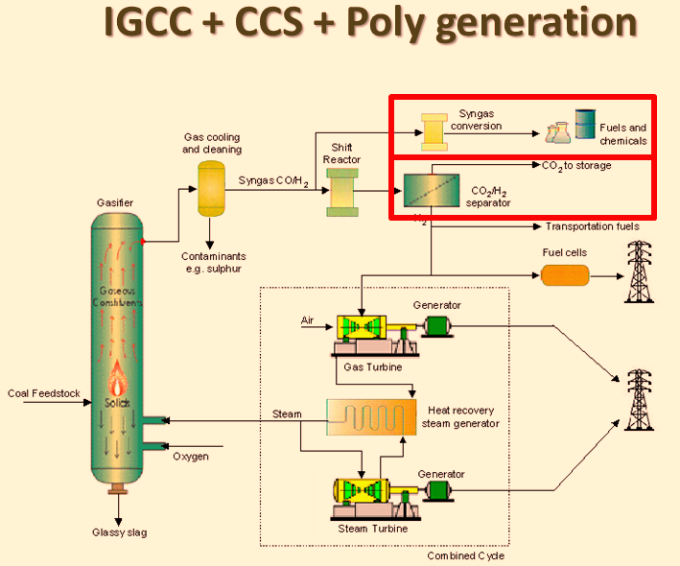
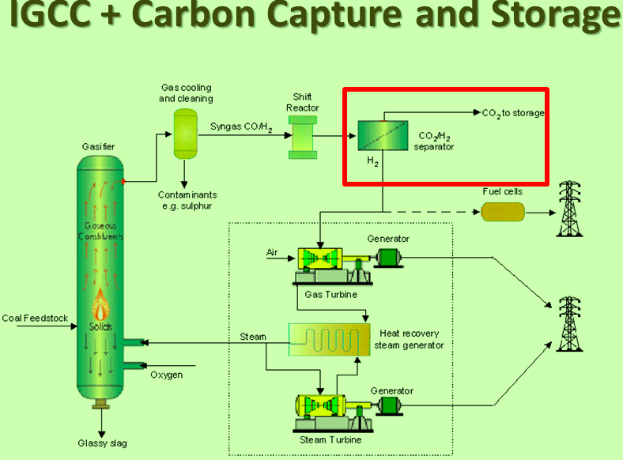
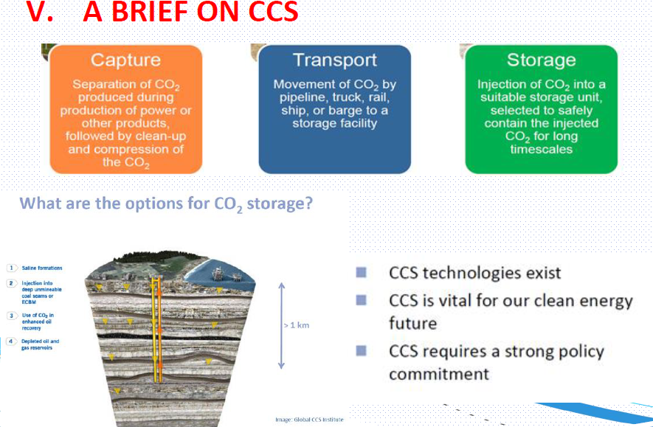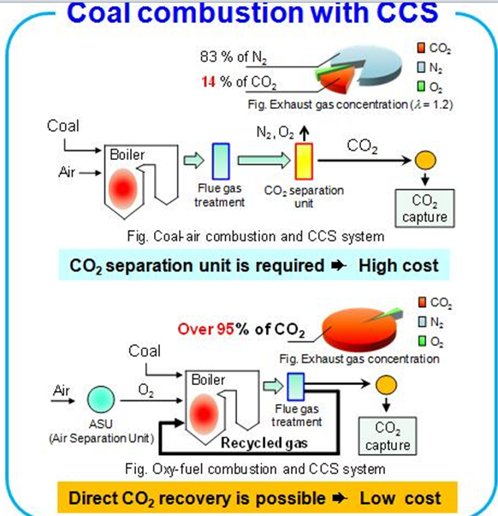
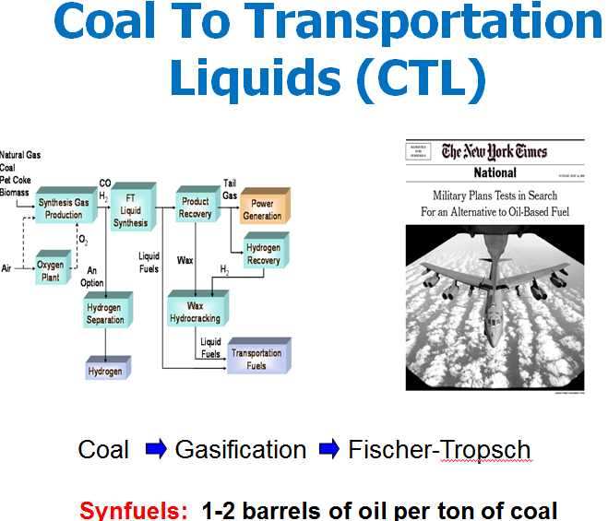

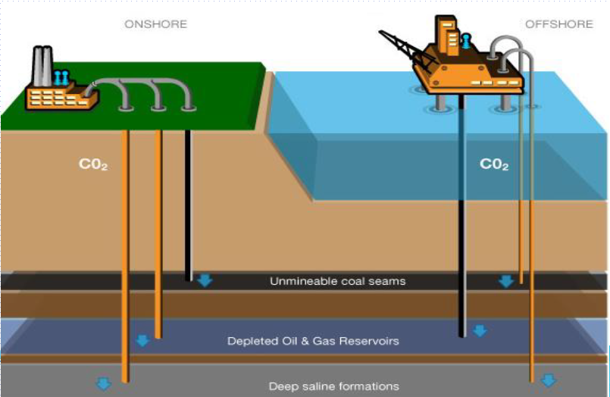
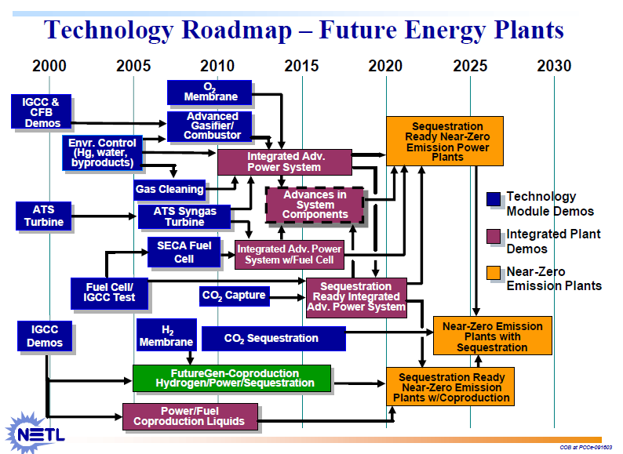
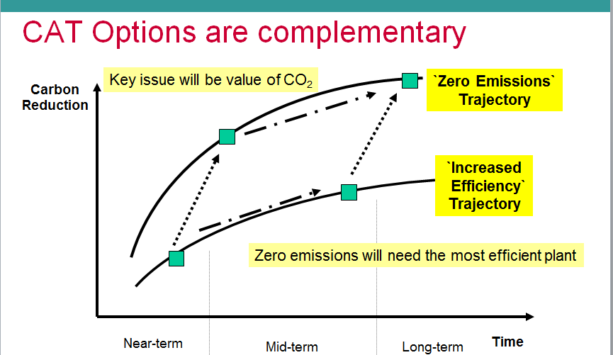
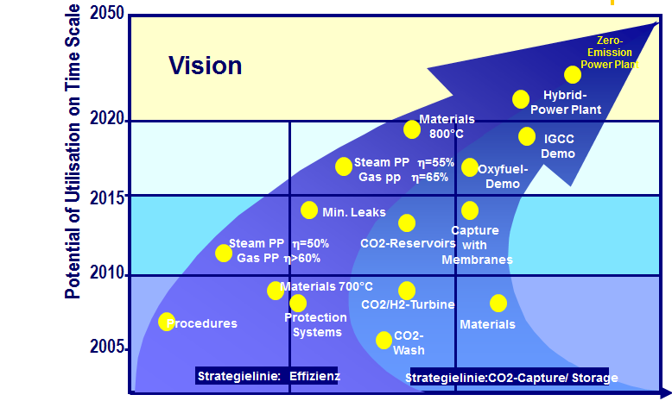
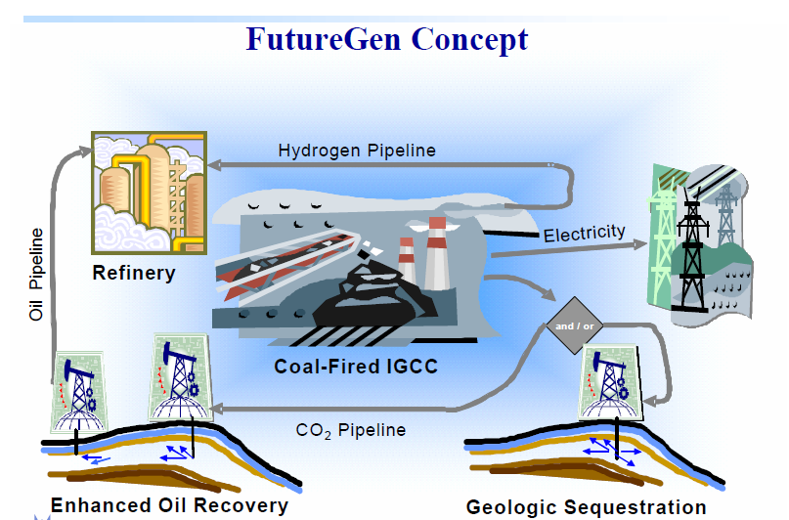
Conclusions
Produce electricity and hydrogen from coal using advanced technology,  Emit virtually no air pollutants & Capture and permanently sequester CO2.

References
[1] International Energy Agency. CO2 emissions from fuel combustion Highlights. IEA statistics; 2011.
[2] Alstom Technology. System for converting fuel material. Patent WO 2010/142533 A1.
[3] IFP Energies Nouvelles TOTAL. Chemical looping combustion process with a reaction zone incorporating a gas/solid separation zone and plant using such a process. Patent WO 2011/151535 A2.
[4] 37thInternational Technical Conference on Clean Coal & Fuel Systems 2012;Pittsburgh.
[5] Anheden M, Fillman B, Wolf J. Parameter study in order to reveal critical design issues in the design for a CLC power plant
using solid carbon as fuel. 1st International Conference on Chemical Looping 2010;Lyon.
[6] Mattison T, Lyngfelt A, Leion H. Chemical-looping with oxygen uncoupling for combustion of solid fuels. Int. J.
Greenhouse Gas Control 2009;3:11-19.

