Metal homeostasis and infectious disease: siderophore-based strategies to inhibit growth of bacterial pathogens
Elizabeth M Nolan, PhD, Department of Chemistry, Massachusetts Institute of Technology, USA

Abstract
New strategies to treat bacterial infections and counteract the emergence of antibiotic resistance are needed. Metal ions are essential nutrients for all organisms, and almost all bacterial pathogens have a metabolic iron requirement. Thus, these microbes must acquire iron from the mammalian host to replicate and cause disease. Many bacteria biosynthesize and utilize siderophores, secondary metabolites that coordinate iron(III) with high affinity, to scavenge iron from the host. The proteins required for the biosynthesis and transport of these iron-chelating metabolites are expressed under iron-limited conditions. Siderophores are considered to be virulence factors and the notion of employing siderophore and siderophore mimics, as well as targeting siderophore biosynthesis and transport machineries, has attracted significant interest for antibiotic development over many years. Here, we first present vignettes from our studies of siderophore-mediated targeting of small molecule antibiotics to Gram-negative bacteria. We report that siderophore-antibiotic conjugates based on native siderophore platforms allow broad-spectrum antibiotics like β-lactams to be targeted to specific bacterial populations, particularly Gram-negative pathogens, on the basis of siderophore receptor expression. For instance, salmochelin-antibiotic conjugates kill Escherchia coli that express the salmochelin receptor IroN, including uropathogenic strains, but not E. coli that lack this receptor. In a related thrust, we describe our recent efforts to block iron acquisition by gastrointestinal pathogens using siderophore-based immunization. We report that immunization of mice with CTB-Ent, a conjugate of cholera toxin subunit B and the siderophore enterobactin (Figure 1), is well-tolerated, results in generation of anti-siderophore antibodies in the gut, and provides protection against Salmonella enterica serovar Typhimurium in a mouse model of infection. Together, these fundamental studies support the notion that hijacking siderophore uptake pathways and blocking siderophore-based iron acquisition may provide new opportunities for new strategies to prevent and treat infectious disease.

Image
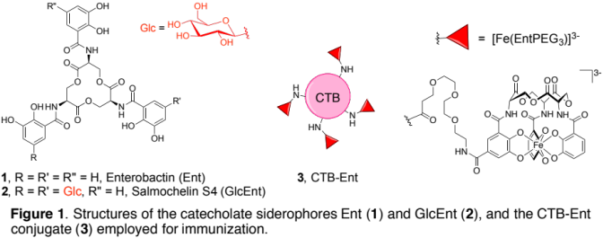

Recent Publications
- Neumann W, Gulati A, Nolan EM (2016) Metal homeostasis in infectious disease: recent advances in bacterial metallophores and the human metal-withholding response. Curr Opin Chem Biol 37: 10-18.
- Sassone-Corsi M, Chairatana P, Zheng T, Perez-Lopez A, Edwards RA, George MD, Nolan EM, Raffatellu M (2016) Siderophore-based immunization strategy to inhibit growth of enteric pathogens. Proc Natl Acad Sci U S A 113: 13462-13467.
- Chairatana P, Zheng T, Nolan EM (2015) Targeting virulence: salmochelin modification tunes the antibacterial activity spectrum of β-lactams for pathogen-selective killing of Escherichia coli. Chem Sci 6: 4458-4471.
- Zheng T, Nolan EM (2014) Enterobactin-mediated delivery of β-lactam antibiotics enhances antibacterial activity against pathogenic Escherichia coli. J Am Chem Soc 136: 9677-9691.
- Zheng T, Bullock JL, Nolan EM (2012) Siderophore-mediated cargo delivery to the cytoplasm of Escherichia coli and Pseudomonas aeruginosa: synthesis of monofunctionalized enterobactin scaffolds and evaluation of enterobactin-cargo conjugate uptake. J Am Chem Soc 134: 18388-18400.

Biography
Elizabeth (Liz) Nolan is an Associate Professor of Chemistry at the Massachusetts Institute of Technology. Her current research interests address the bioinorganic chemistry of infectious disease and the host-microbe interaction, and include investigations of metal homeostasis, host-defense factors, and bacterial metabolites.
Email: lnolan@mit.edu

Notes/Comments:

