Explicating PGP potential of microbial diversity and antibacterial potency of Arnebia euchroma (Ratanjot): A critically endangered plant of Trans-Himalayan region of Himachal Pradesh, India
Devi, S, PhD, Dr YSP University of Horticulture & Forestry Nauni, Solan, Himachal Pradesh-173230 (India)
Sharma, P, M.Sc, Dr YSP University of Horticulture & Forestry Nauni, Solan, Himachal Pradesh-173230 (India)

Abstract

Rhizospheric soil samples of Arnebia euchroma (Ratanjot) collected from Trans- Himalayan region of Himachal Pradesh were processed for elucidating microbial diversity using Standard Plate Count technique. In total, 105 (53 bacteria, 18 fungi and 34 actinomycetes) isolates were obtained. All isolates were screened for multifarious Plant growth promoting (PGP) attributes viz., phosphate solubilization, nitrogen fixation, siderophore, HCN, ammonia production and lytic enzymes production. Only 2 bacterial and 4 fungal isolates were observed to have significant PGP potential and were thus identified at phenotypic and molecular level. The fungal strains were identified as Mortierella alpina NF5 (GenBank Accession No. MH150878), M. alpina CF7 (Accession No. MH150879), Penicillium chalabudae CF9 (Accession No. MH150880) and Chaetomium iranianum GF11 (Accession No. MH150881) while bacterial strains as Bacillus megaterium GR3 (Accession No. MK629238) and Pantoea eucrina NR10 (Accession No. MK629239) through ITS region sequencing and 16S rRNA ribotyping, respectively. These strains were deposited at National Culture Collection Centre - NCMR Pune, Maharashtra (India) with accession numbers CF9 (MCC 1671), GF11 (MCC 1672), NF5 (MCC 1732), GR3 (MCC 4071) and NR10 (MCC 4070). Using UPLC, three pigments namely Shikonin (0.011%), Deoxyshikonin (0.098%) and ββ-dimethylacrylshikonin (0.145%) were detected in the roots of A. euchroma that displayed significant antibacterial activity (well-diffusion method) against human pathogens. Ethanol extract exhibited maximum inhibitory activity (32 mm) against Shigella sp. (MIC - 78µg/ml). Extracts prepared in distilled water showed 18, 25, 13, 12 and 30 mm of inhibition zones against Enterobacter aerogenes (MIC-351.5µg/ml), Proteus sp. (MIC-175.7µg/ml), Klebsiella pneumoniae ATCC 6633(MIC-351.5 µg/ml), Escherichia coli ATCC 10418 (MIC-87.7µg/ml) and Shigella sp. (MIC-87.7µg/ml), respectively. Methanol extracts showed 20 mm (162.5 µg/ml) and 15 mm (MIC-328.0 µg/ml) of inhibition zones against Shigella sp. and Salmonella typhi NCTC 786, respectively, explicating the therapeutic potential of roots of A. euchroma for treating numerous ailments caused by these pathogens.
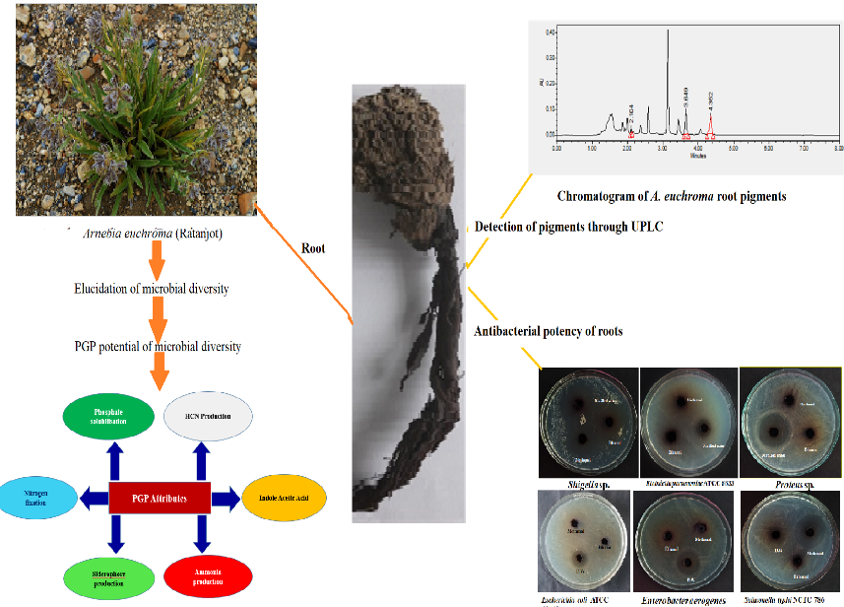
Recent Publications
- Singh AK, Bhardwaj SK, Devi S (2021) Microbiological status of drinking water sources and its relationship with human health in Solan, India. Environmental Monitoring and Assessment 93(1):32. doi: 10.1007/s10661-020-08833-x (NAAS rating: 7.90 and impact factor: 2.273)
- Thakur M, Gupta N, Sharma H, Devi S (2021) Physico-chemical characteristics and mineral status of honey from different agroclimatic zones of Himachal Pradesh, India. British Food Journal. DOI 10.1108/BFJ-10-2020-0881 (NAAS rating: 8.10 and impact factor: 2.102)
- Devi S, Sharma P, Rana A, Pal J, Kumari A (2021) Diversity and PGP potential of actinomycetes associated with the rhizosphere of Arnebia euchroma (Ratanjot): A critically endangered medicinal plant of Himachal Pradesh (India).” Journal of Environmental Biology 42 (4): 964-972 (NAAS rating: 6.78 and impact factor: 0.781)
- Sharma R, Devi S (2019) A novel and discernible plate assay method for the qualitative screening of bacterial keratinase. Indian Journal of Biotechnology18(2): 174-180 (NAAS Rating: 6.41 and impact factor: 0.413 )
- Sharma R, Devi S (2018) Versatility and commercial status of microbial keratinases: a review. Reviews in Environmental Science and Bio-Technology 17 (1): 19-45. doi.org/10.1007/s11157-017-9454-x (Impact factor: 4.957; NAAS rating: 10.96)
- Pal J, Sharma SK, Devi S, Sharma R, Raj H, Karn M, Verma S, Vedukola PR, Sharma A (2020) Screening, identification, and colonization of fungal root endophytes against Dematophora necatrix: a ubiquitous pathogen of fruit trees. Egyptian Journal of Biological Pest Control 30: 112-126 (NAAS rating: 6.76 and impact factor: 0.763)


Biography
Sunita Devi (Ph.D., CSKHPKV, Palampur) is pursuing her career as a Teacher /Researcher at Dr YSPUHF, Nauni- Solan (Himachal Pradesh) in the field of Microbiology. Her thrust areas of research include Microbial Biotechnology, Environmental, and Soil Microbiology. She has been University merit scholarship awardee and Rajiv Gandhi National Fellowship holder (UGC, Govt. of India) during M.Sc. and Ph. D. programmes, respectively. She has guided two M. Sc. students as Major advisor. She has published 21 research papers, 4 book chapters and 7 popular articles. She has completed two externally funded research projects as PI and is currently handling two projects, one each as PI and Co-PI. She has received “JagarNath Raina Memorial All India Best Publication Award- 2018” and also developed a novel and discernible plate assay method for the qualitative screening of bacterial keratinases. She is an Executive Editorial Board member of Agric International Journal, SADHNA, UHF, Nauni- Solan.
Email: sunitachamba@gmail.com

Notes/Comments:
Presenting author details
Full name: Dr Sunita Devi
Contact number: 09418014742
Mail id: sunitachamba@gmail.com
Category: (Oral presentation)

