Isolation and identification of palm oil and soybean oil degrading bacteria from bio-extract

By
Ms. Nahid Esmaeili

Thesis
A thesis submitted in partial Fulfillment of the Requirement for the Degree of Master of Science in Food Biotechnology, Department of Food Biotechnology Assumption University Academic Year 2016
Copyright of Assumption University

Title : Isolation and identification of palm oil and soybean oil degrading bacteria from bio-extract
By : Ms. Nahid Esmaeili
Advisor : Dr. Viyada Kunathigan
Level of study : Master of Science
School : Biotechnology
Academic Year : 2016
………………………………………………………..
Dr. Viyada Kunathigan
(Advisor)

All Right Reserved by Faculty of Biotechnology
Assumption University

The manuscript has been read and in satisfaction of the thesis requirements for the Master of Science in Food Biotechnology

………………………………………. Date…………………………….
Viyada Kunathigan, Ph.D.

………………………………………. Date……………………………..
Patchanee Yasurin, Ph.D. Asst. Prof.
(Committee member)

………………………………………. Date………………………………
Malinee Sriariyanun, Ph.D. Asst. Prof.
(Committee member)

Acknowledgements

First of all I would like to thank my family, my parents for giving me the opportunity to do my master degree in abroad, they support me in financial, emotional, and they encourage me in every steps of my studies.
I would like a special word of gratitude to my advisor, Dr. Viyada Kunathigan for giving me the opportunity to do the master thesis on microbiology and also good advice to me to have more knowledge about my topic and research doing. I deeply appreciate her careful and exigent reading of the thesis, the critical comments, suggestions and corrections. My thanks also goes to her for sharing her knowledge with me.
Lastly, a special word of gratitude to my friend Dr. Zahra Khosravi for her encouragement and good counseling to me which enable me to complete my thesis.

Nahid Esmaeili

Abstract

Wasted vegetable oils released from wastewater of food processing industries, restaurant and kitchens are substances that cause water problem due to their physical properties. One method to solve this problem is the use of bio-extract. Bio-extract derived from the fermentation of vegetable and fruits residues with sugar. It contain organic substances and microorganisms that can degrade oils. The isolation and identification of bacteria from bio-extract which can degrade palm oil and soy bean oil is the aim of this research. The isolation of bacteria was carried out, using M9 liquid media enriched with 1% (v/v) soybean or 1% (v/v) palm oil added with 2 ml bio-extract. The samples were screened for lipid degrading bacteria using serial dilution and spread onto the M9 agar plates enriched by 0.2% (v/v) soybean oil or palm oil and 0.5x PCA media enriched by 0.2% (v/v) palm oil or soybean oil. Thirty microorganisms were isolated from bio-extract that showed ability to degrade palm oil and/ or soybean oil. The bacteria categories in three groups, the first groups including Pcp3y, Pcp16y, M9p10yy, M9p5y, M9p16y, M9p15y, M9p8y, in palm oil, , and M9p16y, Pcp16y, Pcp17y M9p5y and M9p8y in soybean oil. The second groups of bacteria including M9p10yy, M9p15y in soybean, and Pcp17y in palm oil. The first group and second group degrade oils so, these group select as good bacteria due to degrade palm oil and soybean oil. The third groups of bacteria did not degrade oils. So, seven strains of bacteria were selected according to the size of clear zone in soybean and palm oil containing agar plate. The selected bacteria strains were identified using, morphological and physiological characteristics according to the method of “Bergey’s manual of determinative bacteriology”. The bacteria can be categorized in to three groups. The first group consisting of three strains, they are Gram-positive, rod shape, oxidase negative. The second group consisting two strains they are Gram-negative, rod shape and fermented glucose. The third group consisting two strains, they are Gram-negative, rod shape, and did not fermented glucose.

Keywords: Bio-extract, palm oil, soybean oil, degrade, wastewater

Table off Content
Page

Acknowledgements I
Abstract II
Table of content III
List of table IV
List of figure V
Introduction 1
Objective 2
Literature review 2
Bio-extract 3
Wastewater 11
Methodology 20
Identification of bacteria 21
Enzyme activity 23
Result and discussion 24
Conclusion 33
References 34
Appendix 39
List of Table
Page
Table 1: Identity characteristic of crude palm oil 10
Table 2: Comparison of commonly used vegetable oil 16
Table 3: The size of clear zone for 0.5x PCA + (0.2% v/v) Palm oil and 0.5 PCA + (0.2% v/v) Soybean oil and 0.5x PCA + Tributyrin (1% v/v) in streak method and drop method 27
Table 4: Biochemical characterization of seven isolated bacteria from bio-extract 28
Table 5: Average amount of protein and enzyme specific activity for seven strains of bacteria 33

List of figure
Page
Figure 1: Thailand palm oil food domestic consumption by year 7
Figure 2: Thailand Soybean oil food domestic consumption by year 7
Figure 3: World export of 17 oils and fats growth rate 8
Figure 4: Diagrams of simple and mixed triglycerides 9
Figure 5: Growth curves of selected bacteria in PCB broth + soybean oil. 30
Figure 6: Growth curves of selected bacteria in PCB broth + palm oil. 30
Figure 7: Growth curves of selected bacteria in PCB broth + soybean & palm oil 31
Figure 8: Specific activity for seven strains of bacteria 32

Chapter I
Introduction
Fat, oil and grease (FOGs) is one group of substances that is used to determine water quality. FOGs can be released into the environment with wastewater derived from the food processing industry, restaurant and kitchens or by accidental spill of oils. If they were not treated, they can cause adverse effect in environment due to their physical properties. In natural environment, FOGs cover of animals and plants, reduce oxygen transfer rate and increase high biological oxygen demand (BOD) in wastewater (Cipinyte et al., 2009). On the other hand, accumulation of FOG in wastewater treatment systems leads to blockage of drainpipes, appearance of unpleasant odors and erosion of sewer pipes (Cipinyte et al., 2009). The main components of FOGs are animal fats and vegetable oils. They may also contain a mixture of glycerol and free fatty acids whenever hydrolysis has taken place (Cammarota, 2006).
FOGs can form oil film in water surfaces, preventing the circulation of oxygen from air into water and leading to the death of many forms of aquatic lives. Collections formed by oil droplets and other particles present in wastewater can also block water drainage lines. Generally, lipid residues are partially recovered from wastewater by air flotation and the remaining residues are treated by physical and chemical method (Mongkolthanaruk, 2002). Then the floated lipid wastes are usually discarded by sanitary landfill dumping, however, this also pollutes the environment (Mongkolthanruk, 2002). Many bacteria that are capable degrading FOGs, isolated from soil and water. These genera of bacteria such as Bacillus, Pseudomonas, Burkholderia, Acinetobacter, Escherichia and fungi are known to degraded Olive oil and tributyrin (Mongkolthanaruk, 2002).
Bio-extract derived from the fermentation of vegetable and fruits residues with sugar is a brownish liquid. It contains vitamin, minerals, hormones and enzymes. It is organic substances and effective microorganism. Bio-extract or bio-fermented solution is also called as effective microorganisms (EM). There are different microorganisms in bio-extract, such as Lactic acid bacteria, yeast, and Lipolitic bacteria (Kamla, 2007). Thus, it can help to develop soil productivity by presenting organic matters to increase soil fertility. The other benefits of bio- extract have been studied and one application of bio-extract is used in wastewater treatment. Research has shown EM cultures to be highly effective in purifying wastewaters and sewage effluents (Kamla, 2007). The other benefits of bio-extract have been studied and one application of bio-extract is used in purifying of wastewater treatment and sewage effluents (Higa, 1995).
The aim of this study is to isolate bacteria which are able to degrade the vegetable oils from the bio-extract for wastewater treatment application.

Objective

Isolation and identification of bacteria that can degrade soybean oil and palm oil from bio-extract.

Hypothesis

Bacteria in bio-extract can degrade soybean and palm oil.

Chapter II

Literature review

There are some environmental problems caused by FOGs (Fat oil and grease) in wastewater. FOGs form a layer on surface of wastewater, which reduce oxygen transfer rate and increase biological oxygen demand (BOD) in wastewater (Cipinyte et al., 2009). Therefore, it leads to the death of many forms of aquatic lives. For this problem, there are some methods to treat wastewater as will be described later. Bio-extract is a tool which used for treatment of wastewater in this experiment.

2.1. Bio-extract

Bio-extract is the product that produced by fermentation of microorganisms developed EMs in Okinawa during 1970’s. Which called Effective Microorganisms or EM. This solution contain naturally occurring microbes that have the ability to reduce biological toxicity in the wastewater as well as remove the foul odor ((Higa, 1995). Bio-extract is an organic brown liquid made from fermented vegetables and plants composted with sugar (molasses); it plays an important role in the improvement of self-sufficiency agriculture due to their low cost, reduced impact on soil and moderate chemical fertilizer input. Also it is an effective liquid for lessening pollution problems. Furthermore, bio-extracts and bio-ferments are the carbon and energy sources for the microorganism fermentation during decomposition processes (Noisopa, 2010). Bio-extract contain mixture of microorganisms, (Kamla, 2007). It has nutrients, elements, plant hormones, and phosphate solubilizing microbes (Noisopa, 2010). It has been claimed to be used to nourish plants, to remove pests and diseases, to use in animal farming, and to treat wastewater (Srisatit et al., 2008). Bio-extract can reduce the amount of oil and grease in wastewater it mean bio-extract can degrade vegetable oil (Chiu, 2012). Study show bio-extract has a number of applications, including cleaning septic tanks, gardening, agriculture, livestock, alga control and bioremediation (Szymansk and Patterson, 2003).
Bio-extract consist of a wide variety of multicultural of effective, beneficial and nonpathogenic microorganisms. It contains about 80 species of microorganisms. Some microbes that can be found in bio-extract are, Bacilus spp. Lactic acid bacteria, photosynthesizing bacteria, actinomycetes, purple non- sulphur bacteria, yeast and mold (Zakaria et al., 2010) Generally, the bio-extract has the pH of 3.5 to 5.6. Its benefits have been widely studied and the usage of bio-extract solution in wastewater treatment is one of those (Nitsuwat et al., 2012). EM can be applied to many environments to break down organic matter. One of the application of EM is waste management and recycling, environmental remediation and eco-friendly cleaning (Zakaria et al., 2010). The research has been shown bio-extract can degrade vegetable oil in wastewater.

2.1.1 Lactic Acid Bacteria

Lactic Acid Bacteria is gram-positive, non-spore, catalase-negative, devoid of cytochromes, of nonaerobic habit but aero tolerant, fastidious, acid tolerant and strictly fermentative with lactic acid as the major end product during sugar fermentation. Lactic Acid Bacteria are generally associated with habitats rich in nutrients, such as various food products (milk, meat, vegetables), but some are also members of the flora of the mouth, intestine and vagina of mammals (Khalid, 2011), they can produce lactic acid from sugars and other carbohydrates, many fermented beverages and food have been made with lactic acid bacteria. Lactic acid is strong sterilizing compound, so can inhibit the harmful microorganisms and enhances the decomposition of organic matter, moreover, lactic acid bacteria promote the decomposition of material such as lignin and cellulose, and ferment these materials for removing undesirable effects of un-decomposed organic matter. In bio-extract, there are Lactic acid bacteria that promote soil microbial activities and break down organic fertilizer to release nutrients to plants (Kamla et al., 2007).

2.1.2 Photosynthesizing bacteria

Photosynthesizing bacteria play an important role in the activity of bio-extract by enhancing the nitrogen cycling. This group of bacteria, by using sunlight and heat of soil as a source of energy, can synthesize the useful substances from the organic matter. (Kyan et al., 1999).
One of the applications of photosynthetic bacteria is in wastewater treatment; this method is widely available in nature and capable of removing organic substances especially in sunlight intensive area like tropical countries (Chiemchaisri et al., 2001).

2.1.3 Yeast

Yeast is unicellular fungi. One of the well-known characteristics is the ability to ferment sugars for the production of ethanol (Schneiter, 2004). Yeast can synthesize useful bioactive substances such as hormones and enzymes for effective microbes such as Lactic acid bacteria and Actinomycetes. It also can synthesize antimicrobial in bio-extract (Kyan et al., 1999).

2.1.4 Actinomycetes

The structure is intermediate of fungi and bacteria. Actinomycetes can produces antimicrobial from amino acids that secreted by Photosynthetic bacteria and organic matter. As a result, these antimicrobial suppress harmful fungi and bacteria in bio-extract (Kyan et al., 1999).

2.1.5 Fermenting Fungi

Fermenting fungi produce alcohol by decompose organic substance such as Aspergillus and Penicillium. It also suppress the bad smell from wastewater, many fungi produce enzymes in bio-extract that break down organic material (Kyan et al., 1999).

2.1.6 Pseudomonas spp.

The genus Pseudomonas spp. is an ecologically and heterogeneous significant group of bacteria. They are Gram-negative, rod shape, and no fermented glucose bacteria. This genus is found in the soil, marine environment, fresh water, plant and animal (Tripathy et al., 2006). Some species have ability to use for bioremediation and also some species exhibit activities to degrade olive oil (Matsumiya, 2007).

2.1.7 Aeromonas spp.

This group of bacteria are Gram-negative, rod shaped, no spore forming, fermented glucose and they are oxidase and catalase positive. The genus of Aeromonas widely distributed in aquatic environment, including raw and processed drinking water (Erdem et al., 2009). Some researcher was done to use of Aeromonas spp as treatment of wastewater (Martone-Rocha, et al., 2010).

2.2. What is a fat or oil?

Fats and oils are known as essential nutrients in human and animal diets. Nutritionally, they are sources of energy (9 cal/gram) and provide essential fatty acids which are the building blocks for the hormones needed to control body systems. Oil and fats are a carrier for the oil soluble vitamins A, D, E, and K. They also improve the foods we eat by providing texture, mouth feel, flavor, and caused to the feeling of satiety after eating. One of the most important products we can use for cooking food is oil (Strayer, 2006).
Fat and oils includes matter such as food leftovers, meat fats, pork, butter, tallow, margarine, cooking oil, dressings, cheeses, deep-fried food and baked goods. (Husain et al, 2014).
In the tropical belt of Africa, Southeast Asia and Brazil soybean oil and palm oil is common cooking ingredient. Its use in the commercial food industry, because of its lower cost and the high oxidative stability (saturation) of the refined product when used for frying (Che Man et al, 1999).In Thailand palm oil and soybean oil is very popular because of high production and lower cost. In 2013, Thailand produced 2.0 million tons of crude palm oil on unevenly 626 thousand hectares (FAOStat). In figure 1. And 2. Shows the rate of domestic consumption of palm oil and soy bean in Thailand, as we can see the ratio of growth of different of the oils in the world. As the figure shows the first oil in the world is palm oil and the second one is soybean oil. Figure 3. Shows world export of 17 oils and fats growth rate.

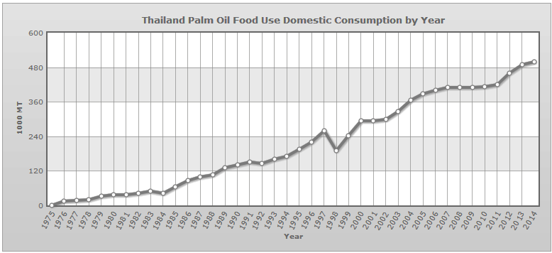
Figure 9: Thailand palm oil food domestic consumption by year (http://www.usda.gov)

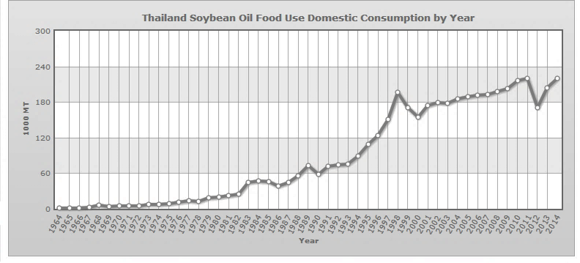
Figure 10: Thailand Soybean oil food domestic consumption by year (http://www.usda.gov)

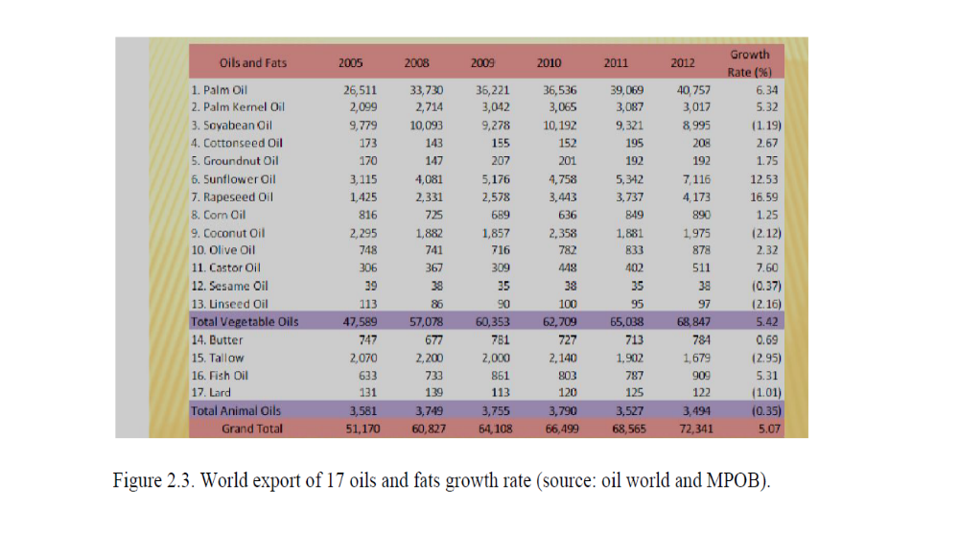
Figure 11: World export of 17 oils and fats growth rate (source: oil world and MPOB).

2.2.1. The chemical structure of oil

Fats and oils are made of building blocks called “triglycerides” resulting from the mixture of one unit of glycerol and three units of fatty acids. They are soluble in most organic solvents but are insoluble in water. The density is lower than water, and may have consistencies at ambient temperature of solid, semisolid, or clear liquid. When they are solid at a normal room temperature, they called as “fats,” and when they are liquid at that temperature, they are called “oils.”(Strayer, 2006).
Triglycerides are the main components of fats and oils. A triglyceride consists of three fatty acids attached to one glycerol molecule. If all three fatty acids are identical, it is a simple triglyceride. The more common forms are the “mixed” triglycerides in which two or three kinds of fatty acids are present in the molecule. Pictures of typical simple and mixed triglyceride molecular structures are shown below.
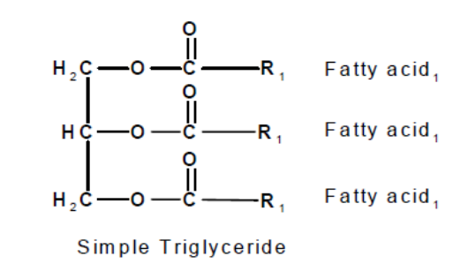
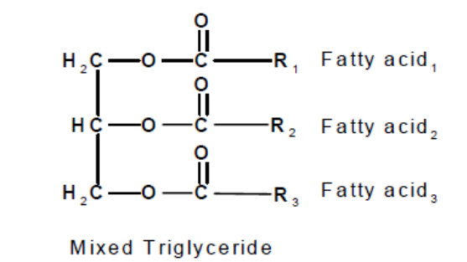

Figure 12: Diagrams of simple and mixed triglycerides (Strayer, 2006).

2.2.2. Palm oil characteristic

Palm oil is extracted from the mesocarp of the fruit of an oil palm. Palm oil is composition of saturated and unsaturated acid that the level of saturated fatty acid is equal to the unsaturated fatty acid. The major component is palmitic acid (44% - 45%,) and oleic acid (39% - 40%), palmitic acid is saturated fatty acid and oleic acid is unsaturated fatty acid and linoleic acid (10% - 11%). The low level of linoleic acid and virtual absence of linolenic acid make the oil relatively stable to oxidative deterioration. The table 1. Shows characteristics of crude palm oil (MPOB’s Regional Office).

Table 6: Identity characteristic of crude palm oil (source MS814: 2007)
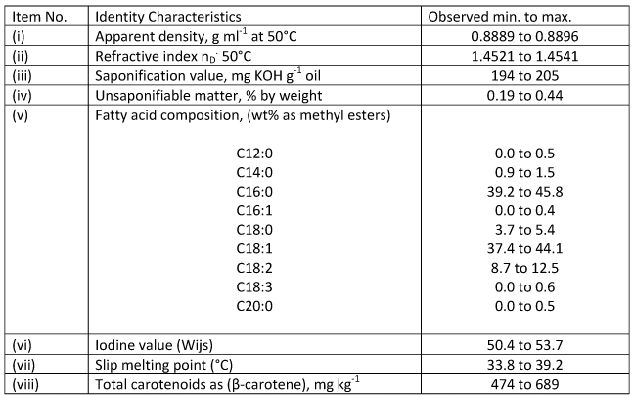

2.2.3. Soybean oil characteristic

Soybean extracted from the seeds of the soybean. It is one of the most widely consumed cooking oils. Soybean oil contains (85% - 88%) unsaturated fatty acid which is oleic, linoleic, and linoleic acid (12%-15%) saturated fatty acids which is mostly palmitic acid (Ribeiro et al., 2009).

2.3. Wastewater

2.3.1 Definition of wastewater

Any water that has been affected in quality by anthropogenic influences is wastewater. It contains liquid waste discharged by industrial, domestic, agriculture and can include the potential contaminants and pollutants. In the most common usage, it refers to the wastewater that contains a wide range of contaminant resulting from the mixing of wastewater from different sources (Chiu, 2012).

2.3. 2 Component of wastewater

In general, wastewater has been produced from agriculture, domestic and industrial sources that contain many contamination and pollutant. These contaminants are required to be properly handled and removed, if the contaminants can cause health problem or effect to environment diversity (Chiu, 2012). The components of wastewater may be divided into four categories:
- Biochemical oxygen demand, total suspended solids and fats, oils and grease
(BOD, TSS, FOG),
- Pathogens (fecal coliform, viruses)
- Nutrients (nitrogen, phosphorus)
- Other chemicals.

2.3.2.1 Organic compound

The organic compound like carbohydrate, protein or fat content can be decomposed by using aerobic microbe. When the organic compound is decomposed, dissolved oxygen in water will be reduced. The organic compound can be determined by measurement of biochemical oxygen demand (BOD). If the wastewater contain high amount of organic compound, BOD is also high, and the wastewater will cause putrid easily (Chiu, 2012).

2.3.2.2 Inorganic compound

Inorganic compound consists of minerals like sulfur or chloride, which are harmful to the living thing and environment when they have in high amount. Inorganic compound originate from a variety of sources in the community including industrial and domestic sources. Most inorganic compounds are relatively stable and cannot be degraded easily by microorganism in wastewater (pollution Control Department Thailand, 2002).

2.3.2.3 Heavy metal and poison

Heavy metals are elements that have density greater than 6 g/cm³; they are one of the most continuous pollutants in wastewater. The continuous of heavy metals in wastewater is due to their non-biodegradable and toxicity nature. Heavy metal and poison can be form of organic or inorganic compound, which can be accumulate in the natural food chains, and be harmful to any organism. Heavy metal and poison mostly caused by pesticide or herbicide for agriculture and wastewater discharged from industries (Akpor et al, 2014).

2.3.2.4 Nutrient

Nutrient is compounds as a raw material for growing and developing of the organism; phosphorus, nitrogen and potassium are primary nutrients. These nutrients have different chemical characteristics: nitrogen is more mobile in the soil, while phosphorus tends to bind to soil particles (University of Minnesota, 2011). When the amount of nitrogen and phosphate are high in wastewater, the algae bloom will be occurred, as a result the dissolved oxygen in water will be reduced for using in the degradation of nutrients or organic compounds, so the reduction of dissolved oxygen will affect the aquatic organisms, and it can cause the lack of oxygen in water (Chiu, 2012).

2.3.2.5 Microorganism

Wastewater covers different types of bacteria, virus, protozoa, algae, fungi etc. Some of these are pathogens to animal life and harmful to the human, some of microorganism uses the oxygen for their living which causes the decreasing of dissolved oxygen in water (Dept, 2010).

4. Type of wastewater

All the water that we use at home and disposed through the drains or into the sewage collection system is wastewater. This includes water from baths, showers, sinks, dishwashers, washing machines, and toilets. Small businesses and industries often contribute large amounts of wastewater to sewage collection systems.
Water pollution is mainly caused by wastewater which is discharged from domestic used, industrial used and agricultural used.

2.4.1. Domestic wastewater

Domestic wastewater is depletion from the residential area, like house or apartment. Usually, it can produce by water from the restroom, food, kitchen and place that use water. Domestic wastewater contains the extreme nutrient that can support the growth of harmful microbe and these groups of microbes can be the disease carriers. Furthermore, domestic wastewater contains the household chemicals like detergent which composes toxicities these toxicities can contaminate the natural water sources (Scott and Tyler, 2010).

2.4.2 Industrial wastewater

Industrial wastewater is a liquid waste that obtained from industrial processes as a result from manufacture, automotive repair, vehicle wash, trade, medical, business, and some, activity that may contain toxic or hazardous constituents (University of Minnesota, 2011).
Wastewater in the food industries obtained the cooking, cooling and boiling process of food production, so the wastewater contain high amount of carbohydrate, oil, fat, protein, and other minerals. Wastewater from industries normally contains several organic compounds, which leads the stream to be turbid and contain high BOD. Moreover, wastewater with high temperature can cause the thermal pollution in water. So the thermal pollution will interrupt the bioprocesses of the living thing, also it can reduce the diversity of aquatic animals and plants in natural water system (Scott and Tyler, 2010).
2.4.3 Agricultural wastewater

One of the activities that can cause the water pollution is agricultural activity. Agricultural wastewater can cause by excessive used of pesticide, fertilizer and herbicide, which contain the toxic compound or high amount in nutrient, and then these compounds have penetrated into underground and polluted the underground water. If agricultural area is closed to the stream, the herbicide, pesticide and fertilizer will be released to the natural stream or irrigation system directly (Scott and Tyler, 2010).

2. 5 Parameters for wastewater quality

2.5.1 Biochemical Oxygen Demand

Biochemical Oxygen Demand or BOD is one of the parameter for water quality it is the quantity of dissolved oxygen consumed by aerobic microorganisms during the microbial and chemical oxidation of the components contained in a wastewater sample during an incubation period at a given temperature. The BOD represents the oxygen utilized during the oxidation of both carbon and nitrogenous compounds (University of Minnesota, 2011).

2.5.2 Fat

Fat is quite sensitive to temperature, it can be solid at 80 ⁰F, and wastewater temperature usually is less than 80 ⁰F. Animal fat in the soil will break down, but it takes four times more energy to break down than other organic substances. Fat is added to the system from clean up, dish washing and cooking, so commercial systems will generally have higher levels of fat than residential systems (University of Minnesota, 2011).

2.5.3 Oils

Vegetable oils are not as sensitive to temperature as fat. It can be broken down through a biological process; it can take 12 times more energy to break down oil than the organic substance. Despite there are many different types oil, but vegetable oil is very popular, normally, vegetable oil use in liquid form, also it can be solid. Table2. Lists several different types of vegetable oils that are commonly used and their physical properties.
Oil has the ability to separate influenced not only by temperature, but also by how the oil was generated and used. Free oil can be easily raised to the wastewater surface and separated when the mixture is allowed to become motionless. Emulsified oil can break down to very small droplets and occurs either by chemical or mechanical action. For example of mechanical emulsification happened when hot water is mixed with the oil. After period time and a decrease temperature, oil can be separated. When detergents or cleaners mix with the oil in water by chemical emulsification, it takes a longer time to separate (University of Minnesota, 2011).

Table 7: Comparison of commonly used vegetable oil (source Wikipedia)
Vegetable oils
Type of oils | Saturated  fatty acids | Mono-  unsaturated  fatty acids | Polyunsaturated fatty acids |  |  | Smoke point
Type of oils | Saturated  fatty acids | Mono-  unsaturated  fatty acids | Total polyunsaturated | linolenic acid  (ω-3) | Linoleic acid  (ω-6) | Smoke point
Canola (rapeseed) | 7.365 | 63.276 | 28.142 | 10 | 10 | 400 °F (204 °C)
Coconut | 91.00 | 6.000 | 3.000 |  | 2 | 350 °F (177 °C)
Corn | 12.948 | 27.576 | 54.677 | 1 | 58 | 450 °F (232 °C)
Cottonseed | 25.900 | 17.800 | 51.900 | 1 | 54 | 420 °F (216 °C)
Flaxseed/Linseed (European) | 7.5 | 15.5 | 79 | 64 | 15 | 225 °F (107 °C)
Olive | 14.00 | 72.00 | 14.00 | 1.5 | 15 | 380 °F (193 °C)
Palm | 49.300 | 37.000 | 9.300 |  | 10 | 455 °F (235 °C)
Safflower | 8.00 | 15.00 | 75.00 |  |  | 410 °F (210 °C)
Soybean | 15.650 | 22.783 | 57.740 | 7 | 50 | 460⁰ F  (238⁰ C)

2.5.4 Grease

Grease is one of the petroleum-based and it can be toxic to a system, grease cannot be broken down because is petroleum based, but it can be separated. Grease comes from soaps, lotion and hair products. Usually, there will be a higher percentage of grease in the FOG from residential systems when compared to most commercial systems. Grease can build up over time, coating components and inhibiting treatment of other constituents in the wastewater (University of Minnesota, 2011).

6 wastewater treatment

The aims of wastewater treatment are: to convert the waste materials present in wastewater into stable oxidized end products which can be safely discharged to inland or coastal waters without any adverse ecological effects; to protect public health; to ensure wastewater is effectively disposed of on a regular and reliable basis without nuisance or offence; to provide an economical method of disposal; and more recently, to recycle and recover the valuable components of wastewater (Gray, 1989).

2.6.1. Unit treatment processes can be classified into five stages:

2.6.1.1 Preliminary treatment:

The removal and disintegration of gross solids, the removal of grit, and the separation of storm-water, oil and grease are also removed at this stage if present in large amount.

2.6.1.2. Primary (sedimentation) treatment:

The first major stage of treatment following preliminary treatment, which are usually involves the removal of settle able solid which are separated as sludge.

2.6.1.3. Secondary treatment:

The dissolved and colloidal organics are oxidized in the presence of microorganisms.

2.6.14. Tertiary treatment:

Further treatment of biologically treated effluent to remove BOD, bacteria, suspended solid, specific toxic compounds or nutrients to enable the final effluent to comply with a standard more stringent than before discharge.

2.6.1.5. Sludge treatment:

The dewatering, stabilization and disposal of sludge.

2.6.2. Methods for wastewater treatment

There are some methods to treatment oil in wastewater, classification of oil waste treatment processes:
Physical method such as carbon adsorption, membrane filtration and using reserve osmosis treatment is very effective to remove dissolved and emulsified oils (Rhee et al, 1983). Another method is to remove oil and grease using skimming tanks which oil and grease is trapped in treatment plants (Gawad, 2014)
The main disadvantage of physical methods is their low efficiency of removal. The remaining oil FOGs causes clogging of pipes in treatment units that need cleaning.

Biochemical method is the usage of enzymes such as lipase and surfactant. In addition, it should be mentioned that the application of these enzymes are recently becoming popular. It has potentially increased more attention due to their effective performance on degradation of vegetable oils (Gawad, 2014).

Biological treatment is effective in degrading dissolved oils and other types of stabilized emulsions which cannot be destabilized by chemical coagulants. However, a biological system is only effective on very weak oil-contaminated wastewaters (Rhee et al, 1983). Bio-extract is a tools that we can use for treatment wastewater, because in bio-extract there are effective microorganisms, bio-extract contains naturally occurring microbes that have ability to reduce biological toxicity in the wastewater as well as remove the foul odor (Higa, 1995). Many microorganisms that are capable of degrading FOGs have been isolated from soil and water samples such as Bacillus, Pseudomonas, Barkholderia, Acinetobacte, Escherichia and fungi they can degraded Olive oil and tributyrin (Matsumiya, 2007). An European company of environmental biotechnology research, using process called bio-fixation which bacteria in granules to degrade almost all industrial and municipal organic pollutants such as FOG from wastewater (Nasr, 2010). The research from Mongkolthanaruk et al. (2002) showed that consortium of 3 bacterial of Bacillus sp., Acinetobacter calcoaceticus and Pseudomonas aeruginosa could be successfully use for lipid-rich wastewater, this research showed reduce the lipid from 3,600 mg/l and 2,100 mg to less than 20 mg/l within 12 days.

2.7. Consortium of bacteria

A consortium is a group of specific microorganisms which has capability to degrade the components present in the wastewater (Dhall et al., 2012). The use of single microorganism may not be sufficient to degrade organic matter. A mixture of microorganism may have an increasing effect on the biomass activity growth efficiency, and enzyme production (Fadile et al., 2011). Fadile showed degrading lipid-rich in wastewater by mixture of bacteria is more efficiently. Kachien’s and Momba (2015), used mixture of three protozoan species, namely Aspidisca sp., Trachelophylum sp. and Peranema sp. to degrade fat and oil in domestic wastewater. This study found protozoan isolates as revealed by low biodegradation of oil. Cipinyte et al., (2009) show mixed culture cultivated of bacteria biodegradation gradually slowed down; however, after 72 hours of degradation by the mixed culture, the concentration of sunflower oil decreased from the initial value of 5.0 to 0.52 g/l (90% of oil was degraded). Bio-extract is mixture of microorganisms, it has potential to degrade oils in wastewater (Chiu, 2012).

2.8. Lipases

Lipases (EC 3.1.1.3) are the most important groups of biocatalysts for biotechnological application. They catalyze the hydrolysis and synthesis of esters from glycerol and long chain fatty acid (Dey et al., 2014). Microorganism have been found produce emulsifying agents or bio-surfactant to help solubilize lipid (Van Dyke et al. 1991). lipolytic enzymes play an important role in the turnover of the water-insoluble compounds, it can break down lipid. Psychrotrophic Gram-negative bacteria, such as Pseudomonas species, pose a significant spoilage problem in refrigerated meat and dairy products due to secretion of hydrolytic enzymes, especially lipases (Hasan et al., 2005). In this research bacteria from bio-extract have shown ability to produce lipase.

Chapter III

Methodology

Materials and methods

In this experiment our sample is commercial bio-extract purchased from Royal project shop.

3.1. Screening and isolation of bacteria

Two ml of bio-extract were add to M9 liquid media which enrichment with 1% (v/v) soybean or 1% (v/v) palm oil. Incubated it for one week at room temperature. The enriched sample were screened for lipid degrading organisms using serial dilution in and spread onto the M9 agar plates and 0.5x PCA plates the recipe is in Appendix A ( 0.5x PCA media is half concentration of normal PCA). Both media enriched with 0.2% (v/v) palm oil or 0.2% (v/v) soybean oil.
Drop plate method and PCA media was used for selecting the biggest clear zone, for this part prepared 0.5x PCB broth for palm oil or soybean oil and PCB for tributyrin. Both 0.5x PCB broth enriched with 0.2% (v/v) palm oil or 0.2% (v/v) soybean oil after that the microorganisms inoculated into them, after 48 hours measured the OD 600 ,(appendix C) then prepared 0.5x PCA media which enrichment with 0.2% (v/v) soybean or 0.2% (v/v) palm oil, also prepare media that contain 1% (v/v) tributyrin as a control, put 10 µl of microorganisms in the enrichment plate. The other method were streak method as a selected best strains of bacteria, for this condition 0.5xPCA media prepared and then the bacteria streak into the plate, finally measured the size of clear zone by Vernier caliper.

3.2. Identification of bacteria

3.2.1. The bacteria screening using Gram stain

Gram’s staining will be used in-order to primarily classify the bacteria. From 48hrs slant cultures, stained the cells using Gram’s stain and observed the colony under the microscope, there were two groups of bacteria gram positive rod shape, and gram negative rod shape.

3.2.2. Biochemical test

To identify the isolated strains, morphological and physiological characteristics will be examined according to the method of “Bergey's Manual of Determinative bacteriology”, the corresponding test were performed according to the dichotomous key as showed in Appendix D and E (1957).

- Oxidase test. (Shields and Chathcart, 2013) The oxidase test is a biochemical reaction that depend on presence of cytochrome oxidase, some of the bacteria can produce an enzyme that called indophenol oxidas (Gabyhe and Free, 1985). For this test soaked a piece of filter paper in 1% Kovaces Oxidase reagent, then use a loop and pick of isolated colony from fresh ( 48hrs) bacteria plate and rub onto filter paper, after that observed the change of the color
- Catalase test. (Reiner, 2013) This test is depend on the presence of catalase, an enzyme that catalysis the release of oxygen from hydrogen peroxide H₂O₂, it is used to differentiate those bacteria that produces an enzyme catalase. The slide method used in this test. Use a loop to transfer a small amount of colony growth in the surface of a clean, dry glass slide. Then added a drop of 3% H₂O₂ in the glass slide, after that observed oxygen bubbles.
- Fermentation of glucose. Reiner, (2013) Carbohydrate fermentation tests detect the ability of microorganism to ferment a specific carbohydrate. During fermentation an organic substrate as a final electron acceptor the end product of carbohydrate fermentation is acid or acid with gas. Fermentation are detected by the color change of a PH indicator when acid product are formed. Phenol red is used as a pH indicator (Vera, 1948).
- Fluorescent diffusible yellow pigment. Talaiekhozani et al.,( 2015) UV fluorescent pigment is characteristic of some strain of Psedomonas spp. But not all Psedomonas spp.
- Na^{+_} required for growth. Shields and Tasang, (2013) the optimum NaCl concentration to growing for Aeromonas is 0-4 % (Harf-Monteil et al, 2004). In this experiment the PCA media enriched with 7% NaCl.
- Oxygen required to growth. Eddleman, (1999) There are three groups bacteria for oxygen required to growth, some group are aerobic bacteria, these groups of bacteria use oxygen to growing the other groups can grow without oxygen, and the third groups are facultative bacteria these group of bacteria; If oxygen is available can grow with oxygen but if there were not oxygen they can use the other source of electron. For this part the deep tub was preferred.
- Voges-proskauer (VP). McDevitt, (2013) The Voges-Proskauer test determines the capability of some organisms to produce non acidic or neutral end products, such as acetyl methyl carbinol, from the organic acids that result from glucose metabolism. M9p16y and M9p8y inoculated to VP broth, incubated for 24 hours at 37⁰ C. the result show after add 2-3 drops Barritt's reagent, is a mixture of alcoholic a-naphthol and 40% potassium hydroxide solution. A deep cherry color in the culture after adding the Barritt’s reagent is positive result.

- Motility test. Motility. Shield and Cathcart, (2013) Test medium is used to determine the motility of microorganisms. Motility in bacteria can be provided by a variety of mechanisms, but the most common involve flagella (Jarrell et al, 2008).
- Gelatin hydrolase by bacteria. Edison and Martin, (2013) Gelatin hydrolysis detects the presence of gelatinases. Gelatinases are proteases secreted extracellularly by some bacteria which hydrolyze or digest gelatin
- Starch hydrolase test. Lal and Cheeptham, (2013) the bacteria inoculated to the starch agar for 72 hours at 37⁰C. The negative result showed the purple color by poured the iodine on the plate and positive result show the clear zone with iodin.
- Arginine dihydrolase. Himedia, (2015) the purpose of this test is to see if the microbes can use the amino acid arginine as a source of carbon and energy for growth. Bromo cresol purple is the pH indicator which forms purple color in alkaline condition. Color change from purple to yellow and then back to purple is positive reaction.

3.3. Enzyme activity

3.3.1. Preparation of crud enzyme extract

The lipase assay was carried out according the method of titration, modified from Dey et al, (2014), using palm oil as a substrate at 30⁰ C.
The bacteria were grown in Erlenmeyer with 50 ml of 0.5x PCB media contain 1% (v/v) palm oil as substrate, the flasks incubated in shaker incubator with 120 rpm at 30⁰ C for 24 hours. Then the cell harvested by centrifugation at 5000 for 15 minute. The supernatant was stored at -20⁰ C for enzyme activity.

3.3.3. Lipase assay

The bacterial culture supernatant were centrifuged at 5000 for 15, then add 1ml of 0.1M Tris-HCl buffer (pH 8), 50mM KCl, 200 µl Tween 80, 1 ml palm oil and 1 ml of culture supernatant, mixed well on shaker incubator with 60 rpm for 3 hours at 30⁰ C. Then added 3 ml ethanol, the mixture was shaken vigorously to stop the enzyme reaction and the emulsion break down, after that the titration was done with 10 mM NaOH, using phenolphthalein indicator. One unit of lipase activity was amount of enzyme required to liberate 1 µM equivalent of free fatty acid per minute. Specific activity was as units of lipase activity per milligram protein. Specific activity was measured by using following formula.

$$\text{Specific activity=}\frac{\text{(ml titrant ÷min) ×molarity of titrant ×1000}}{\text{Amount of protein ÷1000 (mg)}}$$

3.3.4. Protein assay

Protein assay was determined following the method of Bradford (1976). Using the BSA protein to made standard curve, information used for calculating enzyme specific activity. The figure of standard curve shows in Appendix F.

Chapter IV

Result and discussion

4 .1. Screening and isolation of bacteria

The bacteria isolation was carried out, 30 strains were isolated, 18 strains were from enrichment M9 media and 12 strains were from enrichment 0.5x PCA media that made clear zone, these were included 15 strains of bacteria and 15 strains of yeast. The result of Statistical Analysis System (SAS), illustrates that 15 strains of bacteria showed significant difference (P< 0.05) in the ability to degrade three kinds of oil, (palm oil, soybean oil or tributyrin) according to the size of clear zone. All of the bacteria can degrade tributyrin, but 8 of them have ability to degrade palm oil. The bacteria showed the ability to degrade palm oil better than soy bean oil. The result of clear zone showed in table 3. According to the statistics analysis, bacteria degrade palm oil better than soybean because most of bacteria degrade palm oil. In general, the bacteria showed the ability to degrade palm oil better than soy bean oil; it depends on the structure of different type of oil. Tributyrin has a simple structure of butyric acid and glycerol, so the bacteria can hydrolysis it easier than other oil. The other oil which was used in this experiment was palm oil and soybean oil. The 8 of the bacteria could degrade palm oil and 7 strains can degrade soybean oil, depending on what kind of lipase which was produced by bacteria. They can degrade palm oil better, because the major component of palm oil; palmitic acid (44% - 45%), and oleic acid (39% - 40%), palmitic acid is saturated fatty acid and oleic acid is unsaturated fatty acid with linoleic acid (10% - 11%), but soybean oil contains (85% - 88%) unsaturated fatty acid which is oleic, linoleic, and linoleic acid (12%-15%) saturated fatty acids.
The bacteria which isolated from bio-extract categories in three groups in drop plate method, the first groups include, Pcp3y, Pcp16y, M9p10yy, M9p5y, M9p16y, M9p15y, M9p8y, in palm oil, they are the same to degrade palm oil, and M9p16y, Pcp16y, Pcp17y M9p5y and M9p8y in soybean oil according the size of clear zone are the same, these bacteria make biggest size of clear zone in palm oil and soybean oil.
The second groups of bacteria include, M9p10yy, M9p15y in soybean, and Pcp17y in palm oil, are the same to degrade oils. The size of clear zone is not significant different. But the size of clear zone less than first groups.
The third groups of bacteria include, M9p10ycs, M9p10ycb, Pcp4y, M9p3y, M9p4y, Pcp5y, and M9p8w2 in both oils are the same to degrade oils. The third groups of bacteria did not degrade oils.

The second method which was used to compare the size of clear zone is streak method, the result of statistical analyses showed the bacteria categories in two groups. According to this method the bacteria which degraded palm oil and soybean oil is the same bacteria which degrade in drop plate method, such as, M9p10yy, M9p5y, M9p16y, M9p15y, M9p8y, Pcp16y, and Pcp17y that can confirm drop plate method.
As a result 8 strains degrade palm oil in drop plate method, 7 strains degrade soybean oils in drop plate method, and 13 strains degrade palm oil in streak method. 7 strains degrade soybean oil in streak method. Bacteria in streak method degrade better than drop plate method, in streak method the number of bacteria is not defined but in drop plate method the number of bacteria is defined. The bacteria which degrade in drop plate method are common in streak plate method such as M9p8y, M9p16y, Pcp16y, M9p15y, M9p10yy, Pcp17y, and M9p5y.
M9p5y make biggest clear zone in soybean oil (0.14 ± 0.06 cm) and palm oil (0.19 ± 0.06 cm) in drop plate method; it also makes clear zone in streak method but the size of clear zone is less than drop plate method. Pcp16y is the other strain that make big size clear zone in palm oil (0.18 ± 0.02 cm) and soybean oil (0.13 ± 0.04 cm). M9p10yy degrade palm oil (0.16 ± 0.03 cm) better than soybean oil (0.02 ± 0.01 cm) (the smallest size of clear zone). M9p16y is the other strain that degrade palm oil (0.13 ± 0.06 cm) and soybean (0.14 ± 0.01cm) efficiently, M9p8y also is the same M9p16y, it degraded palm oil (0.14 ± 0.05 cm) and soybean oil (0.12 ± 0.03 cm). M9p15y degrade palm oil (0.15 ± 0.00 cm) and soybean oil (0.03 ± 0.00 cm) in drop plate method and streak method (0.06 ± 0.01cm). Pcp17y degrade palm oil (0.06 ± 0.00 cm) and soybean oil (0.14 ± 0.02 cm) this strain degrade soybean oil better than palm oil. Pcp5y, M9p8w2, M9p4y, Pcp3y and M9p3y degrade palm oil but they did not degrade soybean oil efficiently. These strains degrade palm oil in streak method. It means the lipase that these strains produced have the ability to degrade palm oil due to the structure of palm oil. So, 7 strains showed the best ability to degrade palm oil and soybean oil in both methods, namely M9p5y, M9p16y, M9p8y, M9p10yy, M9p15y, Pcp17y, and Pcp16y.
In previous research, bio-extract showed the ability to reduce amount of oil and grease 77.2% in wastewater of shopping malls (Chiu, 2012). The other research showed the bacteria which isolated from soil, such as Bacillus, Pseudomonas, Burkholderia, Acinetobacte, Escherichia and fungi can degraded Olive oil and tributyrin (Matsumiya et al., 2007). In this research the 47% bacteria from bio-extract produce lipase to degrade palm oil and soybean oil. 100% of bacteria shown the ability to degrade tributyrin. In future studies, it is recommended to study degrading different oils with yeast from bio-extract, because during this research the yeasts have shown good ability to degrade different oils.

Table 8: The size of clear zone for 0.5x PCA + (0.2% v/v) Palm oil and 0.5 PCA + (0.2% v/v) Soybean oil and 0.5x PCA + Tributyrin (1% v/v) in streak method and drop method

0.5 PCA + Palm oil |  |  | 0.5 PCA + Soybean oil |  | 0.5 PCA + Tributyrin
Name | Streak method | Drop method | Streak method | Drop method | Drop method | Streak method
Name | size of clear zone (cm) | size of clear zone (cm) | Size of clear zone (cm) | Size of clear zone (cm) | Size of clear zone (cm) | Size of clear zone (cm)
1.m9p8y | 0.13±0.00^{bc} | 0.14±0.05^{becd} | 0.09±0.02^{gefhd} | 0.12±0.03^{bc} | 0,256±0.044 | 0.17±0.01
2.m9p16y | 0.12±0.02^{ecd} | 0.13±0.06^{bc} | 0.08±0.01^{gfh} | 0.14±0.01^{bc} | 0.188±0.035 | 0.21±0.03
3.pcp16y | 0.06±0.00^{gih} | 0.18±0.02^{ab} | 0.09±0.01^{gefhd} | 0.13± 0.04^{bc} | 0.125±0.035 | 0.21±0.02
4.m9p15y | 0.07±0.02^{gih} | 0.15±0.00^{bc} | 0.06±0.01^{gifh} | 0.03±0.00^{d} | 0.138±0.018 | 0.19±0.01
5.pcp17y | 0.07±0.00^{gefh} | 0.06±0.00^{d} | 0.10±0.01^{gefcd} | 0.14±0.02^{bc} | 0.363±0.035 | 0.28±0.03
6.m9p5y | 0.08±0.02^{bc} | 0.19±0.06^{bc} | 0.11±0.05^{efcd} | 0.14±0.06^{bc} | 0.219±0.062 | 0.24±0.03
7.m9p10yy | 0.06±0.02^{gih} | 0.16±0.03^{bc} | 0.04±0.01^{gefhd} | 0.02±0.01^{d} | 0.187±0.035 | 0.14±0.00
8.m9p10ycs | 0.00±0.00^{j} | 0.00±0.00e | 0.00±0.00^{j} | 0.00±0.00e | 0.15±0.035 | 0.12±0.08
9.m9p10ycb | 0.00±0.00^{j} | 0.00±0.00e | 0.00±0.00^{j} | 0.00±0.00e | 0.15±0.017 | 0.3±0.16
10.pcp5y | 0.17±0.00^{abc} | 0.00±0.00e | 0.00±0.00^{j} | 0.00±0.00e | 0.20±0.08 | 0.17±0.00
11.m9p8w2 | 0.17±0.00ª | 0.00 ±0.00e | 0.00±0.00^{j} | 0.00±0.00e | 0.37±0.21 | 0.19±0.06
12.m9p4y | 0.15±0.02^{ab} | 0.00±0.00e | 0.00±0.00^{j} | 0.00±0.00e | 0.36±0.018 | 0.24±0.00
13.pcp4y | 0.03±0.09^{ij} | 0.00±0.00e | 0.00±0.00^{j} | 0.00±0.00e | 0.26±0.00 | 0.2±0.08
14.pcp3y | 0.08±0.02^{ih} | 0.21±0.00ª | 0.00±0.00^{j} | 0.00±0.00e | 0.27±0.03 | 0.15±0.02
15.m9p3y | 0.05±0.06^{gefcd} | 0.00±0.00e | 0.00±0.00j | 0.00±0.00e | 0.28±0.035 | 0.22±0.00
Note: the bacteria categories in different methods (streak method and drop plate method) according to Statistical Analysis System

4.2. Identification of selected bacteria

4.2.1. Gram staining

Slant cultures were taken after 48 hours, the stained cells used Gram’s stain and observed the colonies under the microscope. The selective bacteria were consisted of two groups, gram positive, rod shapes, and gram negative, rod shape. M9p10yy, M9p5y and Pcp16 were gram positive rod shape and M9p16y, M9p8y, Pcp17y and M9p15y were gram negative rod shape.

4.2.2. Biochemical test

The biochemical test was carried out according to the guide line from Bergey’s manual of determinative bacteriology (University of Idaho). The table 4. Shows biochemical characteristic of bacteria.

Table 9: Biochemical characterization of seven isolated bacteria from bio-extract
Test | M9p5y | Pcp16y | M9p10yy | M9p16y | M9p8y | M9p15y | Pcp17y
Gram test | + Rod | + Rod | + Rod | - Rod | - Rod | - Rod | - Rod
Oxidase | - | - | - | + | + | + | +
Catalase | + | + | + | + | + | + | +
VP | na | na | na | + | + | na | na
Glucose | - | - | - | + | + | - | -
Motility | - | - | - | - | - | + | +
Gelatin | - | - | - | - | - | - | -
Arginine | na | na | na | na | na | - | -
Spore | - | - | - | - | - | - | -
Na⁺ required | na | na | na | - | - | na | na
Oxygen require | + | + | + | + | + | + | +
Fluorcent | na | na | na | na | na | - | -
Starch | + | + | + | na | na | + | +
Note: + positive reaction, - negative reaction, na, not analyzed

In this study, seven strains of bacteria selected and identification was carried out, for more identification, molecular identification is necessary. Physical and biochemical test was carried out to identify bacteria, as a result it showed these bacteria categorized in three groups, the first groups (M9p5y, Pcp16y, and M9p10yy) are gram positive and rod shapes bacteria which might be Corynebacterium spp, because as a result it shows this genus of bacteria are non-motile and straight to slightly, they widely distributed in different ecological such as soil, vegetables, sewage, and skin (Burkovski, 2008). The other groups (M9p8y, and M9p16y) might be belong to the Aeromonas spp. because of their characteristics, they are gram negative, rod shapes and fermented glucose; the other characteristic that made it different from other groups is that they can grow in 0% NaCl but did not grow in 7% NaCl and also is VP positive, they are found in aquatic environment (Abbott et al., 2003). The third groups of bacteria are M9p15y and Pcp17y, accordingly the biochemical test results show these groups of bacteria might be Pseudomonas spp. the genus Pseudomonas is gram negative rod shape, and aerobic that are wide-spread throughout nature and ecologically significant they are found in soil, fresh water, and marine environments and in plant (.Ugur et al., 2012). There are some species of Pseudomonas exhibit activity of bioremediation and biocontrol agents in seawater (Tripathy et al., 2006). The aerobic degradation of FOGs in wastewater by active microbial cultures is a common and one of the most efficient practices of biological treatment (Cipinyte et al., 2009).

3. Growth curve

The figure 5, 6, and 7. Showed the growth curve of the 7 strains of selected bacteria. These figures showed the bacteria have the highest growth in the 0.5x PCA media + 1% (v/v) palm oil. It might be dependent on the structure of palm oil; the main fatty acid in palm oil is palmitic acid (44% - 45%), and oleic acid (39% - 40%), it might be broken down ester bond between glycerol and palmitic acid and use it as carbon source which is easier than the other fatty acid. And the kind of lipase which bacteria produce. According to these figures the bacteria in 24 hours can produce lipase for lipase assay as a research showed.

Figure 13: Growth curves of selected bacteria in PCB broth + soybean oil.

Figure 14: Growth curves of selected bacteria in PCB broth + palm oil.

Figure 15: Growth curves of selected bacteria in PCB broth + soybean & palm oil

4.4. Lipase activity

The crude enzyme was extracted and enzyme specific activity was carried out after overnight and 24 hours, as the result showed in 24 hours bacteria have better lipase specific activity; the result of overnight enzyme specific activity showed in Appendix H. The result of 24 hours shows seven strains produced lipase; statistical analyses system shown all of seven strains which are not significantly different, they have ability to produce lipase. The figure 8. Shows the result of enzyme specific activity, the maximum of enzyme activity is (0.27 ± 0.05 U/ml). In previous research by Cypinyt (2009), shown the bacteria isolated from the environment polluted with various lipid have potential to lipase activity, the best lipase activity was from Enterobacter aerogenes and Arthrobacter sp it was 1.87 u/ml after 24 hours. Tanasupawat et al., (2015) shows the Lactic acid bacteria from fermented meet has lipase activity in tween 80 (0.938±0.127 U/ml). The condition of Lactic acid bacteria was the same this research; it was at 30°C. In this research M9p5y have shown the best activity to produce lipase (22.66 U/ mg).
The table 5. Shows the amount of protein for 7 strains of selected bacteria, as the table shown the amount of protein in M9p10yy is higher than the other strains (19.11 ± 3.4µg/ml) but enzyme specific activity is (13.94 ± 1.2 u/ mg) despite M9p10yy produced more protein but protein is not lipase because enzyme specific activity is less than another. In this research bacteria from bio-extract have shown the ability to produce lipase. Figure 9. Appendix G shows the standard curve.

Figure 16: Specific activity for seven strains of bacteria

Table 10: Average amount of protein and enzyme specific activity for seven strains of bacteria
Name | Average amount of protein (µg/ml) | Average of enzyme specific activity (u/ mg) | Average of enzyme activity (u/ml)
m9p10yy | 19.11 ± 3.4 | 13.94 ± 1.2 | 0.27 ± 0.05
m9p8y | 17.90 ± 1.2 | 12.57 ± 4.2 | 0.23 ± 0.08
m9p16y | 14.17 ± 0.9 | 18.86 ± 4.0 | 0.26 ± 0.04
pcp17y | 18.06 ± 8.2 | 13.58 ± 4.2 | 0.22 ± 0.02
m9p15y | 15.81 ± 1.6 | 13.88 ± 2.4 | 0.22 ± 0.01
m9p5y | 12.14 ± 6.8 | 22.66 ± 5.9 | 0.25 ± 0.09
pcp16y | 18.13 ± 3.3 | 14.35 ± 2.7 | 0.26 ± 0.04

Chapter V

Conclusion

Thirty candidate colonies were isolated from M9 and 0.5x PCA media enriched by bio-extract, 15 strains were bacteria. These bacteria degrade tributyrin, 7 strains including M9p8y, M9p16y, Pcp16y, M9p15y, M9p10yy, Pcp17y, and M9p5y selected as the best bacteria, due to the size of clear zone to degrade palm oil and soybean oil. The result obtained from this study shows that all of them produce enzyme. The highest lipase specific activity is (22.66 ± 5.9 u/mg) and the lowest is (12.57 ± 4.2 u/mg). These bacteria from bio-extract has proved to have potential to use for degrading of palm oil and soybean oil in wastewater.

References

Akpor O. B., Ohiobor G. O., Olaolu T. D., (2014), Heavy metal pollutants in wastewater effluents: Sources, effects and remediation, Advances in Bioscience and Bioengineering. Vol. 2, No. 4, 2014, pp. 37-43.

Abbott S. L., Chunge W. K., and Janda J. M, (2003), The Genus Aeromonas: Biochemical Characteristics, Atypical Reactions, and Phenotypic Identification Schemes, J Clin Microbiol; 41(6): 2348–2357.
Anonymous, (1957), Bergey's Manual of Determinative Bacteriology: [online], Available at: https://archive.org/details/bergeysmanualofd1957amer, (cited July 20, 2015)
Anonymous, (2008), Corynebacteria: Genomics and Molecular Biology. [ed.] Burkovski A. Erlangen : Caister Academic Press, 2008. 978-1-904455-30-1.
Anonymous, (2015), Aeromonas. [ed.] Graf J., Norfolk, UK, Caister Academic Press. 230. ISBN: 978-1-908230-56-0.
Anonymous, (2015), Himedia Arginine Dihydrolase Broth, Available at: www.vumicro.com/vumie/help/vumicro/Arginine_dihydrolase_Tes, (cited July 25, 2015)
Anonymous, (2015), University of Idaho, [online], Available at: https://www.uiweb.uidaho.edu/.../IDFlowcharts.pdf, (cited May 16, 2015)
Bradford MM.,(1976), A rapid and sensitive method for quantion of microgram quantities of protein utilizing the principle of protein-day binding. Anal Biochem 72: 248-254.
Bunchoo, M., (2002), the Study of Microorganism Isolated From EM. Bachelor Degree Thesis. Assumption University, Thailand.
Cammarota M.C, Freire D.M.G, (2006), A review on hydrolytic enzymes in the treatment of wastewater with high oil and grease content, Bioresource Technology 97, 2195–2210
Che Man, YB; Liu, J.L.; Jamilah, B.; Rahman, R. Abdul (1999). "Quality changes of RBD palm oil, soybean oil and their blends during deep-fat frying". Journal of Food Lipids 6 (3): 181–193. doi:10.1111/j.1745-4522.1999.tb00142.x.
Čipinytė V., Grigiškis S. , Baškys E., (2009), Selection of fat-degrading microorganisms for the treatment of lipid-contaminated environment, 55. No. 3–4. P. 84–92
Chiemchaisri C., Jaitrong L., Honda R., Fukushi K., and Yamamoto K., (2001), Application of Photosynthetic Bacteria Treatment System for Recovery of Organic Carbon from Noodle Processing Wastewater
Chiu P., (2012), the treatment of community wastewater using local bio-extract at laboratory scale: case studies in wastewater from food industries and shopping malls, Bachelor Degree Thesis, Assumption University in Thailand.
Dept, (2010), The effect of using microorganisms on sludge reduction in wastewater treatment plant, Fourteenth International Water Technology Conference, IWTC 14 2010, Cairo, Egypt.
Dey A., Chattopadhaya A., Mukhopadhyay S. K., Saha P., and Chatterjee S., (2014), Production, partial Purification and characterization of extracellular psychrotrophic lipase from pseudomonas sp. ADT3. 2155-6199.1000242.

Dhall P., Kumar R., and Kumar A., (2012), Biodegradation of Sewage Wastewater Using Autochthonous Bacteria, Scientific World Journal 861903.

Edison T. and Martin J., (2013), ASM Microbelibrary, Gelatin Hydrolysis Test Protocol, available at: http://www.microbelibrary.org/library/laboratory-test/3776-gelatin-hydrolysis-test-protocol, (cited July 24, 2015)

Eddleman H., (1999), Oxygen Requirements of Bacteria: [online], Available at: http://www.disknet.com/indiana_biolab/b061.htm, (cited July 24, 2015)

Erdem B., Karipta E., Elif C., Isik K., (2009), Biochemical identify cation and numerical taxonomy of Aeromonas spp. isolated from food samples in Turkey, 10.3906/biy-0904-11.

Fadile A., Hassani F. Z., Halah A., Merzouki M., and Benlemlih M., (2011), Aerobic treatment of lipid-rich wastewater by a bacterial consortium, 5333-5342.
Graf J. (2015). Aeromonas. Caister Academic Press. Norfolk, UK: Caister Academic Press. 230. ISBN: 978-1-908230-56-0 (ebook, publication April 2015).
Gaby, W. L., and L. Free., (1958), Differential diagnosis of pseudomonas-like microorganisms in the clinical laboratory. J. Bateriol. 76:442–444.
Gawad H.S., (2014), Oil and Grease Removal from Industrial Wastewater Using New Utility Approach, Advances in Environmental Chemistry, Article ID 916878, 6 pages.
Gray N. F., (1989), Biology of wastewater treatment, Oxford University Press, ISBN: 0198590148, 9780198590149 [online], available at: https://books.google.co.th/books/about/Biology_of_wastewater_treatment.html: (cited May 11, 2015).
Harf-Monteil C, Fleche AL, Riegel P, Prevost G, Bermond D, Grimont PA, Monteil H. (2004) Aeromonas simiae sp. nov. Isolated from monkey faeces. International Journal of Systematic and Evolutionary Microbiology; 54: 481-485.
Hasan F., Shah A. A., Hameed A.,(2005), Industrial applications of microbial lipases, Enzyme and Microbial Technology 39, 235–251
Husain I.A.F., alkhatib M.F., Jammi M.S., Mirghani M.E.S., Zainudin Z.B., Hoda A., (2014), problems, control, and treatment of fat, oil and grease. J.oleo Sci, 63, (8) 747.
Higa T., and Okuda A,(1995), Purification of Wastewater with Effective Microorganisms and its Utilization in Agriculture, University of the Ryukyus, Okinawa, Japan
Jeremiah D., Japareng L.N., (2014), Biodegradation of vegetable oil by Microorganism, International Journal of Scientific and Research Publications, Vol 4, N 3, P 87
Jun Yoon S., Jaie Choi Y. Ki Mint H., Keun Cho K., Wook Kim J., Cheol Lee’ S and Hoo Jung Y, (1996), Isolation and identification of phytase-producing bacterium, Enterobacter sp. 4, and enzymatic properties of phytase enzyme, Suweon 441-744, Republic of Korea
Kamla N., Limpinuntana V., Ruaysoongnern S. and W Bell2 R., (2007), Role of Microorganisms, Soluble N and C Compounds in Fermented Bio-Extract on Microbial Biomass C, N and Cowpea Growth. J. 35(4) : 477-486, 478.
Kachieng’a L.O & Momba M. N. B., (2015), Biodegradation of Fats and Oils in Domestic Wastewater by Selected Protozoan Isolates, Water Air Soil Pollut 226: 140. DOI 10.1007/s11270-015-2405-7.
Khalid K., (2011), An overview of lactic acid bacteria, International Journal of Biosciences (IJB), ISSN: 2220-6655 (Print) 2222-5234
Kyan T., Shintani M., Kanda S., Sakurai M., Ohashi H., Fujisawa A., (1999), Kyusel nature farming and technology of Effective Microorganisms, Asia Pacific Natural Agriculture Network (APNAN).
Lal A. and Cheeptham N., (2013), ASM Microbelibrary, Starch Agar Protocol, http://www.microbelibrary.org/library/laboratory-test/3780-starch-agar-protocol
Martone-Rocha S.,. Piveli R. P., Matte G. R ´, M. C. Do´ ria, M. Dropa, M. Morita, F. A. eternella and M. H. Matt, (2010), Dynamics of Aeromonas species isolated from wastewater treatment system, 01246-904 Sa˜ o Paulo SP, Brazil.

Matsumiya Y, Wakita D, Kimura A, Sanpa S, Kubo M,(2007), Isolation and characterization of a lipid-degrading bacterium and its application to lipid-containing wastewater treatment. J Biosci Bioeng;103(4):325-30.
Minnesota, (2011), Wastewater Treatment Plant Endocrine Disrupting Chemical Monitoring Study, Minnesota pulsation control agency, section 5.

McDevitt S., (2013), ASM Microbelibrary, Methyl Red and Voges-Proskauer Test Protocols, http://www.microbelibrary.org/component/resource/laboratory-test/3204-methyl-red-and-voges-proskauer-test-protocols
Mongkolthanaruk W., Dharmsthiti S., (2002), Biodegradation of lipid-richwastewater by a mixed bacterial consortium, International Biodeterioration & Biodegradation 50, 101 – 105
MPOB’s Regional Office, (2015), official palm oil information source,[online], Available at: http://www.palmoilworld.org/index.html
Noisopa C., (2010), Effects of Bio-Extracts on the Growth of Chinese Kale, Kasetsart J. (Nat. Sci.) 44: 808 – 815, 808
Nitsuwat S. Sanjaya S. Wiratthikowit S. Kunathigan V., (2012), The study of the biodiversity in local bio-fermented solution and the treatment of community wastewater at laboratory scale: wastewater from restaurants, The 25th Annual Meeting of the Thai Society for Biotechnology and International Conference.

Office of Wastewater Management, (2004), Environmental Protection, United States, EPA 832-R-04-001

Rhee C.H., Martyn P.C. and Kremer J.G., (1983), Removal of oil and grease in oil processing wastewater, Sanitation Districts of Los Angeles County
Pollution Control Department Thailand, (2002), Domestic waste water and water treatment system, Khurusapha Ladprao printing, Bangkok, Thailand

Reiner K., (2013), ASM Microbelibrary, Catalas teset protocol, available at: http://www.microbelibrary.org/index.php/library/laboratory-test/3226-catalase-test-protocol, (cited July 11, 2015)

Ribeiro, A.P.B., Grimaldi, R., Gioielli, L.A. and Gon Alves, L.A.G., (2009). Zero trans fats from soybean oil and fully hydrogenated soybean oil: Physico-chemical properties and food applications, Food Research International, 42(3), 401–410.
Shields P. and Chathcart L., (2013), ASM Microbelibrary, Oxidase test protocol, available at: http://www.microbelibrary.org/index.php/library/laboratory-test/3229-oxidase-test-protocol, (cited July 11, 2015)

Shields P. and Tsang A. Y., (2013), ASM Microbelibrary, Salt Agar Plates Protocols, available at: http://www.microbelibrary.org/component/resource/laboratory-test/3034-mannitol-salt-agar-plates-protocols, (cited July 15,2015)

Shield P. and Cathcart L., (2013), ASM Microbelibrary, Motility Test Medium Protocol, available at: http://www.microbelibrary.org/library/laboratory-test/3658-motility-test-medium-protocol, (cited July 16, 2015)

Thailand Palm Oil and soybean oil Food Use Domestic Consumption by Year, available at: http://www.indexmundi.com/agriculture/?country=th&commodity=palm-oil&graph=food-use-domestic-consumption (cited August 1, 2015)
Strayer D., (2006), Food Fats and oils, Institute of Shortening and Edible Oils 1750 New York Avenue, NW, Suite 120 Washington, DC 20006 p, 7

Scott E. S. and Tyler M. G., (2010), 13th edition, Environmental Science, Brooks/Cole, Cengage Learning, 20 Davis Belmont, CA 94002-3098, USA

Srisatit T., Chonchanachai S., (2008), Bioextract production using distillery slop as a carbon source for the anaerobic digestion process, DOI 10.1007/s10163-010-0301.

Szymanski N., and Patterson R., (2003), Effective microorganism and wastewater system, Copyright Lanfax Laboratories Armidale NSW Australia.

Szymanski, N., Patterson, R., (2003), Effective Microorganisms (EM) and wastewater systems, ISBN 0-9579438-1- 4 pp 347-354
Talaiekhozani A., Alaee S., Ponraj M., (2015), Guidelines for quick application of biochemical tests to identifyunknown bacteria, AOBR, 2(2) [065-082]
Tanasupawat S., Phoottosavako M., Keeratipibul S., (2015), Characterization and lipolytic activity of lactic acid bacteria isolated from Thai fermented meat, 10.7324/JAPS.2015.50302

Tripathy S., Kumar N., Mohanty S., Samanta M., Mandal RN and Maiti NK., (2006), Characterisation of Pseudomonas aeruginosa isolated from freshwater culture systems. Microbiol. Res. 162:391-396.

Uğur A., Ceylan O., and Aslım B., (2012), Characterization of Pseudomonas spp. from seawater of the southwest coast of Turkey, J. BIOL. ENVIRON. SCI., 6(16), 15-23.
Van Dyke MI, Lee H, Trevors JT. Applications of microbial surfactants ,Biotechnol Adv 1991;9:241–52.

Vera HD.,(1948). A simple medium for identification and maintenance of the gonococcus and other bacteria. J. Bacteriol. 55:531–536.
Zakaria, Z. Gairola, S.,and Shariff N. M, (2010), Effective Microorganisms (EM) Technology for Water Quality Restoration and Potential for Sustainable Water Resources and Management, International Environmental Modelling and Software Society (iEMSs).

Appendix
Appendix A. Media composition
Coomassie Brilliant Blue Solution (100) for protein assay
0.5ug/ul Bovine Serum Albumin
0.15 M NaCl
Table 1. Material for Commassie Brilliant Blue Solution
material | gram
Coomassie Brilliant Blue | 10 mg
95% Ethanol | 5 ml
85% Phosphoric acid | 10 ml
Deionized H₂o | 85 ml

Filter through Whatman No.1 filter paper
Store at 4⁰C.
Procedures
Table 2. Mix of the components and make triplicate tubes.
Tube Number | 0.5ug/ul BSA | 0.15M NaCl | Coomassie Brilliant Blue Solution
1 | 0 | 500 | 1 ml
2 | 10 | 490 | 1 ml
3 | 20 | 480 | 1 ml
4 | 30 | 470 | 1 ml
5 | 40 | 460 | 1 ml
6 | 50 | 450 | 1 ml
7 | 60 | 440 | 1 ml

- Allow to stand 2 minutes at room temperature.
- Determine the A₅₉₅ using a 1 cm pathlength microcuvette(1 ml) and make a standard curve by plotting absorbance at 595 nm versus protein concentration.

Recipe media composition
Table 3. PCB broth media
composition | g/ liter
Casein enzyme | 5
Yeast extract | 2.5
dextrose | 1
water | 1 liter
Note: Adjust the volume up to 1000ml by water.
Autoclave at 121⁰C for 15 mins
Table 4. Phenol Red Glucose broth

Composition | g/ liter
Trypticase | 10
Beef extract | 1
Glucose | 5
Sodium chlorid | 5
Phenol red | 0.025
water | 1 liter
Note: Adjust the volume up to 1000ml by water.
Autoclave at 121⁰C for 15 mins

Table 5. Motility test
Composition | g/ liter
Pancreatic digest of casein | 10
Sodium chloride | 4
Beef Extract | 3
Agar | 4
Triphenyl tetrazolium chloride | 0.5
water | 1 liter
Note: Adjust the volume up to 1000ml by water.
Autoclave at 121⁰C for 15 mins

Table 6. 10 x minimal media (M9 salt)
Composition | g/ liter
Na₂Hpo₄.2H₂o | 75.2
KH₂Po₄ | 30
NaCl | 5
NH₄Cl | 5
Note: Adjust the volume up to 1000ml by water.
Autoclave at 121⁰C for 15 mins

Glucose 40%

1M MgSo₄.7H₂O 24.65 g/100 ml

1 MCaCl₂.2H₂O 14.70 g/100 ml

Table 7. Starch agar
Composition | g/liter
Beef extract | 3
Soluble starch | 10
Agar | 12
Water | 1 liter
Note: Adjust the volume up to 1000ml by water.
Autoclave at 121⁰C for 15 mins

Table 8. Arginine dihydrolase broth
Composition | g/ liter
Peptic digest of animal tissue | 1
Sodium chlorid | 5
Dipotassium hydrogen phosphate | 0.3
L- Arginine | 10
Bromo cresol purple | 0.016
Agar | 3
water | 1 liter
Note: Adjust the volume up to 1000ml by water.
Autoclave at 121⁰C for 15 mins

Table 9. Voges-Proskauer test
Composition | g/ liter
Potassium Phosphate | 5.0
casein | 3.5
Peptone | 5.0
Dextrose | 5.0
Note: Adjust the volume up to 1000ml by water.
Autoclave at 121⁰C for 15 mins

Appendix B. The result of OD 600 for growing curve

Table 10. The growth of selected bacteria in palm oil by OD 600nm
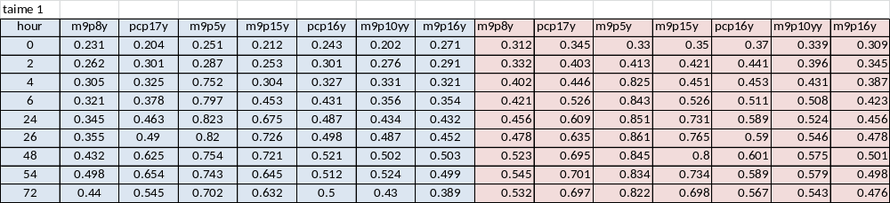
Table 10. The average growth of selected bacteria in palm oil by OD 600nm
time | m9p8y | pcp17y | m9p5y | m9p15y | pcp16y | m9p10yy | m9p16y
0 | 0.27 | 0.27 | 0.29 | 0.28 | 0.31 | 0.27 | 0.29
2 | 0.30 | 0.35 | 0.35 | 0.34 | 0.37 | 0.34 | 0.32
4 | 0.35 | 0.39 | 0.79 | 0.38 | 0.39 | 0.38 | 0.35
6 | 0.37 | 0.45 | 0.82 | 0.49 | 0.47 | 0.43 | 0.39
24 | 0.40 | 0.54 | 0.84 | 0.70 | 0.54 | 0.48 | 0.44
26 | 0.42 | 0.56 | 0.84 | 0.75 | 0.54 | 0.52 | 0.47
48 | 0.48 | 0.66 | 0.80 | 0.75 | 0.56 | 0.54 | 0.50
54 | 0.52 | 0.68 | 0.79 | 0.69 | 0.55 | 0.55 | 0.50
72 | 0.49 | 0.62 | 0.76 | 0.67 | 0.53 | 0.49 | 0.43

Table 11. The growth of selected bacteria in soybean oil by OD 600nm
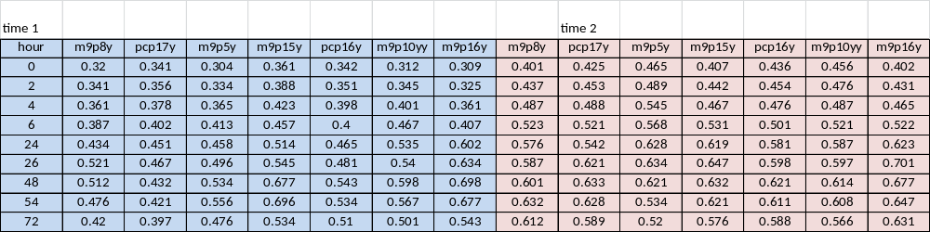

Table 12. The average growth of selected bacteria in soybean oil by OD 600nm
time | m9p8y | pcp17y | m9p5y | m9p15y | pcp16y | m9p10yy | m9p16y
0 | 0.3605 | 0.383 | 0.3845 | 0.384 | 0.389 | 0.384 | 0.3555
2 | 0.389 | 0.4045 | 0.4115 | 0.415 | 0.4025 | 0.4105 | 0.378
4 | 0.424 | 0.433 | 0.455 | 0.445 | 0.437 | 0.444 | 0.413
6 | 0.455 | 0.4615 | 0.4905 | 0.494 | 0.4505 | 0.494 | 0.4645
24 | 0.505 | 0.4965 | 0.543 | 0.5665 | 0.523 | 0.561 | 0.6125
26 | 0.554 | 0.544 | 0.565 | 0.596 | 0.5395 | 0.5685 | 0.6675
48 | 0.5565 | 0.5325 | 0.5775 | 0.6545 | 0.582 | 0.606 | 0.6875
54 | 0.554 | 0.5245 | 0.545 | 0.6585 | 0.5725 | 0.5875 | 0.662
72 | 0.516 | 0.493 | 0.498 | 0.555 | 0.549 | 0.5335 | 0.587

Table 13. The growth of selected bacteria in palm oil & soybean oil by OD 600nm
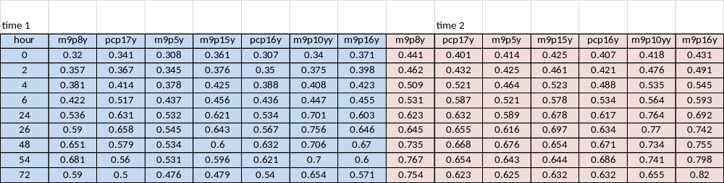
Table 14. The average growth of selected bacteria in palm oil & soybean oil by OD 600nm
time | m9p8y | pcp17y | m9p5y | m9p15y | pcp16y | m9p10yy | m9p16y
0 | 0.3805 | 0.371 | 0.361 | 0.393 | 0.357 | 0.379 | 0.401
2 | 0.4095 | 0.3995 | 0.385 | 0.4185 | 0.3855 | 0.4255 | 0.4445
4 | 0.445 | 0.4675 | 0.421 | 0.474 | 0.438 | 0.4715 | 0.484
6 | 0.4765 | 0.552 | 0.479 | 0.517 | 0.485 | 0.5055 | 0.524
24 | 0.5795 | 0.6315 | 0.5605 | 0.6495 | 0.5755 | 0.7325 | 0.6475
26 | 0.6175 | 0.6565 | 0.5805 | 0.67 | 0.6005 | 0.763 | 0.694
48 | 0.693 | 0.6235 | 0.605 | 0.627 | 0.6515 | 0.72 | 0.7125
54 | 0.724 | 0.607 | 0.587 | 0.62 | 0.6535 | 0.7205 | 0.699
72 | 0.672 | 0.5615 | 0.5505 | 0.5555 | 0.586 | 0.6545 | 0.6955

Appendix C. The result of OD for selecting bacteria according the size of clear zone

Table 15. Result from OD 600 48 hour’s
name | soybean | palm | PCB T
pcp5y | 0.483 | 0.398 | 0.218
pcp17y | 0.433 | 0.136 | 0.183
m9p10yy | 0.406 | 0.159 | 0.237
m9p10ycs | 0.346 | 0.159 | 0.234
pcp4y | 0.291 | 0.207 | 0.388
m9p10ycb | 0.291 | 0.135 | 0.257
m9p5y | 0.269 | 0.027 | 0.234
m9p8w2 | 0.262 | 0.085 | 0.217
m9p8y | 0.248 | 0.267 | 0.298
m9p15y | 0.203 | 0.121 | 0.189
pcp3y | 0.17 | 0.507 | 0.132
m9p3y | 0.169 | 0.426 | 0.247
m9p16y | 0.169 | 0.155 | 0.27
pcp16y | 0.134 | 0.119 | 0.284
m9p4y | 0.122 | 0.146 | 0.176

Appendix D. The result of SAS

Table 16. The Statistical Analysis System (SAS) of the differentiation of 15 strains of bacteria
Source | DF | Type III SS | Mean Square | F Value | Pr > F
mo | 14 | 0.25241059 | 0.01802933 | 47.30 | <.0001
oil | 1 | 0.03574719 | 0.03574719 | 93.78 | <.0001
mo*oil | 14 | 0.06739240 | 0.00481374 | 12.63 | <.0001
test | 1 | 0.00000263 | 0.00000263 | 0.01 | 0.9341
mo*test | 14 | 0.06683832 | 0.00477417 | 12.52 | <.0001
oil*test | 1 | 0.00014465 | 0.00014465 | 0.38 | 0.5402
mo*oil*test | 14 | 0.08472920 | 0.00605209 | 15.88 | <.0001

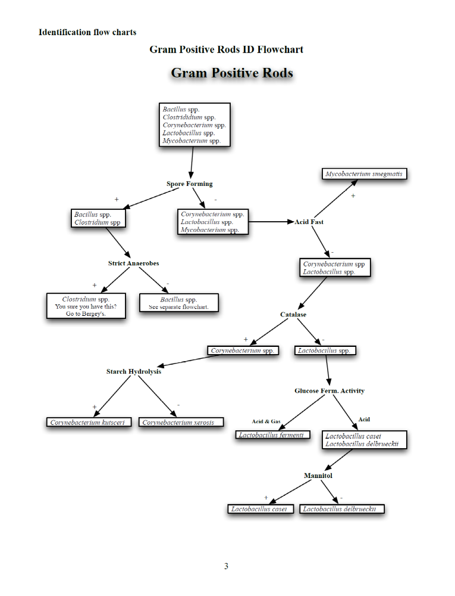
Appendix E. Flowchart

Appendix F: Flowchart

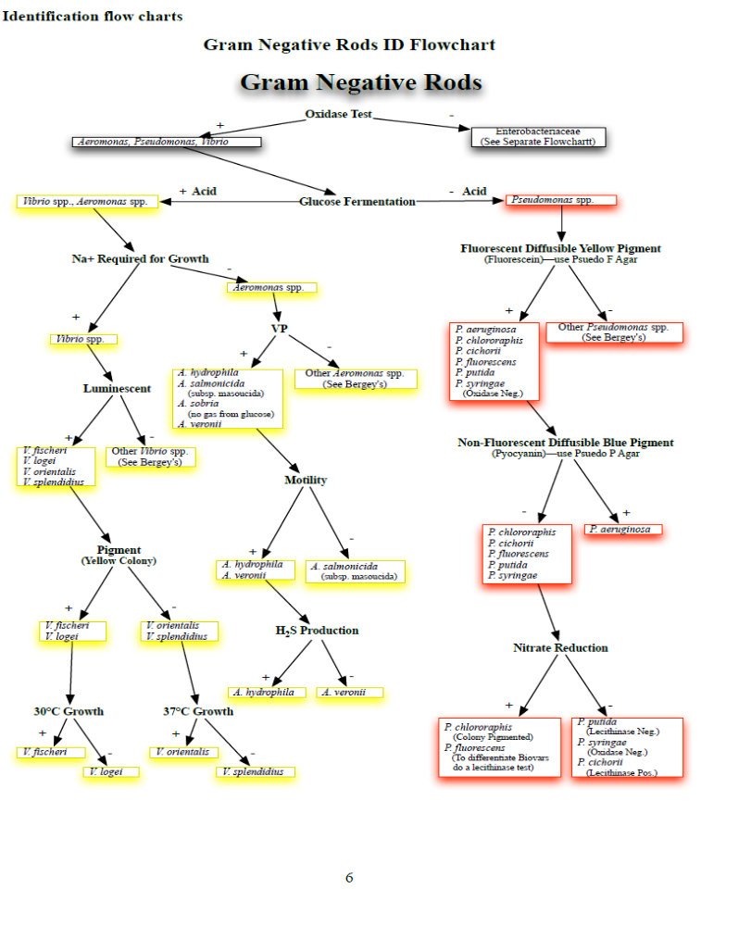

Appendix G. Standard curve

Figure 9. Standard curve of protein assay.

Appendix H. The result of overnight for enzyme activity

Result of Enzyme specific activity overnight for two strains

