Enhancement of PGP activities and host colonization by Gluconacetobacter diazotrophicus using co-inoculation with Terribacillus saccharophilus

Name: Inmaculada del Castillo
Azotic Technologies Ltd, Nottingham, UK

Abstract
Gluconacetobacter diazotrophicus (Gd) is a plant growth promoting (PGP) nitrogen fixing microorganism found in association with a variety of crops, such as sugarcane, coffee, rice, tomato and wheat (Luna, et al. 2010, Eman and Rasha 2015, Stephen, et al. 2015). In addition to nitrogen fixation, Gd has been reported to produce plant-growth promoting hormones including IAA. Gd colonisation has also been associated with phosphate and zinc solubilisation and siderophore production (Eskin, Vessey and Tian 2014). In previous research at Azotic Technologies Ltd [AT], we have detected important genotypic and phenotypic differences between strains, that are characterized by features associated with host interaction. A characteristic associated with the proprietary strain identified by AT, is the ability to colonise plant tissues intracellularly. This is one of the key features that differentiates the AT variant from the type strain, PAL5 (Cocking, Stone and Davey 2006). The above characteristics allow the AT strain to develop a more intimate symbiotic relationship with the host, facilitating the supply of fixed nitrogen directly to host cells.
Although originally discovered in sugar cane (Cavalcante and Döbereiner, 1988) and largely associated with sucrose-rich plant species, AT has developed a range of formulations with Gd that can be applied to the seeds and cut surfaces of a large number of crops including rice, maize and wheat. The use of PGP bacteria in non-native hosts presents Gd with additional challenges to the establishment of successful colonisation that can be overcome using formulation additives including co-inoculation with other beneficial microorganisms. In this study we have demonstrated how the co-inoculation of Gd with the gram-positive microbe, Terribacillus saccharophilus (Ts) enhances the endophytic colonisation of Brassica napus seedlings by Gd concomitantly enhancing additional plant-growth-promoting responses including nitrogen fixation. Using the acetylene reduction assay (ARA), nitrogenase activity levels up to 1.6-fold higher were recorded for mixed, compared to Gd or Ts-only cultures. The current research demonstrates a synergetic effect associated with co-inoculation with Gd and Ts that is able to enhance the nitrogen-fixing performance of Gd in the plant promoting increased seedling biomass two weeks after application with the mixed inoculant.

Image
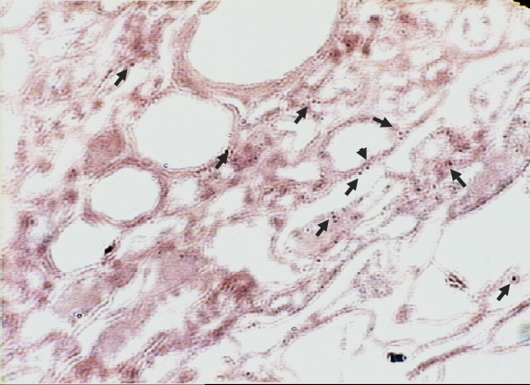  A  B | 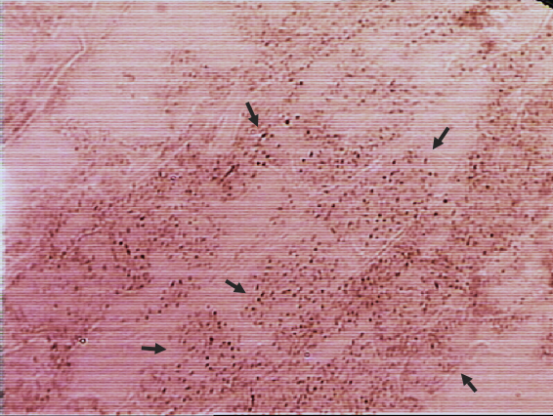
Figure 1. Light microscopy images of B. napus seedlings inoculated with (A) gus-Gd and (B) gus-Gd+Ts, section of histochemically stained root 1 week after inoculation. Arrows show some examples of intracellular endophytic colonisation of root cells by Gd.

Recent Publications (minimum 3)
- I. Del Castillo, J. Ojeda, et al. (2015). “Isolation of endophytic, epiphytic and rhizosphere plant-growth-promoting bacteria from cultivated rice paddy soils of the Guadalquivir river marshes”, Global Advanced Research Journal of Agricultural Science 4:2 (2015): 127-136
- L. Andrades-Moreno, I. del Castillo, et al. (2013). “Prospecting metal-resistant plant-growth promoting rhizobacteria for rhizoremediation of metal contaminated estuaries using Spartina densiflora”, Environmental Science and Pollution Research: DOI 10.1007/s11356-013-2364-8.
- I. del Castillo, P. Hernández, et al. (2012). “Self-bioremediation of cork-processing wastewaters by (chloro)phenol-degrading bacteria immobilised onto residual cork particles”, Water Research 46 (2012): 1723-1734.



Biography (Limit 250 Words): Inmaculada del Castillo is a Scientist at Azotic Technologies Ltd. She holds a PhD in Plant’s Microbiology by the University of Seville. Her main focus is the use of beneficial bacteria on agriculture and the impact of inoculants on the soil microbiome. She has studied the relationships established between bacteria through quorum sensing / quorum quenching mechanism, and conducted research on Microbial Ecology in different environments, agricultural and industrial, as a post-doc at the University of Seville (Spain) and at the University of Nottingham (UK).

Presenting author details
Full name: Inmaculada del Castillo Madrigal
E-mail: inmaculada.del.castillo@azotictechnologies.com
Contact number: +44 (0) 7733902293
Scientific Session name: Microbial Interactions
Category: (Oral/Poster presentation): Oral presentation
Facebook/Twitter account:

