Application of soil microorganisms for the improvement of bean seed yield and quality in conditions of reduced fertilization

Massa N., Bona E., Cantamessa S., Cesaro P., Todeschini V., Gamalero E., Lingua G., Berta G.
Università Piemonte Orientale “A. Avogadro”, 15121 Alessandria, Italy

Abstract
Legumes, like common bean, have the capacity to form symbiotic associations both with ancient arbuscular mycorrhizal fungi (AMF) and recent Rhizobium bacteria. Phaseolus vulgaris cv. Billò is an important and valuable crop widely cultivated in western Piedmont (Northern Italy). AMF are known to improve plant nutrition, in particular phosphorus acquisition, and hence fruit or seed quality. Rhizobium leguminosarum is a gram-negative bacterium, symbiont of various species of Fabaceae that is able to fix atmospheric nitrogen.
In this study, 15 different Rhizobium strains were isolated either from root nodules or soil, and characterized by a molecular and a biochemical point of view (phosphate solubilization, siderophore and IAA production, intrinsic antibiotic resistance). Among them, one strain was selected for a field trial. The aim of this work was to check, in field conditions, the possibility to improve bean seed yield and quality by means of inoculation with AMF and/or rhizobia under conditions of low fertilization. At harvesting, yield (pod and seed number and weight) and seed quality parameters (starch, protein, fiber and metal contents) were evaluated. Nodulation and mycorrhizal colonization of roots were assessed.
Yield parameters and fiber content were not influenced by the inoculation of microorganisms nor by the reduced fertilization, whilst protein concentration was significantly higher in the seeds of Rhizobium-inoculated plants in combination or not with AMF. Starch concentration significantly increased in the seeds of plants inoculated with rhizobia alone. Mg, K and Zn concentrations were positively affected by AMF, while Mn concentration was higher in the presence of Rhizobia. Ca and Fe levels did not show differences between the treatments.
In conclusion, an environment-friendly practice like low chemical fertilization can be associated to inoculation with soil microorganisms in order to improve bean seed quality, which can be differently affected by different combinations of inoculated microorganisms.
Image

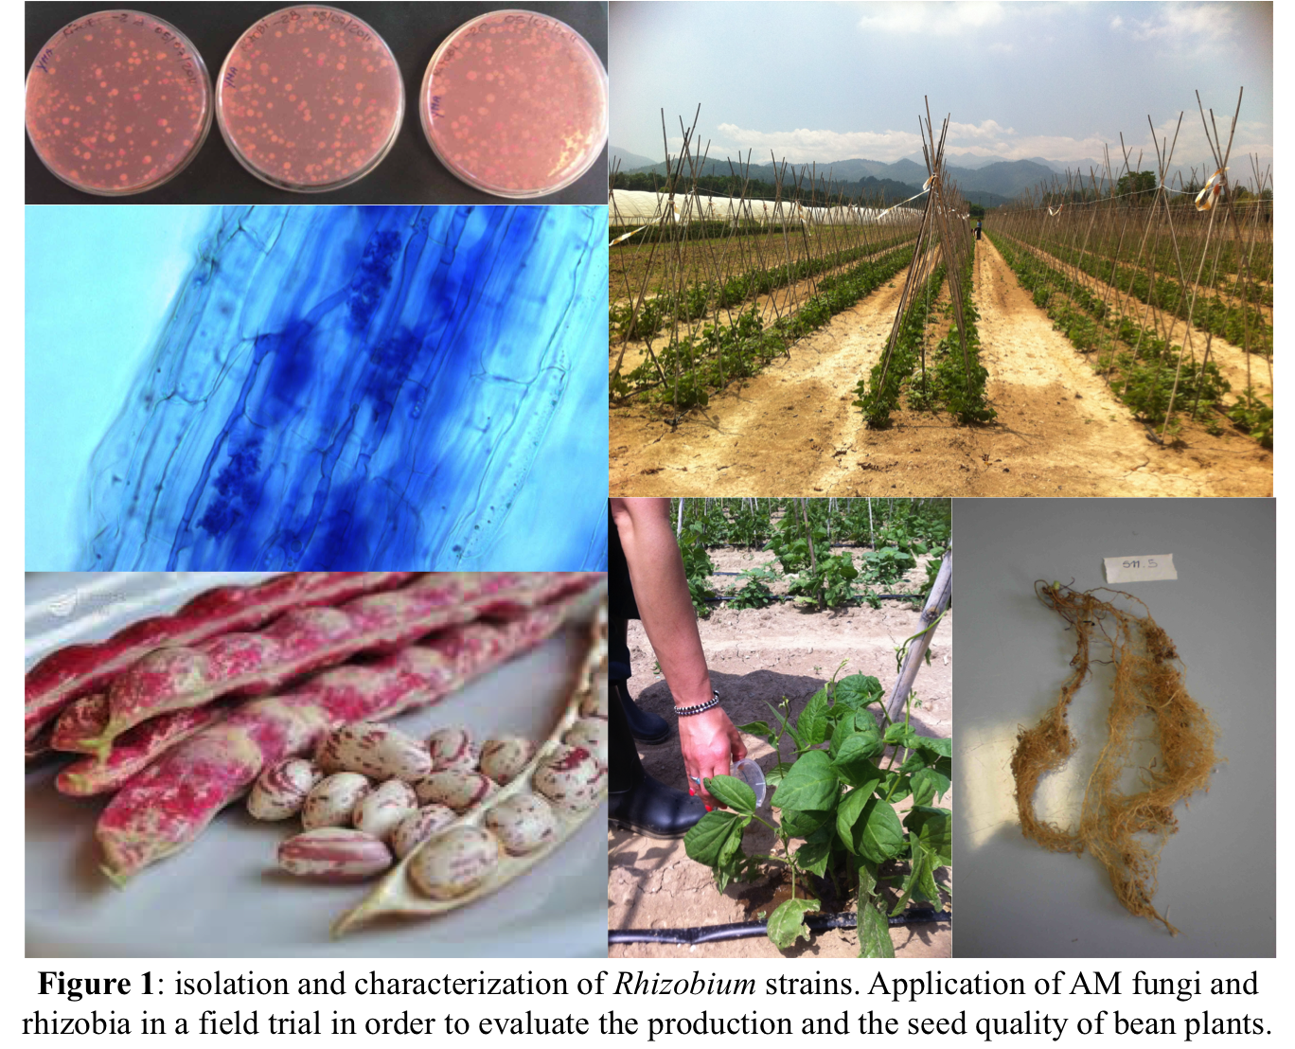

Recent Publications
- Bona E., Todeschini V., Cantamessa S., Cesaro P., Copetta A., Lingua G., Gamalero E., Berta G., Massa N. (2018). Combined bacterial and mycorrhizal inocula improve tomato quality at reduced fertilization. Scientia Horticulturae 234: 160-165.
- Novello G., Gamalero E., Bona E., Boatti L., Mignone F., Massa N., Cesaro P., Lingua G., Berta G. (2017). The rhizosphere bacterial microbiota of Vitis vinifera cv. Pinot Noir in an integrated pest management vineyard. Frontiers in Microbiology 8: 1-11.
- Bona E., Cantamessa S., Massa N., Manassero P., Marsano F., Copetta A., Lingua G., D’Agostino G., Gamalero E., Berta G. (2017). Arbuscular mycorrhizal fungi and plant growth-promoting pseudomonads improve yield, quality and nutritional value of tomato: a field study. Mycorrhiza 27:1-11.
- Massa N., Cesaro P., Todeschini V., Bona E., Cantamessa S., Berta G. (2018). Evaluation of soil toxicity using different biotests on Pisum sativum: a case study. Plant Biosystems - An International Journal Dealing with all Aspects of Plant Biology. doi: 10.1080/11263504.2018.1435570.



Biography:
Nadia Massa is a technician in the Biological Laboratories of the Università del Piemonte Orientale, Italy. She graduated cum laude in Biological Sciences at the University of Piemonte Orientale and attained a PhD in "Environmental Science, internal waters and agroecosystems" at the same university. Her research has been focused in: i) effects induced by heavy metals on the wild vegetation of polluted sites and their associated AM fungi, with particular interest in hyperaccumulator plants to be used in remediation programs; ii) setting up of a number of biotest using model plants and AM fungal spores to evaluate the effect of different pollutants on vegetation and hence on living organisms; iii) evaluation of benefits due to AM symbiosis both in biotic (phytoplasmas, aphyds) and (salinity and heavy metals) stress; iv) application of AM fungi and PGP bacteria for the improvement of fruit quality in crop plants. This research has required application of various methodologies such as: optical, fluorescence, confocal and electron microscopy, flow cytometry, molecular analyses and specific image analysis software as well as statistical ones.

Presenting author details
Full name: Nadia Massa
E-mail: nadia.massa@uniupo.it
Contact number: 0039 0131360231
Scientific Session name: Applied and Environmental Microbiology
Category: Oral presentation
Facebook/Twitter account: none

