Protective Effect of Exopolysaccharides Produced by Lactobacillus plantarum LRCC5310 on Rotavirus-Induced Diarrhea and Safety Assessment in Mice
Miri Park, Seokmin Yoon, Sungkeum Seo, Hoontae Kwon, Siyoung Yang, Hyunsuk Bae, Hyeokjun cho, Jonghwa Kim, Wonyong Kim
Microbiology, Chung-Ang University, Seoul, Korea
Lotte R&D center, Seoul, Korea

Abstract (300 word limit)

Rotaviruses are the most important cause of diarrhea in infants and children worldwide. However, to date, no specific antiviral drugs for the treatment of rotavirus infection have been developed. We isolated Lactobacillus strains from the Korean traditional fermented food, Kimchi. Among them, Lactobacillus plantarum LRCC5310 strain, specifically, the exopolysaccharides(EPS) produced from the strain, were shown to have an antiviral effect against human rotavirus Wa strain in vivo. The oral administration of EPS led to a decrease in the duration of diarrhea, viral shedding and the destruction of enteric epithelium integrity in the infected mice. Also, to assess safety, oral administration to mice for 14 days had no adverse effects on liver, heart, stomach, lung, kidney and intestine through histology and blood analysis. The findings indicate that the strain L. platarum LRCC5310 does not raise safety concerns in mice, up to 5,000 ppm concentration. Thus, this EPS is likely to be safe for human consumption and it can be used for the effective control of rotavirus infection. Further studies in humans should be conducted.

Image
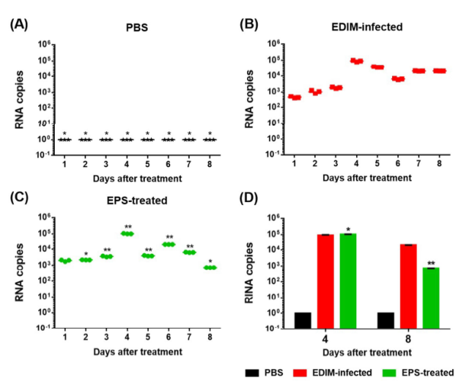
Effects of the exopolysaccharide (EPS) on viral shedding. (A) Viral shedding, determined using the stoolsamples of the neonatal mice inoculated with PBS, (B) rotavirus only, and (C) EPS (D)Quantification of the obtained results at day 4 and 8.

Recent Publications (minimum 5)
- KiyoungK (2018) Exopolysaccharide from Lactobacillus plantarum LRCC5310 offers protection against rotavirus-induced diarrhea and regulates inflammatory response. Dairy Science(to be published).
- N.S.Oh,J.H.Koh, M.R.Park(2016) Hypolipidemic and anti-inflammatory effects of fermented Maillard reaction products by lactobacillus fermentum H9 in an animal model. Dairy Science 99(12):9415-9423.
- N.S.Oh(2015) Dietary Maillard reaction products and their fermented products reduce cardiovascular risk in an animal model. Dairy Science 98(8):5102-5112.

Biography (150 word limit)
Miri Park has completed her master’s degree in life science from Korea University, Republic of Korea. She is the researcher of Ingredients and Solution Team at Lotte R&D center, Republic of Korea. She is responsible to search for useful food materials, especially probiotics, to evaluate efficacy and apply it to products.
Email: rndmiri@lotte.net

