240.pdf

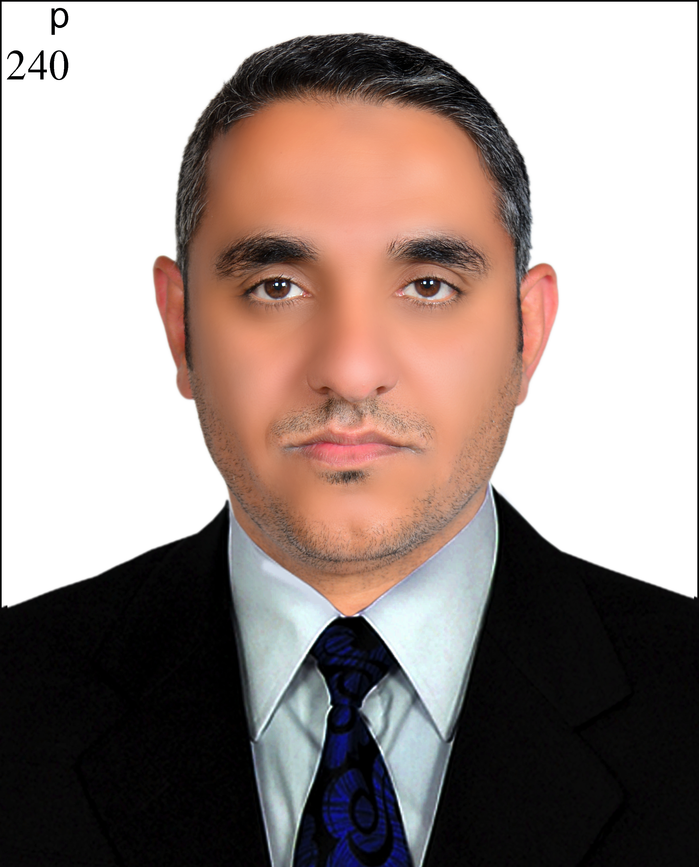
Title:Evaluation of the antimicrobial activities of ultra-sonicated spinach leaf extracts using RAPD markers and electron microscopy

Ammar Altemimi^{1,2,*}, Naoufal Lakhssassi¹, Amer Abu-Ghazaleh³, Vjollca Konjufca⁴, David A. Lightfoot¹
Spinach (Spinacia oleracea L.) leaves represent an important dietary source of nutrients, antioxidants and antimicrobials. As such, spinach leaves play an important role in health and have been used in the treatment of human diseases since ancient times. In this study we aimed to optimize the extraction methods for recovering antimicrobial substances of spinach leaves, determine the minimum inhibitory concentrations (MICs) of the antimicrobial substances against Gram-negative Escherichia coli O157:H7 and Gram-positive bacteria Staphylococcus aureus and finally, evaluate the effects of spinach leave antimicrobials on bacterial DNA. Using central composite face centered methods (CCFC) we have optimized the parameters for ultrasound-assisted extraction of spinach leafs. The effect of extracts on model bacterial pathogens was examined by scanning electron microscopy (SEM) and random amplification of polymorphic (bacterial) DNA (RAPD). We show that the optimal extraction conditions were at temperature of 45°C, ultrasound power of 44% and extraction time of 23 min. The spinach extracts exhibited antimicrobial activities against both bacterial pathogens with MICs in the 60-100 mg.ml⁻¹ range. SEM showed that treated bacterial cells appear damaged compared to the controls. RAPD analysis of genomic DNA showed that the number and sizes of amplicons were decreased for the treated compared with non-treated bacteria. Based on these results we hypothesize that spinach leave extract exerts its bactericidal activity by inducing mutations and by causing cell wall disruptions. Therefore, spinach leaf extract may be used as a source of antibacterial compounds for food safety, dietary health or for topical treatments of infections.

Biography
Ammar Altemimi worked as Lecturer (2009 - 2011) in Department of food science and Biotechnology, University of Basrah, Iraq. He taught biochemistry and biotechnology for undergraduate, food chemistry, dairy products .Developing academic programs, monitor students educational progress, train and motivate other non-teaching staff; manage career counseling and other student service. He has published more than 5 papers in reputed journals such as Ultrsonic Sonochemistry Journal and Molecules Journal; and he has been serving as an editorial board member and reviewers of repute Journals. He got his phD. In field of non-thermal processing and food safety from SIUC University, USA on 2016.

Presenting author details
Full name: Dr.Ammar B.Altemimi
Contact number:+9647735640090
Twitter account:
Linked In account: https://www.linkedin.com
Session name/ number:
Category: (Poster presentation)

