You are what you eat: get mature faster by foraging on your parents, the discus fish example
Francois-Etienne Sylvain, MSc, Laval University, Canada

Abstract

The Discus fish (Symphysodon aequifasciata) is an Amazonian ornamental fish with a unique parental behaviour. After hatching, the fry feeds exclusively on a cutaneous mucus secretion from both parents during three weeks. Studies have documented a differential protein pattern on the mucus layer of discus in reproductive phase, suggesting that specific elements are vertically transferred from parents to their offspring to stimulate fry growth. The aims of our study were (1) to characterize the ontogenesis of discus fish gut microbiota; (2) to determine if reproduction phase induced a differential shift of cutaneous mucus microbiota composition on parental fish; and (3) to assess the impact of parental feeding on the compositional dynamics of discus fry gut microbiota. To achieve these goals, we sampled thoroughly one brood of S. aequifasciata, during four months post-hatch. We sampled fry and parental feces, parental mucus and aquarium water. We sequenced the hypervariable region V4 of the rRNA 16S to characterize bacterial communities in all samples. The results show that (1) there is a convergence of the gut microbiota composition of the fry towards the gut microbiota of their parents as soon as the fry starts feeding on their parents cutaneous mucus; (2) there is a differential shift of the parental mucus microbiota composition when the parents get in reproductive phase; and (3) the taxonomic structure of the fry gut microbiota stabilizes earlier than what has been observed for the shorter-lived zebrafish. Our results highlight the beneficial influence of vertical parent-offspring transfer of parental bacteria via skin mucus feeding.

Image

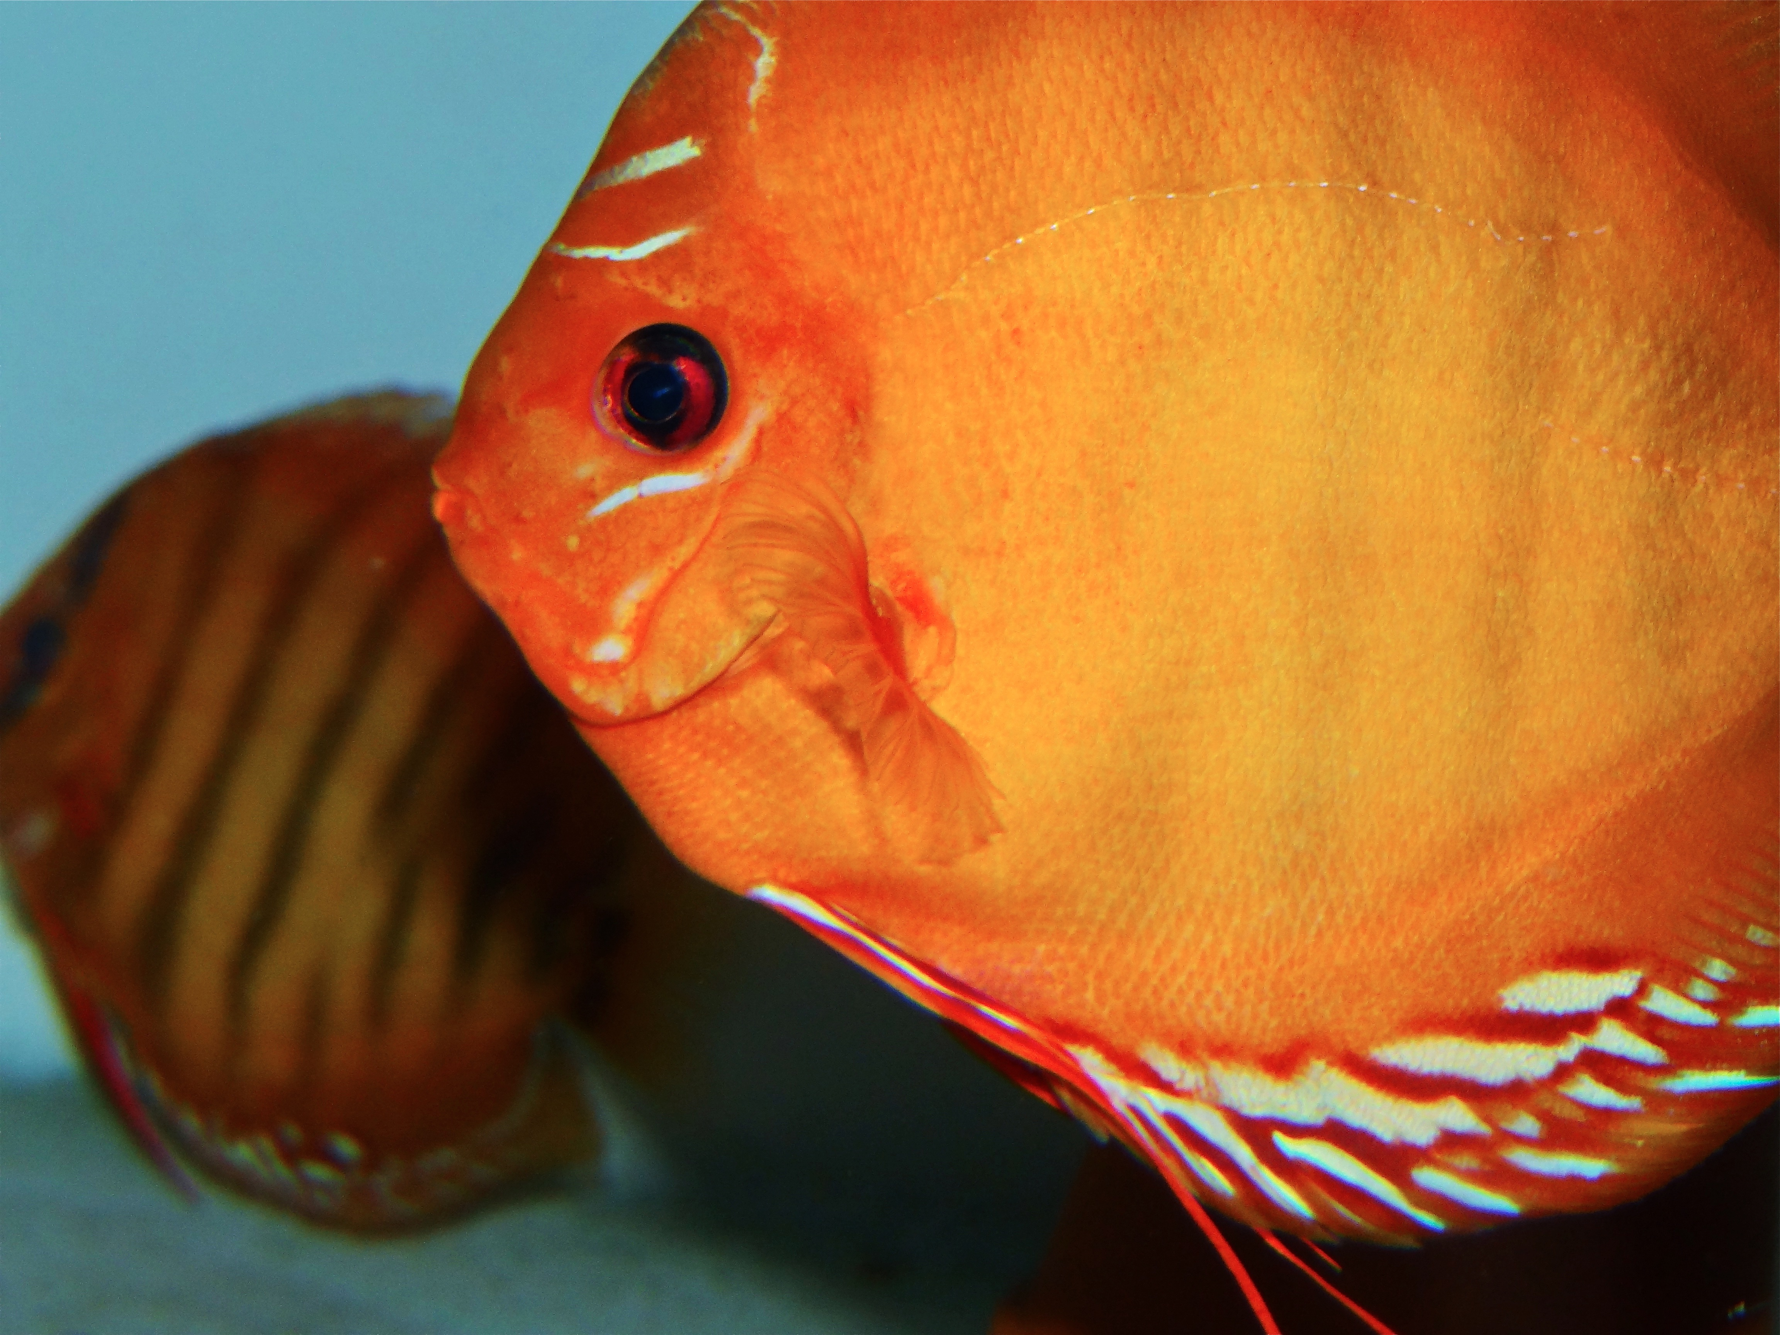

Recent Publications
- Buckley, J., R. J. Maunder, A. Foey, J. Pearce, A. L. Val, and K. A. Sloman. 2010. Biparental mucus feeding: a unique example of parental care in an Amazonian cichlid. Journal of Experimental Biology 213:3787-3795.
- Chong, K., S. Joshi, L. T. Jin, and A. C. Shu-Chien. 2006. Proteomics profiling of epidermal mucus secretion of a cichlid (Symphysodon aequifasciata) demonstrating parental care behavior. Proteomics 6:2251-2258.
- Chong, K., T. S. Ying, J. Foo, L. T. Jin, and A. Chong. 2005. Characterisation of proteins in epidermal mucus of discus fish (Symphysodon spp.) during parental phase. Aquaculture 249:469-476.
- Khong, H. K., M. K. Kuah, A. Jaya-Ram, and A. C. Shu-Chien. 2009. Prolactin receptor mRNA is upregulated in discus fish (Symphysodon aequifasciata) skin during parental phase. Comparative Biochemistry and Physiology B-Biochemistry & Molecular Biology 153:18-28.
- Sylvain, F. E., B. Cheaib, M. Llewellyn, T. G. Correia, D. B. Fagundes, A. L. Val, and N. Derome. 2016. pH drop impacts differentially skin and gut microbiota of the Amazonian fish tambaqui (Colossoma macropomum). Scientific Reports 6:10.



Biography

Francois-Etienne Sylvain completed his Master's thesis at Laval University (Quebec). His longtime passion for the underwater world led him to work on fish-associated microbiomes. Francois-Etienne is particularly interested in understanding what are the factors that shape the structure of Amazonian fish microbiota, as the Amazon River Basin contains the highest fish biodiversity in the world, as well as very contrasted aquatic environments (e.g. black and white water). Francois-Etienne and his thesis advisor, Nicolas Derome, have established a research collaboration with the National Institute of Research of the Amazon (Brazil), where two collaborative research projects were completed. For his research on the discus fish gut microbiota ontogeny, Francois-Etienne received the JC Bill Costerton Award, for «research that best involves new theories in microbial ecology and wider inter-disciplinary significance» at the 16th International Symposium of Microbial Ecology (ISME 2016).
Email: francois-etienne.sylvain.1@ulaval.ca

