Use of a water-boost rocket for the exposure plate method
Chamikara H J M Pasindu, B.Sc. Hon’s (Microbiology) Sp. University of Kelaniya, Sri Lanka Chamikara H J M Pasindu, B.Sc. Hon’s (Microbiology) Sp. University of Kelaniya, Sri Lanka

Abstract
A ‘water-boost rocket’ method was developed to collect air samples from different layers of the atmosphere. The water-boost rocket is consisted of two main parts: the rocket part and the sample collecting part. Rocket is made out of a 1.5 L capacity plastic bottle. Four fins were attached to the bottom of the bottle using a plastic board. The nosecone of the rocket was made by using another 1.5 L plastic bottle. The neck and the bottom part of the bottle was removed to preserve the cone shaped part of the bottle. Then 50 g of clay was pasted on the top of the cone shaped part. This adds weight to the nose cone and the center of gravity is moved higher, thus making it more stable. The prepared nosecone was attached to the top of the rocket by gluing and taping. The nozzle of a size of 0.6 cm was prepared using a PVC pipe. The rocket launcher wad made up of wood. A separate pipe line was used to fill air to the rocket. Rocket can be filled with water through the nozzle. After pumping air, launcher can release the rocket.A petri plate can be attached to the rocket using another nosecone, which can be attached over the pre-attached nosecone. Between two nosecones medium containing petri plate was placed. Then a timer circuit is placed on the first nosecone. This circuit helps to open and close the secondary nosecone at a specified time. When the nosecone is opened, plate is exposed to the environment and then it should be closed within a pre-determined time period (3 sec.). After the rocket is landed, we can take the plate, incubate it and isolate the microorganisms. Different types of microbes are dominant in specific heights in atmosphere. Some of are beneficial and some of are pathogenic microorganisms.

Image
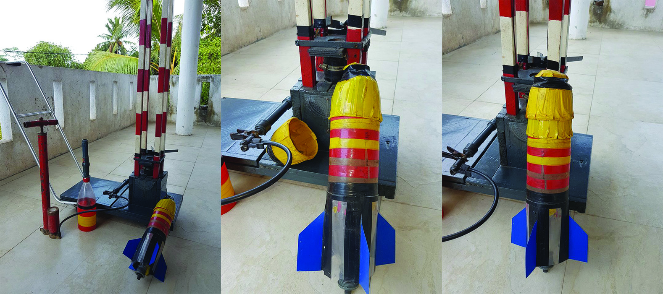

Figure: Parts of the Water boost rocket system

Recent Publications
- R Barrio-Perotti, E Blanco-Marigorta, J Fernández-Francos , M Galdo-Vega (29/07/2010), Theoretical and experimental analysis of the physics of water rockets 31:5-10
- Joseph M. Prusa (2014), Hydrodynamics of a Water Rocket, 42(4):719–726.
- C. Napoli, S. Tafuri, L. Montenegro, M. Cassano, A. Notarnicola, S. Lattarulo, M.T. Montagna, B. Moretti (2012) Air sampling methods to evaluate microbial contamination in operating theatres: results of a comparative study in an orthopaedics department: Volume 5, Issue 4:386–390
- Fan, Zih-Hua Tina (2011) Passive Air Sampling: Advantages, Limitations, and Challenges: Volume 22 - Issue 1 :132
- Barbara M. Andon (2013) Active Air vs. Passive Air (Settle Plate) Monitoring in Routine Environmental Monitoring Programs: vol. 60:350-355

 Biography
H.J.M. Pasindu Chamikara is an undergraduate, B.Sc. Hon’s (Microbiology) sp. at University of Kelaniya, Sri Lanka. Currently he is the president of the Society of Microbiology, University of Kelaniya. Although he is the admin of the facebook page and official website of the society of Microbiology. He invented a low-cost light microscope in 2015 and also it was published it in the International Research Symposium on Pure and Applied Sciences which was held on 1st December 2016. He was selected to participate in the Summer Camp held at Chongqing Normal University, China 2016. Pasindu Chamikara represented the Department of Microbiology on behalf of his contribution for the Society and his best performances in academics. Recently he finished the 3 months Microbiology internship at Ansell Lanka(Pvt) Ltd as a trainee microbiologist. Within a short period of the time he completed 3 big projects at Ansell Lanka.
Email: pasindu.chamikara12@gmail.com
pasindu.chamikara@uokmicro.com

