“Serum NMR metabolomic study in acute spinal cord injury (ASCI): A possible recovery pathfinder as indicated in a pilot study”

R. N. Srivastava¹, Alka Singh¹, Raja Roy², Saloni Raj¹
¹Department of Orthopaedic Surgery, King George’s Medical University, Lucknow, India
²Centre of Biomedical Research, Sanjay Gandhi Post-Graduate Institute of Medical Sciences, Rae Bareli Road, Lucknow, India
Abstract:
Study Design: A prospective case control study of ¹H NMR spectroscopic metabolic profiling to determine the severity of injury and prognosticate neurological recovery in Acute Spinal Cord Injury.
Objective: To evaluate the level of metabolites with their significance in SCI recovery and to determine the effect of stem cell on their levels in facilitating recovery.
Methods: 20 ASCI recruited subjects were classified into fixation alone (Group-1, n=10) and stem cell therapy (Group-2, n=10) along with healthy controls (Group-0, n=10). Serum samples were isolated at admission as baseline and at 6th month as follow-up. The spectra for serum were acquired using NMR spectrometer and analyzed by Wilcoxon and ANOVA tests to observe difference between three groups on the basis of metabolomic perturbation. Results were correlated with recovery.
Result: Seven out of fifteen identified metabolites were found significant for the study. Acetone, acetate, isoleucine and succinate level had direct correlation with recovery and stem cell infusion. Valine level had direct relation with recovery but no relation with stem cell infusion. Glycine level had negative relation with recovery and stem cell infusion. Lactate level had negative relation with recovery but positive relation with stem cell infusion.
Conclusions: Seven metabolites were correlating with injury either positively or negatively. Stem cell behaves differently to these metabolites - most correlate positively, one negatively and one has no correlation.
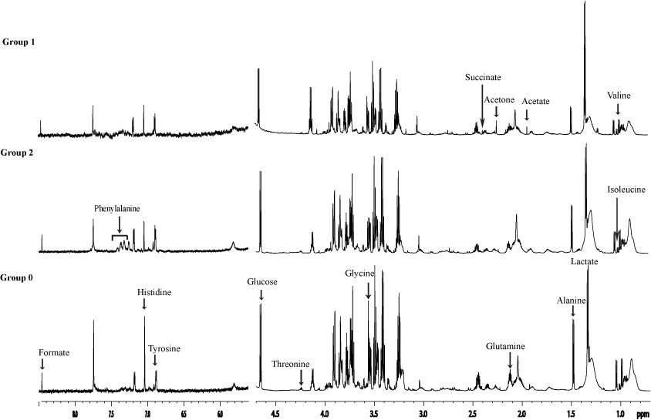
Figure 1: A representative ¹H NMR spectra of quantified serum metabolites of all three groups at baseline.
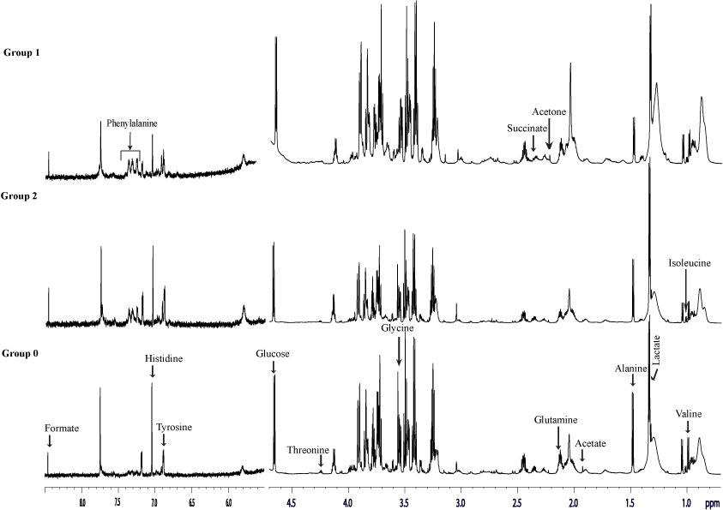
Figure 2: A representative ¹H NMR spectra of quantified serum metabolites of all three groups at 6th month follow up.
Recent Publications (minimum 5):
    - Awasthi V, Singh A, Srivastva RN, Verma NS, Kumar S, Mahadi AA. “A Randomized Controlled Trial: Evaluation of Yoga with Il-6 as Biomarker in the Management of Osteoarthritis Knee”. International Journal of Health Sciences and Research. 2015; 5, Issue 1

    - Singh A, Srivastava RN, Ali S. “Evaluation of acute compartment syndrome of extremities in emergency room: a case series of 32 children”. Internet Journal of Medical Update. 2015 July;10(2):37-40. doi: 10.4314/ijmu.v10i2.6

    - Singh N. K., Waliullah S., Srivastava RN, Kuma V., Singh A., Sharma V. “Ligamentotaxis in Compound Distal Tibial Fractures”. Journal of International Academic Research for Multidisciplinary. 2015 December; Vol. 3, Issue 11, ISSN: 2320-5083

    - Chandra T., Srivastava RN, Chooramani S. G., Rizvi SNF, Agarwal D., “Processing of Bone Marrow Mononuclear Stem Cells in Acute Spinal Cord Injury”. EJPMR, 2016,3(1), 226-232

    - Dwivedi M.K., Srivastava RN, Bhagat A.K., Agarwal R., Baghel K., Jain A., Raj S., Journal of Wound Care. April 2016, Vol 25, No 4

Biography (150 word limit)
Prof. Rajeshwar Nath Srivastava, is a great researcher and has contributed extensively in the genetics, epigenetics and translational health sciences in the field of Osteoarthritis and Osteoporosis in Indian population. Prof RNS is a great researcher and has important contributions in the family of Spinal Cord Injury (SCI) researchers. He has developed an indigenized, innovative negative pressure device for bedsores in SCI, a step wise reduction protocol in management of cervical fracture dislocations and an algorithm for processing of bone marrow derived stem cells for clinical use in orthopaedic diseases. His research centres on treatment modalities influencing neurological recovery and metabolomics in SCI. He has extensively travelled abroad, a recipient of many awards, 45 publications with 288 citations, an H-index of 10 and i-10 index 11 in last five years. He has been a Reviewer of manuscripts in many International Journals of repute including “BMJ”, “Spinal Cord”, “Spine” and “JSCM”.
Email: drrnsrivastava@yahoo.com
Mobile No.:+919415054330

