The metabolomics window into diabetic complications
Tao Wu, Institute of Interdisciplinary Integrative Medicine Research
Shanghai University of Traditional Chinese Medicine, Shanghai 201203, China.

Abstract (300 word limit)

Diabetes mellitus has become a major global health problem with almost 415 million people affected in 2015, and a projected figure of 642 million by 2040 (International Diabetes Federation, 2015). Metabolomics is a systems biology approach that provides global metabolic information about biological samples. It has been widely used in the diagnosis and treatment of diabetes. However, studies of diabetic complications are scarce. We recently reviewed the application of metabolomics on diabetic complications in order to provide an update on the application of metabolomics in diabetic complications, and also to provide some guidance about the prevention and prediction of the development of diabetic complications. It was shown that metabolomics can reflect the metabolic patterns, development and differentiation of diabetic complications. For Diabetic Nephropathy, in clinical studies, the perturbations in amino acid metabolism, fatty acid metabolism and PL metabolism were shown in serum or plasma, whereas tryptophan metabolism and mitochondrial metabolism were shown in urine. In animal studies, abnormal glucose, lipid metabolism and methylamine metabolism, intrarenal accumulation of organic toxins, disturbed purine metabolism, and its related XO pathway, as well as the tricarboxylic acid cycle, were found in DN based on the urine, serum or kidney. As for Diabetic Retinopathy, abnormal fatty acids, amino acids and glucose metabolism were involved the mechanism.
Image
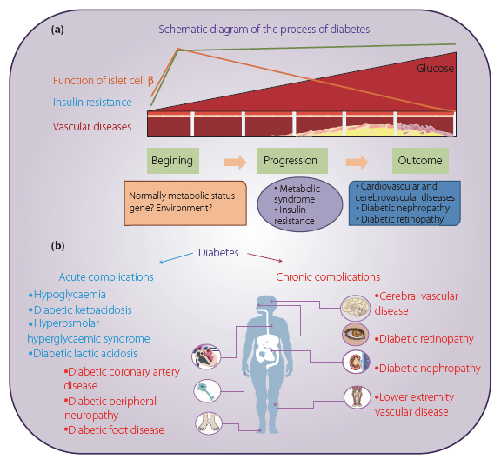
Recent Publications
- Tao Wu, et al (2018) Metabolomics window into diabetic complications. J Diabetes Investig 9(2): 244–255.
- Tao Wu, et al (2017) Serum lipid alterations identified in chronic hepatitis B, hepatitis B virus-associated cirrhosis and carcinoma patients. Sci Rep 15;7:42710

 Biography
Dr.Wu has completed her PhD at the age of 35 years from Shanghai University of Traditional Chinese Medicine. She is mainly engaged in the field of the prevention and treatment of metabolic disease and application of metabonomics in clinical metabolic disease. She has published more than 20 papers in reputed journals.
Email: wutao001827@163.com
Phone: +86-21-51322748

Notes/Comments:

