Metabolomic analysis of a brain metastasis cell line of lung cancer origin revealed differential adaptive responses to metabolic stresses
Indy K.L. Wong, Penelope M.Y. Or, and Andrew M. Chan*
School of of Biomedical Sciences, The Chinese University of Hong Kong. Room 705, Lo Kwee Seong Integrated Biomedical Sciences Building, Shatin, Hong Kong SAR. *presenter

Abstract

Metastatic diseases in lung adenocarcinoma are often associated with poor prognosis. We have previously characterized a brain metastasis cell line of lung cancer origin, A1115, which possessed heightened glycolytic activity when compared with other lung adenocarcinoma cell lines such as, A549, derived from a primary site. A1115 has greater lactate production than A549. Conversely, A549 has a greater oxygen uptake rate that could be effectively blocked by oligomycin. Indeed, the proliferation of A549 was hypersensitive to oligomycin treatment while A1115 was greatly inhibited by glucose deprivation. Western blotting analysis revealed both hexokinase I (HK1) and phosphoenolpyruvate carboxykinase 1 (PCK1) were preferentially expressed in A1115. For energy sensing signaling, AMPKα, which senses cellular AMP level, was phosphorylated in A549 but not in A1115. Indeed, the proliferative capacity of A1115 was drastically reduced by an AMPK activator, AICAR, while A549 was not affected. Metabolite profiles under reduced (1 g/L) revealed a 5- to 24-fold increase in metabolites that are linked to purine metabolism (e.g. hypoxanthine, GMP, and adenosine). Treatment with a XOD inhibitor, allopurinol under reduced glucose condition increased cell viability in A1115 at low doses while toxic at high doses. This data suggests that heightened hypoxanthine may be a prosurvival adaptive response in A1115 under nutrient stress conditions. We further selected A1115 sublines that could survive at a low glucose concentration (0.15 g/L). Western blotting analysis revealed a drastic overexpression of PCK1 and PKC2 when compared to parental cells. Transcriptomic analysis was also performed to reveal genes that could play a role in the survival of brain metastatic lung cancer cells under nutrient stresses. Taken together, these results identified multiple vulnerable points in metabolic signaling that could be therapeutic targets for treating metastatic lung cancers.

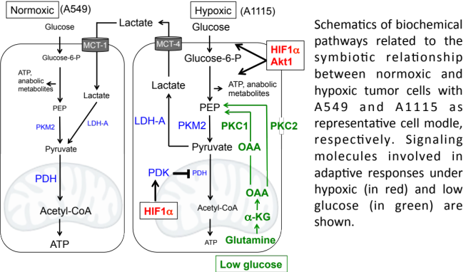
Recent Publications
- Ni, J. et. al. (2016) MAGI-1 Interacts with Nephrin to Maintain Slit Diaphragm Structure Through Enhanced Rap1 Activation in Podocytes. J. Biol. Chem. 291:24406-24417.
- Knafo, S. et. al. (2015) PTEN Recrutiment Controls Synaptic and Cognitive Function in Alzheimer’s Models. Nature Neuroscience. 19:443-453.
- Yan, X. et. al. (2015) R-Ras regulates Murine T cell migration to peripheral lymph nodes and chemokine-induced activation of lymphocyte function-associated antigen-1. Plos One 10:e0145218.
- Feng, H. et. al. (2015) A CCRK-EZH2 epigenetic circuitry drives hepatocarcinogenesis and associates with tumor recurrence and poor survival of patients. J. Hepatology. 62:1100-1111.
5. Kennedy, C.R. et. al. (2013) Differential sensitivities of glioblastoma cell lines towards metabolic and signaling pathway inhibitions. Cancer Letters. 336:299-306.

 Biography
Prof. Andrew M. Chan is currently a Professor and Chief of the Cancer Biology & Experimental Therapeutics Thematic Research Program at the School of Biomedical Sciences of the Chinese University of Hong Kong. He obtained his Ph.D. degree from the Chester Beatty Laboratory of the Institute of Cancer Research in London in 1989. He was a Fogarty International Fellow at the US National Cancer Institute in the laboratory of Cellular & Molecular Biology. Dr. Chan was a faculty member at the Mount Sinai School of Medicine and the Medical College of Wisconsin. His research is in the area of cancer cell signaling and mouse models of human cancers with focuses on the PI3-K and Ras-mediated signaling mechanisms in brain, breast and lung cancers.
Email: andrewmchan@cuhk.edu.hk
Phone: +852 39433771

Notes/Comments:

