Review of Literature
Chapter 1: Brief Anatomy and Physiology of the Pancreas
Location and description of the pancreas :
The pancreas is 12 to 18 centimeters (about 4.7 to 7.1 inches) long and weighs about 70 to 100 grams. It is made up of a head, a body and a pointy tail-like end. Located in the upper abdomen behind the stomach, it has two important functions: It produces enzymes that break down foods in the intestine, as well as hormones that regulate blood sugar levels, (NCBI,2018).
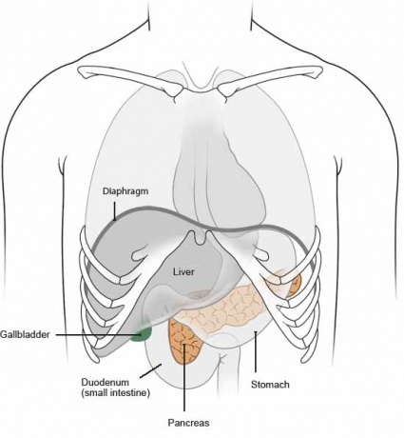
Figure 1.Position of the pancreas.
Several major blood vessels surround the pancreas, the superior mesenteric artery, the superior mesenteric vein, the portal vein and the celiac axis, supplying blood to the pancreas and other abdominal organs.
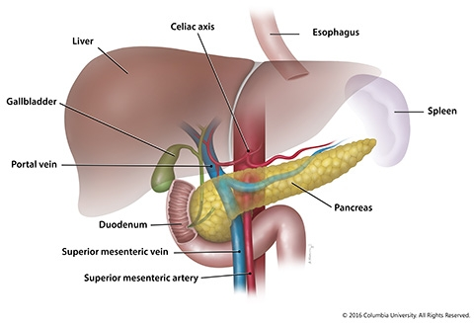
Figure 2. Anatomic relationships of the pancreas with surrounding organs and structures
Almost all of the pancreas (95%) consists of exocrine tissue that produces pancreatic enzymes for digestion. The remaining tissue consists of endocrine cells called islets of Langerhans. These clusters of cells look like grapes and produce hormones that regulate blood sugar and regulate pancreatic secretions The wide part, called the head of the pancreas, is positioned toward the center of the abdomen. The head of the pancreas is located at the juncture where the stomach meets the first part of the small intestine. This is where the stomach empties partially digested food into the intestine, and the pancreas releases digestive enzymes into these contents ,( Columbia University Irving Medical Center,2016).
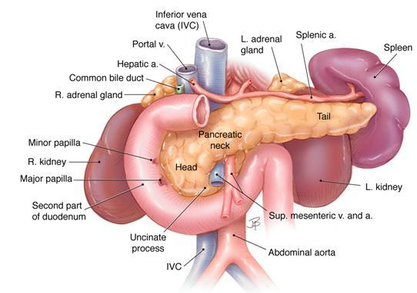

American Pancreatic Association, Pancreapedia, 2014.
The head of the pancreas lies in the loop of the duodenum as it exits the stomach. The tail of the pancreas lies near the hilum of the spleen. The body of the pancreas lies posterior to the distal portion of the stomach between the tail and the neck and is unlabeled in this drawing. Image by Jennifer Parsons

Gross anatomy of the pancreas :
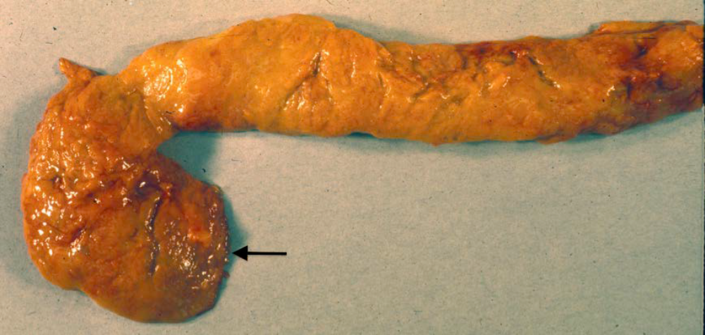
Figure 3. The gross anatomy of the human pancreas can vary. Figures 1A and 1B are two normal human pancreases from autopsies of adults. Both pancreases have been dissected to remove fat and adjacent organs. The two photos illustrate that there is considerable individual variation in the shape of the pancreas(Longnecker,2014). (
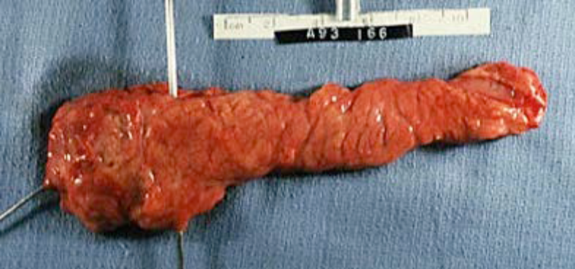
Figure 3B. In this pancreas the uncinate portion is fused to the remainder of the head. A probe (image left) has been put into the main pancreatic duct, and a second probe (vertical) is in the portal-superior mesenteric vein behind the pancreas. The diagonal groove in the tip of the tail (image right) marks the course of a branch of the splenic artery or vein (Longnecker,2014).

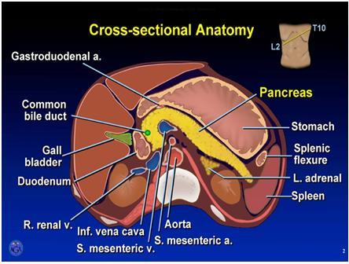
Figure 4. Cross section of the upper abdomen at the level of the pancreas. Note that the plane of the transection is angled upward on the left as indicated in the drawing upper image right. The major organs except the liver (image left) and kidneys are labeled. Splenic flexure (image right) refers to the colon. Used with permission. Copyright, American Gastroenterological Association.
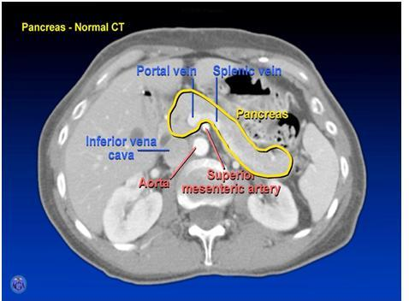
Figure 5. CT scan of the upper abdomen at the level of the pancreas.
This annotated CT scan is oriented with the abdominal wall at the top and the spine and muscles of the back at the bottom viewing the cross section from below. Thus, the spleen is at the extreme image right and the liver is image left inside the ribs that appear as white ovals in the abdominal wall. Kidneys lie lateral to the spinal column with the tail of the pancreas nearly touching the left kidney. Used with permission. Copyright, American Gastroenterological Association.

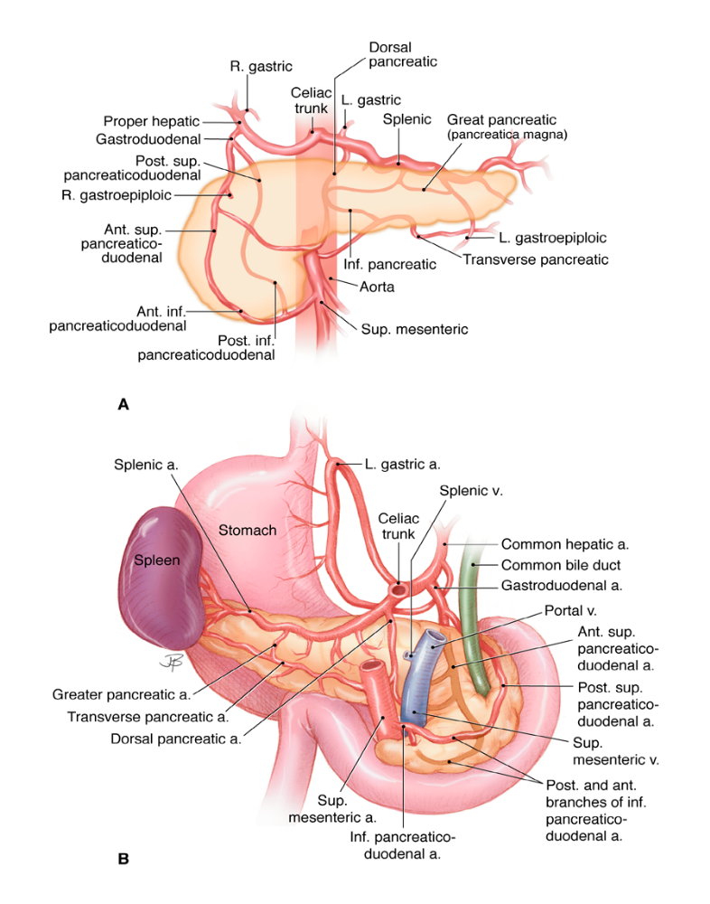 Image by Jennifer Parsons
Figure 7. The arterial blood supply of the pancreas:
The upper panel (A) is visualized from the front, and the lower panel (B) is seen from the back. The celiac trunk and the superior mesenteric artery both arise from the abdominal aorta. Both have multiple branches that supply several organs including the pancreas. The anastomosis of their branches around the pancreas provides collateral circulation that generally assures a secure arterial supply to the pancreas. Most of the arteries are accompanied by veins (not shown) that drain into the portal and splenic veins as they pass behind the pancreas as shown in B. The superior mesenteric vein becomes the portal vein when it joins the splenic vein ( Chavan ,(2015)
Histology of the pancreas :
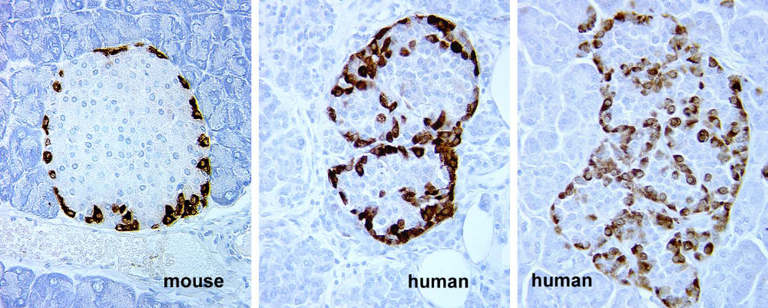
Figure 8. Mouse and human islets stained for glucagon (Immunoperoxidase). These images show a minor species difference in the location of α-cells in mouse and human islets. In humans, α-cells appear within the islet although they seem to be on the periphery of clusters of β-cells. Compare the staining in mouse islet to Fig. 35, a mouse islet stained for insulin. Micrographs provided by Susan Bonner-Weir.
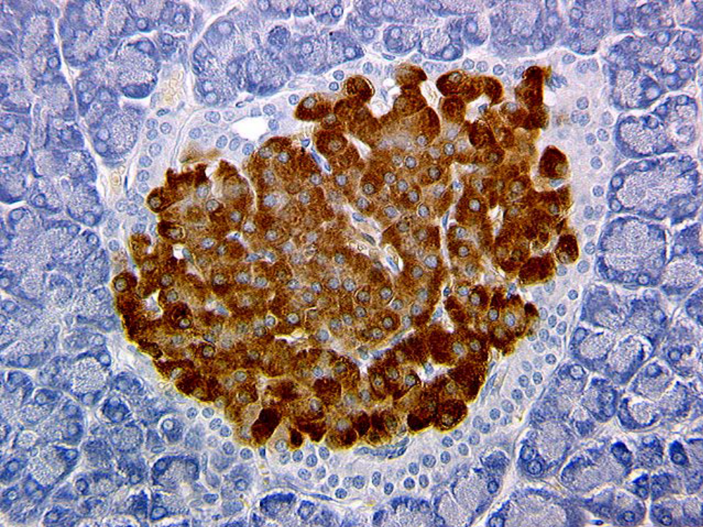
Figure 9. Mouse islet stained for insulin (Immunoperoxidase). Note that unstained cells are located in the periphery of the islet corresponding to the location of glucagon staining in Fig. 8. Micrograph provided by Susan Bonner-Weir.

References :
1-National Center for Biotechnology Information(2018).How does the pancreas work? Available at https://www.ncbi.nlm.nih.gov/books/NBK279306/

4-Longnecker, Daniel (2014). Anatomy and Histology of the Pancreas. V 1.0, , [DOI: 10.3998
5- Chavan N, Wabale R.(2015)Arterial arcades of Pancreas and their variations V.03,PP: 23:33.
Capurso G, Traini M, Piciucchi M, Signoretti M, Arcidiacono PG. Exocrine pancreatic insufficiency: prevalence, diagnosis, and management. Clin Exp Gastroenterol. 2019;12:129-139. [PMC free article] [PubMed]
Vettoretti M, Facchinetti A. Combining continuous glucose monitoring and insulin pumps to automatically tune the basal insulin infusion in diabetes therapy: a review. Biomed Eng Online. 2019 Mar 29;18(1):37. [PMC free article] [PubMed]

