Effectiveness of a Therapeutic Educational Program for type 2 diabetic patients on eating habits and metabolic control.
M Rosário Pinto, RN MD, IPSantarém, Higher School of Health, Portugal
Pedro Parreira, RN PhD, Higher School of Nursing of Coimbra, Portugal
Marta Lima Basto, RN PhD, Lisbon University, Higher School of Nursing, Portugal
Lisete Mónico, PhD, University of Coimbra, Phycology Faculty, Portugal

Abstract
Statement of the Problem: Prevalence of diabetes is increasing worldwide, with a known strong relation to obesity and eating habits. In face of this situation, for diagnosed people metabolic control is a major objective. Lifestyle approaches, with a highlight on eating and exercise habits have proven to be an effective contribute to achieve this goal. In Portugal, reality where this study was conducted, 90% of the population with diabetes is overweight (49.2%) or has obesity (39.6%), (PREVADIAB¹). With this, comes an urgent need to identify effective interventions to reduce this burden. With this study we intend to analyse the impact of a lifestyle centred intervention on metabolic control and self-care activities of poorly controlled type 2 diabetic patients. Methodology & Theoretical Orientation: To assess the effectiveness of the 24 weeks Program, a controlled before and after experimental study was conducted. Measures were taken before and after intervention program, including Glycosylated haemoglobin (HbA_{1c}), Body Mass Index (BMI) and self-care activities (SCA)- through the application of Summary of Diabetes Self-Care Activities Scale. Findings: The comparison between pre and post-test in Control Group (CG), which received usual care, and Experimental Group (EG) showed that only in EG was a statistically significant decrease in HbA_{1c} and BMI (see Fig 1). Adherence to SCA is higher in EG, having an estimated increase in 40% more than CG (η_{p}²=.40). Expected behaviours concerning eating habits, increased a mean of 2 days/week and physical activity 1 day/week in EG while in CG changes were lower (+0.6 days/week and +0.28 days/week, respectively). Conclusion & Significance: The educational program designed was effective for people with type 2 diabetes, with higher metabolic control and more frequent self-care behaviours for EG. With distinct effect sizes, EG participants reduced significantly HbA_{1c} and BMI, while increased expected behaviours related to eating habits.

Biography
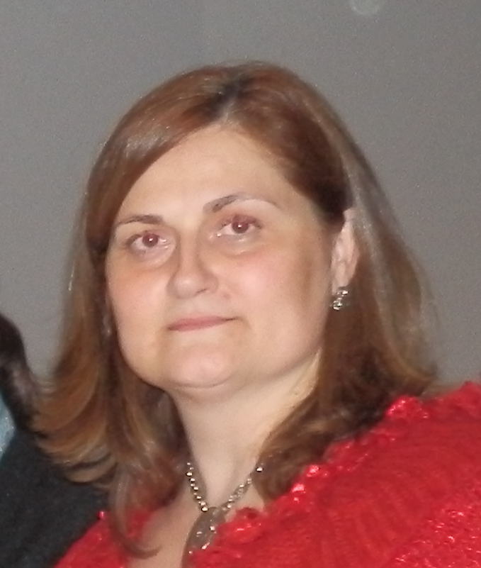
Nursing are her major interests, lecturing in these areas in Bachelor and Master Degrees. She is the coordinator for Internationalization of her Health School, participating in a TEMPUS project in which is doing research on VaKE strategy applied to nursing fields, participating in the conduction of several workshops on the theme (Portugal, Salzburg, Israel).
Email: mrosariopinto.essaude@gmail.com
Maria do Rosário Pinto has her expertise in medical surgical nursing. Her research has been on gender sociology (in MD context), Therapeutic Education (diabetic patients) and Complex Interventions effectiveness assessment. As an Academic, HIV, Cancer and Emergency and Critical Care in

Image

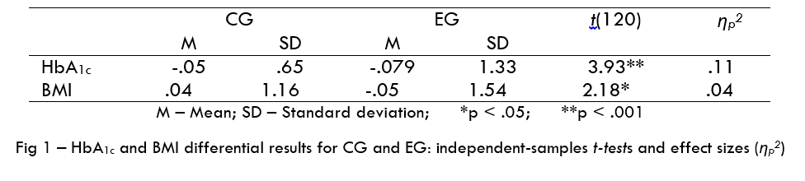

Notes/Comments:

Recent Publications (minimum 5)
- Pinto MR, Parreira P, Basto ML, Neves M & Monico L (2016). Assessing the effectiveness of a Complex Nursing Intervention, BMC Health Services Research, 16(Suppl 3):O89
- Pinto MR, Parreira P, Basto ML, Rei A & Monico L (2016). Lifestyle Educational Programme for primary care diabetic patients: the design of a complex nursing intervention, BMC Health Services Research 2016, 16(Suppl 3):O16
- Pinto MR, Parreira P & Basto ML, (2016). Health professionals’ skills development to implement Therapeutic Education. A case study with diabetes certificated educators, 5th EARLI SIG 13 Conference. Moral and Democratic Education – Program and Abstracts, July, pp. 17-18
- Pinto MR, Parreira P & Basto ML (2015). Investigar intervenções complexas em enfermagem. Resultados preliminares da fase de modelação de um programa educativo direcionado a pessoas com diabetes mellitus, Revista da Unidade de Investigação do Instituto Politécnico de Santarém (UIIPS), nov, 3 (5), pp. 415-431, ISSN: 218-9608
- Pinto MR, Parreira P & Basto ML (2014). Resultados da intervenção de enfermagem na adequação do estilo de vida das pessoas com Diabetes Mellitus tipo 2. Uma Revisão Sistemática da literatura. Revista da Unidade de Investigação do Instituto Politécnico de Santarém (UIIPS), nov, 5 (2), pp. 259-278 ISSN: 218-96

