The Effect of 20- HETE Antagonism on Myocardial Infarction of Metabolic Syndrome Rats
Petra Rocic, PhD, New York Medical College, USA Corinna Lozano, Student, Pawling High School,USA
Abstract (300 word limit)
20-hydroxyeicosatetraenoic acid (20-HETE) is an eicosanoid metabolite of that has a wide range of effects on the vascular system such as Collateral cell growth, vascular rebuilding of the heart. Metabolic Syndrome and 20-HETE have been shown to be correlated together.There is a higher concentration of 20-HETE in Metabolic Syndrome patients. With a higher concentration of 20-HETE patients with Metabolic syndrome have symptoms that are more severe. The effect of elevated 20-HETE is negative and can influence the cell growth after a Myocardial Infarction. Myocardial Infarction (MI) is another term for a heart attack. In previous studies, it shows an MI size increases with an elevated level of 20-HETE. During the study, the Metabolic Syndrome rats and control group of rats will be induced with an MI for about 30-minutes. After rats from both groups are given an MI and 20-HETE antagonist named 20-SOLA which counteracts 20-HETE levels will be given. 20-SOLA treatment was given to the rats at 48 hours, 1 week and 8 weeks. The results indicated that the AMPK antibody for both total and phosphorylated showed a significant decrease in 48-hour samples. 20-SOLA was found to create an equilibrium in 20-HETE levels in all tissue samples and significantly more in JCR MI rats. 20-SOLA aided the decrease in ischemia for both rats, but again results indicate a more reliable significance in JCR MI rats. These findings are relevant to the epidemic of cardiovascular diseases plaguing populations globally.
Image
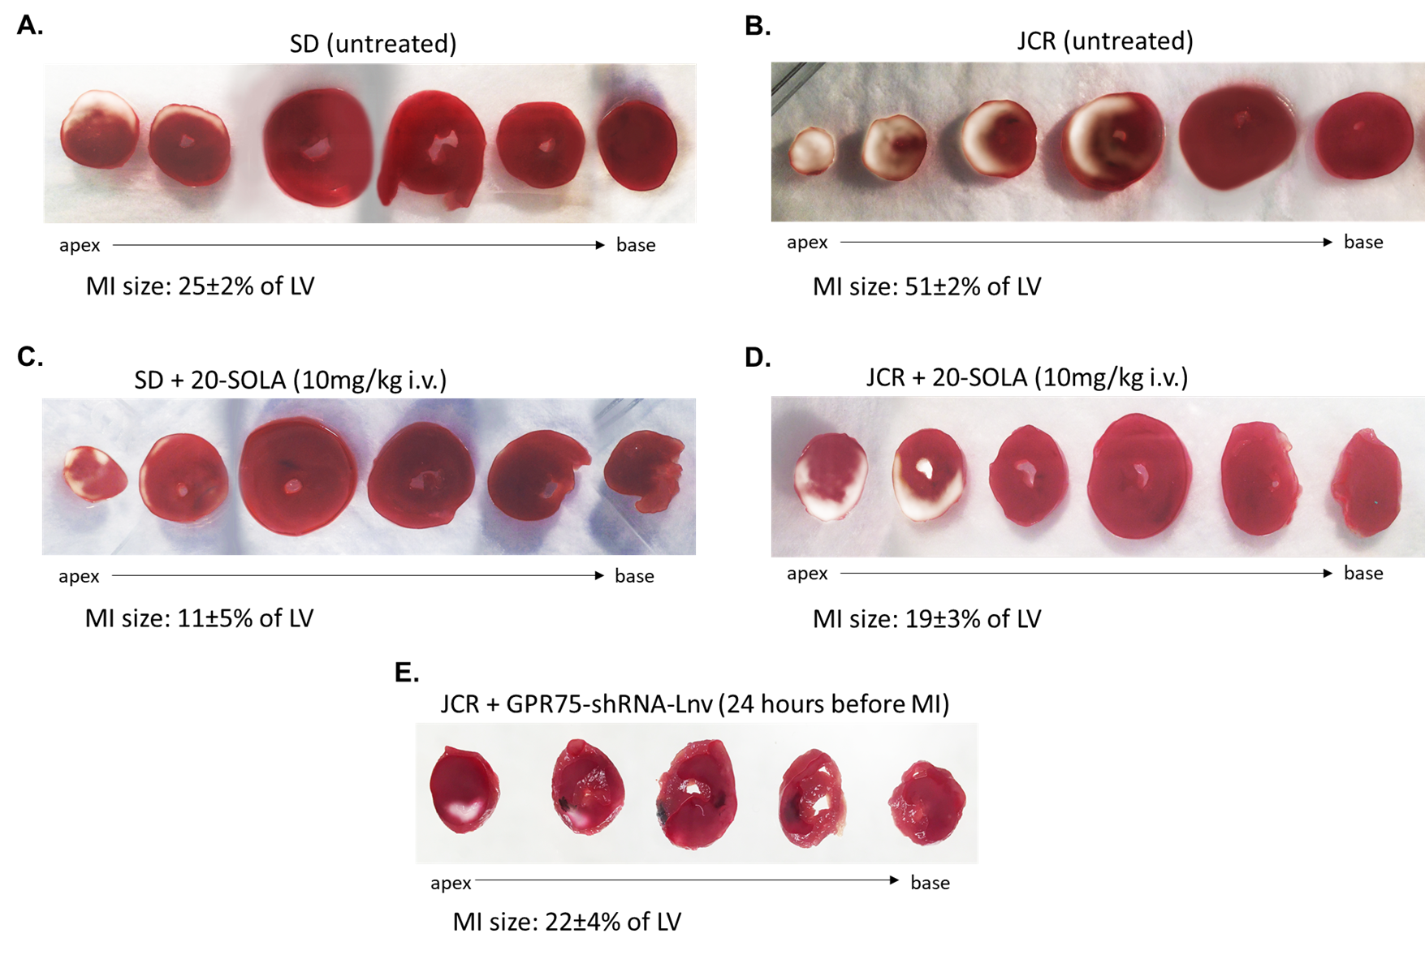
Recent Publications (minimum 5)
1. Kroetz DL, Xu F (2005). "Regulation and inhibition of arachidonic acid omega-hydroxylases and 20-HETE formation". Annual Review of Pharmacology and Toxicology. 45: 413–38. :. . 2. Fan, F; Muroya, Y; Roman, R. J. (2015). . Current Opinion in Nephrology and Hypertension. 24(1): 37–46. :. .
3. Bylund, J; Ericsson, J; Oliw, E. H. (1998). "Analysis of cytochrome P450 metabolites of arachidonic and linoleic acids by liquid chromatography-mass spectrometry with ion trap MS". Analytical Biochemistry. 265 (1): 55–68. :. .
4. Yurtoğlu,N.(2018).
Http://www.historystudies.net/dergi//birinci-dunya- savasinda-bir-asayis-sorunu-sebinkarahisar-ermeni-is yani20181092a4a8f.pdf. History Studies International Journal of History,10(7), 241-264. doi:10.9737/hist.2018.658
5. Supplemental Information 7: Complete western blot from Fig. 2F. (n.d.). doi:10.7717/peerj.3728/supp-7
Biography (150 word limit)
Corinna Lozano is a junior and a second year in the Science Research program run through SUNY Albany. Corinna is a member of peer leadership in which she is the secretary and the town of Pawling’s interact club. She is an active participant in soccer and dance team. When Corinna is out of school she enjoys spending time with her family and volunteering in her community.She is very dedicated to working hard in school and in her sports. Corinna is very friendly and enjoys meeting new people through school programs.Pawling High School is a great environment in which has been bettered by Corinna’s bright and cheery spirit. The teachers of Pawling High School all enjoy having Corinna as she is super helpful when her fellow peers have a problem. She is currently working with her mentor on her research project that focuses on the effects of 20-HETE.
lozanocorinna@gmail.com
Notes/Comments:

