Proposal: Art Therapy Presentation for The
16th International Conference on Mental Health & Psychiatry

Submitted to:
Conference Series LLC
35 Ruddlesway,
Windsor, Berkshire, SL4 5SF

February 28, 2022

PRESENTATION TITLE- Efficacy Study of The START UP!TM ART THERAPY TO REWIRE YOUR BRAIN School-Based Arts Intervention in American Indian Youth

ABSTRACT:

The START UP! Art Therapy SystemTM,, is a year long classroom therapeutic arts intervention, designed to heal historical and inter-generational trauma within American Indian Youth as prevention and early intervention, bringing mental health into the classroom as an integrated part of the educational curriculum. The START UP! Art Therapy Facilitators Manual, co-authored by Carey MacCarthy, MA, ATR, LPCC and Linda Chapman MA, ATR-BC, was based on the work of Linda Chapman in Neurodevelopemental Art Therapy (NDAT) and her book, Neurobiologically Informed Trauma Therapy with Children and Adolescents: Understanding Mechanisms of Change (Chapman, 2014). The START UP! Art Therapy SystemTM is an evidence-based, culturally relevant healing technique, which neurobiologically builds and strengthens neural pathways in the brain for optimal physiological functioning; healing PTSD, depression, anxiety, ADD/ADHD, which may lead to violence, substance abuse and suicide, also instilling healthy boundaries, healthy relationships and community building. South Dakota State University and I conducted a research study titled “Efficacy Study of a School-Based Arts Intervention (Start Up!) in American Indian Youth.” Pre-test//post-test measurements using three instruments measuring reduction of trauma and depressive symptoms and substance use were administered, as well parent/guardian questionnaires. This research study demonstrated the dramatic reduction of trauma symptoms, including anger, depression, anxiety, dissociation and sexual thoughts, and determined the START UP! Art Therapy SystemTM, school-based arts intervention as an evidence-based trauma treatment specifically for the American Indian population.
REFERENCES

Chapman, L. (2014). Neurobiologically Informed Trauma Therapy with Children and Adolescents: Understanding Mechanisms of Change. New York, NY: Norton.
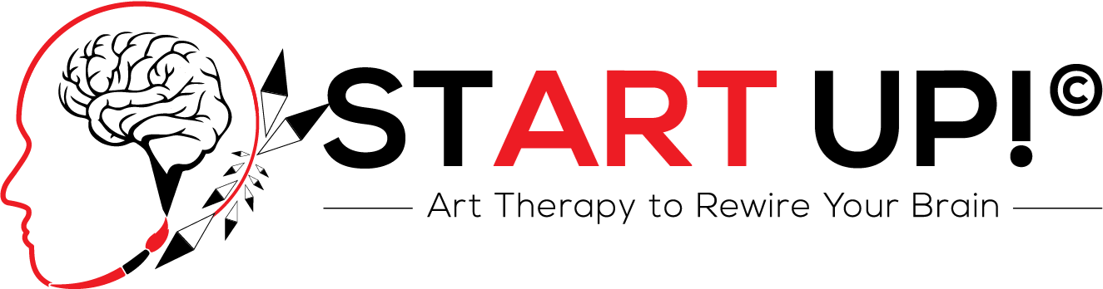
415-947-9608 careymaccarthy@gmail.com (website under construction)

START UP! Art TherapyTM utilizes a whole-brain healing approach in Neurodevelopmental Art Therapy (NDAT) for acute and chronic trauma treatment, coping skills and empowerment. This holistic model is an evidence-based, trauma- informed, Culturally Competent, neuroplasticity-based approach, demonstrating its efficacy in neurobiologically rewiring the brain from trauma, resulting in long-term symptom reduction of PTSD, depression, anxiety, ADD/ADHD, suicide prevention and other maladaptive stress responses. START UP! can be used in the K-12 Classroom as prevention and early intervention, in private practice for mental health professionals/ coaches and at home for parents and children. START UP! Art TherapyTM is culturally competent/relevant and promotes preservation of Spiritual and Cultural Heritage in Native American and other underserved communities.
TRAININGS:
Training seminars are offered to mental health professionals/coaches, educators, and parents involved in the health and well-being of children, adolescents and adults. Training professionals in the START UP! Art Therapy System will meet the growing and urgent need to provide evidence-based, trauma-informed and long-term trauma treatment solutions to address mental health across ALL ages and cultures..
BIO:
CAREY MACCARTHY, MA, ATR, LPCC,Founder/Chief Executive Officer (CEO) is a Registered Art Therapist with the Art Therapy Credentials Board (ATCB), and a Licensed Professional Clinical Counselor through the Board of Behavioral Sciences (BBS), and professionally active within the Art Therapy field since 2001. She is the Founder, CEO, and Facilitator of START UP! Art Therapy To Rewire your BrainTM and is the co-author of START UP!TM: A School-
Based Arts Curriculum for Native American Youth and ALL Cultures: Interventions for Development and Learning, Facilitators Manual (Amazon Kindle 2017). Carey is a contributing author to the American Art Therapy Association Journal, presenter, lecturer, and researcher. Carey has practiced in the Art Therapy field with diverse populations, specializing in trauma and Native American Culture, and is trained in the Red Road Approach to Healing with Lakota/Dakota/Nakota Tribes.
