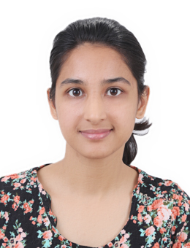

Title: Exploring Sexual Desire in Middle aged women in Indian Context
Author: Meharmeet Kaur, Research Scholar, Department of Psychology,
University of Delhi, New Delhi, 110007
Abstract
Sexual desire is one of the basic instinctual and driving forces of human behavior. The word desire is usually used interchangeably with emotion. But, the legit understanding of desire would be, a “bodily urge’’ similar to other innate human needs such as; hunger, thirst. Along with physiological formulation, sexual desire has some emotional and psychological dimensions which together interact and manifest in human sexual behavior. As, quoted by Dr. Robenski , “In many ways we can't control what we desire because it is a hard-wired emotional and physiological response." The very renowned psychoanalytic school of thought believes that desire is the consequence of redirected sexual energy of what is known in psychoanalytic terminology is, “libido’’ towards other goal directed behaviors. Sexual desire is primarily physiological in nature but what follows it, is an “emotional state’’ which is further manifested explicitly. (Wolfson, E., 2010)
Sexual desire in women is less spoken of, especially in Indian context, presumably due to the stigma associated with it. There is an air of myth surrounding over middle aged women regarding low sexual desire and activity. But on the contrary, researches have pointed out that there is an increase in sexual satisfaction in majority of middle aged women. This paper aims to explore the dynamics and intricacies of sexual desire in married middle aged women. The data will be collected through semi structured interviews from a sample of 10 women hailing from Punjab and New Delhi. The age range would be 40-60 years. Narrative inquiry would be employed.

Biography
Meharmeet Kaur is a doctoral scholar at Department of Psychology, University of Delhi, New Delhi. She is working in the area of Women mental health. She has published and presented papers to her credit in the same , and other areas such as, as art therapy, mental health of transgenders in India. She has interned in hospitals and drug de -addiction centres. She aims to expand her knowledge and expertise in the areas of gender, sexual desire and sexuality, and women mental health.
Presenting author details:
Full name: Meharmeet Kaur
Contact number: 9877369229
Email id: meharkt94@gmail.com
Category: Oral presentation

