Title: Protecting Our Youth: Conversion Therapy & Institutional Abuse

By Samantha I. Gerson (ACSW/LMSW)

Abstract
Institutional Abuse is a national epidemic that our country has chosen to ignore. Many parents send their children to Residential Treatment Facilities when the child's behavior becomes too much for the parent to handle. Other parents send their children to these facilities when the child comes out to them and they want a quick fix to what they view as a problem. While treatment facilities and educational reparative environments can be a great resource and beneficial to those they offer treatment to, many abuse their power and physically, emotionally, and sexually abuse the children they are there to care for. This epidemic is ongoing, and many lawsuits have been filed, but the abuse has not stopped. Advocates have worked with legislation to change laws, but this work has not been enough. This is true of Conversion Therapy as well, as it has not been outlawed federally. In fact, it is a common practice in many of these facilities. The truth about conversion therapy is frightening and this workshop will touch on the facts, details and all other information to what occurs behind Residential Facility’s closed doors. Television and other forms of media often make these types of environments look fun, friendly, and safe; but the truth is they often result in youth leaving with PTSD, physical disorders, and sometimes, death (by suicide). This workshop will help attendees become familiar with institutional abuse and how they can advocate against it; in addition to connecting survivors to resources. This workshop will be from a Social Work lens, and very interactive.

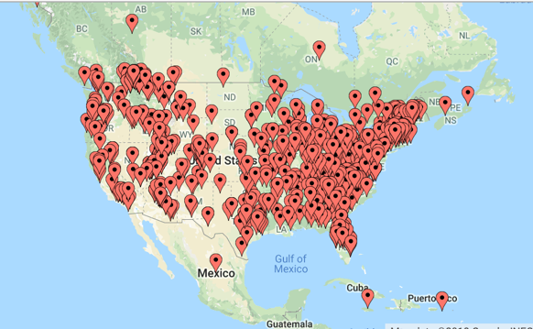
Recent Publications (minimum 5)
- Connor, D. F., Doerfler, L. A., Toscano, P. F., Volungis, A. M., & Steingard, R. J. (2004). Characteristics of children and adolescents admitted to a residential treatment center. Journal of Child and Family Studies, 13(4), 497-510.
- Herek, G. M., & Garnets, L. D. (2007). Sexual orientation and mental health. Annu. Rev. Clin. Psychol., 3, 353-375.
- Marshal, M. P., Friedman, M. S., Stall, R., King, K. M., Miles, J., Gold, M. A., ... & Morse, J. Q. (2008). Sexual orientation and adolescent substance use: a meta‐analysis and methodological review. Addiction, 103(4), 546-556.
- McDaniel, J. S., Purcell, D., & D'Augelli, A. R. (2001). The relationship between sexual orientation and risk for suicide: Research findings and future directions for research and prevention. Suicide and Life-Threatening Behavior, 31(Supplement to Issue 1), 84-105.
- Morrow, D. (2004). Social work practice with gay, lesbian, bisexual, and transgender adolescents. Families in Society: The Journal of Contemporary Social Services, 85(1), 91-99.

Biography (150 word limit)

Samantha Gerson is a Clinical Social Worker living in Los Angeles, CA. Her studies all had an emphasis on trauma and reparative educational environments. She is currently working full time as an outpatient therapist, as well as launching her own Non-Profit- UnBroken. UnBroken serves survivors of Institutional Abuse and Conversion Therapy, providing them psychological, legal and vocational resources at no cost. The crux of Samantha’s life work is to abolish conversion therapy entirely.

Email: sigerson217@gmail.com
- Samantha Gerson
- sigerson217@gmail.com
- 310-980-3118
- linkedIn.com/us/sigerson217
- facebook.com/sgerson1
- Oral Presentation/Workshop
- 07/26/1993
- 430 S Fuller. #3F, Los Angeles, CA 90036

