Expectations from ‘ready to marry’ Indian youngsters; Implication towards Pre marriage education services for ensuring couple mental health.

Bino Thomas, Asst Professor, NIMHANS, India

Abstract
Marriage as an institution in India has a major influence on lives of individuals and their families. Recent years are showing increasing number of divorces and marital conflicts. The struggles couple goes through in saving difficult marriages have prompted to initiate preventive programmes for the youth who have decided to get married. 96 Christian youth, whose marriages fixed, attended a compulsory marriage education programme organized by a church in Southern India. They were examined to understand their expectations from marriage as they were going to get married in two months of time from the time of pre marriage course before the course began. Average age of the participants was 27.5 years. Lowest age of marriage was 23 years and upper age was 37 years. 51 males and 45 females attended the programme. On an average females had 16.5 years of education and males 16.2 years of education. 21 of them reported having severe issues in their families especially between their parents, 17 moderate level and 12 reported to have minimal problems making 51.5% of the participants to have seen problems among their parents. 19.6% reported to have absent parent in their growing years. 42.3% of them reported to have concerns in sexual practices, which needs to be explored further. 38.1% knows the partner only in three months of time, 14.4% less than seven months and ten percent less than a year. The information and guidance they require from a pre marriage education services vary from the way to understand partner to deal with in laws and relationship building and problem solving strategies. The results give us focus to develop pre marriage guidance programme in an educational level as well as therapeutic level considering the risk groups who have had impacts from the marital issues of their parents and family issues.

Recent Publications (minimum 5)
- Bino Thomas. Marriage Preparation Programme: Expressed Needs of Young Adults. Vinayasadna Dharmaram J Psycho-spiritual formation. 2017; 8 (1). ISSN 09760946. 43-56
- Diptty Joseph and Bino Thomas (2017).Life skills development training for adolescent girls at risk- Rescued Devadasi girls in Karnataka. Arth-Journal of social Sciences. 16(1).ISSn 0975-329X. doi 10.12724
- Bino Thomas. (2014). Preparation for parenthood programme: Experiences from Southern India. International Review of Psychiatry. 26(4). 493-499. ISSN 0954-0261.
- Bino Thomas, Parthasarathy R and Bhugra D. (2014) Integrated skills for parenting the adolescents: an intervention to strengthen parent-adolescent relationship. Revista de Neuro- Psiquiatria. 76(4). 236-245.ISSN 1600-7394.
- Bino Thomas (2012). Treating Troubled Families: Therapeutic Scenario in India. International Review of Psychiatry. 24(2). ISSN 0954-0261. Shock 29:377.

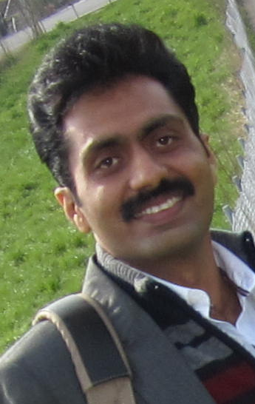
Dr Bino Thomas is a consultant to Child and Adolescent Psychiatry and Asst. Professor of Psychiatric Social Work, NIMHANS, Bangalore. He is a trainer, practitioner, supervisor and researcher in the area of couple counseling, marriage preparation programme, parenting skills development programmes, parent guidance, Family therapy, Parent guidance and Youth Guidance on relationships. His interests are in hild, adolescent and youth and public mental health. He guides PhD and MPhil research programmes at the National Institute of Mental Health and Neuro Sciences, India.
.
Email: binonimhans@gmail.com
Phone Number: +91 9986030098
Track Name:
Type of Presentation: Oral
Notes/Comments:

