

Proton Exchange Membrane erect Sulphonated Novel p-PBI-Bz-4-F Blend Membrane Nano yielding for High Temperature
MD MOFASSERUL ALAM, PhD Candidate, Functional Membrane Lab, USTC, China

Abstract (300 word limit)
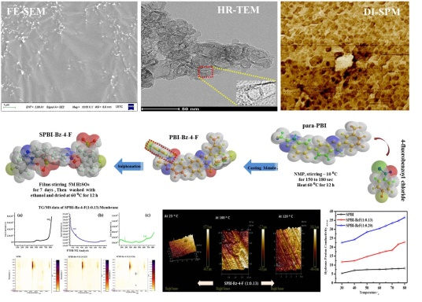
To optimize the thermal and chemical stability of polymer base on p-PBI at high-temperature in electrochemical devices has created attention on recent research. A significant impact on carbon oxidation has formed due to temperature. para-Polybenzimidazole is a derivative form of aromatic tetraamine, and aromatic dicarboxylic acid & 4-Fluorobenzoyl chloride is a function of the carbonyl group with a benzene ring. Herein, Proton exchanges membranes (PEMs) from p-PBI and 4-Fluorobenzoyl chloride have been explored for High-temperature implementation in the chemical energy conversion system. Attempted behaviors such as the membrane formation, AFM (SPM) morphology at a different temperature, Hydrous conductivity around 85⁰C temperature, Thermo-Mechanical-Chemical stability, and TG-MS & TG-FTIR analysis at high temp for carbon oxidation rate, and low deformation as well. $1_{H}$ , ${19}_{F}$ spectra, and FTIR-(ATR) were following to sustain the functional group into the matrix of the membrane. SEM and HRTEM used to check the topology of the prepared membranes. Roughness study of the prepared membrane (using SPM as AFM) was investigated at a different temperature to preform excellent Ra value. The thickness of membranes about (28-52) µm and conductivity at (30-85)⁰C membranes approximately (5.31-38.08) mScm⁻¹ in hydrous conditions were examined. These membranes have excellent oxidative stability at 60⁰C as a maximum of 128 hrs in (Fenton Test: 30% H₂O₂ through 9 ppm anhydrous Fe²⁺ salt) solution. Moreover, TG-MS & TG-FTIR executed low emission of CO & CO₂ and low deformation at the high-temperature performance. The membrane SPBI-Bz-4-F(1:0.13) & SPBI-Bz-4-F(1:0.20) will selected for high-temperature proton exchange through pilot-scale fuel cells being further aspects.

Key words: proton exchange membrane; para-polybenzimidazole; 4-Fluorobenzoyl chloride; high-temperature; conductivity; HRTEM; SPM; TG-MS/FTIR

Graphical Abstract

Recent Publications (minimum 5)
- M. M. ALAM; Epoxide Functional Temperature-Sensitive Semi-IPN Hydrogel Microspheres for Isolating Inorganic Nanoparticles. Advances in Polymer Technology, Vol. 37, No. 1, 2018 (Accepted November 22, 2015)
- Innovative anion exchange membrane achieved via mono & di-functional ammonium moieties (1-naphthol derivatives) for Electro-desalination; Submit soon.
- Novel quaternized moiety grafting through Br-PPO for innovative AEM via TIPS as Anion (bisulfite) selective-electrodialysis; Submit soon.
- Proton Exchange Membrane erect Sulphonated Novel p-PBI-Bz-4-F Blend Membrane Nano yielding for High Temperature; Submit soon.

Biography
Md Mofasserul Alam is a PhD Fellow at the University of Science and Technology of China. He earned his B.Sc. (2011) And M.Sc. in Organic thesis (2012) from Rajshahi University, Rajshahi-6205, Bangladesh at the Department of Chemistry under the supervision of Professor Dr Hasan Ahmad. He published an article on the Journal of Advances in Polymer Technology in 2015 and then he got CAS-TWAS President fellow scholarship-2017 for further researching on Ion Exchange membrane under the supervision of Professor Dr Xu Tongwen. Moreover, he interests in innovative works.

Presenting author details
Full name (As per the passport): MD MOFASSERUL ALAM
University/Industry/Organization name: University of Science and Technology of China
Designation (Director/Prof/Assistant or Associate prof/Researcher/Student): PhD Candidate
Country: China
Mobile number (country code – number): +8615256276350
Email: mmalam@mail.ustc.edu.cn
Track number: https://membranescience.europeannualconferences.com/call-for-abstracts.php (For track number follow this link)
Category (Oral presentation/ Poster presentation/Young researcher forum/E-poster): Oral presentation
Research interest: Membrane methodology; Membrane Ions Separation; Novel application etc.
Your profile page URL in your department:
Year of birth:
Linked In/Facebook/twitter account:

Note: Please fill up the Red mark fields so that it would be easier for us to cite your details in the conference particulars. (Please do not forget to fix your photo and Logo above the title)

