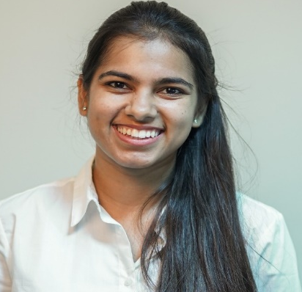


Paste your Logo here

Title: Formulation and Optimisation of Disintegrating Chlorhexidine tablets for Immediate use
Name: Simrandeep Kaur*, Vivek Ranjan Sinha

University Institute of Pharmaceutical Sciences, Panjab University, Chandigarh, India

Formulation and Optimisation of Disintegrating Chlorhexidine tablets for Immediate Use: In the present study disintegrating tablets containing chlorhexidine as an active ingredient has been prepared to be used as a mouth wash. The chlorhexidine disintegrating tablets when dispersed in water, it disintegrates immediately within seconds and acts as a mouthwash liquid. It is prepared as alternate to liquid mouthwashes as it would dispense drug uniformly and would be convenient to use and carry and it is a stable form as compared to liquid form. The disintegrating tablets were prepared by direct compression method using crospovidone as super-disintegrant and hydroxypropyl cellulose as a binder. The optimization of formulation parameters such as the concentration of super disintegrant and binder was done by using quality by design approach with of help of Design Expert®. The evaluation parameter for optimization was disintegrating time and wetting time. After optimization with the help of design space, the best formulations were selected which have minimum disintegrating time and wetting time. The disintegration time and wetting time for the optimized formulation on the basis of design space were found to be 24 seconds and 32 seconds respectively.

Biography

I am currently pursuing Master of Pharmacy (Pharmaceutics) from University Institute of Pharmaceutical Sciences, Panjab University, Chandigarh and I have done my graduation from the same institute. I have also presented poster in DISSO-INDIA 2019 International Symposium.

