Abstract
First reported case of Rivaraxoban used for primary prophylaxis causing massive spontaneous hemothorax
Authors: K. Bogdansky, M. Ghias, R. Mikkilineni

Introduction:
Massive spontaneous hemothorax is a rare entity that is often caused by trauma or iatrogenic secondary to procedures involving the chest wall and much less frequently due to anticoagulant use. To the best of our knowledge our case if the first reported case of massive spontaneous hemothorax caused by Rivaroxaban use for primary stroke prevention from atrial fibrillation.

Case Presentation:
73-year-old male with past medical history significant for coronary artery disease, diabetes mellitus type 2, hypoerl;ipidemia, hypertension, atrial fibrilation on Xarelto presented to emergency department for worsening SOB for 3 days. Initially symptoms were on exertion only but progressed to shortness of breath at rest and with conversation. CXR revealed large left pleural effusion with opacification of left hemithorax.
Pt also found to have significant coagulopathy with elevated INR of 5.5, renal failure and transaminitis.
Pt had a CT Chest that was performed as an outpatient for follow up of lung nodule which revealed a 21 x 9 mm atherosclerotic ulcer, possibly penetrating, in the proximal descending thoracic aorta. Given patients presentation there was concern that patient developed hemorrhage into left hemithorax causing multi-organ dysfunction.
A CTA was performed that revealed Large left hemothorax with significant associated mass effect upon the mediastinum with mediastinal hemorrhage. There were Irregular penetrating ulcers in the proximal descending thoracic aorta which were suspicious for the source of the hemorrhage.
Pt underwent a TEVAR procedure for endovascular stent graft placement although intra-operative angiogram did not reveal any extravasation of contrast. Pt also required resuscitation with fluids, vasopressors, and blood products during hospital course. Pt had a chest tube placed with evacuation of about 1.8L of gross blood and near total re-expansion of left lung. Other etiologies of spontaneous hemothorax were excluded and pleural fluid analysis was consistent with hemothorax. Pt during hospital course also required urgent hemodialysis for contrast induced nephropathy, volume overload, oliguria which resolved by discharge.
Discussion:
Our case of massive hemothorax was complicated by our initial concern of hemorrhage from patient’s penetrating atherosclerotic ulcers (PAU). Although patient did get an endovascular stent graft placed due to concern for mediastinal hemorrhage on initial CTA, an intra-operative angiogram did not reveal any extravasation of contrast. This shows that our case was a massive hemothorax caused by our patient being on anticoagulation for primary prophylaxis for stroke prevention in the setting of atrial fibrillation and not aortic disease or trauma.

Conclusions:
After extensive workup and treatment we concluded our patient had a massive hemothorax caused by him being on Rivaraxoban.

Clinical Implications:
Given the increasing use of Rivaraxoban and other NOACs for both treatment and prevention of VTE there needs to be increasing suspicion for hemothorax when evaluating a non-traumatic pleural effusion in patients taking a NOAC.

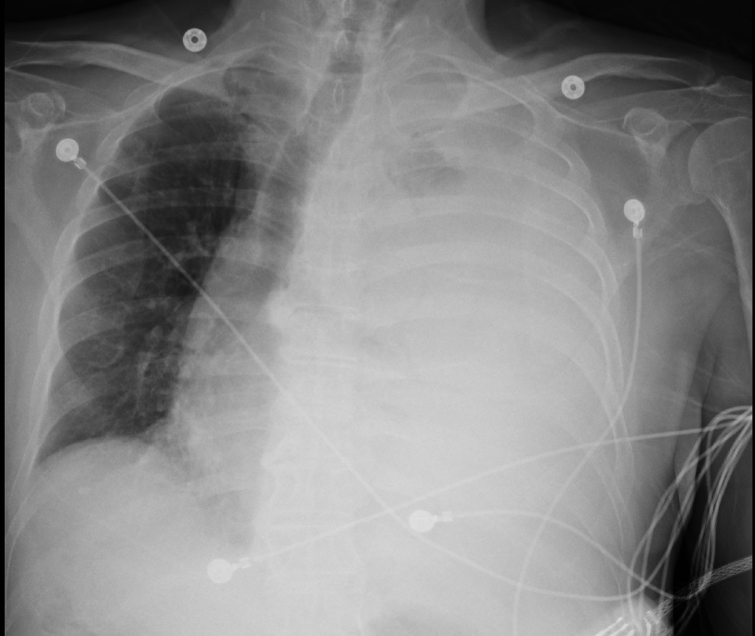
Figure 1: Initial chest x-ray demonstrating near complete opacification of L hemi-thorax with mediastinal shift to the right

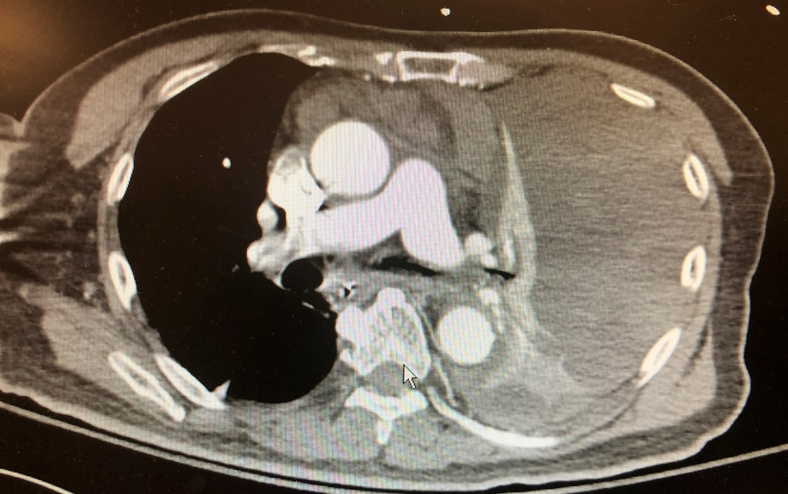
Figure 2: CT Angiographhy demonstrating fluid filled L hemi-thorax and a suspected mediastinal hemorrhage and L sided mediastinal shift compatible with initial CXR. Hounsfield units of fluid on CT compatible with blood.

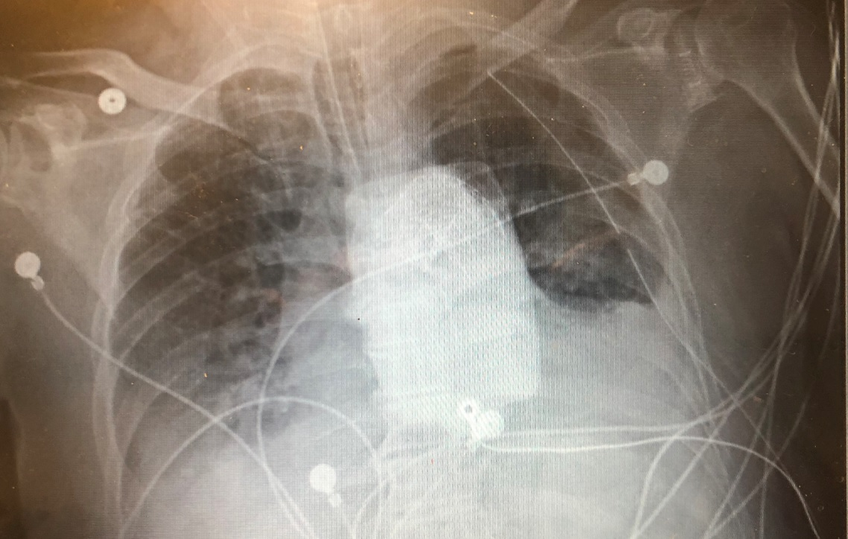
Figure 3 (above) and Figure 4 (below): Chest x-ray performed immediately after L sided chest tube placement with near total re-expansion of L lung and evacuation of approximately 1.8L of blood product from L hemi-thorax (below)
