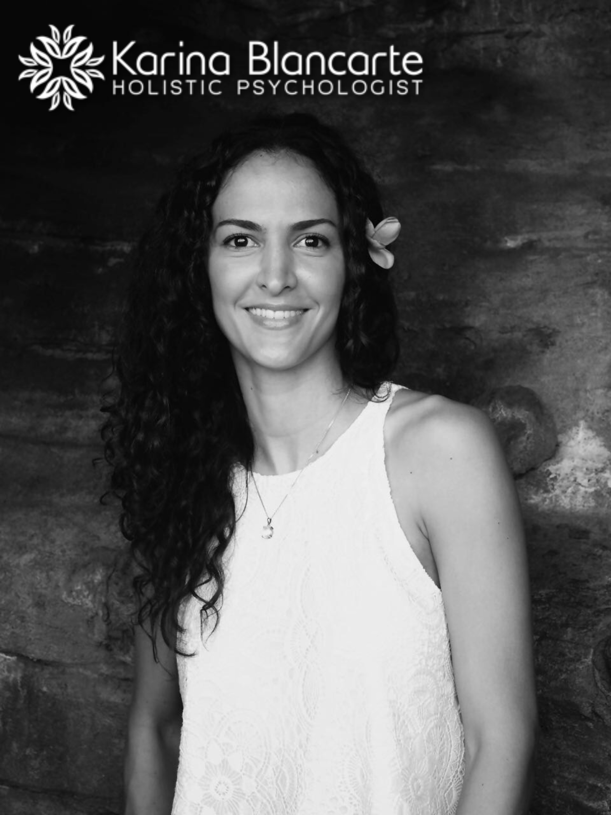

Title: Women’s Holistic Psychology. Breaking stereotypes in understanding female’s psychology in the 21st century.

Dr. Karina Blancarte Figueroa
International University of Professional Studies
Department of Holistic Psychology (Researcher)

According to The Mayo Clinic, Pre-Menstrual Dysphoric Disorder (PMDD) is a severe, sometimes disabling extension of premenstrual syndrome (PMS). Although regular PMS and PMDD both have physical and emotional symptoms, PMDD causes extreme mood shifts that can disrupt your work and damage your relationships.
PMDD is considered a mental disorder according to the Diagnostic and Statistical Manual of Mental Disease (DSM-5), however, the causes of PMS and PMDD have not been found.

As a matter of fact, Premenstrual syndrome (PMS) is a medical condition that affects some women of childbearing age. More than one in three women suffer from PMS. One in 20 suffer so severely that their lives are seriously affected.

The lack of understanding and information about what women’s cycle is, is affecting thousands of women causing frustration, discrimination and self-judgment creating an inner and outer lack of balance that most of the times ends up in severe depression affecting women physically, emotionally and mentally.
With the speed we live on a daily basis there’s been acceleration on the levels of depression and anxiety and other mood disorders. Many of them have turned to medication for relief. The use of anti-depressants has increased nearly 400% since 1990.

The program is designed to cover: A shift in the perception of what women’s cycle is. Understanding the energetic (Energy Psychology) point of view of women’s cycle providing information about the advantages of it, breaking with stigmatized patterns as well as hints to use it as a tool for a balanced and mindful lifestyle.

Biography

Karina Blancarte Figueroa has completed her M.A. in Holistic Psychology and is currently a Ph.D. candidate from The International University of Professional Studies. She is the owner of The Holistic Center, which provides psychotherapy, Reiki Treatments and Yoga Classes. Her extensive yoga, meditation, and scientific research have taken her to the Amazonian jungle to test and explore the ancient traditions, environmental healing medicine's impact and to The Himalayas to learn the ancient yoga practices reviving wisdom of yogis. She has delved into science to decode the power of inner energy and mastered personal and social transformation, successfully taking people from suffering to loving, appreciating and unleashing their potential in life.

Author Details

Dr. Karina Blancarte Figueroa
Contact number: +86 1500 183 2474
LinkedIn: Karina Blancarte
Session name: Women’s Holistic Psychology
Category: Psychology

