Title: Accuracy and traceability in the calibration of insulin pumps
Elsa Batista, João Alves e Sousa, Portuguese Institute for Quality,Portugal

Abstract (300 word limit)

Flow measurements are critical in sectors like health, industry, chemistry and pharmaceutics. In the microflow range, there are several applications such as process technology, drug development, and special health-care applications as organ-on-a-chip technology or implantology, some of them developed very recently. The majority of the instruments used for the specified applications are not sufficiently studied in terms of their accuracy and traceability. It is, therefore, necessary to develop specific calibration methodologies for those instruments working at the specified low range with adequate accuracy and uncertainty values. During the last year, under the framework of the European Metrology Programme for Innovation and Research (EMPIR) - project Metrology for Drug Delivery -, the gravimetric and optical methods have been successfully employed on the preliminary calibration of insulin pumps and other microfluidic devices from 1000 μL/h down to 1 μL/h in the Volume and Flow Laboratory of the Portuguese Institute of Quality. One type of insulin pump was tested at 1 U/h representing 10 μL/h, where U means a unit of insulin. The average error obtained from these measurements was 8 % and the uncertainty 44 %. After analyzing all uncertainty components, it was verified that the flow variability is the largest source.
Although preliminary, the calibration of the studied insulin pump carried out during the course of this work shows beyond doubt that under continuous use, the patient will not get a continuous steady dose of insulin and this can potentiate a severe health problem, if not death. This variability is possibly due to the stepper motor operating mode. At these small flow rates the infusion is imposed in short positive-displacement pulses via the lead screw connected to the stepper motor which instead of continuously, operates for only short periods of time.
Recent Publications (minimum 5)
1. Batista, E. et al., Comparison of infusion pumps calibration methods, Meas. Sci. Technol. 2017, 28
2. Batista, E. et al., Assessment of drug delivery devices, Biomed. Eng. 2015, 60 (4); 347–57
3. Batista E, Almeida N, Godinho I and Filipe E, Uncertainty Calculation in Gravimetric Microflow Measurements (AMCTM X) 2015, vol 86, pp 98–104 (London: World Scientific)
4. Furtado, A., Batista, E., Ferreira, M.C., Godinho, I., Lucas, P. Uncertainty calculation in the calibration of infusion pumps using the comparison method, (2017), Book of proceedings of AMCTM XI e IMEKO TC21, Glasgow, Scotland 2017-08-29 a 31
5. Batista, E., Paton R. The selection of water property formulae for volume and flow calibration, Metrologia, 2018, 55, 731-746
6. Ferreira M.C., Batista E., Godinho I., Improving measurements in metrology for health, OIML Bulletin volume LIX number 3 July 2018

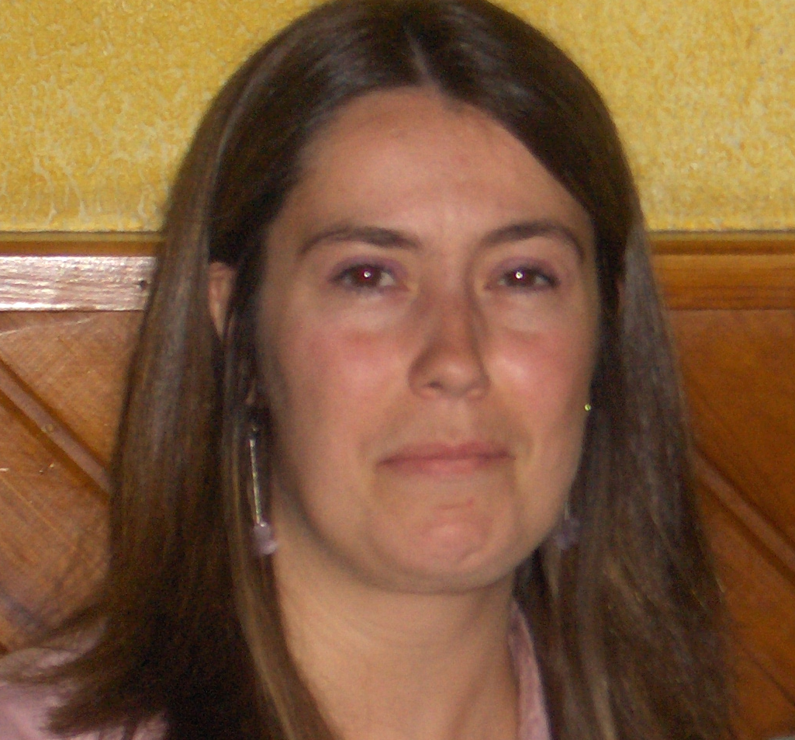
Biography (150 word limit)
Elsa Batista has her expertise in volume and flow measurements. She has a master degree in Applied Chemistry by the University of Lisbon and in now a PhD Student in Mechanical Engineering under the topic microflow measurements methodologies. She has 20 year experience in the Volume and Flow laboratory of the Portuguese Institute of Quality (IPQ). She has participated in several research projects in the field of metrology for microflow devices and is now the coordinator of one of this projects - Metrology for drug delivery under the European Metrology Programme for Innovation and Research. She has implemented and developed the microflow calibration setup of IPQ over the last 5 years.

Email:ebatista@ipq.pt
- Full Name: Elsa Maria Isqueiro Batista
- Personal Email: ebatista@ipq.pt
- Mobile Number: +351917180889
- Linked In: Elsa Batista
- Facebook:
- Session Name/ number: Diabetes and Obesity Drug discovery and therapy
- Category: (Oral presentation/ Poster presentation) Oral
- Date of Birth: 05-11-1976
- Postal Address: Rua António Gião, 2 2829-513 Caparica Portugal

Notes or Comments:

