Isoniazid-phenolic acid co-drugs: Synthesis, pharmacokinetics and investigation of antimycobacterial and hepatoprotective potential
Neha V. Bhilare, Department of Pharmaceutical Chemistry, Arvind Gavali College of Pharmacy, Satara-415004, Maharashtra, India
Suneela S. Dhaneshwar, Amity Institute of Pharmacy, Amity University Uttar Pradesh, Gomti Nagar Extn, Lucknow-226028, India
Kakasaheb R. Mahadik, Department of Pharmaceutical Chemistry, Poona College of Pharmacy, Bharati Vidyapeeth University, Erandwane, Pune-411 038, Maharashtra, India

Abstract
Statement of the Problem: According to WHO statistics of 2018, there were an estimated 1.2 million TB deaths among HIV-negative people. Isoniazid is being used for more than 60 years in the treatment of this deadly disease, but emergence of resistance towards this drug and metabolic and morphological aberrations in the liver have raised serious concerns regarding its continued use in future. Methodology & Theoretical Orientation: To overcome these hazardous effects, a novel hepatoprotective and antimycobacterial prodrug strategy was developed by combining INH with phenolic acids (gallic acid, syringic acid & vanillic acid) as antioxidant promoeities for probable synergistic effect. Prodrugs synthesized by Schotten Baumann reaction were characterized by spectral analysis and in vitro and in vivo release studies were carried out using HPLC. Their hepatoprotective potential was evaluated in male Wistar rats by performing the liver function tests, oxidative stress markers and histopathology studies. The antimycobacterial efficacy of prodrugs was examined in terms of its ability to decrease the lung bacillary load in Balb/c mice infected intravenously with Mycobacterium tuberculosis. Findings: All the prodrugs were effective in abrogating oxidative stress and re-establishing the normal hepatic physiology. Especially the effect of prodrugs of INH with gallic acid and syringic acid in restoring the levels of enzymes superoxide dismutase and glutathione peroxidase and abrogating liver damage was noteworthy. The findings of antimycobacterial activity assessment evidently demonstrated that prodrugs were as potent as INH in lowering the mycobacterial load in mice. Conclusion & Significance: The outcome of this investigation confirmed that the reported prodrugs can offer desirable safety and therapeutic benefit in management of tuberculosis.

Image
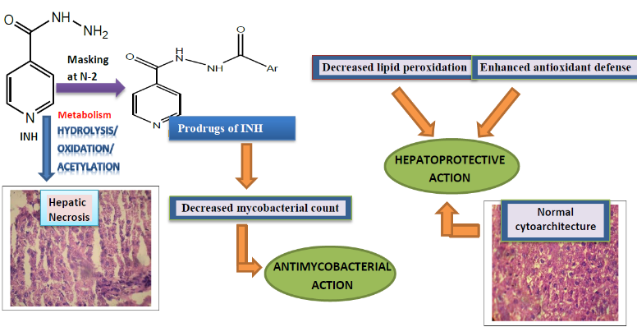
Recent Publications (minimum 5)
- Bhilare NV, Dhaneshwar SS, Sinha AJ, Kandhare AD, Bodhankar SL. Novel Thioester Prodrug of N-acetylcysteine for Odor Masking and Bioavailability Enhancement. Curr Drug Deliv 2016; 13: 611-620
- Bhilare NV, Dhaneshwar SS. Synthesis and evaluation of morpholinoethylester conjugate of N-acetylcysteine in ovalbum ininduced airway hyperresponsiveness in Sprague dawley rats. Lett Drug Des Discov 2016; 13: 1-7
- Bhilare NV, Dhaneshwar SS, Mahadik KR. Phenolic acid-tethered isoniazid for abrogation of drug-induced hepatotoxicity: design, synthesis, kinetics and pharmacological evaluation. Drug Deliv Transl Res 2018; 8: 770-779
- Bhilare NV, Dhaneshwar SS, Mahadik KR. Amelioration of hepatotoxicity by biocleavable aminothiol chimeras of isoniazid: Design, synthesis, kinetics and pharmacological evaluation. World J Hepatol 2018; 10(7): 496-508
- Prodrug for enhancement of lipophilicity” Neha Bhilare and Suneela Dhaneshwar. In Recent Advancement in Prodrugs, CRC Press, USA, 2020

Biography
Dr. Neha V. Bhilare has completed her M.Pharm in Pharmaceutical Chemistry at the Bharati Vidyapeeth’s Poona College of Pharmacy, India in 2014. She recently received her Ph.D. degree from the same institution (Nov. 2019). She is currently associated with Arvind Gavali College of Pharmacy, India and is actively involved in research on prodrug design and development. She has published papers in SCI journals with good impact factors and also authored a chapter on “Prodrugs for Lipophilicity enhancement” (In book “Recent advancement in Prodrugs”-CRC Press Taylor and Francis Group, 2020).
Full Name:Neha V. Bhilare
Tel: 8446836451
Session Name/Number: Drug delivery chemistry
Category: Poster presentation
Email: bhilareneha@rediffmail.com

