Modified paracetamol with potent antimicrobial activities
Mohamed abdou S. El-Tabl*¹, Abdou S. El-Tabl² and Reham ali ³
¹Menoufia university hospital, Shebin El-Kom, Egypt.
2,3Department of Chemistry, Faculty of Science, El-Menoufia University, Shebin El-Kom, Egypt.

ABSTRACT:
In recent years, various strategies have been suggested to improve the microbial resistant drugs. One of the recommended strategies has involved the combination of other molecules with the failing antibiotic drugs which apparently restores the desirable antimicrobial activity. These molecules can create opportunities for innovative therapeutic approaches. In regards to this case, paracetamol (N-(4-hydroxy phenyl) acetamide) has exhibited potent activities such as headache, muscle aches, arthritis, backache, toothache, cold and fever. It relieves pain in mild arthritis but has no effect on the underlying inflammation and swelling of the joint. New bioactive compounds N-(2-acetamido phenyl_-4-hydroxybenzamide) and its nano-organo metallic compounds have been prepared and spectroscopically characterized using ¹H-NMR, Mass spectra, IR, UV-VIS and ESR spectra, Magnetic moments, Conductance measurements, as well as Elemental and Thermal analyses (DTA and TGA). In vitro antimicrobial activity of the prepared compounds was tested using the filter paper diffusion method and the chosen strains. Some of these bioactive compound exhibit very promising antibacterial and antifungal activities in comparing with standard drugs.

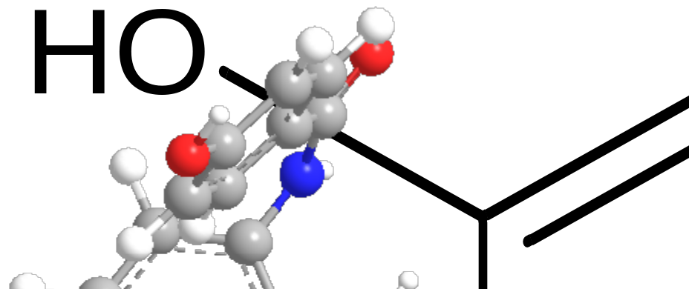
For example ,nano-cadmium compound has inhibitory effect 33 for Escherichia coli (ampicillin 24), staphylococcus aureus 29(ampicillin 21),Aspergillus flavus 33(amphotericin 170 and candida albicans 27(amphototericin 21).

