Synthesis and antiproliferative activity of novel amino substituted tetracyclic imidazo[4,5-b]pyridine derivatives
Marijana Hranjec, Nataša Perin and Ida Boček, Faculty of Chemical Engineering and Technology University of Zagreb, Department of Organic Chemistry, Marulićev trg 19, 10000 Zagreb, Croatia
Borka Lučić, Pliva d.o.o, TAPI I&R, 10000 Zagreb, Savski Marof, Croatia
Marijeta Kralj and Marija Mioč, Institute Rudjer Bošković, Laboratory of Experimental Therapy, Division of Molecular Medicine, Bijenička cesta 54, 10000 Zagreb, Croatia

Abstract (300 word limit)
Statement of the Problem: Due to the structural similarity of imidazo-pyridine heterocyclic system with naturally occurring purines and great therapeutic potential and significance, suchlike derivatives nowadays play an important role in medicinal chemistry and drug discovery. Imidazo-pyridine derivatives foregrounded their importance in the prevention of proper functioning of cancerous cells, diseases related to the central nervous system, inflammation, etc. Methodology & Theoretical Orientation: Taking into account a great biological potential and the fact that imidazo[4,5-b]pyridine scaffold is among the most privileged and important building blocks in medicinal chemistry as well as our previously published significant biological results of imidazo[4,5-b]pyridine derivatives, we have designed and synthesized novel tetracyclic derivatives as novel and potent antiproliferative agents. Findings: The synthesis of all newly prepared compounds was conducted using conventional methods of organic synthesis and microwave assisted synthesis. Tetracyclic derivatives were substituted with chosen amino side chains which have significantly enhanced the antiproliferative activity of tetracyclic derivatives and are placed at the different position of skeleton. Additionally, the impact of the N atom position in pyridine nuclei on biological activity was studied. Conclusion & Significance: The antiproliferative activity of regioisomers was studied against human cancer cells and non-tumour cells. As a standard drug etoposide was used and interestingly, the majority of compounds showed improvement of antiproliferative activity on HCT116 and MCF-7 cancer cells when compared to etoposide. From the obtained results it could be noticed that the position of N nitrogen in pyridine ring has strong impact on the antiproliferative activity while the type of amino substituent did not influence activity signifcantly. Thus, regioisomers 6, 7 and 9 substituted with amino substistuents at position 2 showed noticeable enhancement of activity in comparison to their counterparts 10, 11 and 13 having IC₅₀ values from 0.3 μM to 0.9 μM against all three cancer cells.

Image
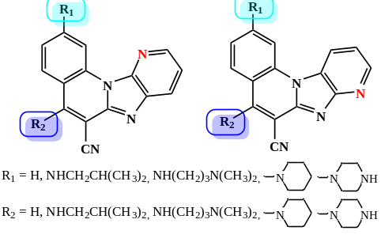
Recent Publications (minimum 5)
- Hranjec M, Lučić B, Ratkaj I, Pavelic SK, Piantanida I, Pavelic K, Karminski-Zamola G (2011) Novel imidazo[4,5-b]pyridine and triaza-benzo[c]fluorene derivatives: Synthesis, antiproliferative activity and DNA binding studies. Eur J Med Chem 46:2748–2758.
- Newhouse BJ, Wenglowsky S, Grina J, Laird ER, Voegtli WC, Ren L, Ahrendt K, Buckmelter A, Gloor SL, Klopfenstein N, Rudolph J, Wen Z, Li X, Feng B (2013) Imidazo[4,5-b]pyridine inhibitors of B-Raf kinase, Bioorg Med Chem Lett 23:5896-5899.
- Ghanema NM, Farouka F, Georgeb RF, Abbasb SES, El-Badrya OM (2018) Design and synthesis of novel imidazo[4,5-b]pyridine based compounds as potent anticancer agents with CDK9 inhibitory activity. Bioorg Chem 80:565–576.
- Perin N, Nhili R, Ester K, Laine W, Karminski-Zamola G, Kralj M, David-Cordonnier MH, Hranjec M (2014) Synthesis, antiproliferative activity and DNA binding properties of novel 5-Aminobenzimidazo[1,2-a]quinoline-6-carbonitriles. Eur J Med Chem 80:218–227.
- Perin N, Martin-Kleiner I, Nhili R, Laine W, David-Cordonnier MH, Vugrek O, Karminski-Zamola G, Kralj M, Hranjec M, Biological activity and DNA binding studies of 2-substituted benzimidazo[1,2-a]quinolines bearing different amino side chains, Med Chem Comm 4 :1537–1550.

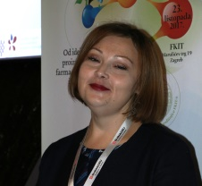 Biography (150 word limit)
Marijana Hranjec is a full professor where she works from 2001. She obtained her PhD in 2007 in the field of organic synthetic chemistry. She is highly experienced synthetic organic and medicinal chemists with research interests including the synthesis, spectroscopic characterization and biological activity of versatile heterocyclic derivatives. She published 50 papers indexed in Current Contents and supervised 1 doctoral dissertation, co-supervised 1 doctoral dissertation, 33 graduate and undergraduate students. In 2012, she spent some time working at the Jean-Pierre Aubert Research Centre (Lille, France). She teaches several courses at undergraduate, graduate and postgraduate studies at University of Zagreb. She was awarded with 2 prestigious awards, namely, Annual award for young scientists and artists (The society of university teachers) and The prize for organic chemistry Vladimir Prelog (Croatian Chemical Society). She was the leader of two scientific projects and currently is a collaborator on two projects.
Full Name: Marijana Hranjec
Tel: +385 1 4597 245
Session: Medicinal Chemistry and Drug Discovery
Category: Poster presentation
Email: mhranjec@fkit.hr

Notes/Comments:

