Computer Assisted Design, Synthesis and Biological Evaluation of Thiazole Based Molecules As Bcl2 Inhibitors
Sagarkumar Patel, Amit Shard*
Department of Medicinal Chemistry, National Institute of Pharmaceutical Education and Research Ahmedabad, Opposite Air Force Station, Gandhinagar, Gujarat 382355, India

Introduction: With the emergence of chemo-resistance and vast cancer types, quest to design novel and potent anticancer molecules is always a priority to enrich the armamentarium of medicinal chemists. The antiapoptotic Bcl-2 proteins are significantly over expressed in several tumor types and are striking targets for therapeutic intervention. This is because once the recalcitrant Bcl-2 proteins are inhibited, the cell follows the regular pathway of apoptosis, that significantly halts tumor progression.
Method: Virtually designed molecules were subjected to rigorous in silico screening (docking and ADMET studies). The intuition verified by computation was confirmed by wet bench experiments. Here several thiazole based scaffolds were designed in 3 steps and in vitro evaluated against Bcl-2-Jurkat, A-431 and ARPE-19 cell lines.
Results: Among them molecules 32, 50, 53, 57 are 59 showed potent activities against Bcl-2 Jurkat cell line at concentrations ranging from 32-46 µM respectively. One of the ligands 32 emerged as most potent and was subjected to molecular dynamics (MD) simulation with death defying anti-apoptotic Bcl-2 proteins (4IEH). It was shown that 32 interacted with protein majorly via hydrophobic interactions and few electrostatic interactions were also observed. During the MD simulation conformational changes in Bcl-2 protein were observed that facilitates the movement of ligand inside the cavity of protein (majorly involving α3, α4, α5, helices) Flow cytometry analysis of compound 32 suggested that cell undergoes 87.66% Annexin A5 positive.
Discussion: This confirmed our hypothesis that rationally designed molecules validated by computational means can significantly target tumor cells and hits developed can be effectively converted into leads by downstream modifications.

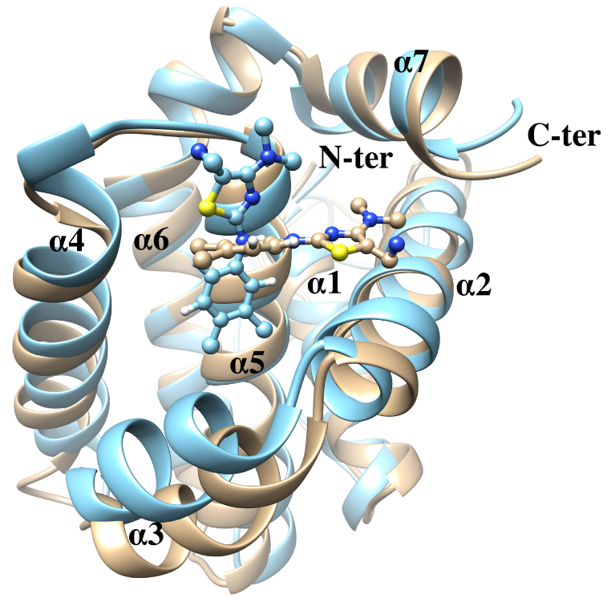
complex displaying the conformational change occurring during the MD simulation. Starting structure and the structure after 100 ns simulation time are displayed in tan and blue colour, respectively. Ligand 32 is displayed in ball and stick representation showing the positional transition of ligand during the simulation. All the helices are numbered based on the Bcl-2 X-ray structure (PDB ID: 4IEH). Nitrogen, sulphur and hydrogen atoms are shown in blue, yellow and white colour, respectively. Carbon atoms are displayed in tan and blue colour for starting and final simulated structure, respectively. This figure and subsequent molecular plots were created using the UCSF Chimera package.

References
- Azmi AS, Wang Z, Philip PA, Mohammad RM, Sarkar FH (2011) Emerging Bcl-2 inhibitors for the treatment of cancer. Expert opinion on emerging drugs 16: 59-70.
- Abraham MJ, Murtola T, Schulz R, Pall, S, Smith JC, Hess B, Lindahl E (2015) GROMACS: High performance molecular simulations through multi-level parallelism from laptops to supercomputers. SoftwareX, 1: 19-25.
- Pang YP, Dai H, Smith A, Meng XW, Schneider PA, Kaufmann SH (2012) Bak conformational changes induced by ligand binding: insight into BH3 domain binding and Bak homo-oligomerization. Scientific reports 2: p257.
- Pettersen EF, Goddard TD, Huang CC, Couch GS, Greenblatt DM, Meng EC, Ferrin TE (2004) UCSF Chimera-a visualization system for exploratory research and analysis. Journal of computational chemistry 25: 1605-1612.
- Petros AM, Olejniczak ET, Fesik SW (2004) Structural biology of the Bcl-2 family of proteins. Biochimica et Biophysica Acta (BBA)-Molecular Cell Research, 1644: 83-94.
- Ayati A, Emami S, Asadipour A, Shafiee A, Foroumadi A, (2015) Recent applications of 1, 3-thiazole core structure in the identification of new lead compounds and drug discovery. European journal of medicinal chemistry 97: 699-718.

Figure: Superposed starting and final conformations of Bcl-2-ligand 32


Sagarkumar Patel completed his B. Pharm from Ganpat University, Gujarat in 2014 and obtained M. Tech (Pharm) degree from the National Institute of Pharmaceutical Education and Research (NIPER), Mohali (India) under guidance of Dr. Joydev K Laha, in 2016. Now his pursuing fourth Year Ph. D in department of Medicinal Chemistry in National Institute of Pharmaceutical Education and Research (NIPER)- Ahmedabad under the guidance of Dr. Amit Shard. Current his research area is designing and synthesis of kinase inhibitors/activators.
Sagarkumar Patel
Tel: +918160091972
Category: Poster presentation
Email: sagarpatel6766@gmail.com

Notes/Comments: This work have been published in European Journal of Pharmaceutical Sciences entitle as Design, Computational Validation, Synthesis and Biological Evaluation of Thiazole based Molecules as Anticancer Agents

