Design, Synthesis and Molecular Modeling of Isothiochromanone Hybrids Bearing N-benzyl Pyridinium Moiety as Dual Binding Site Acetylcholinesterase Inhibitors
Jinyi Xu, Department of Medicinal Chemistry, China Pharmaceutical University, 24 Tong Jia Xiang, Nanjing 210009,
P. R. China
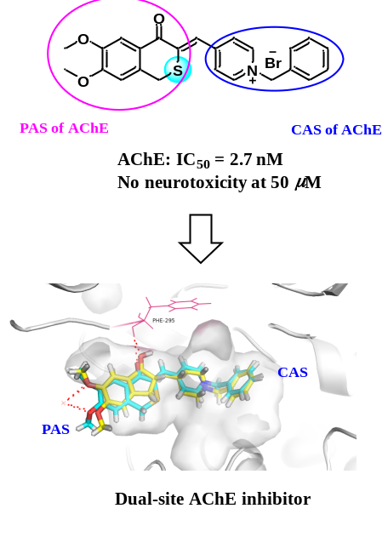

Abstract

Alzheimer's disease (AD), which is characterized by dementia, memory loss, cognitive impairment and ultimately death, is a progressive neurodegenerative disease. It is estimated that over 132 million elderly people will be affected by AD at 2050. Although considerable researches have been devoted to the pathogenetic mechanisms of AD, the etiology of AD still remain unclear. Several pathological hallmarks including acetylcholinesterase (AChE) have been verified to play vital roles in the pathogenesis of AD. In this study, a series of novel isothio- and isoselenochromanone derivatives were designed, synthesized and evaluated as AChE inhibitors. Most of the target compounds exhibited potent anti-AChE activities with IC₅₀ values in nanomolar ranges. Among which, compound 15a exhibited the most potent anti-AChE activity (IC₅₀ = 2.7 nM) and the highest AChE / BuChE selectivity (SI > 163) with low neurotoxicity. Moreover, the kinetic and docking studies revealed that compound 15a was a mixed-type inhibitor, which binds to PAS and CAS of AChE. Those results suggested that compound 15a might be a potential agent for AD treatment.

Image

Recent Publications
- Wang CL (2015) Design, synthesis, biological evaluation and docking study of 4-isochromanone hybrids bearing N-benzyl pyridinium moiety as dual binding site acetylcholinesterase inhibitors. Bioorg Med Chem Lett. 25: 5212-5216.
- Wang J (2018) Design, synthesis, biological evaluation, and docking study of 4-isochromanone hybrids bearing N-benzyl pyridinium moiety as dual binding site acetylcholinesterase inhibitors (part II), Chem. Biol. Drug Des. 91: 756-762.

Biography
Jinyi Xu, Ph.D., is a professor at China Pharmaceutical University. Jinyi Xu obtained her PhD at China Pharmaceutical University in 1998, and then pursued her postdoctoral research at Kindai University, Japan. In 2002, Dr. Jinyi Xu joined the Department of Medicinal Chemistry at China Pharmaceutical University. Her research field includes design, synthesis, and pharmacological investigation of small molecules in metabolic disorders, infectious disease, and oncology therapeutics. She has published more than 150 peer-reviewed scientific papers, over 20 patents, one book and three book chapters. Dr. Jinyi Xu has been invited to numerous lectures and seminars, and her research has been awarded at the national and international level.
Jinyi Xu
Tel: +86-25-86184328
Category: Poster presentation
Email: jinyixu@china.com

Notes/Comments:

This study was supported from the National Natural Science Foundation of China No. 81874289

