Evaluating CARE's Community-based Approach through a
Community Organizing Framework
Andrew Saxon, Emory University School of Medicine, MD Candidate 2018
Michelle Kegler, PhD, Emory University Rollins School of Public Health
Monique Hennink, PhD, Emory University Rollins School of Public Health

Abstract

CARE, an international development NGO, is a global leader in using a community-based approach in public health. This study sought to understand how CARE uses community organizing to implement public health interventions among underserved populations in three programs in two countries. The programs were assessed through Ganz’s principles: 1) leadership development, 2) creating shared values through storytelling and 3) catalyzing action through strategy and team building. Programs were selected by CARE staff. Participants were selected by familiarity with the program, diversity, pragmatic sampling techniques and purposively recruited through formal CARE networks. Data collection was completed through sixteen in-depth interviews and two focus groups were conducted from October through December 2016. The sample size was determined by saturation. Each interview and transcript was analyzed for themes around leadership development, storytelling, team-based organizing, community organizing strategies and other topics that were identified as important to the program’s execution. A codebook was created through analysis of literature, the interview guide and transcripts. Transcripts were coded and analyzed using MaxQDA software for usage, frequency, consistency and context of each theme and analyzed across interview subjects and sites. Study findings showed that all programs concentrated on building the capacity of community members to implement program activities. Other important strategies included systems strengthening, coalition building and government outreach. Two of the three projects focused on Freirean liberation education style trainings, developing community member’s understanding of social forces and their role in society. Storytelling and team-based organizing were used sporadically. Each program activated participants to become further involved in community work, including running for local office. CARE’s programs focused on building community capacity through leadership development. Ganz’s framework could enhance the practice of storytelling in recruitment and activation of community members. Building more effective community groups through a team-based structure could be advantageous.
Image
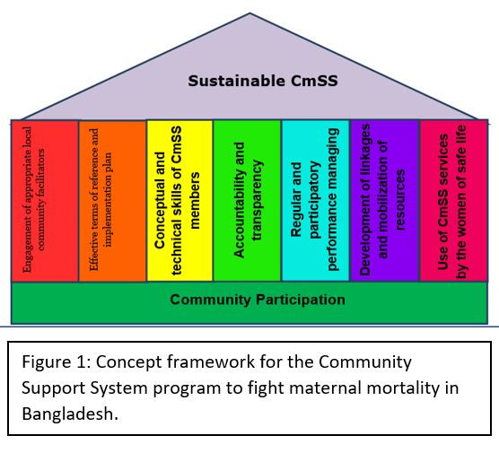
Recent Publications
None

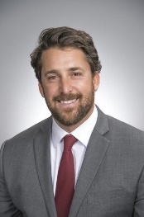 Biography:
Andrew Saxon is a fourth year medical student at Emory University School of Medicine. An Atlanta native, he has previously lived in Buenos Aires and worked as a paralegal, a community organizer on the 2008 Obama presidential campaign, an administrator for KIPP Public Charter Schools in Washington, D.C., and as a policy analyst for the National Center of Immunizations and Respiratory Diseases at the CDC. He is interested harnessing the power of communities to make children and families healthier. He wants to practice community-based medicine and work in public health as a future physician.

Email: andrew.saxon@emory.edu

Notes/Comments:

