Dosimetric evaluation of electron beams on scalp using EBT2 films and Rando phantom
Nafise Hasoomi, Akbar Sarabi Asl, Mansour Naderi

Abstract:

Electron irradiation for superficial tumors is tremendous modalities in radiotherapy. electon has a good coverage of skin tumors although heterogeneity of tissue especially in low density cause to absence of electron equilibrium. Scalp malignancies treat with variety techniques includes photons and electrons. Electron need a precise dosimetry before each treatment as well as it should be a planning system based on Mont carlo simulation. It obviously can spare normal tissue during irradiation.
In this essay used a rando phantom and gafchromic EBT2 films to analyses electron behavior through scalp malignancy treatment. Gafchromic. EBT2 films verified by a plane parallel chamber as a reference dosimeter. Then calibration curve plotted. In last step it used for electron dosimetry on scalp.
Electron has sharp fall off and good coverage of skin tumor but for preventing lateral scattering, fields should be shifted through radiotherapy sessions.
There was an acceptable dose range through field except in borders dose ranges varies sharply(more than 50%).

Key words : scalp treatment, gafchromic EBT2, electron, scalp treatment.

Introduction:

Radiation therapy is using of ionizing radiation for superficial malignancies as cutaneous lymphoma, melanoma, angiosarcoma, mycosis fungoides, Kaposi’s sarcoma, sebaceous carcinoma, basal and squamous cell carcinoma that may extend into the entire scalp region and forehead. In most patients, irradiation of the total scalp as a treatment technique may be necessary to treat these superficial tumors, particularly when surgical excision is not the treatment of the choice[1]. The goal of total scalp irradiation is to deliver a uniform dose throughout the target while minimizing dose to the brain and optical structures. Though dosimetry of electron field which has especial shape is necessary before radiotherapy session. Due to the convex surface of the calvarium and the close proximity of the scalp to the adjacent normal brain tissue as well as multifocal spread of the malignant lesions on the scalp, dose delivery is technically challenging subject and therefore the goal of scalp irradiation is difficult to achieve. In this regard, various irradiation techniques concerning the treatment of scalp malignancies have been suggested in the medical literature and include lateral electron-photon technique, high dose rate helmet-shaped mold based brachytherapy[2], linac based intensity-modulated radiation therapy and helical tomotherapy[3].
The traditional electron-beam techniques have relatively high and low dose on the scalp and underlying brain tissues, respectively. Nevertheless, electron-beams may cause labor intensive treatment set up with numerous electron-beam junctions[4, 5]. In the conventional combined electron-photon modality technique, an adequate target volume dose could be accomplished with improved dose uniformity by virtue of overlapped fields and signiﬁcant dose to the normal brain tissues and eyes alleviated as well. This makes the treatment set up less tedious and less time consuming but incidence of beam angle and field matching are the problem [6, 7].Combined electron-photon modalities suggested in Principles and Practice of Radiation Oncology named MD Anderson and UCSF techniques.[8] These techniques need a modulated treatment planning system which can match both electron and photon simultaneously to monopolize the problem of using both of them. The HDR brachytherapy plan is most conformal and the treatment delivery is well endured. This technique could be clinically convenient for treatments requiring a lower prescription dose and for patients who cannot lie on the treatment couch. However, due to the dose fall-off characteristics of ¹⁹²Ir source, the HDR modality produced a 58–242% dose gradient within the target. Moreover, the underlying brain tissues and optical structures received the highest doses with the HDR technique[2, 9]. The IMRT technique constitutes a promising and possible way to treat extensive scalp lesions and provided superior target coverage of the treatment volume with most homogenous as well as conformal dose distribution within the target. The dose to the brain tissue and lens are slightly higher in the IMRT plan, although this is clinically satisfactory. The IMRT is sensitive to setup uncertainty and can involve long treatment times in an uncomfortable position [8]. Most recently, helical tomotherapy has shown that it is able to treat the scalp with tangential beamlets more than multiple abutting fields of different energy or modality. Despite the concern that tomotherapy planning system can overestimate the calculated superﬁcial dose for head and neck treatments, this modality eliminates the need for bolus as well as avoiding field matching problems and use of more than one modality [7, 10]

Although electron has multiple problems during treatment such as lateral scattering; but it has a sharp fall off and good coverage for skin tumors. Symmetry and flatness of an electron beam are relying on the outline of the flattening system and the equipment’s used for beam collimation. Electron field uniformity can be defined by specific setup which is recommended on field symmetry and flatness for a specified area of the beam at depth. The reference depth used for this determination has traditionally been at or close to the depth of maximum dose. [11]

Uniformity across the electron field, which is compulsory for quality assurance, is another statement of symmetry and flatness. It determines dose variation over 80 percent at plane parallel to surface of phantom and perpendicular to central axis in a standard field size in 10 cm depth this is accepted around 3 percent , as well as, we can calculate flatness and symmetry from following formula:[12]
Flatness (%) = Dmax/D min × 100% (1)
Symmetry (%) = [D(x, y)]/[D (-x,-y)] × 100%
We measured profile and PDD using GAFCHROMIC® EBT2 films for 6 MeV and variation of superﬁcial dose as well as impact of bone and heterogeneity in increasing of skin dose delivered to an anthropomorphic phantom (RANDO, Alderson Radiation Therapy phantom (ART)) with abutting non-coplanar electron fields.

Method and material

A:Calibration and verification:
Gafchromic EBT2 as a dosimeter instrument was used in this project ,which has a low sensitivity to light , independence to energy and …,handling of film was formed based on AAPM TG55 report, these films including yellow dye marker that known as active layer and it has less sensibility to light. Films analyzed by scanner with a RGB mode (in red channel) because the wavelength of scanner is about 632nm well matched to the spectral maximum in EBT2 film. For preventing newton rings flat board Microtek scanner was utilized. Scan systems have the advantage of shortening time to read the film.
Nominally changes between two sides of film top and right of each film lead to create a small cutting or marking film based on recommended company to achieve uniform response in scan during the scan of film [13]
During work with gafchromic films care should be taken to fingerprints and dust. these should remove before reading film[14] .
To achieve calibration curve prepared 33 pieces of films in size of 1.5×2 ${cm}^{2}$(figure1) 24 hours before radiations. Based on ISP protocols scanning process(by Mikroteck scanner) should be done 24 hours after irradiation, then scans were analyzed with Image J software produced by America's Health Research Center [15, 16]
To determination profile and PDD, measurements, were accomplished in a slab phantoms, All results normalized to 100 which was dose on central axis dose for a 10×10 applicator.
Accelerator machine was Varian Clinac2100C in IMAM Khomeini Hospital Tehran, Iran. The accelerator is capable of generating electron energies (6, 9, 12, 18, and 20)MeV and photon energies (6, 18)MV.

Figure 1: pieces of films for calibration

Based on optical density and doses were irradiated to films (dose steps: 0, .5, 1,2,3,5 Gy) calibration curve was extracted. [Figure 1]

netOD = ${OD}_{exp}$ – ${OD}_{unexp}$
(2)
netOD${=log}_{10}$ $\frac{I_{unexp}- I_{exp} }{I_{exp}-I_{backg}}$

Figure 2: film for profile and PDD
Film features include wide dose rang (0-8 Gy),not depend on energy, not sensitivity to natural light and high uniformity [14];these features encouraged us to use Gafchromic EBT2 films.
Another step was plot PDD and Profile which got them by exposing and analyzing a piece of film which is shown in figure 2&3.
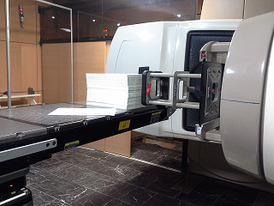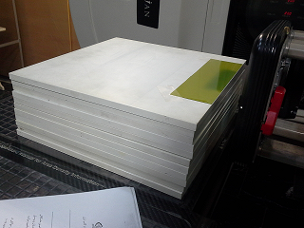
Figure 3:Set up of film for achieve Profile and PDD(energy 6 MeV ,Varian Linac accelerator, SSD=100,FS=10×10)
For verify our data was extracted from films used a plane-parallel chamber as a reference dosimeter .It should be used for beam qualities R50 < 4 g/${cm}^{2}$)(Eo _ 10 MeV). The reference point for plane-parallel chambers is taken to be on the inner surface of the entrance window, at the center of the window [17]. Dosimetry data carried out at the point of interest (0.5, 1.4, 2.4 cm) in the water phantom. Well-guarded plan parallel ionization chambers are designed to minimize scattering perturbation effect; additionally the effective point of measurement of chamber is the inner surface of entrance window, at the center of the window. for all beam qualities and depths, thus the effective point of measurement is as the same point of the measurement [17].

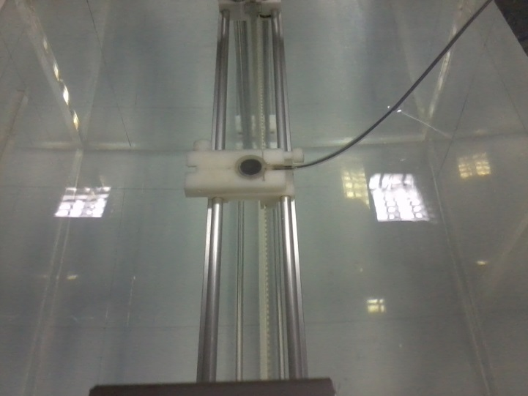
Figure 4:Set up of plane parallel chamber(reference dosimetry)

B:Phantom irradiation

To simulate treatment part used a Rando phantom which was equivalent to human scalp; In our method we use 5 fields without any gaps between them. Fields specified by gantry , couch angle and shielding; as shown in figure 5 . By declining the number of fields, both set up errors and hot or cold spots during transformations will be decreased. Point of interests were field`s match lines and curvature of scalp.
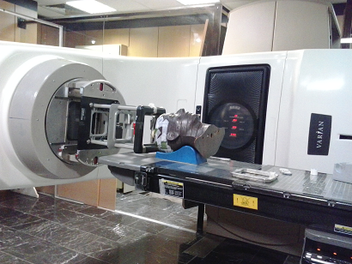
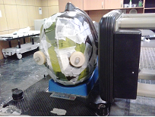

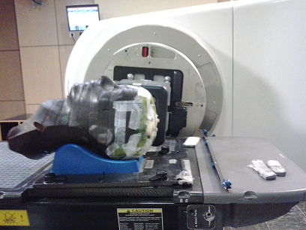
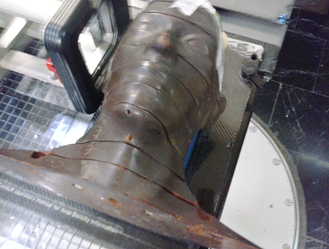

Figure 5: Set up of Rando phantom
Results:

The calibration curve of film was plotted based on the optical density(formulas 2) and doses which is showed in figure 6.

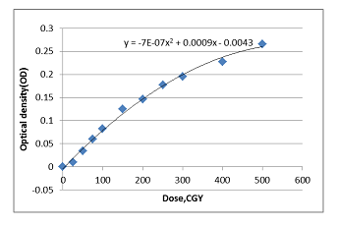
Figure 6: :calibration curve(SSD=100, Field Size=10$×$10 gantry rotation=0)

For better using calibration curve we achieved equation below from the figure 6

D$\left(cGy\right)=642.857-(714286\sqrt{.0000007988-.0000028*OD})$ (3)

Percentage Depth Dose and Profile curve were achieved from film and plane parallel chamber. the applicator was 10$×$10 ${cm}^{2}$ and MU=100 monitor unit.(figure7,8,9,10).
Figure 7: :profile of parallel plane chamber and gafchromic EBT2 (Energy:6 MeV,depth:5mm,field size:10×10

Figure 8 :profile of parallel plane chamber and gafchromic EBT2 (Energy:6 MeV,depth:14mm,field size:10×10)

Figure 9:profile of parallel plane chamber and gafchromic EBT2 (Energy:6 MeV,depth: 24mm,field size:10×10(

Figure 10: PDD of parallel plane chamber and gafchromic EBT2 (Energy:6 MeV ,field size:10×10)

According to the graphs there is an acceptable result between film EBT2 and plane parallel chamber. Conformity and symmetry of gafchromic EBT2 had approved, after testifying EBT2 it was used for phantom. Dose calculated on scalp by films showed significant outcome (figure 11&table 1). Border doses varies sharply (table 2); calculated doses are between 80-97CGy (more than 50%), It shows electrons make hotspot in borders..

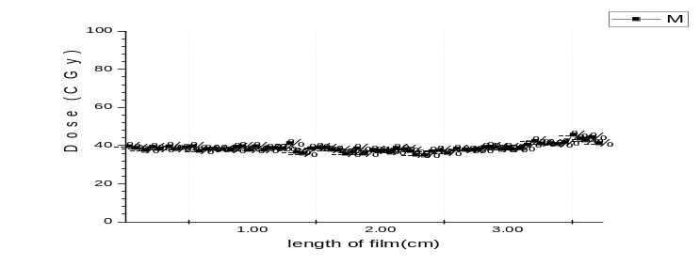dose Changing in one field as showen in figure 11

Figure 11: dose variations in scalp by film in one lobe
Table below showed dose and pixle value in a part of film which exposed in the parietal lobe
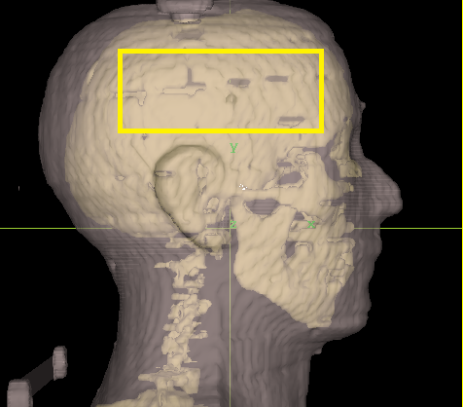
Figure 12: view of parietal field in Rando phantom scalp

Table 1: dose variations and pixel values and optical density in a part of film through the field
Mean Pixle value | Max pixle v | Min pix v | x | y | Optical density | Dose (CGy)
57520 | 57520 | 57520 | 4.053 | 0.067 | 0.039522 | 50.32703
57639 | 57639 | 57639 | 3.98 | 0.08 | 0.038624 | 49.24602
57666 | 57666 | 57666 | 3.907 | 0.073 | 0.038421 | 49.00133
57594 | 57594 | 57594 | 3.827 | 0.073 | 0.038963 | 49.65431
57568 | 57568 | 57568 | 3.747 | 0.073 | 0.039159 | 49.89048
57376 | 57376 | 57376 | 3.68 | 0.073 | 0.04061 | 51.64079
57533 | 57533 | 57533 | 3.593 | 0.08 | 0.039424 | 50.20873
57465 | 57465 | 57465 | 3.5 | 0.08 | 0.039937 | 50.82808
57380 | 57380 | 57380 | 3.42 | 0.087 | 0.04058 | 51.60421
57446 | 57446 | 57446 | 3.353 | 0.087 | 0.040081 | 51.00138
57508 | 57508 | 57508 | 3.267 | 0.087 | 0.039612 | 50.43627
57477 | 57477 | 57477 | 3.2 | 0.087 | 0.039846 | 50.71868
57605 | 57605 | 57605 | 3.113 | 0.093 | 0.03888 | 49.55445
57702 | 57702 | 57702 | 3.027 | 0.093 | 0.03815 | 48.67542
57554 | 57554 | 57554 | 2.947 | 0.093 | 0.039265 | 50.01774
57892 | 57892 | 57892 | 2.86 | 0.093 | 0.036722 | 46.96161
57901 | 57901 | 57901 | 2.76 | 0.1 | 0.036654 | 46.8807
58017 | 58017 | 58017 | 2.687 | 0.1 | 0.035785 | 45.83985
57949 | 57949 | 57949 | 2.607 | 0.1 | 0.036295 | 46.44953
57904 | 57904 | 57904 | 2.52 | 0.087 | 0.036632 | 46.85373

Table below showed dose in the match lines of parietal and occipital lobs

In the frontal lobe variation of dose is constant and monotonous nearly; the rang of variation was around 6 ±% but in the junctions; there was a conspicuous Changes around 78-97 CGy.

Table 2: dose variations and pixel values and optical density in a part of film in the border
Mean PV | Max PV | Min PV | X(inch) | Y(inch) | OD | Dose (CGy)
53481 | 53481 | 53481 | 0.364 | 2.64 | 0.071141 | 97.22727
52778 | 52778 | 52778 | 0.364 | 2.773 | 0.076888 | 78.15041
54611 | 54611 | 54611 | 0.364 | 2.871 | 0.06206 | 74.68164
54958 | 54958 | 54958 | 0.364 | 2.978 | 0.05931 | 80.42293
54386 | 54386 | 54386 | 0.364 | 3.084 | 0.063853 | 83.11321
54122 | 54122 | 54122 | 0.364 | 3.182 | 0.065967 | 84.89036
53949 | 53949 | 53949 | 0.356 | 3.298 | 0.067357 | 82.50971
54181 | 54181 | 54181 | 0.356 | 3.387 | 0.065494 | 84.14936
54021 | 54021 | 54021 | 0.347 | 3.511 | 0.066778 | 84.5402
53983 | 53983 | 53983 | 0.364 | 3.618 | 0.067084 | 83.15417
54118 | 54118 | 54118 | 0.364 | 3.724 | 0.065999 | 82.80618
54152 | 54152 | 54152 | 0.364 | 3.822 | 0.065726 | 82.27481
54204 | 54204 | 54204 | 0.364 | 3.938 | 0.065309 | 88.80286

Conclusion:

In treatment with electron, curvature of scalp cause to either air gap and lateral scattering, the later one conduce to decrease Dmax around the treatment field as well as dose decrease due to decline of flux of electrons. Oblique factor is important when the radiation angle is more than 60 degree, if depth is constant with increasing the angle or gap between applicator and scalp dose will be increases. As well as bone influences on electron dose in scalp surface
Heterogeneity of tissue especially in low density cause to absence of electron equilibrium ,disregard heterogeneity of tissue in the calculation make increment of organ at risk dose and decrease tumor dose so dosimetry for this organs is necessary, film is a nice selection because of high spatial resolutions and flexibility and easy to use.
Behavior of electron showed dose distributions depends on field curvatures and air gap between scalp and applicator.
In our study without any gap between fields skin dose was uniform but doses in junction weren’t acceptable.
Because in scalp treatment brain is an organ at risk and TD of brain is 55Gy and for cure scalp tumor as BCS need a 60 Gy so treatment of these tumors need a modified technique to decrease brain dose, in electron technique because electron have a rapid fall off dose can obstacle complication of brain tissue and also can achieve to a good coverage of tumor but these treatments need a precise dosimetry and planning with a good fixation. So its lead to further studies about scalp irradiation.

Compliance with Ethical Standards:

This article does not contain any studies with human participants or animals performed by any of the authors.

Author Nafise Hasoomi declares that she has no conflict of interest. Author Akbar Sarabi Asl declares that he has no conflict of interest. …Auther Mansour Naderi declares that he has no conflict of interest

This article does not contain any studies with human participants or animals performed by any of the authors.

- References

1. Tung, S.S., et al., Dosimetric evaluation of total scalp irradiation using a lateral electron-photon technique. International Journal of Radiation Oncology* Biology* Physics, 1993. 27(1): p. 153-160.
2. Liebmann, A., et al., Helmet mold-based surface brachytherapy for homogeneous scalp treatment: a case report. Strahlentherapie und Onkologie, 2007. 183(4): p. 211-214.
3. Able, C.M., et al., Evaluation of a total scalp electron irradiation technique. International Journal of Radiation Oncology* Biology* Physics, 1991. 21(4): p. 1063-1072.
4. Mellenberg, D.E. and S.L. Schoeppel, Total scalp treatment of mycosis fungoides: the 4× 4 technique. International Journal of Radiation Oncology* Biology* Physics, 1993. 27(4): p. 953-958.
5. Walker, C., N. Wadd, and H. Lucraft, Novel solutions to the problems encountered in electron irradiation to the surface of the head. The British journal of radiology, 1999. 72(860): p. 787-791.
6. Akazawa, C., Treatment of the scalp using photon and electron beams. Medical dosimetry: official journal of the American Association of Medical Dosimetrists, 1988. 14(2): p. 129-131.
7. Orton, N., et al., Total scalp irradiation using helical tomotherapy. Medical Dosimetry, 2005. 30(3): p. 162-168.
8. Halperin, E.C., et al., Perez & Brady's Principles and Practice of Radiation Oncology. 2013: Lippincott Williams & Wilkins.
9. Wojcicka, J.B., et al., Dosimetric comparison of three different treatment techniques in extensive scalp lesion irradiation. Radiotherapy and Oncology, 2009. 91(2): p. 255-260.
10. Hardcastle, N., et al., Dosimetric verification of helical tomotherapy for total scalp irradiation. Medical physics, 2008. 35(11): p. 5061-5068.
11. Khan, F.M. and J.P. Gibbons, Khan's the Physics of Radiation Therapy. 2014: Lippincott Williams & Wilkins.
12. Pathak, P., et al., Analytical Study of Flatness and Symmetry of Electron Beam with 2D Array Detectors. Journal of Cancer Science & Therapy, 2015. 2015.
13. Lynch, B.D., et al., Important considerations for radiochromic film dosimetry with flatbed CCD scanners and EBT GAFCHROMIC® film. Medical physics, 2006. 33(12): p. 4551-4556.
14. GafchromicVR, E., Self-Developing Film for Radiotherapy Dosimetry. ISP White Paper, 2010.
15. Mayers, S., Characterisation of gafchromic EBT2 film for use in radiation therapy dosimetry. 2011.
16. Sim, G., J. Wong, and K. Ng, The use of radiochromic EBT2 film for the quality assurance and dosimetric verification of 3D conformal radiotherapy using Microtek ScanMaker 9800XL flatbed scanner. Journal of Applied Clinical Medical Physics, 2013. 14(4).
17. Andreo, P., et al., Protocols for the dosimetry of high-energy photon and electron beams: a comparison of the IAEA TRS-398 and previous international Codes of Practice. Physics in medicine and biology, 2002. 47(17): p. 3033.

MSc of Medical Radiation Engineering, BCs of Radiation Therapy, cancer institute Imam Khomeini Hospital of Tehran, Tehran, Iran, email:nhasoomi@gmail.com Mobile number: 00989129320564
MSc of Medical radiation Engineering, Department of Nuclear Engineering, Faculty of Advanced Science & Technologies, University of Isfahan, Isfahan, Iran
MSc of Medical radiation Engineering, Department of Nuclear Engineering, Islamic Azad University, Science and Research Branch, tehran, Iran

