Protamine/Carboxymethyl dextran based nanoadjuvant for co-delivery CpG oligonucleotides and EV71 inactivated vaccine against hand, foot and mouth disease
Hao Liang, College of Life Science and Bioengineering, Beijing University of Technology, PR China

Abstract
Enterovirus 71 (EV71) is a major causative pathogen of hand, foot, and mouth disease (HFMD) in young children. HFMD induced by EV71 can cause a high rate of neurologic complications and even death. Although there are three inactivated EV71 vaccines were approved in China, the adjuvants used with EV71 vaccines have many defects and need to be improved. In this study, we generated a novel protamine/Carboxymethyl dextran based nanoadjuvant for CpG oligonucleotides (ODNs) and EV71 inactivated vaccine co-delivery. The new nanovaccine was administrated in mice to evaluate its immune activity. Results showed that it can induced high level EV71-specific neutralizing antibodies toward Th1-bias response. The specific antibodies from mice administered nanovaccine shown stronger neutralization activity in vitro and in vivo than any other groups with nanoadjuvant or CpG ODNs alone. The CpG-1826，a B-type CPG ODNs, were loaded in the nanoadjuvant and stimulated immune cells to secrete a great deal of both IFN-α and IFN-γ in vivo. This results demonstrated that nanoadjuvant endow CpG-1826 with A-type CpG ability to secreting type I IFN without losing its B-type activity to enhance immune respones. Taken together, the novel nanovaccine can be a potential candidate for medically necessary EV71 vaccines, and CpG ODNs loaded nanoadjuvant may be a excellent adjuvant used in other immunotherapeutic applications which demand type I and type II IFN induction.

Image
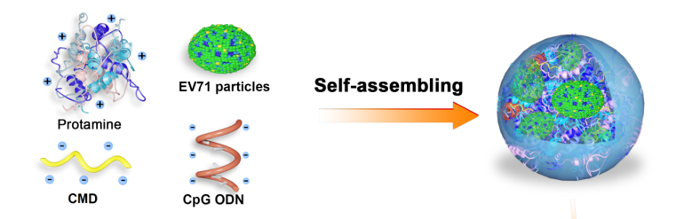
Fig 1. Schematic illustration of design strategy of the nanovaccine
Recent Publications (minimum 5)
- Deng, X., Yin, Z., Lu, J., Li, X., Shao, L., & Zhao, C., et al. (2018). In situ monitoring of microrna replacement efficacy and accurate imaging‐guided cancer therapy through light‐up inter‐polyelectrolyte nanocomplexes. Advanced Science, 5(4), 1700542.
- Singh, S. M., Alkie, T. N., Nagy, É., Kulkarni, R. R., Hodgins, D. C., & Sharif, S. (2016). Delivery of an inactivated avian influenza virus vaccine adjuvanted with poly(D,L-lactic-co-glycolic acid) encapsulated cpg odn induces protective immune responses in chickens. Vaccine, 34(40), 4807-4813.
- Qiao, D., Liu, L., Chen, Y., Xue, C., Gao, Q., & Mao, H. Q., et al. (2018). Potency of a scalable nanoparticulate subunit vaccine. Nano Letters.
- Kobiyama K, Aoshi T, Narita H, Kuroda E, Hayashi M, & Tetsutani K, et al. (2014). Nonagonistic dectin-1 ligand transforms cpg into a multitask nanoparticulate tlr9 agonist. Proceedings of the National Academy of Sciences of the United States of America, 111(8), 3086-91.
- 5. Zupančič, E., Curato, C., Paisana, M., Rodrigues, C., Porat, Z., & Viana, A. S., et al. (2017). Rational design of nanoparticles towards targeting antigen-presenting cells and improved t cell priming. Journal of Controlled Release, 258..

Biography
Hao Liang is a PhD student of Beijing University of Technology with Prof. Wang Sheng and major in bioengineering at College of Life Science and Bioengineering. He has specialized in developing novel vaccines and immune therapy and takes participate in a National Natural Science Project, " Design and Construction of beta-glucan/CpG ODN-based Dual Combined Nano-adjuvant and Studies on its Immune Effects of Entervirus 71 Vaccine " (Grant No. 31770999).
Email: 13426150365@163.com

