Nanofibers of poly (vinyl alcohol co-vinyl acetate) as novel scaffold for mammalian cell culture and controlled drug delivery.

Francisca Villanueva-Flores¹, Margarita Miranda-Hernández², José O. Flores-Flores³, Alberto Porras-Sanjuanico¹ Hailin Hu², Leonor Pérez-Martínez¹, Octavio T. Ramírez¹ and Laura A. Palomares¹
¹ Instituto de Biotecnología. Universidad Nacional Autónoma de México. Cuernavaca, México.
² Instituto de Energías Renovables. Universidad Nacional Autónoma de México. Temixco, México.
³ Centro de Ciencias Aplicadas y Desarrollo Tecnológico. Universidad Nacional Autónoma de México. Cuidad de México, México.

Abstract
The development of novel materials as scaffolds for cell culture has gained attention. The current challenge is to provide a scaffold that mimics natural tissues. We synthetized at physiological temperature a pH-responsive and biocompatible nanostructured hydrogel with three different crosslinking degrees by varying the content of glutaraldehyde (GA). According with our data of scanning electron microscopy (SEM) and FTIR, we observed that the hydrogel is conformed highly ordered nanofibers of poly (vinyl alcohol co-vinyl acetate) (nsPAcVA). By atomic force microscopy (AFM), we showed that nsPAcVA has nanopores homogeneously distributed on its surface. We characterized the relative amount of remaining hydroxyl groups and of formed acetal bridges by FTIR, and by mechanical tests, we measured the Young’s modulus, strain stress, elastic deformation and tensile strength. nsPAcVA had swelling dynamics dependent on pH and crosslinking. By cyclic voltammetry, we showed that nsPAcVA has ionic conductivity properties inversely proportional to its crosslinking degree. Based on this, we evaluated its capability to controllably release a model molecule. Diffusion analysis through the Peppas equation showed that at lower crosslinking degrees (5 and 10% of GA content), diffusion from nsPAcVA was Fickian. Moreover, we demonstrated for the very first time that nsPAcVA is an efficient scaffold for growth of mammalian cells (embryonic mouse hypothalamic mHypoE-N1 and human lung carcinoma A-549 cells). mHypoE- grown on nsPAcVA had lower proliferation than the control, but after 108 h of adaptation, cells proliferated at comparable growth levels than the control. No significant difference in A-549 cell growth over nsPAcVA and the control was observed. We present a very easy synthesizable, cheap, biocompatible and nanostructured scaffold for controlled drug release with promising physicochemical characteristics to be applied as a tissue engineering material that integrates abiotic and biotic components towards a new generation of smart implants which ultimately could mimic natural tissues.

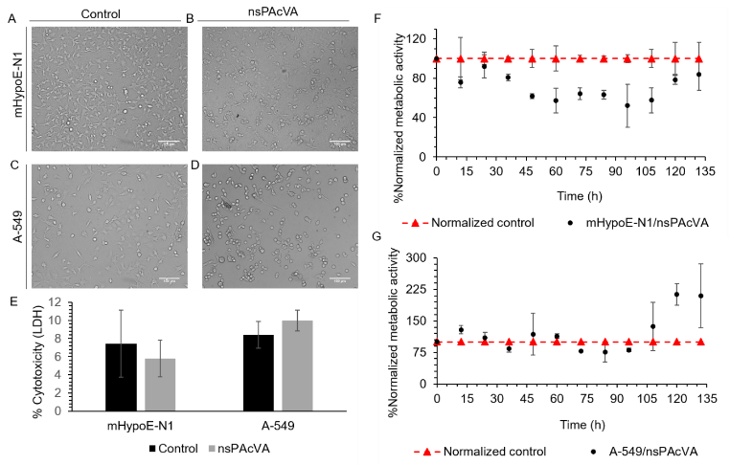
Fig. 1. Cell growth on nsPAcVA films (10% GA). mHypoE-N1 grown on A) cell culture plates and B) on nsPAcVA films at 48 h of culture. A-549 grown on C) cell culture plates and D) on nsPAcVA films at 48 h. E) Cytotoxicity measured as the release of LDH at 72 h of culture (n=3). Normalized metabolic activity as indirect measurement of proliferation (n=2) of F) mHypoE-N1 and G) A-549 grown on nsPAcVA versus on commercial cell culture plates. Error bars represent standard deviations or differences between replicate experiments
Recent Publications
K. C. S. Figueiredo et al. “Poly(vinyl alcohol) Films Crosslinked by Glutaraldehyde Under Mild Conditions,” J. Appl. Polym. Sci., 111: 6, 3074–3080, 2009.
H. S. Mansur et al. “FTIR spectroscopy characterization of poly (vinyl alcohol) hydrogel with different hydrolysis degree and chemically crosslinked with glutaraldehyde,” Mater. Sci. Eng. C, 28: 4, 539–548, 2008.
J. E. Gough, et al. “Cytotoxicity of glutaraldehyde crosslinked collagen/poly(vinyl alcohol) films is by the mechanism of apoptosis,” J. Biomed. Mater. Res., 61: 1, 121–130, 2002.
M. Araujo et al., “Polyvinyl alcohol-glutaraldehyde network as a support for protein immobilisation,” 11: 2, 67–70, 1997.
J. Zhu and R. E. Marchant, “Design properties of hydrogel tissue-engineering scaffolds,” Expert Rev. Med. Devices, 8: 5, 607–626, 2011.


Research performed thanks to the support of
UNAM-DGAPA-PAPIIT IT200416.

Biography
Francisca Villanueva-Flores is studying her last year of PhD in biochemistry at Instituto de Biotecnología in the Universidad Nacional Autónoma de México. Her main research focuses in the development of medical nanodevices for neuronal tissue engineering. In her PhD, she synthetized a nanoimplant for restoring cellular function (unpublished data). Her research interests also include the understanding of cell-nanomaterial interactions to develop novel, efficient and safe therapeutic nanobiomaterials. Email: fran@ibt.unam.mx

